Task 7.1

# Student Name: Peter Stacey

# Student ID: 219011171

Question 1

Draw a series of figures demonstrating the insertion of the values:

20, 9, 3, 7, 5, 8, 25, 30, 15, 6, 17

­

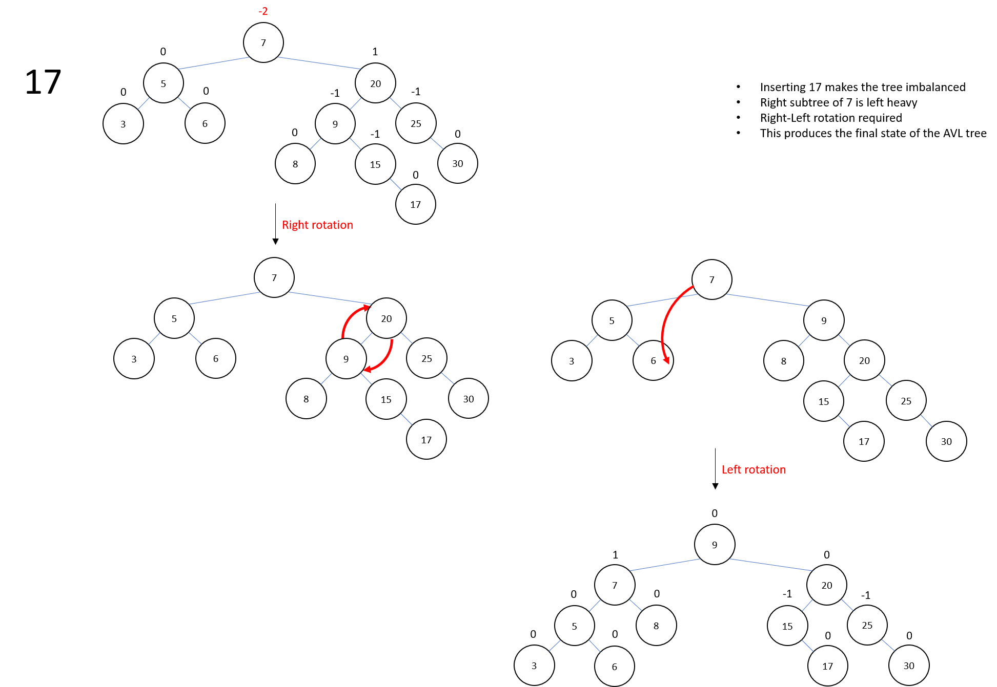

To confirm my results, I wrote an AVL Tree class in C# and tester to print the operations:

Question 2

Now, draw a series of figures showing the deletion of the values:

20, 15, 8, 25, 30, 9, 17, 5, 6, 3, 7

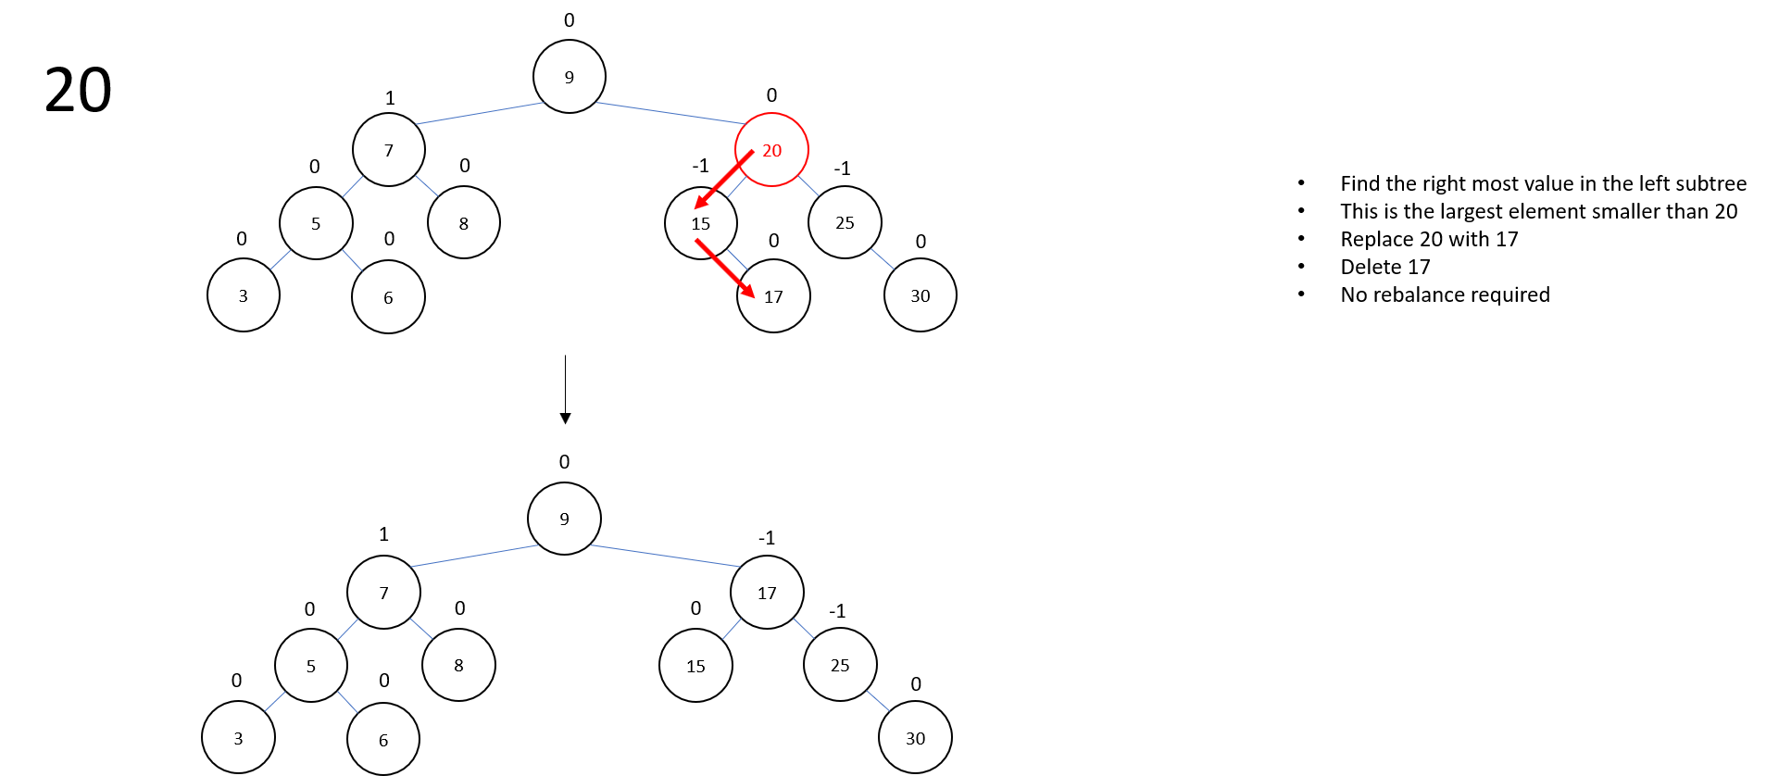

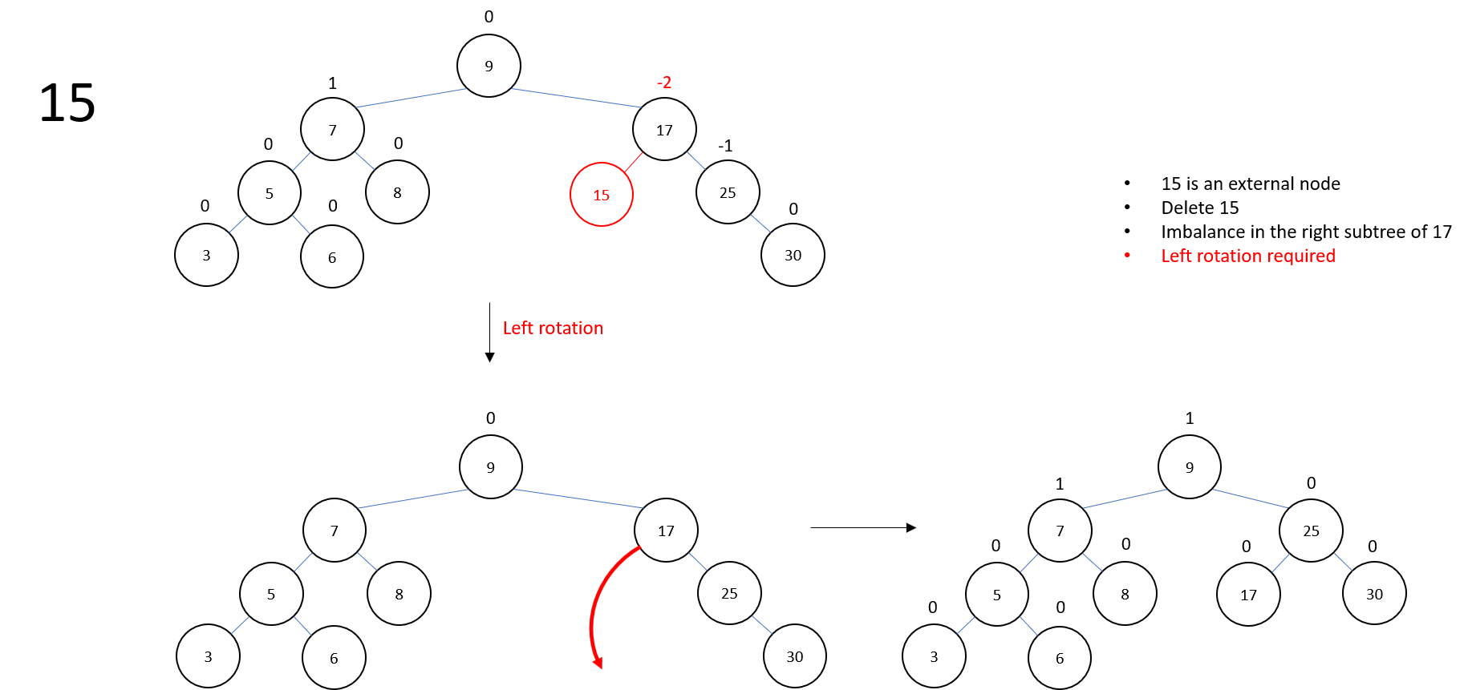

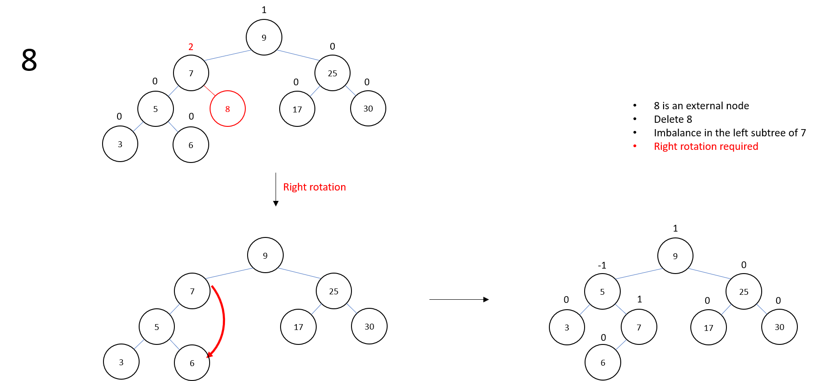

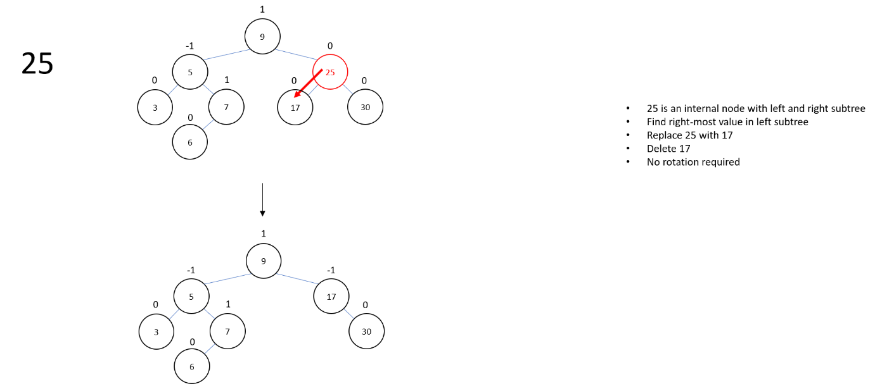

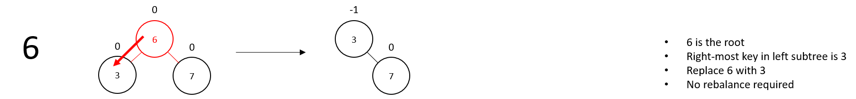

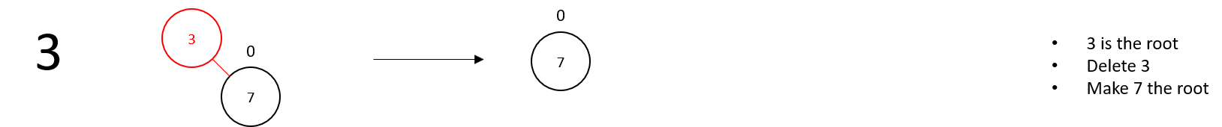

Question 3

What order should we insert the elements ሼ1, 2, … ,7ሽ into an empty AVL tree so that we do not have to perform any rotations on it?

Any of the following orders will not require any rotation:

4, 2, 6, 1, 7, 3, 5

4, 6, 2, 1, 7, 3, 5

4, 2, 6, 7, 1, 3, 5

4, 6, 2, 7, 1, 3, 5

4, 2, 6, 1, 7, 5, 3

4, 6, 2, 1, 7, 5, 3

4, 2, 6, 7, 1, 5, 3

4, 6, 2, 7, 1, 5, 3

4, 2, 6, 7, 3, 5, 1

6, 4, 2, 7, 3, 5, 1

4, 2, 6, 7, 3, 1, 5

4, 2, 6, 7, 3, 5, 1

4, 2, 6, 5, 3, 7, 1

4, 2, 6, 5, 3, 1, 7

4, 6, 2, 5, 3, 7, 1

4, 6, 2, 5, 3, 1, 7

3, 2, 5, 1, 6, 4, 7

3, 5, 2, 1, 6, 4, 7

3, 2, 5, 6, 1, 4, 7

3, 5, 2, 6, 1, 4, 7

3, 2, 5, 1, 4, 6, 7

3, 5, 2, 1, 4, 6, 7

3, 2, 5, 4, 1, 6, 7

3, 5, 2, 4, 1, 6, 7

5, 3, 6, 2, 7, 4, 1

5, 6, 3, 2, 7, 4, 1

5, 3, 6, 7, 2, 4, 1

5, 3, 6, 7, 4, 2, 1

5, 3, 6, 4, 7, 2, 1

5, 6, 3, 4, 7, 2, 1

5, 3, 6, 2, 7, 1, 4

5, 6, 3, 2, 7, 1, 4