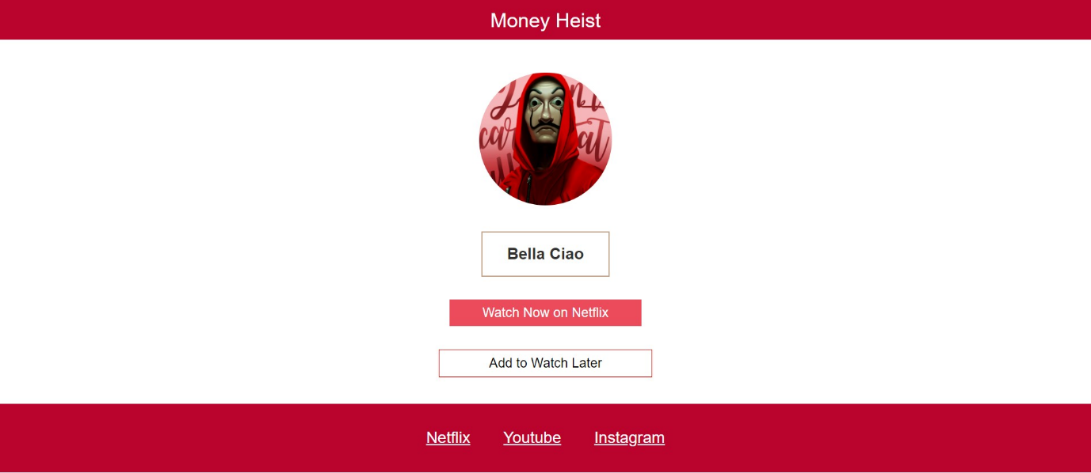

HTML code below: -

<!DOCTYPE html>

<html lang="en">

<head>

  <meta charset="UTF-8">

  <meta http-equiv="X-UA-Compatible" content="IE=edge">

  <meta name="viewport" content="width=device-width, initial-scale=1.0">

  <title>Money Heist</title>

  <link rel="stylesheet" href="reset.css">

  <link rel="stylesheet" href="style.css">

</head>

<body>

  <div class="container">

    <div class="title">

      Money Heist

    </div>

    <div class="image">

      <img class="image-tag" src="Money_heist_image.png" alt="Money_heist_image">

    </div>

    <div class="song-name">Bella Ciao</div>

    <div class="watchNowOnNetflixButton">Watch Now on Netflix</div>

    <div class="AddToWatchLaterButton">Add to Watch Later</div>

  </div>

  <!--container End-->

  <footer class="footer">

    <a target="_blank" href="https://www.netflix.com/in/title/80192098">Netflix</a>

    <a target="_blank" href="https://www.youtube.com/c/lacasadepapel/featured">Youtube</a>

    <a target="_blank" href="https://www.instagram.com/money_heist/?hl=en"> Instagram </a>

  </footer>

</body>

</html>

CSS code below:-

body {

  font-family: sans-serif;

}

.title {

  display: flex;

  align-items: center;

  justify-content: center;

  background-color: #ba042d;

  font-size: 30px;

  color: white;

  height: 60px;

  margin-bottom: 50px;

}

.image {

  display: flex;

  align-items: center;

  justify-content: center;

}

.image-tag {

  border-radius: 50%;

  height: 200px;

  width: 200px;

  margin-bottom: 40px;

}

.song-name {

  display: flex;

  align-items: center;

  justify-content: center;

  font-size: 24px;

  border: 2px solid #c4a287;

  width: 150px;

  margin: auto;

  padding: 20px;

  font-weight: bold;

  color: rgb(51, 48, 48);

  margin-bottom: 35px;

}

.watchNowOnNetflixButton {

  display: flex;

  align-items: center;

  justify-content: center;

  font-size: 20px;

  background-color: #eb4b5b;

  width: 270px;

  padding: 10px;

  color: white;

  outline: none;

  border: none;

  margin: auto;

  margin-bottom: 35px;

}

.watchNowOnNetflixButton:hover {

  cursor: pointer;

  box-shadow: 0px 0px 10px 5px #ba042d;

}

.AddToWatchLaterButton {

  display: flex;

  align-items: center;

  justify-content: center;

  border: 1px solid red;

  font-size: 20px;

  width: 300px;

  padding: 10px;

  outline: none;

  margin: auto;

}

.AddToWatchLaterButton:hover {

  border: 1px solid #edceb5;

  box-shadow: 0px 0px 10px 5px #edceb5;

}

.footer {

  display: flex;

  align-items: center;

  justify-content: center;

  background-color: #ba042d;

  margin-top: 40px;

  padding: 40px;

  width: auto;

}

a {

  color: white;

}

a:hover {

  color: blue;

}

a:nth-child(1),

a:nth-child(2) {

  margin-right: 50px;

}