Possible routines for Intervarsities

Novice
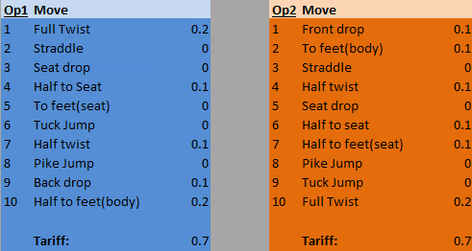
Max Vol Tariff 1.0
Max S/S rotation of 270°

Intermediate
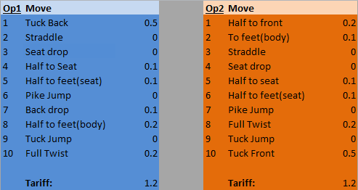
Min Vol Tariff 1.2
Max Vol Tariff 1.9

Intervanced
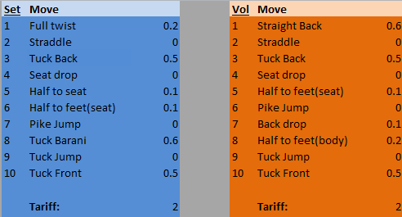
Min Vol Tariff 2.0
Max Vol Tariff 2.9

Advanced*
For Advanced since we have Intervanced and the fact that Elite will be a bit harder in order to push people I think Advanced should be a bit more progressive. It must also be challenging for those who can’t do Elite but would have been pushing it before it was made more difficult. For these reasons I have made 2 versions for Advanced.
The first of these two is the newer Advanced, it contains a lazy back option and a crash dive option. This is to encourage people to learn these skills but they are not required in the vols. It is a simple routine in theory and in tariff, however people usually leave learning crash dives and lazy backs until they reach the edge of Elite.
The second one is a failsafe. It is a generic Advanced pair of options. This may be used in the likely case of people not agreeing with the ideas put forth by Advanced 1.
Please let me know what your opinion is on this idea.
Advanced 1
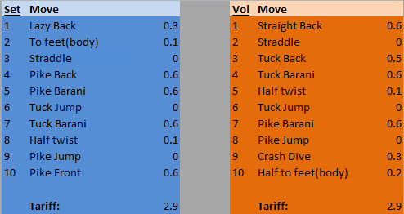
Min Vol Tariff 2.9
Max Vol Tariff 4.0
OR
Advanced 2
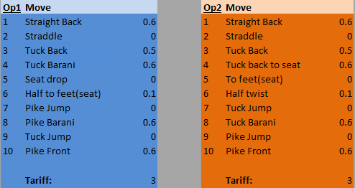
Min Vol Tariff 3.0
Max Vol Tariff 4.0

Elite
- 10 different skills
- 5 skills with a minimum of 360° somersault rotation
- One skill with a minimum 270° somersault rotation landing on front or back, followed by a somersault of 450°
- One skill with a minimum 630° somersault rotation or one skill with exactly 360° somersault rotation and a minimum twist rotation of 360° degrees.

*Skill may not be used to cover more than one requirement

Minimum Vol Tariff 5.2

