Name: Peter Ddamulira
Date: June 25, 2026
Assignment: Module 4.2, MySQL Install
CSD310-300H Database Development and Use (2265-DD)
Screenshot 2: SHOW DATABASES output showing movies database
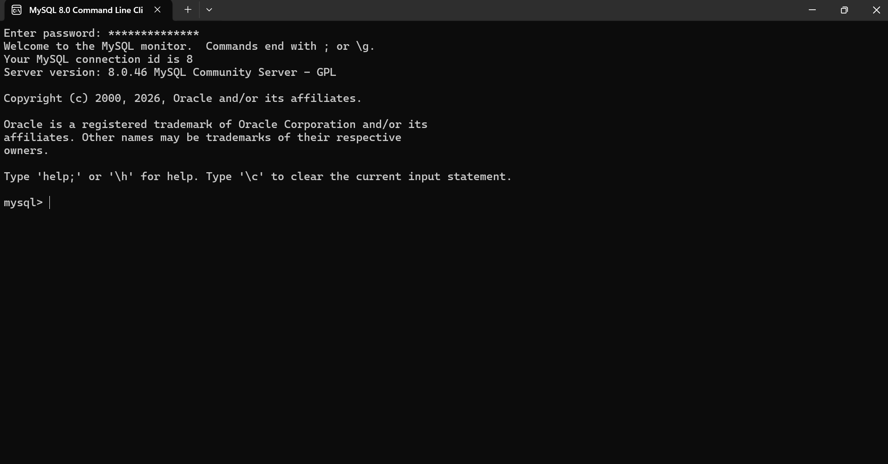
Screenshot 2 & 3: SHOW DATABASES output showing movies database
MySQL Function 1: CONCAT
This function joins text values together and can be used when combining first and last names.
SQL Statement:
SELECT CONCAT('Peter', ' ', 'Ddamulira') AS full_name;
MySQL Function 2: UPPER
This function converts text into uppercase and can be used when formatting data for reports.
SQL Statement:
SELECT UPPER('database development') AS uppercase_text;
MySQL Function 3: ROUND
This function rounds a number to a specific number of decimal places and can be used when displaying prices or totals.
SQL Statement:
SELECT ROUND(59.987, 2) AS rounded_price;
