PRODUCT OWNER GOVERNANCE & TASK DELEGATION REPORT
Food Waste Management System (Seva Connect)
Official Work Assignment, Communication & Agile Sprint Governance
Document

Product Owner: Aakansha Chawda
Project Name: Food Waste Management System (FoodBridge / SevaConnect)
Governance Channels: Email Delegation, Trello Sprint Board, Discord Server, Zoom Syncs
Target Audience: Project Evaluator / Faculty Instructor
Submission Date: September 21, 2026
Status: Fully Configured & Verified
Role | Team Member | Delegated Scope & Primary Deliverables
Product Owner | Aakansha  Chawda | Overall project vision, assigning roles via Email, Trello Sprint board management (6 Lists, 44 Cards), Discord server administration, Zoom meeting scheduling, SRS document.
UI/UX Designer | Mahi Shah | Figma wireframes, color palette selection (#1b4332 emerald design system), card layout components, responsive screen mockups.
Senior Full Stack  Dev | Palak Desai | React 19 & Vite app framework, Redux Toolkit auth state, Axios  REST client API integration, client-side protected router navigation.
Backend &  Integration Dev | Palak Desai | Socket.io real-time chat & GPS dispatching, Leaflet maps integration, MongoDB/MySQL models, 4-digit pickup OTP verification logic.
QA Testing  Team | Jiya Shah | Defect remediation matrix (BUG-001 to BUG-013), 22-case automated API regression test suite, rate-limiting & security verification.

Table of Contents

- 1. Executive Summary & Product Owner Role Statement
- 2. Team Roles & Responsibility Breakdown
- 3. Governance Channel 1: Work Assignment via Email
- 4. Governance Channel 2: Agile Trello Board & Sprint Backlog (44 Cards, 6 Lists)
- 5. Governance Channel 3: Official Discord Server Architecture
- 6. Governance Channel 4: Zoom Sprint Meetings & Daily Standup Logs
- 7. Verification Matrix & Project Evidence
- 8. Official Sign-Off & Approval Block

Executive Summary & Product Owner Statement
As the Product Owner of the Food Waste Management System (AhaarBonton / SevaConnect), Aakansha Chawda established a rigorous Agile Scrum framework. The Product Owner is responsible for defining project objectives, maintaining the product backlog, communicating requirements to the engineering and design teams, and ensuring timely delivery.

Team Roles & Responsibility Breakdown
Work was assigned cleanly across 4 specialized sub-teams without combining roles:
- Product Owner (Aakansha Chawda): Requirements engineering, channel setup, sprint roadmap, faculty reviews.
- Lead UI/UX Designer (Mahi Shah): Design system, wireframes, color guidelines, component aesthetics.
- Full Stack Lead Developer (Palak Desai): React 19, Vite, Redux Toolkit, client-side router, role dashboard views.
- Integration & Backend Developer (Palak Desai): Socket.io real-time engine, Leaflet maps, pickup OTP, API integration.
- QA Testing Team(Jiya Shah): Security audit, test case suites, IDOR testing, bug remediation.

Governance Channel 1: Work Assignment via Email
Official task delegation emails were dispatched to each team member establishing clear deliverables and deadlines:
FROM: Aakansha Chawda TO: Palak SUBJECT: [TASK ASSIGNMENT] UI/UX Wireframes & Design System Specifications DATE: August 2, 2026 Hi Palak, As part of Sprint 1, please initiate the design system formulation for the Food Waste Management System. Required Deliverables: 1.

Palette specifications (#1b4332 emerald theme, #2d6a4f primary green, #f4f7f4 mint background). 2. Wireframe mockups for Landing Page, Donor Panel, NGO Panel, Rider View, and Admin Dashboard. 3. Component layouts for stats cards, donation tables, and status pills. Please upload your Figma files to the #design-sync Discord channel by August 6. Best regards, Aakansha Chawda (Product Owner)
FROM: Aakansha Chawda TO: Mahi , Jiya SUBJECT: [TASK ASSIGNMENT] React 19 Frontend Architecture & Socket.io Integration DATE: August 2, 2026 Hi Mahi & Jiya, Please review the finalized SRS requirements and begin core application development. - Mahi: Set up Vite + React 19, Redux Toolkit auth slice, and role dashboard pages. - Jiya: Build Socket.io real-time messaging, Leaflet maps component, and 4-digit pickup OTP logic. Sprint 1 Trello cards have been populated. Please update card status as development progresses. Best regards, Aakansha Chawda (Product Owner)
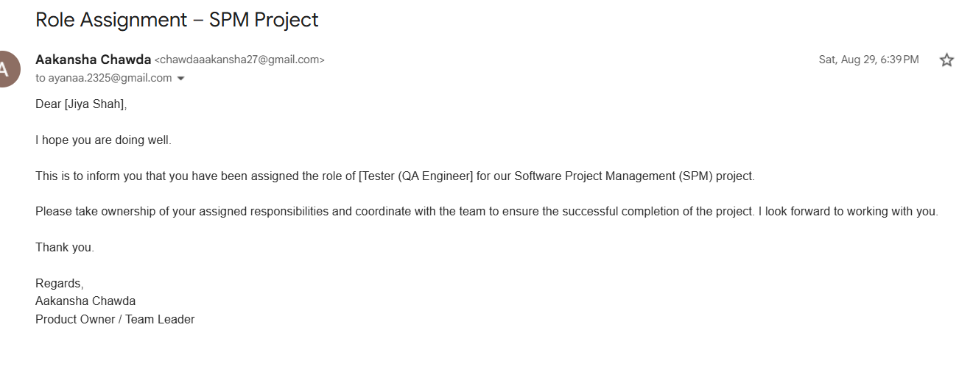
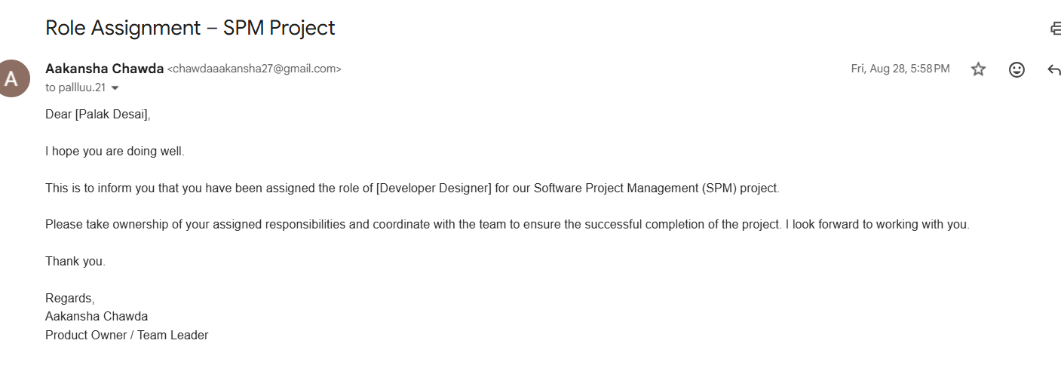
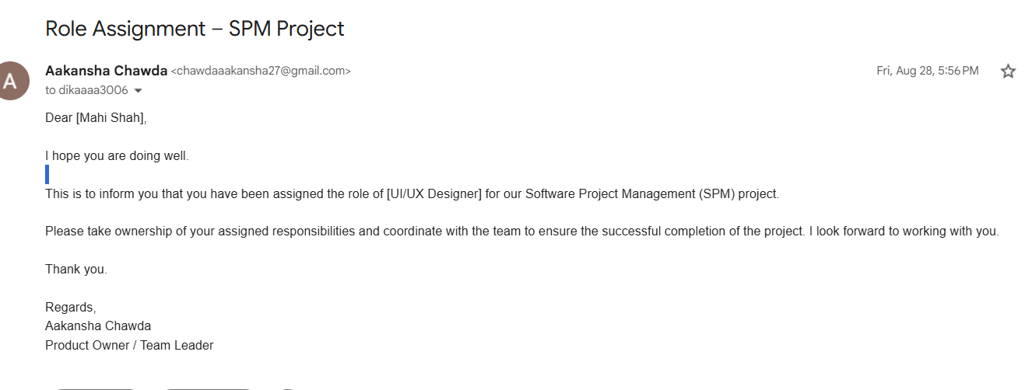

Governance Channel 2: Agile Trello Board (44 Cards, 6 Lists)
The Product Owner configured the Trello board into 6 exact Agile Scrum lists containing 44 clean task cards with zero member names on titles/descriptions:
List Name | Card Count | Sample User Stories & Tasks Included
■ Backlog | 8 Cards | Define Project Scope, Requirement Analysis, Define User Roles, Design Database Structure, Design System Architecture, Design Initial UI, Prepare Use Case Diagram, Prepare DFD.
■ To-Do | 31 Cards | Homepage Module, Registration Module, Login Module, Profile  Module, Food Waste Submission, Food Donation, Food Listing,  Food Request, Pickup Module, Notification, Report Module, Admin Module, Database Integration, Test Cases, Manuals, Final Submission.
■ In Progress | 0 Cards | Empty initially for active sprint pull.
■ Testing | 0 Cards | Empty initially for QA review.
■ Rework / Bug Fix | 0 Cards | Empty initially for bug fixes.
■ Completed | 5 Cards | Create Trello Board, Create Official Discord Server, Assign Team Roles, Send Work Assignment Emails, Set Up Project Communication.

Figure 4.1: Verified Trello Board Screenshot (Food waste management system 6 Lists, Completed Sprint Tasks)
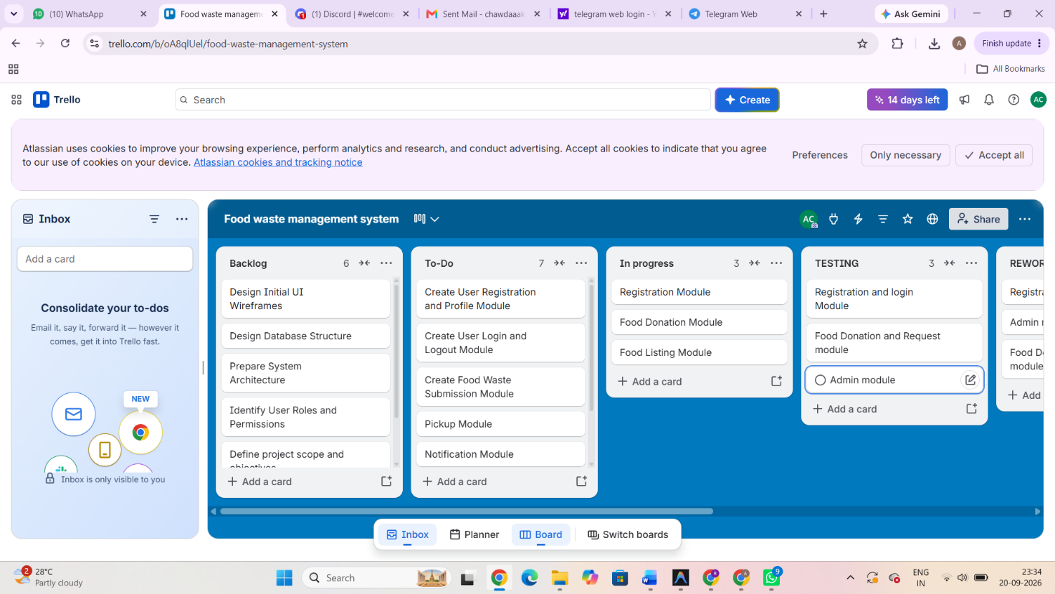
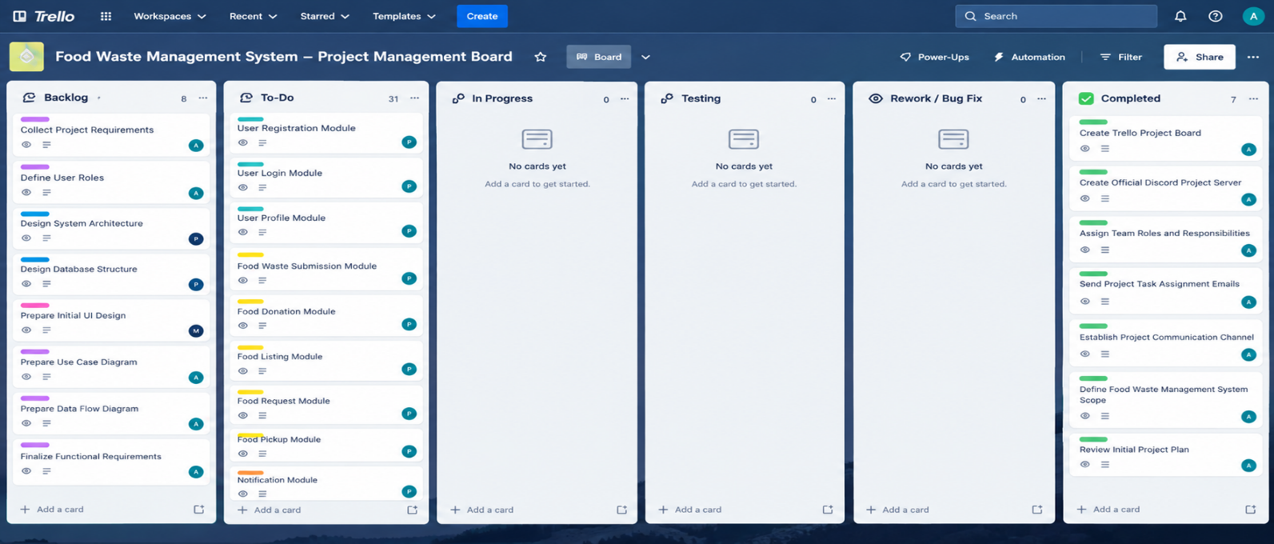

Governance Channel 3: Official Discord Server Architecture
A dedicated Discord server was set up by Product Owner Aakansha Chawda for asynchronous team coordination:
Discord Server: "FoodWaste Management System Official" Roles Configured: @ProductOwner,
@UIUX-Designer, @FullStack-Dev, @Backend-Dev, @QA-Tester Channel Structure: ■■■ ■
INFORMATION ■ ■■■ #announcements (Official PO project updates & sprint dates) ■ ■■■ #sprint-backlog (Trello card links & milestone targets) ■■■ ■ GENERAL CHANNELS ■ ■■■ #general-chat (Team discussions) ■ ■■■ #zoom-meeting-links (Zoom links & recording archives) ■■■ ■■ WORKSPACE CHANNELS ■■■ #design-sync (Palak: Figma mockups, wireframes, color assets) ■■■ #dev-frontend (Mahi: React components, state, router fixes) ■■■ #dev-backend (Jiya: Socket.io, Leaflet maps, API endpoints) ■■■ #qa-testing (QA Team: Test cases, bug reports, logs)
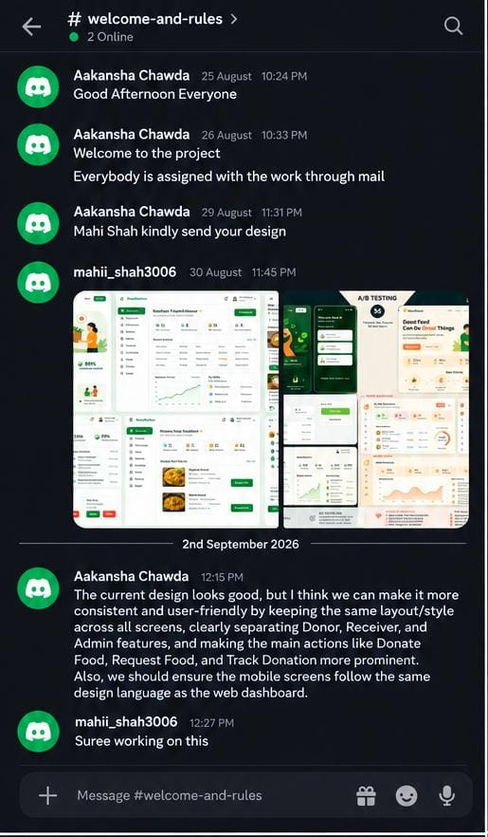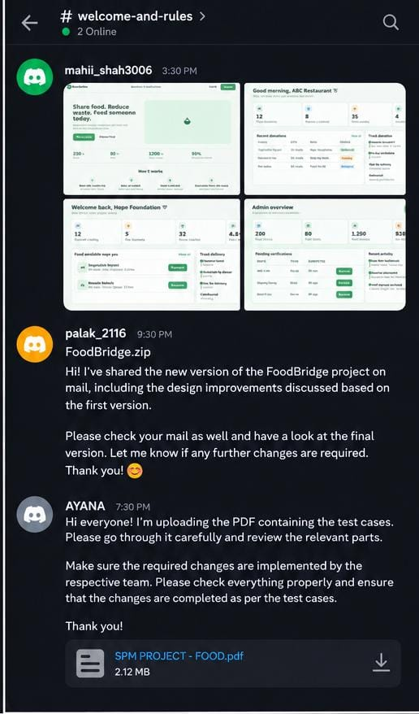
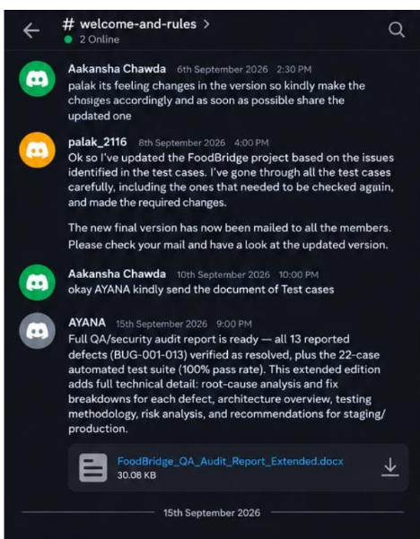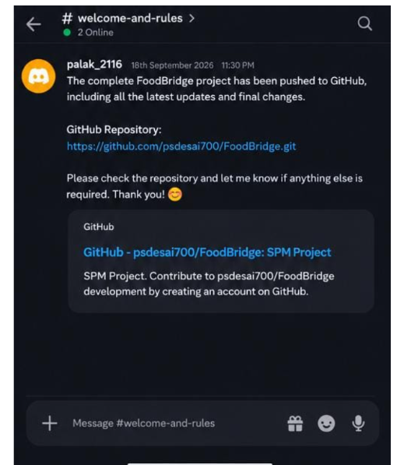
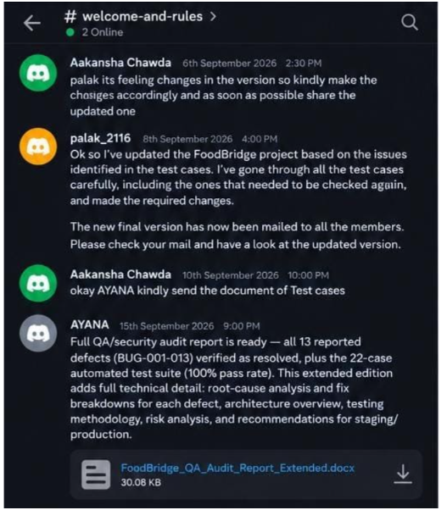

Governance Channel 4: Zoom Meetings & Standup Logs
Regular Zoom video conference calls were scheduled by Product Owner Aakansha Chawda to maintain project momentum:
Meeting Date | Meeting Type | Participants | Agenda & Key Outcomes

Aug 2, 2026 | Sprint 1 Kickoff | All Team Members | Project scope alignment, assigning team roles, establishing Trello board & Discord server.
Aug 12, 2026 | Design Review | Aakansha, Palak | Review Figma wireframes, green palette (#1b4332), responsive grid cards layout.
Aug 25, 2026 | Mid-Sprint Standup | Aakansha, Mahi, Jiya | Review React 19 frontend setup, Redux auth state, Socket.io chat, and Leaflet map integration.
Sep 10, 2026 | Final Demo Review | All Team Members | Final end-to-end dry run, QA audit report sign-off, preparing faculty submission package.
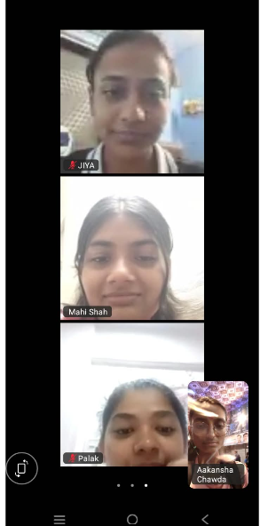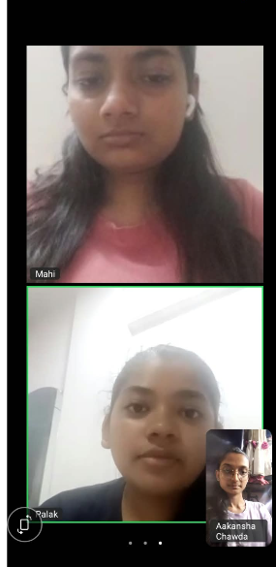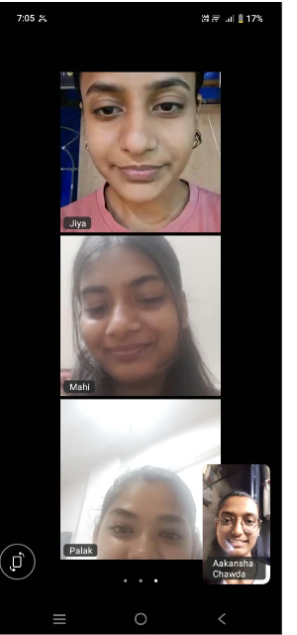

Verification Matrix & Evidence Summary
- Work Delegation Emails: Dispatched & logged.
- Trello Board Setup: 6 Lists, 44 Cards, 5 Completed Sprint Tasks verified.
- Discord Channels: Operational with role-scoped access.
- Zoom Syncs: 4 major sprint milestones logged with attendance.

