Maintaining PSE Website [https://pse.che.lsu.edu/]

The working version of the PSE@LSU website is in https://github.com/pse-che-lsu/pse-che-lsu.github.io.git.
This version can be edited. To access the Github:
- psechelsu@gmail.com [email]
- pse-che-lsu [user]
- joseromagnolilab [password]
Changes can be made here. After pushing to the main branch, the website will be displayed on https://pse-che-lsu.github.io/. This is not the official website, however.
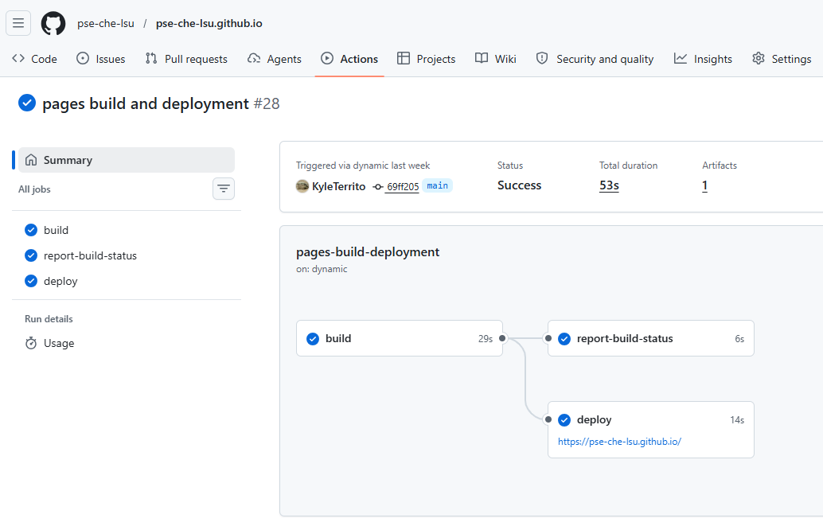
To push to main URL (https://pse.che.lsu.edu/), download FileZilla (or some other SFTP software).

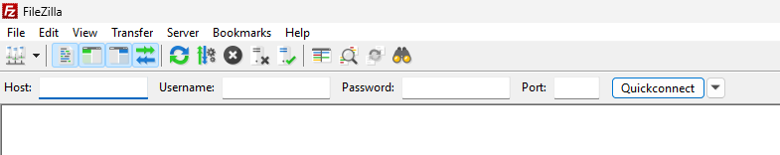
Quickconnect using the following login:
- Host: lamp01.eng.lsu.edu
- User: pse
- Password: pse2026**tiger*(
- Port: 22
Now you will see the PSE folder on the right panel. Double click “pse.che” folder.
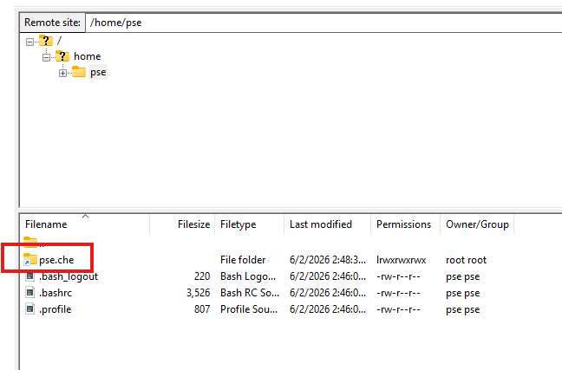
To make changes, drag and drop the updated files here from the Github repo (I don’t think you can git clone here, maybe you can). When the files are replaced, the website should automatically update.

