**Mobile phones aren’t smart… - Mobile Workshop**

**Group Message App**

A smart app to choose a group of friends from the address book and send a short message. iOS messaging app displays all the users in the address book. This document will provide instructions on how to build this app. This app has smart features to filter out contacts only with mobile phone numbers in your address book

**Getting Started**

1. A good tutorial for Beginners to get familiarized with Swift and fundamentals of App development. <https://developer.apple.com/library/ios/referencelibrary/GettingStarted/DevelopiOSAppsSwift/>
2. Get to know about predicate programming -<https://developer.apple.com/library/ios/documentation/Cocoa/Conceptual/Predicates/AdditionalChapters/Introduction.html>
3. Familiarize with <https://developer.apple.com/library/prerelease/mac/documentation/Contacts/Reference/CNContact_Class/index.html>

**Instructions**

1. Mac OS with Yosemite or El Capitan is needed to build and run this application.
2. Validate if you have the Xcode installed. Press the “Command space bar” and type Xcode. If XCode shows up, make sure the version is above 7.2. To check the version, open up Xcode, and follow XCode > About Xcode should show a picture as below 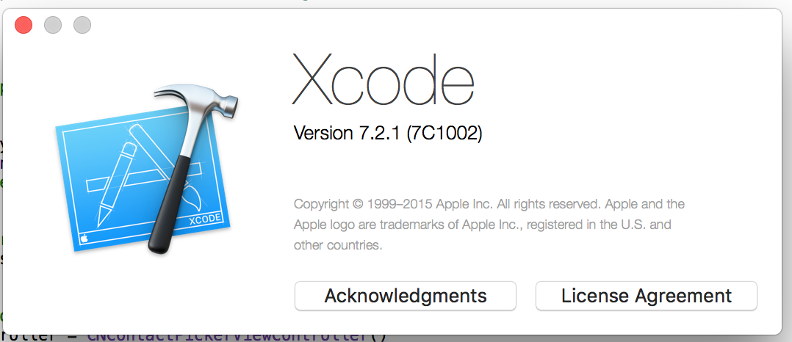
3. The sample code for this project was written using Xcode version 7.2.1. If Xcode is not installed, download and install it from Mac app store <https://itunes.apple.com/us/app/xcode/id497799835?ls=1&mt=12>

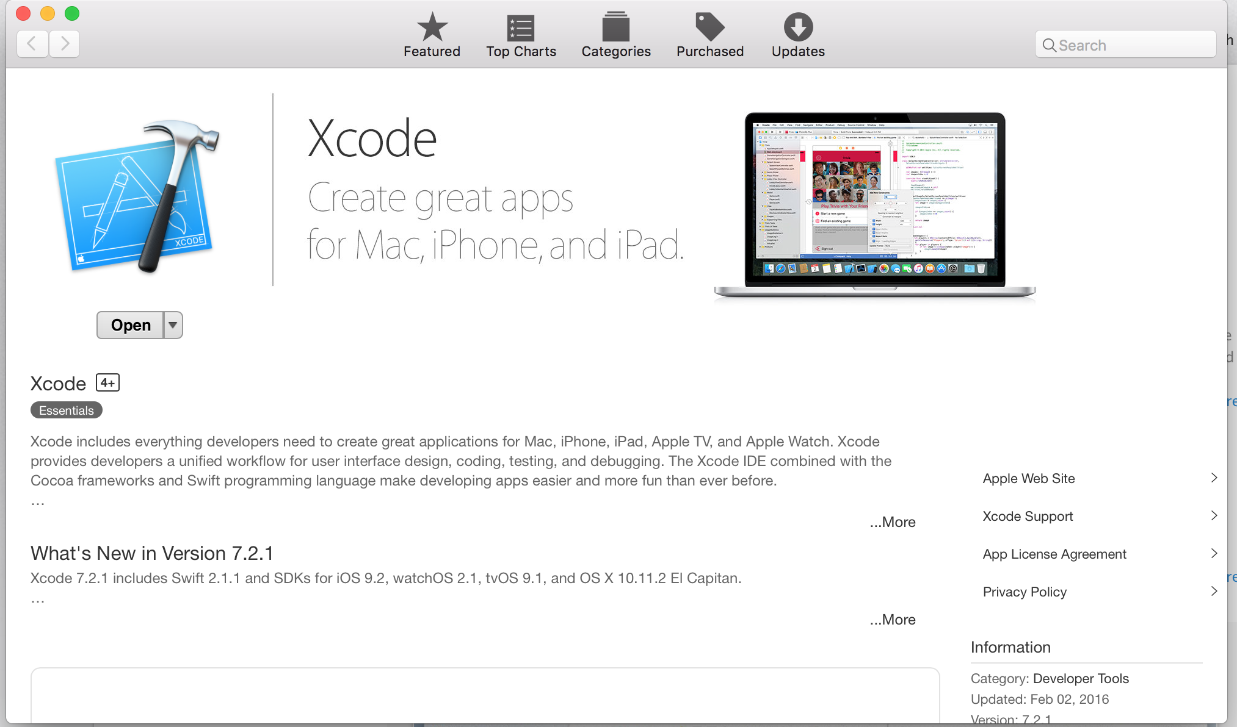

1. Download the project from <https://github.com/psenthil/groupmessage/archive/master.zip> 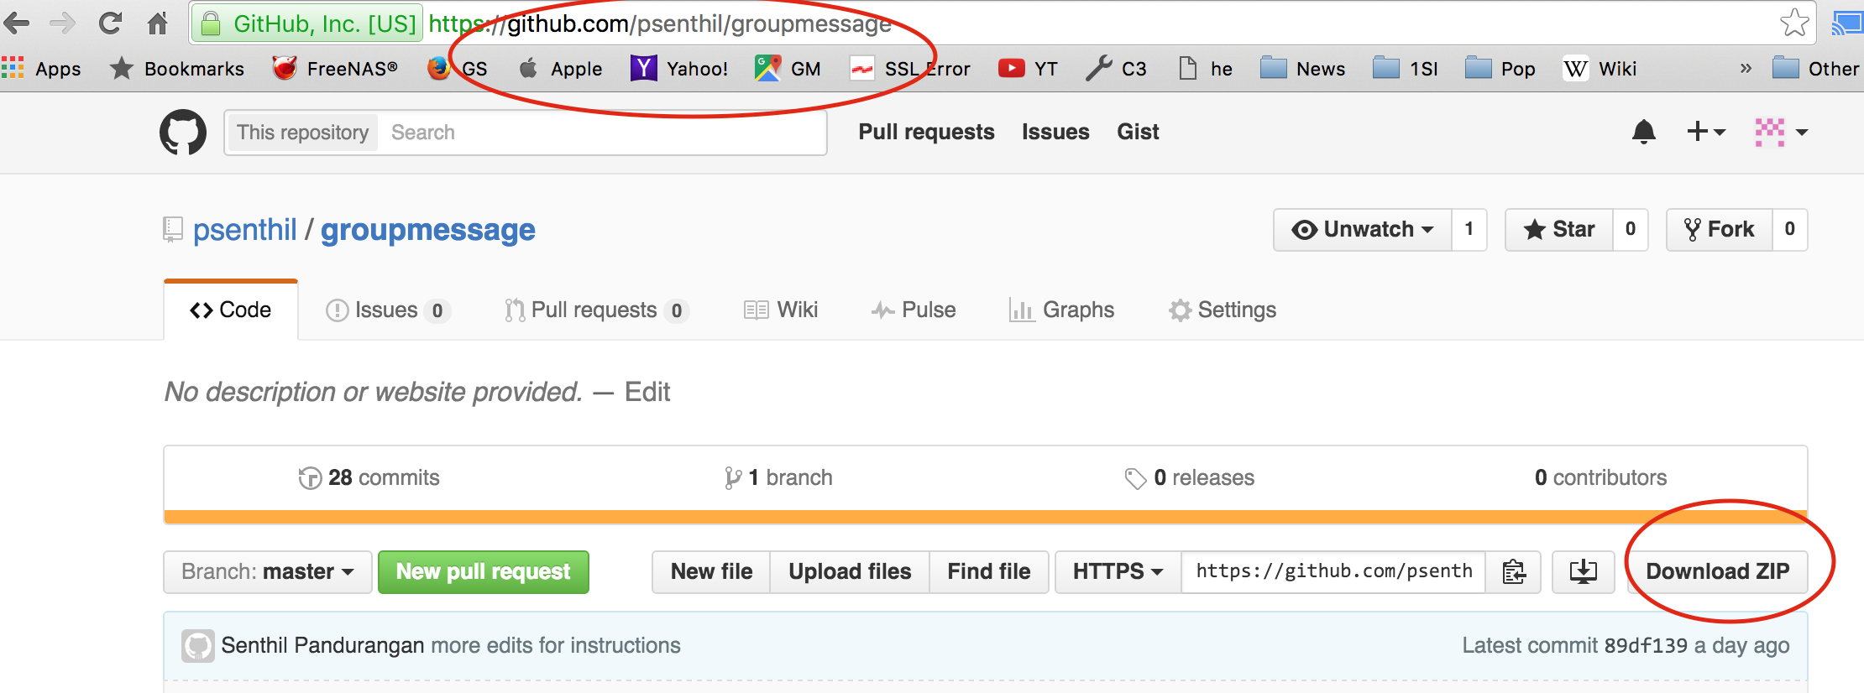Alternatively, you can download the code by opening up Terminal app and use **git clone**[**https://github.com/psenthil/groupmessage.git**](https://github.com/psenthil/groupmessage.git) to download it in your favorite folder.
2. Locate GroupMessage.xcodeproj from the folder from the downloaded location.
3. Double click on the GroupMessage.xcodeproj file and it should open up the project in Xcode.
4. Once opened, make sure to select a simulator device and click on the Play button as shown below

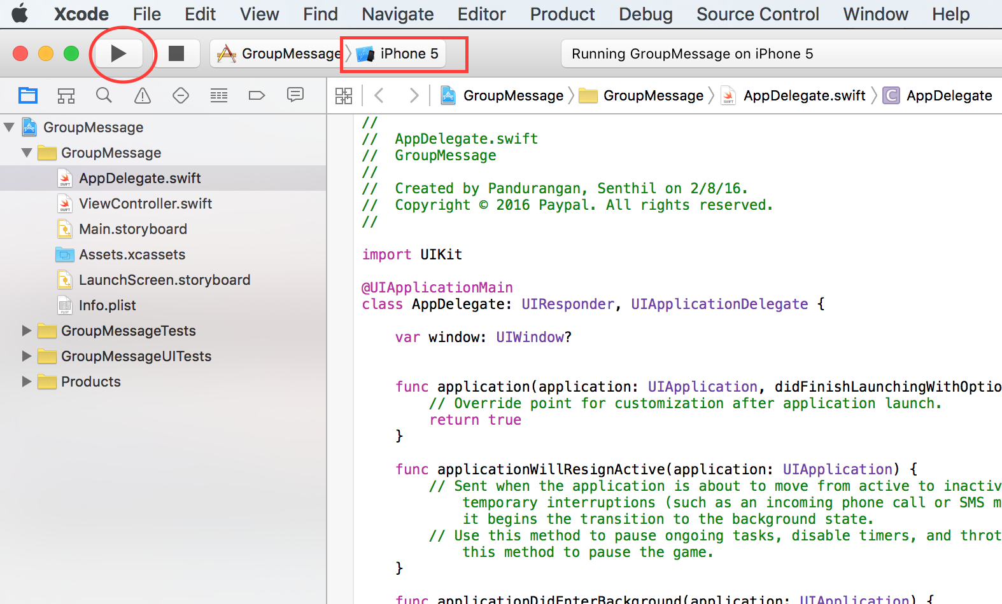

1. It should start the app after installing in the simulator. The first run might take a bit longer, however,the subsequent runs will be faster. It should show the following screen

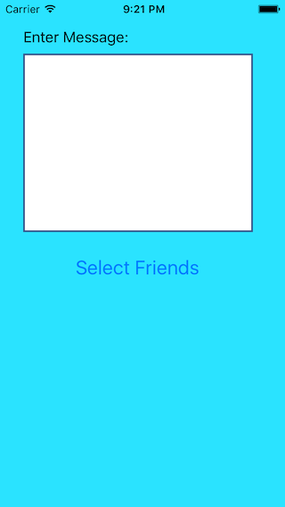

1. Type in the message you want to send to your group of friends in the message box. Clicking on the "Select Friends" button will show the following screen

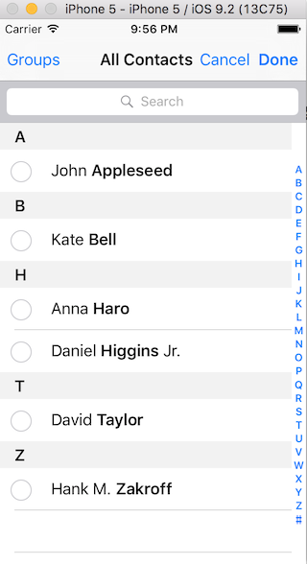

1. Important Note: iOS simulators cannot send messages. You will see the following screen

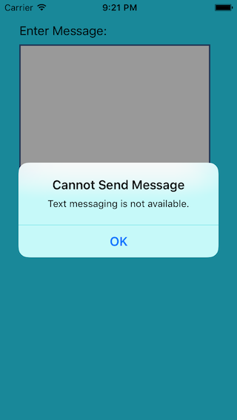

1. Connect your iPhone or iPad device and select the device to install the app. Once installed, follow above steps 8 to 10
2. Select a few friends to send the message. Once you click the "Done" button it will open up the message view with your selected friends and message populated as below.

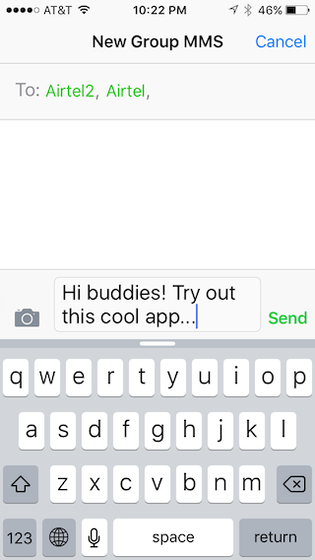

1. Going back to Xcode and clicking on the ViewController.swift will provide the glimpse of the program

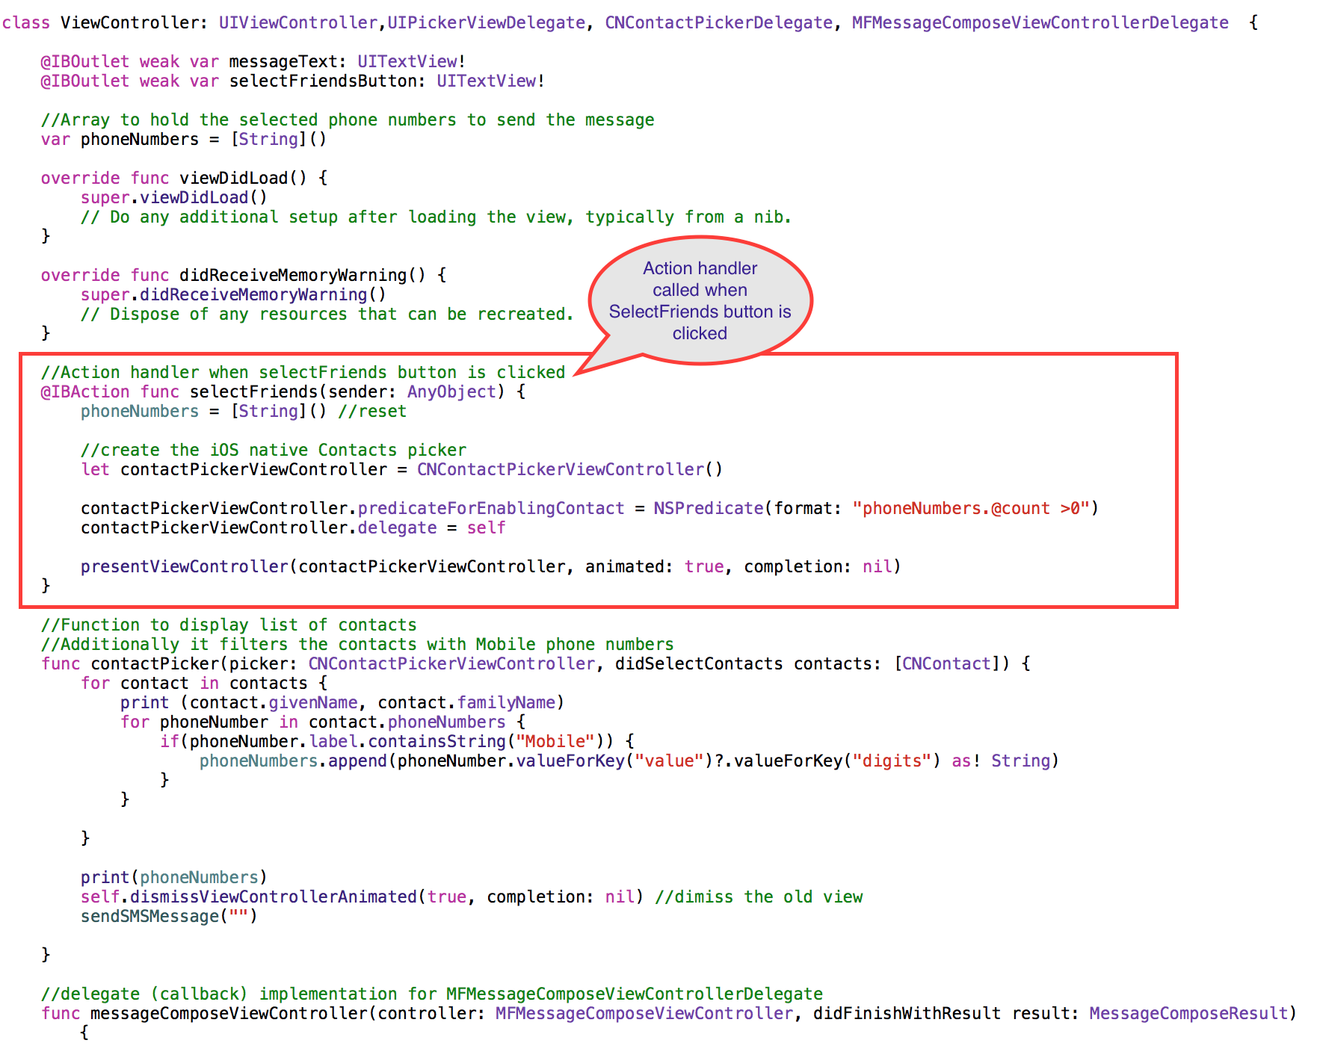

1. Also, Main.storyboard will show how the UI components are laid out.

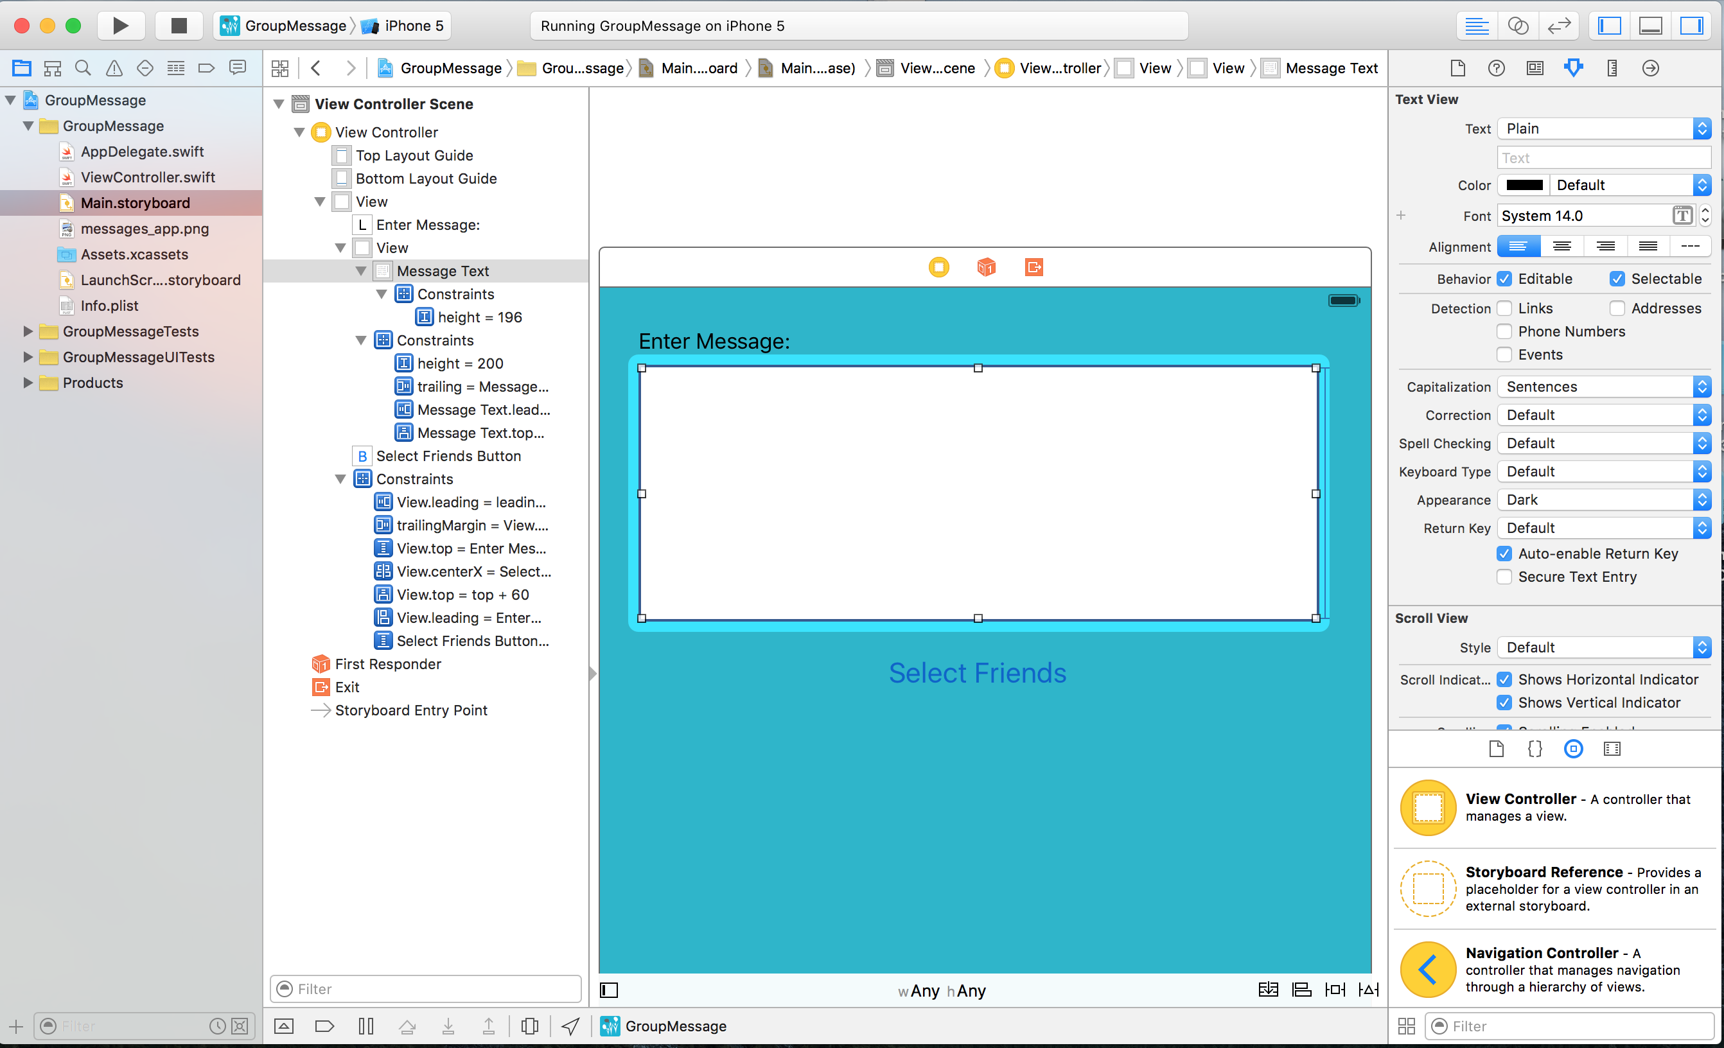

1. Have fun making changes and playing with it.

**Exercise**

1. Change the “Select Friends” to “Select Buddies” and run the app in Simulator. Double clicking on the “Select friends” will allow to change the label of the button.
2. Change the background color. 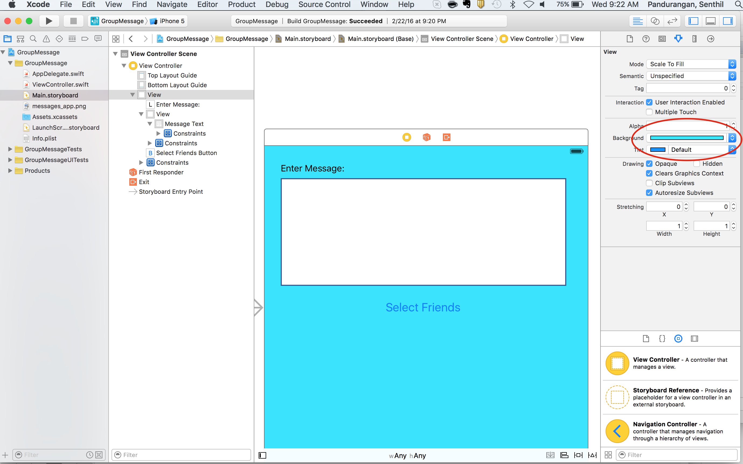
3. Make changes to the app so that you can include the “iPhone” phone types along with “mobile” phone types as well. The changes will be in ViewController.swift

//Function to display list of contacts

//Additionally it filters the contacts with Mobile phone numbers

func contactPicker(picker: CNContactPickerViewController, didSelectContacts contacts: [CNContact]) {

for contact in contacts {

print (contact.givenName, contact.familyName)

for phoneNumber in contact.phoneNumbers {

if(phoneNumber.label.containsString("Mobile") || (phoneNumber.label.containsString("IPhone") ) {

phoneNumbers.append(phoneNumber.valueForKey("value")?.valueForKey("digits") as! String)

}

}

}

print(phoneNumbers)

self.dismissViewControllerAnimated(true, completion: nil) //dismiss the old view

sendSMSMessage("")

}

**Extra Credits/Homework:** Make changes to the above application to fall back to send an email if the contact does not have any mobile phone numbers. This exercise will need more understanding on sending emails framework. You can find more details @ <https://developer.apple.com/library/prerelease/ios/documentation/MessageUI/Reference/MFMailComposeViewController_class/index.html>

**Additional Resources**

1. Swift - <https://developer.apple.com/swift/resources/>
2. <http://www.appcoda.com/ios-contacts-framework/>
3. <http://devstreaming.apple.com/videos/wwdc/2015/223rmo6dv9hxh/223/223_introducing_the_contacts_framework_for_ios_and_os_x.pdf>