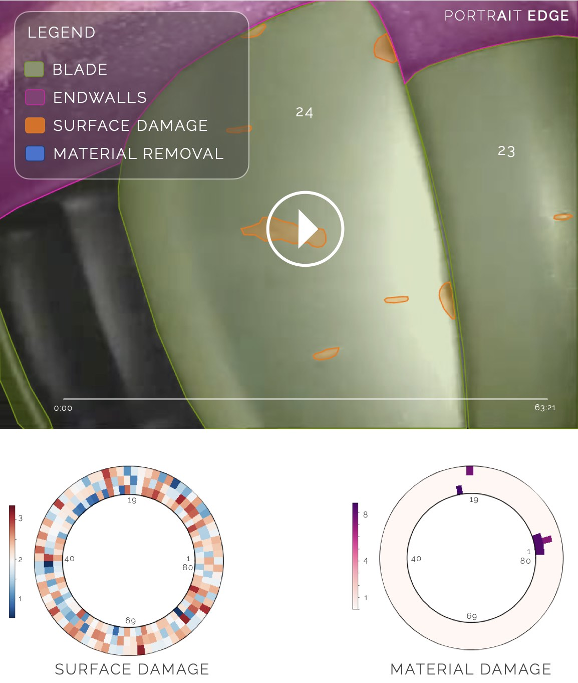PORTRAIT EDGE

FOR MINIMISING SECONDARY BORESCOPE INSPECTION TIMES & REDUCING HUMAN ERROR

A case study regarding work done for a UK-based aircraft maintenance organisation.

A crucial part of assessing the working state of an engine is via a borescope inspection, which forms a key part of the duties of an EASA Part 145 organisation. Depending on the type of inspection required, these may take anywhere from 6 hours to 12 hours and typically have two phases.

The first stage of this inspection requires the borescope specialist to open the outer cover of the engine and manoeuvre the borescope head through assigned ports such that they have an overall view of the blade row being inspected. PORTRAIT EDGE‘s visual inspection module offers real-time damage detection and blade counting that requires a VGA or HDMI output from the borescope device to be paired to a laptop. This real-time ability eliminates the possibility of human error in discerning whether a blade has a defect or not. Once a defect is spotted, the inspector may choose to use a different borescope head – i.e., one that has a narrow focus – to better delineate the exact type of damage and for taking its measurement. The inspector will then consult with the engine manual to verify if the damage detected is below or above tolerance. The client in this case study found the real-time damage detection to be very useful and a helpful aide to the borescope specialist.

The second stage of the inspection requires the borescope specialist to compile a report based on the damages seen in the engine. This may typically take 1-2 days depending on the engine and its state. PORTRAIT EDGE automated reporting tools outputs such a report in approximately 30 minutes. This capability saved the client over a month of engineer’s time over the trial period PORTRAIT EDGE was evaluated.

20th May 2021,

London.