**Getting to Know Your DualShock 4**

**Lab 1**

**Section 1**

**Submitted By:**

**Abhaya Neupane**

**Submission Date:**

**09/08/2023**

**1 Old Computers**

* 1. MITS Altair 8800

Input Device= front panel switches

Output Device= front panel LEDs

Minimum RAM=256 bytes/2048bits

Maximum RAM=64 kilobytes/65536bytes/524288bits

CPU= Intel 8080, 2.0 MHz

* 1. MOS KIM-1

Input Device= on-board hexadecimal keypad

Output Device= 6 digital LED display

RAM=1024 bytes/8192bits

CPU= MOS 6502, 1MHz

* 1. Apple 1

Input Device= keyboard interface port

Output Device= monochrome 280 X 192, 40 X 24 text

Minimum RAM=4 kilobytes/4096 bytes/32768 bits

Maximum RAM=64 kilobytes/65536bytes/524288bits

CPU= MOS 6502, 1MHz

* 1. IBM Personal Computer (PC) 5150

Input Device= keyboard

Output Device= 80X24 text

Minimum RAM=16 kilobytes/16384 Bytes/131072 bits

Maximum RAM=640 kilobytes/655360 Bytes/5242880bits

CPU= Intel 8088, 4.77 MHz

* 1. Apple Macintosh

Input Device= keyboard, mouse

Output Device= 9-inch monochrome screen 512x342 pixels

Minimum RAM=128 kilobytes/131072 bytes/1048576bits

Maximum RAM=512 kilobytes/524288 bytes/4194304bits

CPU= Motorola 68000, 7.83 MHz

1. **Base Conversion**

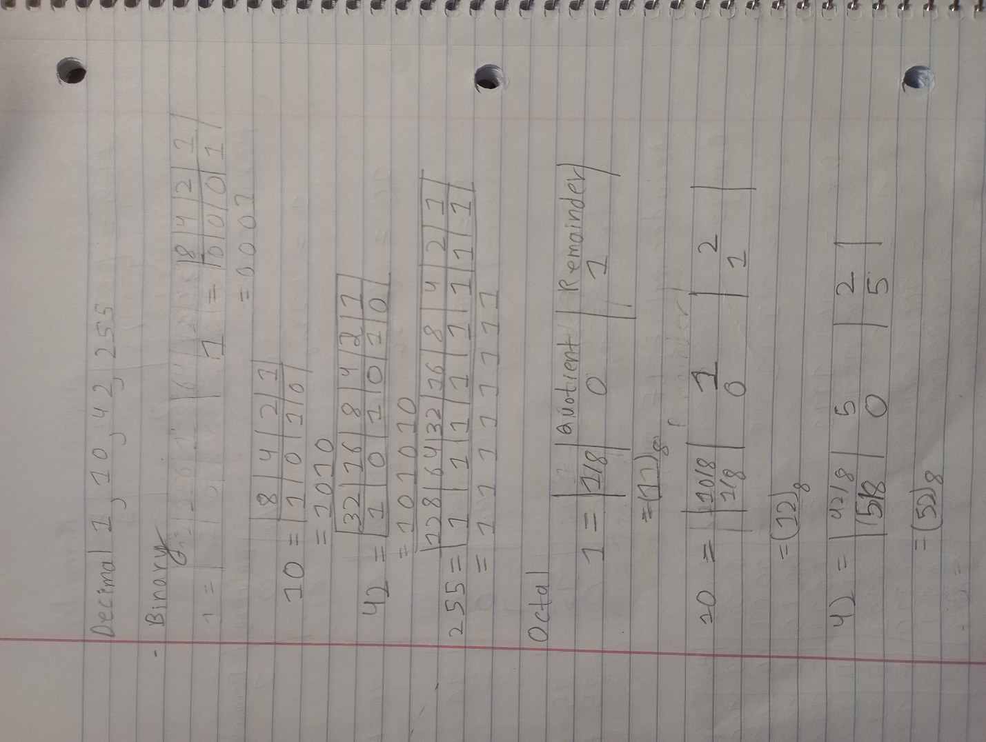

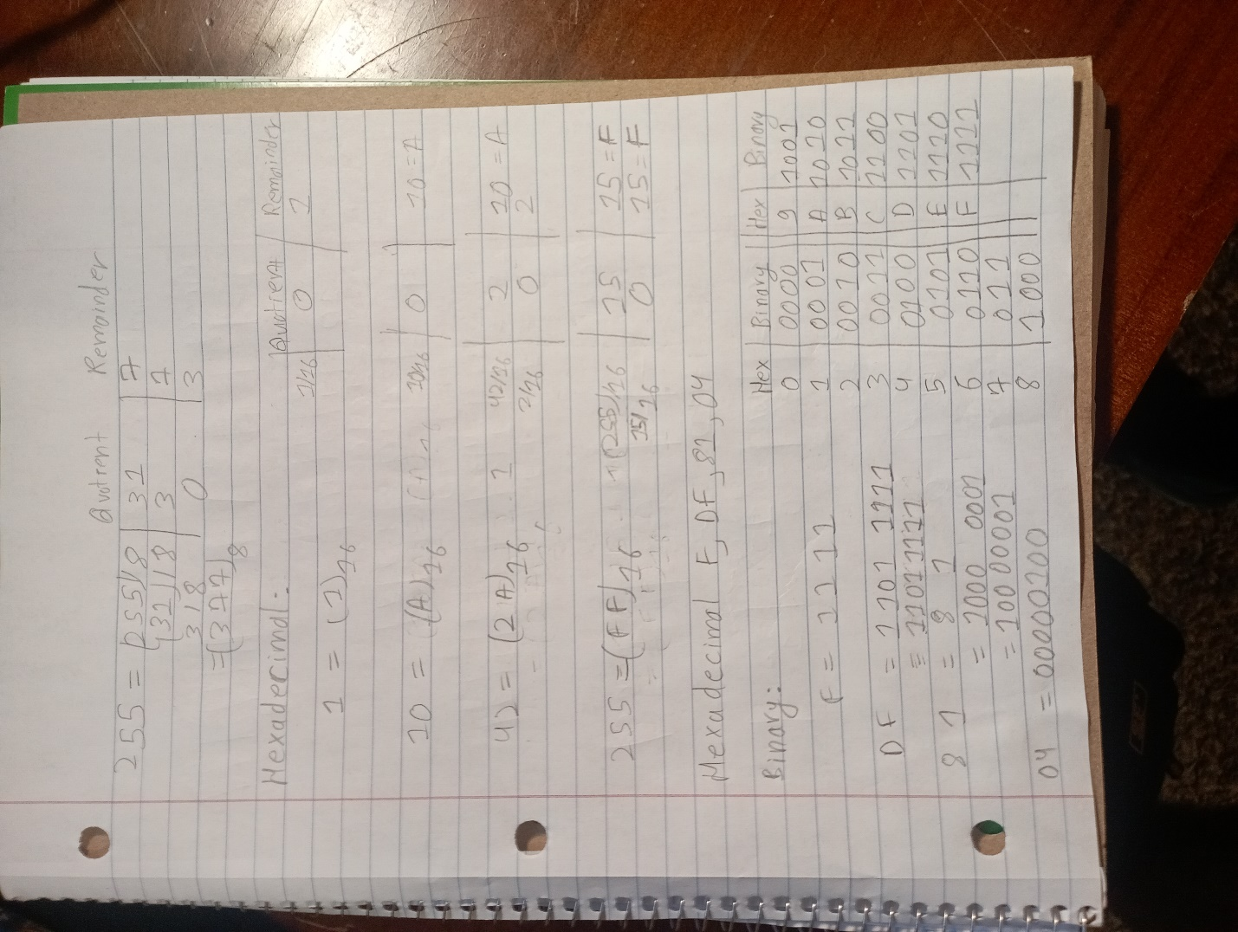

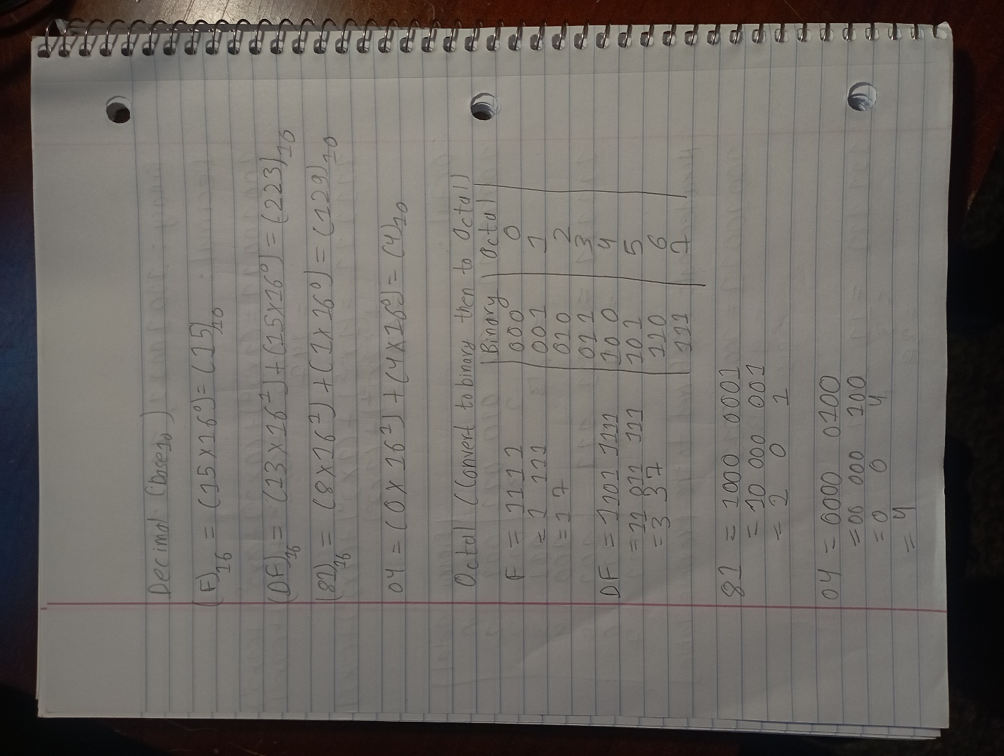

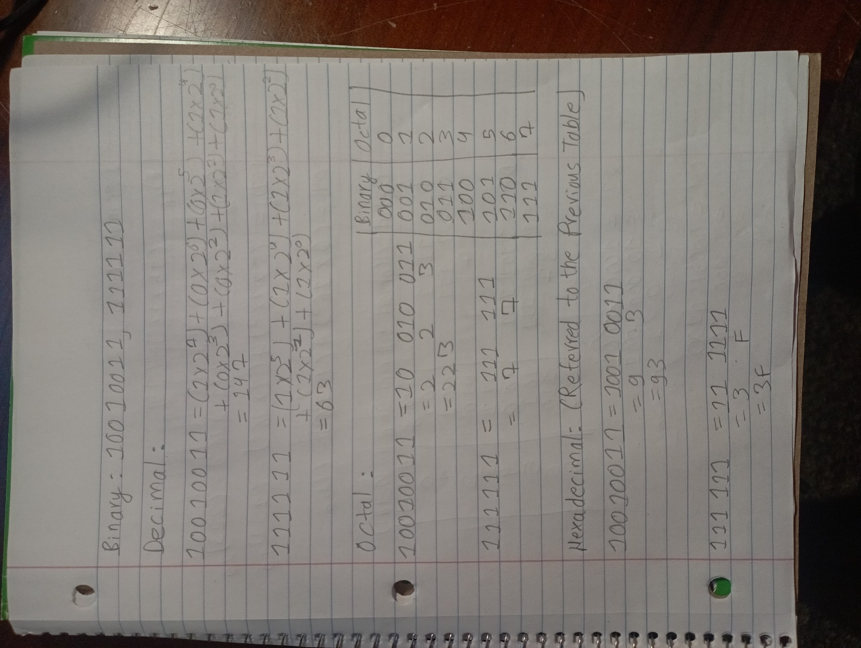

1. **Exploration**

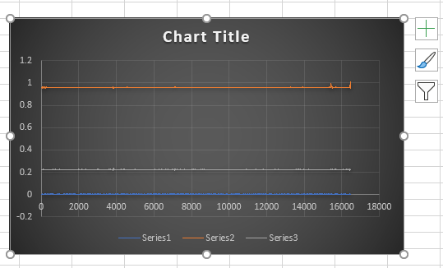

Fig:flat1.csv

Here in this graph we don’t see any ups and downs as the controller is lying flat on the surface.

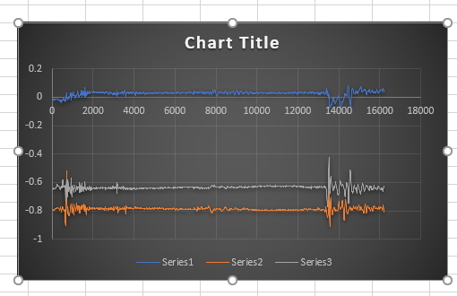

Fig:flat2.csv

Here we see a bit of ups and downs as we are holding the controller in this case and during the time we hold the controller the coordinates have negative values as the controller is above the resting position on the surface of the table

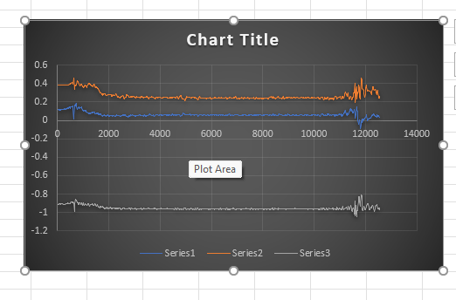

Fig:front1.csv

Here we don’t see much ups and downs but one of the value is negative as the controller is pointing upward and is being held by our hand.

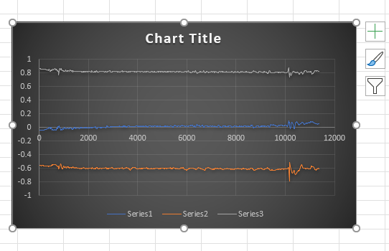

Fig:front2.csv

Here the graph is quiet similar to front1.csv only change is the data that is negative, which is due to the controller being pointed downwards.

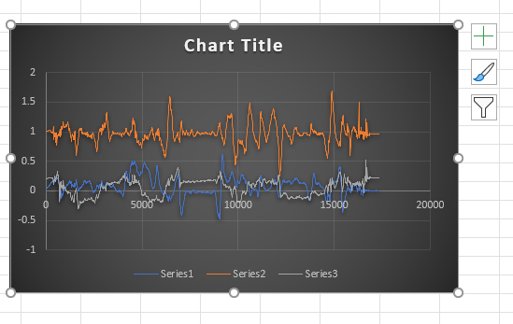

Fig:custom1.csv

In this graph, we see many ups downs which is because the controller was moved up and down in different patterns many times.

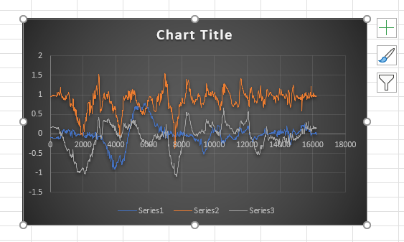

Fig:custom2.csv

In this graph as well, we see a lot of ups and downs as the controller is moved left and right in different patterns.

From, all these graph we can conclude that the data we collected was the real-time position of the controller and the accelerometers present in the controller is providing the location of the controller in coordinates.

1. **Joystick Calibration**

#4.1

The vertical joystick equation is and the horizontal joystick equation is , where is the value in vertical axis and is the value in horizontal axis.

The equations aren’t similar because as the coordinates move leftward and downward they go towards a more negative value.

#4.2

The center point for the joystick is (-3,2) for the left joystick and (-4,-2) for the right joystick. The center is not 0 because it might not be practically possible to get the center at 0.

#4.3

The joysticks is used a lot and there will be a shift in the center point as we keep on using the joysticks. It might also be because of the way the controller is programmed to not have the center 0.

#4.4

We could change the source code the joystick and recalibrate it, to get the center 0.