**Foundations of Computer Graphics Spring 2009 Final Project**

Akshay Kannan (cs184-bf)

Timothy Liu (cs184-cg)

**Spider Hunt: first-person shooter**

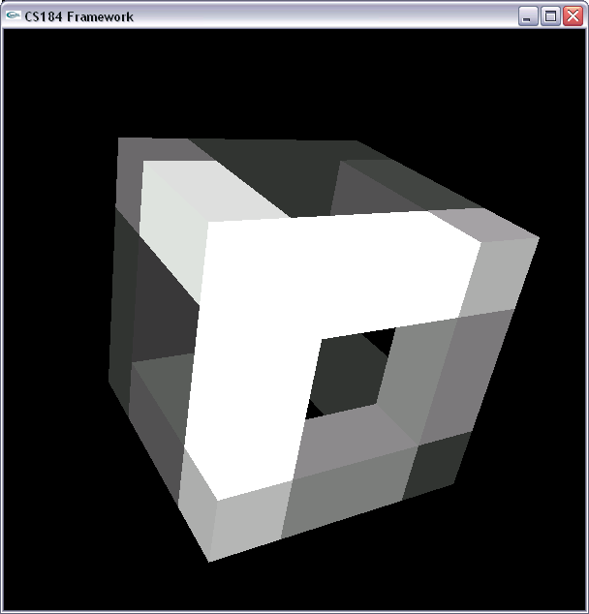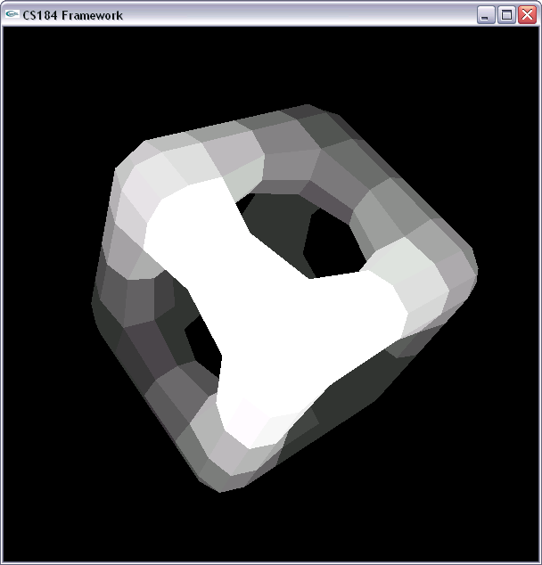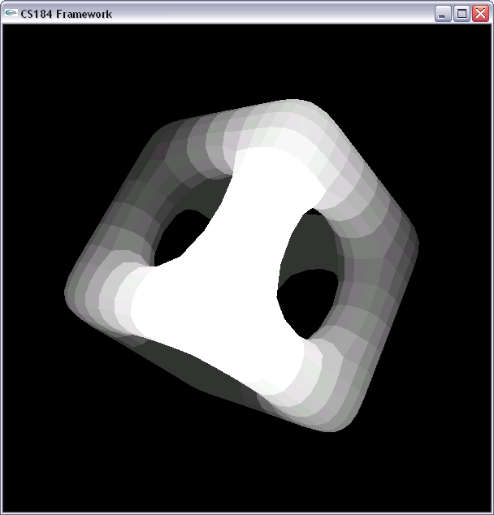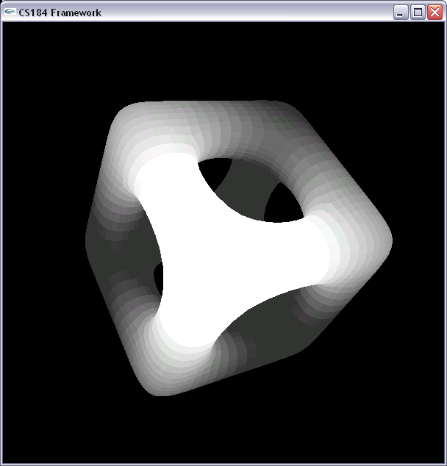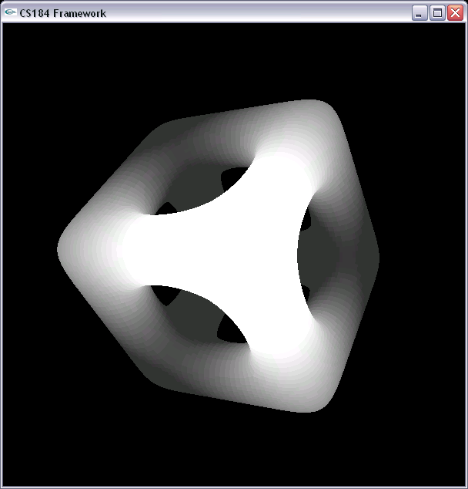

**Spider Hunt: first-person shooter**

**Description:** Spider Hunt is a capture the flag based first-person shooter. The main character starts off in a 3-dimensional world of genus five and can travel across the entire landscape. Armed with a tank, the main character has two objectives to choose from: defend a flag from enemy spiders while visiting various waypoints or find and capture the flag guarded by the enemy.

**Game elements:**

**Single Player –** The main character uses a hovercraft to move around in 3D in a space world. Constant gravity acts downwards on the craft, so intermittently pressing space will allow it to stay afloat. This will take some practice.

**Force Field** – Trying to pass through the force field without destroying all the spiders will cause the main character to bounce backwards. The hovercraft is equipped with the ability to avoid the field, however if you choose to override this by forcing keys, the field will throw you back.

**Spiders** – These creatures guard the flag with a force field. To destroy the field, the main character must kill the spiders. The damage inflicted is inversely proportional to the square distance between the bullet and the center of their body. Pressing ‘h’ toggles the display of damage.

**Goal** – The goal of the game revolves around a waving flag in the wind.

**Controls –** The game uses traditional WASD keys for movement and the mouse for rotation and firing:

* Spacebar = boost upwards
* W = boost forward
* S= boost backward
* A = boost left
* D = boost right
* X = deploy parachute
* Use the mouse to turn left and right
* Left click to fire a bullet
* Left click and drag to orient up and down

**Special Features:**

**Collision detection –** Collision detection is applied between the hovercraft and the force field, preventing the craft from passing through the field until the spiders are killed. Any attempt to force an entry with the force field will result in an elastic collision upon impact. Collision detection is applied between bullets and spiders as well.

**CC-Subdivision Object –** The cube of “spider plasma” is represented by the following data structure and produced with CC-Subdividing the initial structure. An example of this with a simple wire-frame cube is shown.

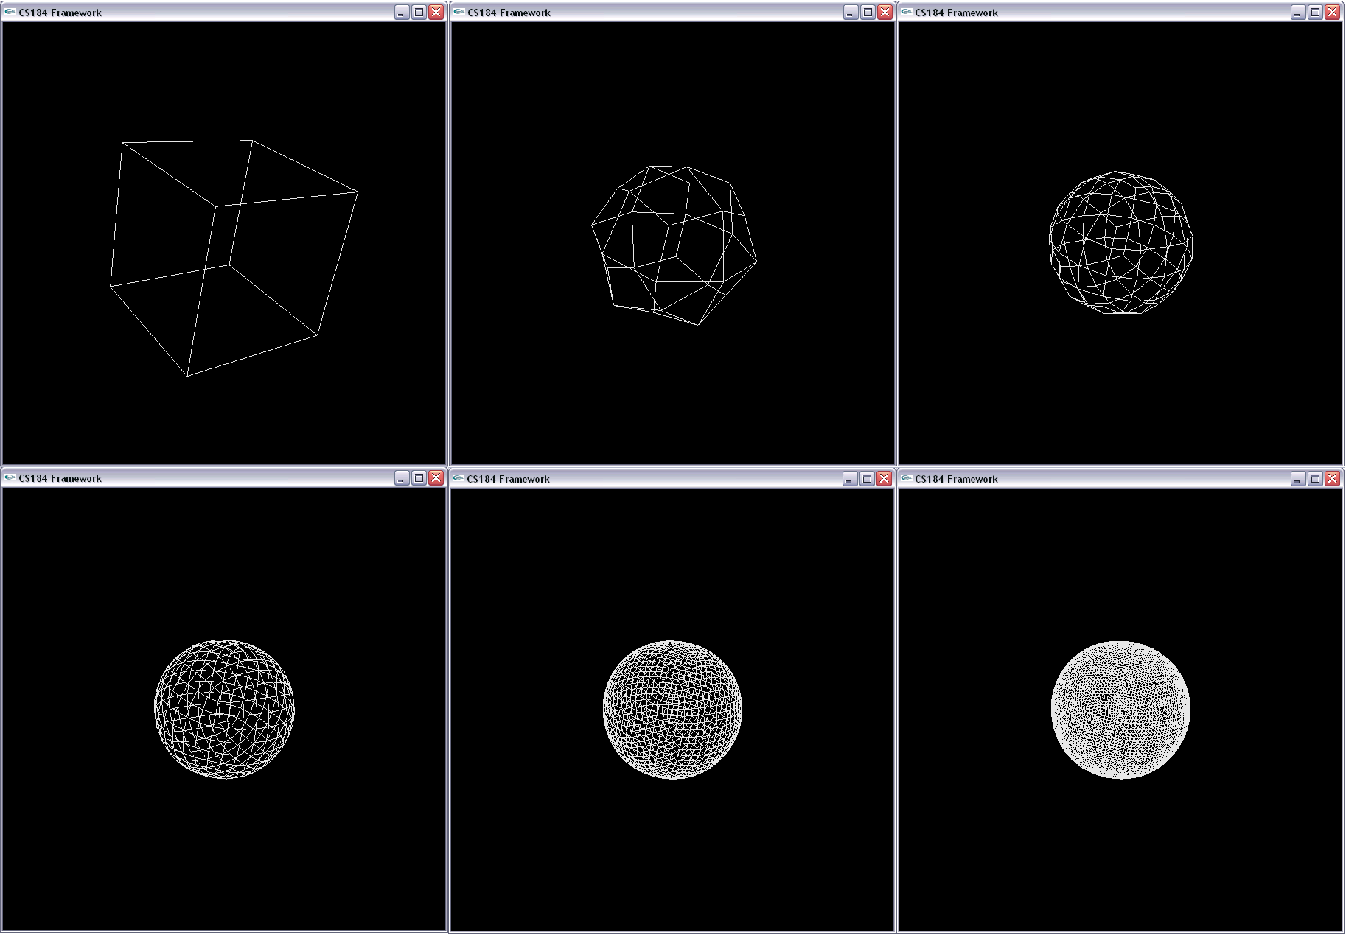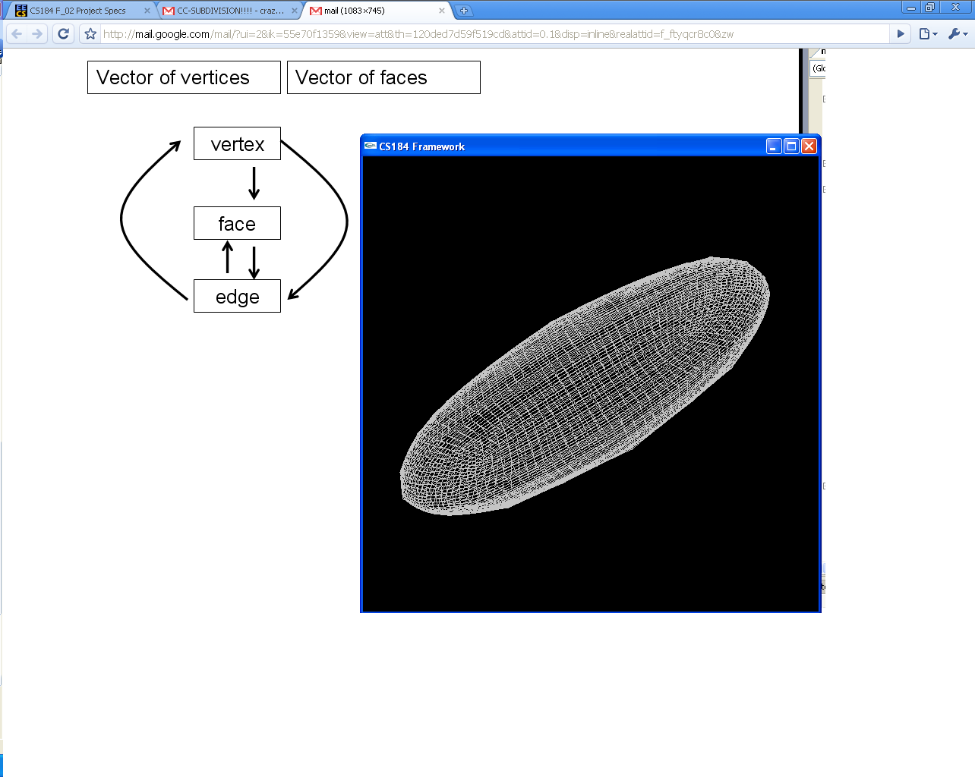

**Motion –** The hovercraft must constantly boosted against gravity with the spacebar, employing parabolic motion in all three dimensions to move throughout the scene.

**1st and 3rd person point of view-** These two perspectives can be toggled using the ‘f’ key on the keyboard.

**A sophisticated shader: Switchable modes. real-time shadows-** Our shader supports phong shading, toon shading, and real-time shadows. One of the spiders has been toon shaded to demonstrate this capability. Shadows can also be seen as the flag waves in the center of the cube. Gouraud shading can be toggled by pressing ‘o’.

**Interactive waving flag –** Thisflag placed in the scene waves interactively along a flag pole placed in the scene. Wind forces acting on the flag can be modified to change the appearance of the mass-spring cloth simulation.

**Realistic Physically-Modeled Spiders –** These spiders have articulated legs, and the movement of their body is calculated to correspond with the movement of the individual legs and joints.