The Great Lunch Bag Chase
A three-dog field report from Maple Loop
At seven on Saturday morning, Maya clipped on her running belt and opened the garden gate. Pepper stepped out first. She was a small terrier with the confidence of a parade marshal. Biscuit followed with his bandana crooked and his breakfast already forgotten. Juniper, tall and patient, brought up the rear.
Their plan was simple: one easy lap, no puddles, and absolutely no unscheduled snacks. The dogs agreed to these terms with the solemn expressions of animals who had understood none of them.
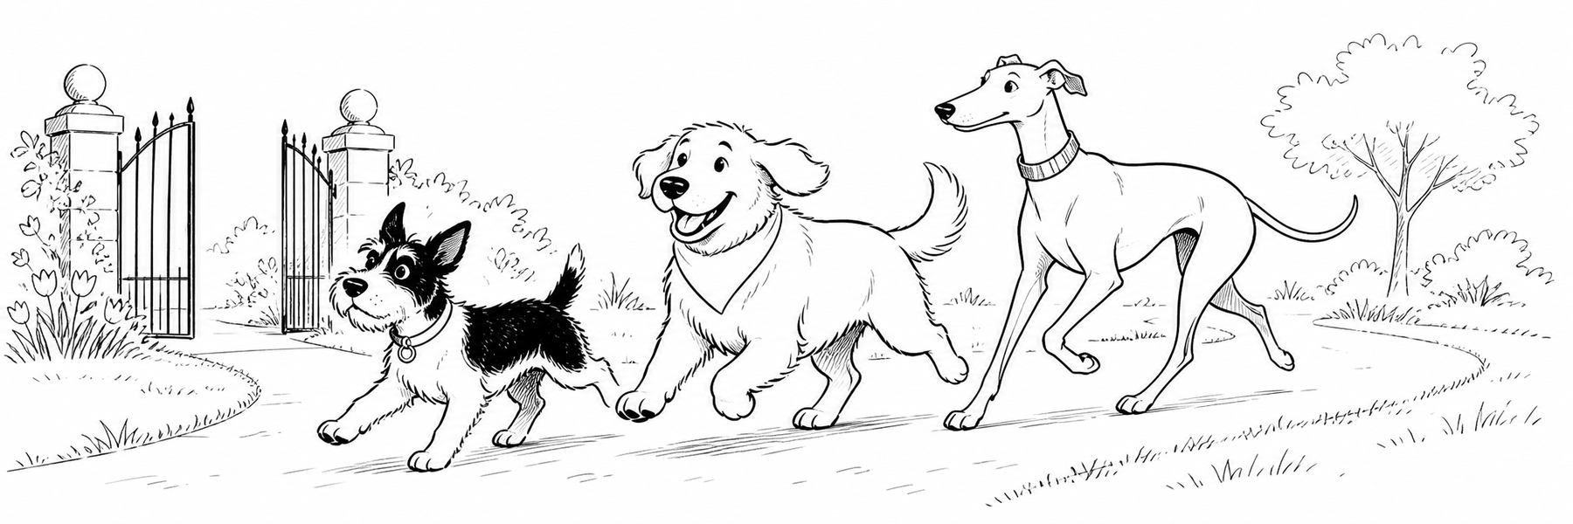
The cast, from shortest stride to longest:
- Pepper, route captain and investigator of suspicious leaves
- Biscuit, snack analyst and enthusiastic cornering specialist
- Juniper, pace keeper and the only member of the team with brakes

Chapter One: A Bag on the Breeze
Maple Loop was quiet enough to hear three sets of paws tapping the path. Pepper held a tidy line. Juniper floated beside her. Biscuit zigzagged between every interesting smell as if he were stitching the park together.
Then a gust lifted a paper lunch bag from a bench.
The bag bounced once. A napkin escaped. Biscuit's ears rose like flags.
“Steady,” Maya called.
The wind, which had not attended obedience class, pushed the bag downhill.
Biscuit changed course. Pepper changed her opinion of the morning. Juniper changed from a jog to the long, careful stride she reserved for emergencies involving Biscuit.
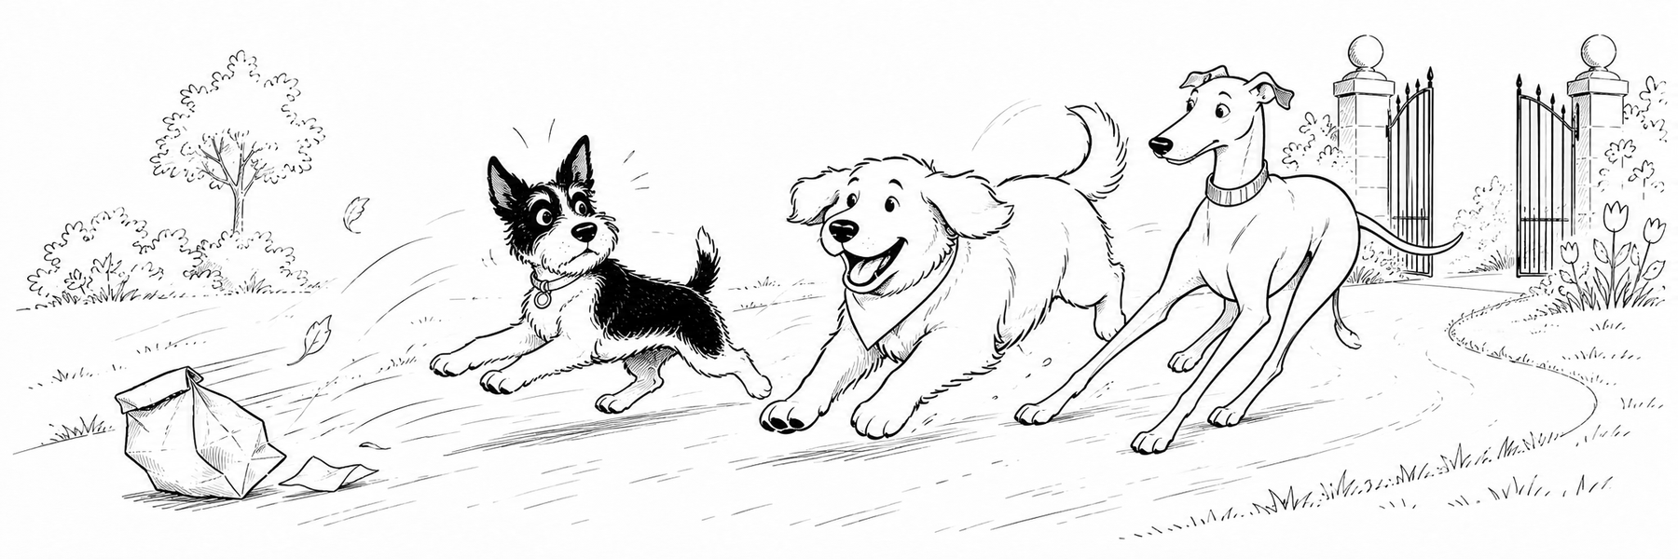
Pepper issued one sharp bark. It meant hold formation, although Biscuit interpreted it as excellent idea, go faster. Juniper made a third interpretation, which was prepare to improvise.

Chapter Two: The Wagon Problem
The runaway bag dropped neatly into a little park wagon. The wagon paused at the top of the slope. For one hopeful second, everybody else paused too.
Then Biscuit bumped it.
The wagon rolled. Biscuit scrambled. Pepper launched herself over the handle. Juniper reached the loose rope and leaned back with all four feet. Leaves flew past like tiny spectators.
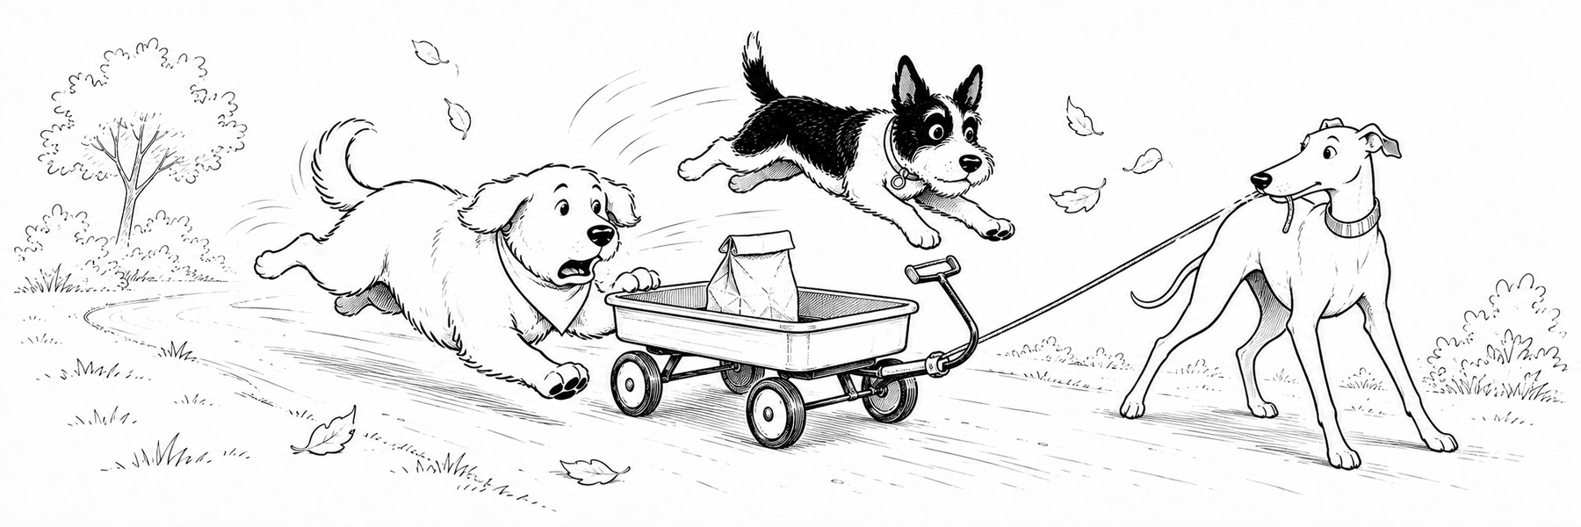
The rescue took three seconds. The explanations took longer:
- Juniper stopped the wagon.
  - Pepper confirmed that the lunch bag was still closed.
    - Biscuit confirmed that it still smelled like lunch.
- Maya returned the bag to the bench.
  - Pepper supervised the handoff.
    - Juniper kept one paw on the wagon rope.
- Biscuit sat down before anyone asked him to.
He looked so virtuous that even Pepper found it suspicious.

Chapter Three: Innocent Until Dinner
The owner of the lunch returned from the water fountain and thanked the unlikely rescue team. Maya apologized for the commotion. Juniper accepted praise with dignity. Pepper accepted a scratch behind the ears. Biscuit watched the bag with professional concern.
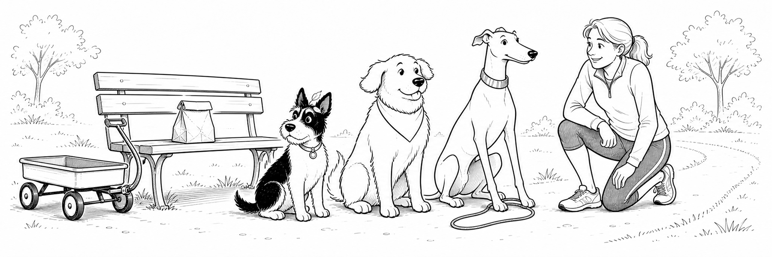
The final incident record was brief.
Moment | Pepper | Biscuit | Juniper
First gust | Alert | Delighted | steady
Wagon rolls | Leaps | Scrambles | Brakes
Bag returned | Supervises | Hopes | Succeeds
Maya called the outing a success. They had completed one lap, helped a stranger, and learned a useful lesson. The dogs remembered the lap. Maya remembered the stranger. Biscuit remembered the sandwich.
The official team portrait 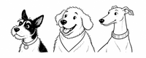 was taken before anyone mentioned the word lunch again.
That is why all three dogs appear to be listening.

Capability Lab
Everything after this point is intentionally functional. It exercises the portable document features in markdown-docx while remaining readable as ordinary Markdown.

Text and hierarchy
This paragraph contains strong text, emphasis, strong emphasis, and inline code. It begins on one source line and continues through a soft source break that becomes a normal space.
This line ends with an explicit hard break.
This sentence begins on the next line in the same Word paragraph.
This line shows strikethrough, H₂O, and x². A bare URL such as https://example.com/docs becomes a native hyperlink.

Setext heading level two
Setext headings create the same Word heading and bookmark as hash headings.

Heading level three

Heading level four

Heading level five

Heading level six
A blockquote uses the configured Quote paragraph style.
A second quoted paragraph confirms that consecutive quote blocks remain editable text.

A heading inside a quote
- A list item keeps native bullets inside the quote.
Quoted code stays editable.
Quoted part | Status
Table | Ready
A second quote level adds another indent.

Fenced code
from pathlib import Path
source = Path("showcase.md")
target = source.with_suffix(".docx")
print(target)
The CSS fence demonstrates a second recognized language.
.showcase {
color: #2464a4
}

Indented code
source = "showcase.md"
print(source)

Jump to list kinds and depths.

List starts and continuation paragraphs
- This ordered list begins at three.
This second paragraph belongs to the same item and has no number.
- This item continues at four.
A paragraph separates the next list from the previous sequence.
- This independent list starts again at one.

List kinds and depths
- Unordered level one
  - Unordered level two
    - Unordered level three
- Ordered level one
  - Ordered level two
    - Ordered level three
- Mixed unordered parent
  - Ordered child
    - Ordered grandchild
- Mixed ordered parent
  - Unordered child
    - Unordered grandchild
The next two lists use all nine native Word levels.
- Ordered level one
  - Ordered level two
    - Ordered level three
      - Ordered level four
        - Ordered level five
          - Ordered level six
            - Ordered level seven
              - Ordered level eight
                - Ordered level nine
- Bullet level one
  - Bullet level two
    - Bullet level three
      - Bullet level four
        - Bullet level five
          - Bullet level six
            - Bullet level seven
              - Bullet level eight
                - Bullet level nine

Rich list items
- This item contains several editable blocks beneath one Word list number.
print("Nested code")
A quote inside the list item stays indented with its text.
Part | Status
Code | Ready
The final paragraph still belongs to the same numbered item.
- Numbering continues after the nested blocks.

Clickable task lists
☐ Review the draft and follow the checklist.
☒ Approve the finished document.
- Plain list items can sit alongside tasks.
- ☐ A numbered task keeps its number and gains a check box.

Thematic breaks and empty blocks
A horizontal rule below uses Word's standard paragraph border.

The empty link label stays visible without a destination.
- A list item before an empty one.

- A list item after an empty one.

The preceding quote is an empty Word paragraph with the Quote style.

A4 Layout Lab
This next-page section uses A4 paper and millimetre margins. The first table keeps automatic width and aligns to the left. It also places strong, emphasized, nested, and code-formatted text inside native table cells.
Feature | Live example
Strong | bold cell text
Emphasis | italic cell text
Code | cell_code()
Nested | bold italic cell text
Hyperlink | Project documentation
The next illustration has no image metadata. Its large natural width is clamped to the usable page width by the renderer.
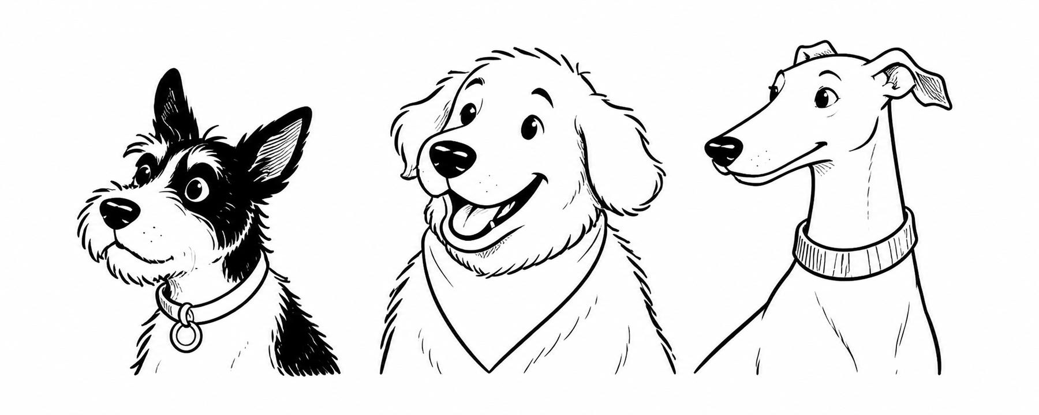

Empty image destinations
An image with no destination becomes a visible placeholder: [Image: Network diagram]. An image with no alt text becomes [Image]. The placeholder also works inside a linked image label such as [Image: Linked diagram].

Legal Landscape Lab
This section uses legal paper in landscape orientation with centimetre margins. Its table is right aligned, fills the usable page width, and uses equal default column widths because no ratios are supplied.
Document scope | Text scope | Layout scope | Asset scope
Styles and fonts | Rich inline runs | Sections and breaks | Local and remote loading
Letter, legal, A4, custom | Quotes, code, lists | Margins and orientation | Width and alignment
The illustration below is physically sized in centimetres and aligned to the right.

Custom Page Lab
This section is seven by ten inches, expressed entirely in points. Its illustration is also sized in points and aligned to the right.

Environment-dependent coverage
The portable showcase uses relative local image paths. Automated tests cover absolute local paths, remote downloads, remote opt-out behavior, cache reuse, structured errors, standard input, custom templates, overwrite protection, and command-line exit codes.
Coverage location | Responsibilities
This document | Portable Markdown, Word layout metadata, native content, and local images
Automated suite | Machine-dependent paths, network behavior, cache behavior, CLI modes, and failure contracts

Back to Document Defaults
The final section returns to letter paper, portrait orientation, inch-based margins, and the document-level style and font mappings.
The generated file remains a normal editable .docx. Headings, paragraphs, quotes, code, lists, tables, hyperlinks, images, page breaks, and sections are all native Word content. Read the project documentation for more examples.

Native footnotes
This statement has an editable Word footnote.

Repeating table headers
Pipe-table headers repeat automatically when their table spans pages. Body rows retain their normal behavior.
Capability | Behavior
Header row | Repeats on later table pages
Body row | Appears once

DOTX formatting templates
The same Markdown can use a blank macro-free .dotx file through --template. Output remains an editable .docx, and the source template stays unchanged.

Syntax Highlighting Gallery
Each code fence names a Pygments language. The colored code remains editable text in Word.

HTML
<main class="card">
<h1>Hello, Word</h1>
</main>

CSS
.card {
color: #2464a4;
padding: 1rem;
}

JavaScript
const greet = name => `Hello, ${name}`
console.log(greet("Word"))

TypeScript
function greet(name: string): string {
return `Hello, ${name}`
}

Python
def greet(name: str) -> str:
return f"Hello, {name}"

PHP
<?php
function greet(string $name): string {
return "Hello, " . $name;
}

C#
class Greeter {
public static string Hello(string name) => $"Hello, {name}";
}

Java
class Greeter {
static String hello(String name) {
return "Hello, " + name;
}
}

C
#include <stdio.h>
int main(void) {
puts("Hello, Word");
return 0;
}

Swift
func greet(_ name: String) -> String {
"Hello, \(name)"
}

Go
package main
import "fmt"
func main() {
fmt.Println("Hello, Word")
}

C++
#include <iostream>
int main() {
std::cout << "Hello, Word\n";
}

Rust
fn main() {
println!("Hello, Word");
}

A formatted explanation with a reference link. A second paragraph keeps the note content together.

