markdown-docx 1.0.0
Predictable, editable Word documents from readable Markdown.
This showcase demonstrates strong text, emphasis, and inline code.
This sentence follows an explicit hard line break.
The source remains ordinary Markdown while invisible comments carry Word layout instructions.
Templates and semantic styles own the visual system.

Text hierarchy
Headings do not create pages or sections. They map directly to the configured Word paragraph styles.

Heading level three

Heading level four

Heading level five

Heading level six

Fenced code
from pathlib import Path
output = Path("brief.docx")
print(output)

Mixed nested lists
- Markdown remains readable
- Metadata stays invisible
- Validation stays strict
- Word content remains editable
- Inspect the syntax
- Inspect the template
- Render the document
- Review the editable result

Native table
Capability | Source | Output
Headings | Markdown | Word styles
Tables | Pipe syntax | Native table
Images | Local or remote | Inline drawing

Standalone image
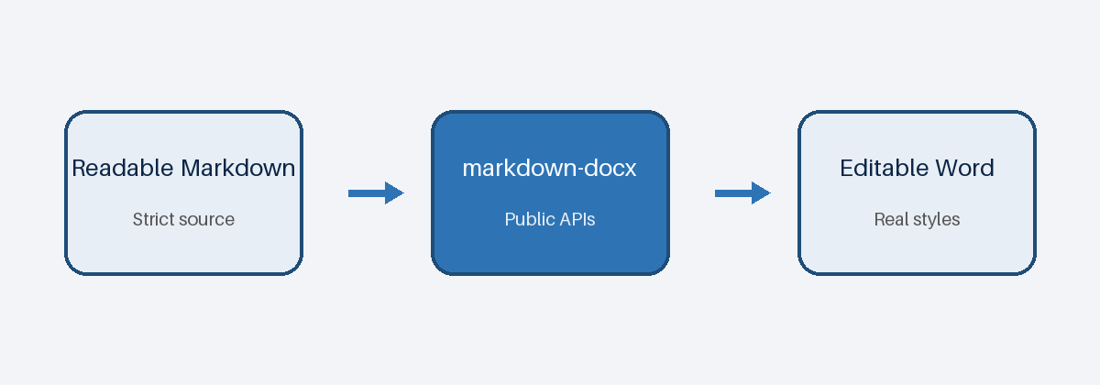

Explicit page break
This heading begins after a page break, but it remains in the same Word section.
An inline image behaves like a character in its paragraph: 

Landscape section
Each section starts from the document defaults, then applies the declared overrides.
Boundary | Page size | Orientation | Inheritance
Document | Letter | Portrait | Defaults
Analysis | Letter | Landscape | Defaults plus overrides
Reset | Letter | Portrait | Document defaults

Back to document defaults
The final section returns to the original portrait geometry. The output remains a normal editable .docx file.

