Module 2. Mesoplane analysis

**Unit 2.1 Mesoplane contextualization**

Group, sector and intersector analyses are used to observe certain behaviors, which are generally standardized. By standardized behaviors, we refer to behaviors that we establish as prioritized solutions to certain situations of play. Due to the complexity of the game, where chaos and organization are two sides of the same coin and are interrelated, it is difficult to standardize situations-specific behaviors-when there are so many variables that make up a situation of play; when the game is open, for example.

To standardize behavior, some of these variables must be prioritized. When making a decision, the player takes all of these variables into account in order to fully adjust to the in-game situation. Having to pay attention to so many variables may cause player errors. Setting some variables as priority makes the player's interpretation easier and they will know what to focus on and make fewer errors. However, by ruling out some variables, less adjustment to the situation. It also facilitates the player's execution since they can better adjust the timing of their play and pay attention to executing the movement or technique.

As we said before, in order to standardize behaviors, it is essential to have a thorough understanding of the game allowing us to develop more successful solutions to certain situations and to identify key variables to focus on when determining behavior. In addition, situations of play that can be standardized should be as specific as possible­ within the openness of the game. We cannot standardize a team's kickoff because there are many elements that greatly influence how to solve that situation and there are many possibly valid solutions. However, we can standardize the continuous support by the 1st center-back P4 when fullback P2 has possession, since there are fewer key variables.

Standardizing behavior on the micro and mesoplanes is easier than on the macroplane. Plus, micro and mesoplanes work as foundations that lead to effective resolution on the macroplane. Understanding that the ball is the element that generates the most uncertainty in the game, it will be easier to standardize behavior in **moments without the ball** (w/o ball) than in **moments with the ball** (w/ ball).

The mesoplane analysis focuses on the observation of game behavior (successful and unsuccessful) that, once transformed into *clips,* can become audiovisual learning tools. These tools, together with training, help the players acquire certain behavior.

We will analyze specific relationships in which more or fewer players participate, which can be applied to different systems of play. The following are some examples:

* Interaction between two P9s (two points).
* Interaction between P2 and P7 (outside full-back/mid-fielder).
* Double pivot (two P6s).
* Corridor and line behavior.
* Interaction between corridors and lines.
* Participation in mutual assistance space (behavior of nearby players).

In order to develop aspects related to the mesoplane with a high degree of specificity, we think it's more useful to focus on a specific example instead of talking in general about the whole mesoplane without going into any detail. Due to its applicability to different systems of play and the possibility of standardizing behavior, we will focus on the **4-player defensive line during moments without the ball (w/o ball).**

**Unit 2.2 Line analysis**

* + 1. **Defensive line (of 4) during moments without the ball (w/o ball)**

The defensive line must behave as a functional unit and constantly adjust its position. Beyond the different situations that must be mastered, there are a number of fundamentals that must always exist in order to maintain line balance:

* + - * Angled position, turning according to where the ball is, ready to run back or jump between lines.
      * Defensive pressure with active feet (adjusting the supporting foot) to be able to react first to in-game stimuli.
      * Constant awareness of blind spots, turning their head, even though their neighboring teammate is responsible for the "blind" spot. P2/P3 full-backs multiply the responsibility from opposite sides. They defend two gaps, as well as the blind spot.
      * Monitoring references, adjusting distance to opponents and communicating with teammates about opponents who try sneak in.
      * Watching the rest of the players on the line in any group movement to control the distances for width and depth, avoiding misalignment of any defender, etc.

# Shifting, spaces within lines and gap defense

The speed of lateral movements, shifting, allows us to reduce distance between players on the line and to close in on the strong side. Moving at maximum intensity becomes a necessity, but the intensity of the movements is relative depending on certain behavior that must be maintained during shifting:

* + - * Continually monitor references, assigned and non-assigned opponents, and master the concept of swapping opponents between players on the defensive line after the team in possession makes a horizontal pass, which involves horizontal movements from advanced defenders. This only affects the defensive line. For this reason, avoid vertical interactions after horizontal interactions or against shifting.
      * Pace of shifting depends on whether the opponent advances past their neighboring players; avoiding that gaps are left for penetration.
      * Combine shifting, horizontal movements, with vertical movements, forward/backward; depending on how the possessor/receiver is situated.
      * Crossover running in adjustment shifts at a medium to high pace. Using a running technique where the stride is not lateral-jumps where both feet are off the ground, or both feet are "planted" in the ground, as this hinders response abilities. Rather, steps must cross which increases speed. Having one foot on the ground almost always improves response abilities.
      * Sprints that are perpendicular/diagonal to the sideline for long stretches at a high pace. A running technique where, in situations of emergency, the normal sprint is prioritized over crossover running.

Within the 4-player defensive line, we will identify 5 penetration gaps (wing - P2 - P4 - P5 - P3 - wing). With regard to gap defense, we have to pay attention to some fundamental aspects:

* + - * + The defender's positioning determines their responsibility for the gap that they are facing. They are responsible for: the gap in front of them, position towards the ball's axis; protecting the space behind them, the "blind" spot of the neighboring teammate with respect to the ball's axis.
        + Defenders on opposite sides, the P2/P3, are responsible for two gaps when the ball is closer to the longitudinal axis than they are-inward facing. The "blind" gap, between their location and the wing is their responsibility. This requires constant awareness of blind spots and an adjustment in distances to keep both gaps balanced. The "blind" gap is also influenced.
        + When facing the axis of the ball, two players will double up to defend the gap. This hinders the chance of an inside pass, as there are two players defending.
        + Prioritize a narrow gap between center-backs (P4 - P5) to force attempts to get open to the outside, away from the goal.
        + Awareness of the adjacent gap for which they are not responsible, mainly while making adjustments. Monitoring the "blind" spot.

# Figure 1: Defensive line of 5 penetration gaps

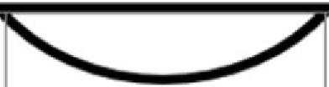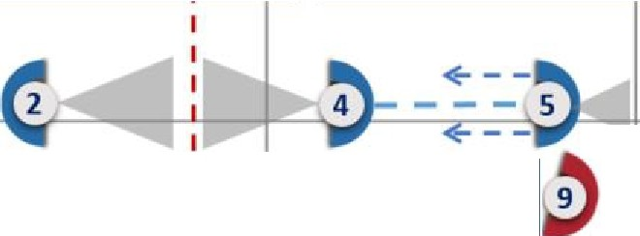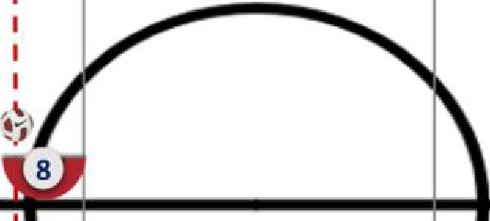

I

Position towards the Reduce P4-P5 gap ball's axis {narrowness)

Responsible for 2 gaps (last in width)

+ - - **3** - - ->

Responsibility for the interval the player is facing

Awareness of blind spot

Source: prepared by the author.

It is essential to maintain balance while shifting and avoid situations of both over­ shifting and open and useable penetration gaps. The width of the defensive line will very much depend on the location of the ball, in both in width and depth; as well as the

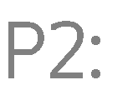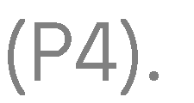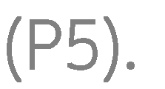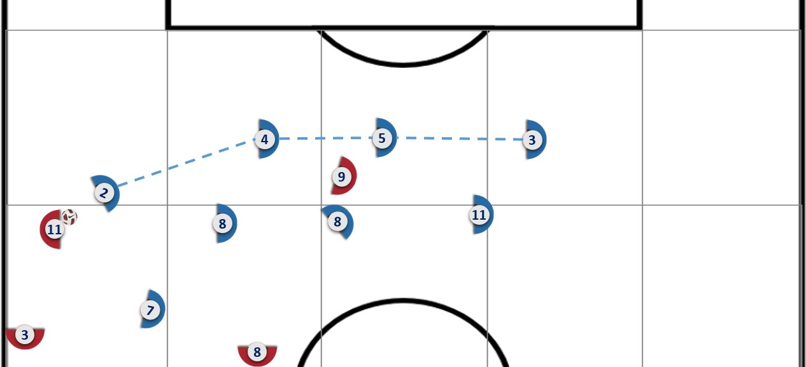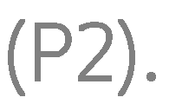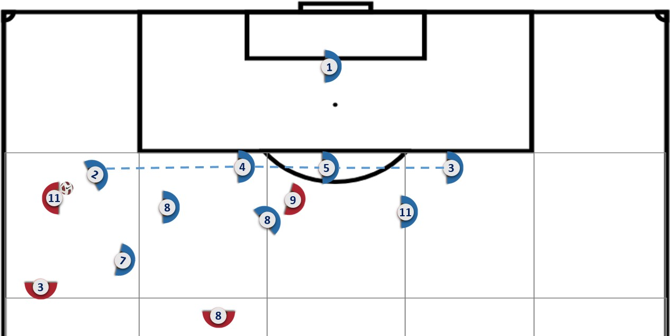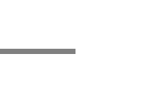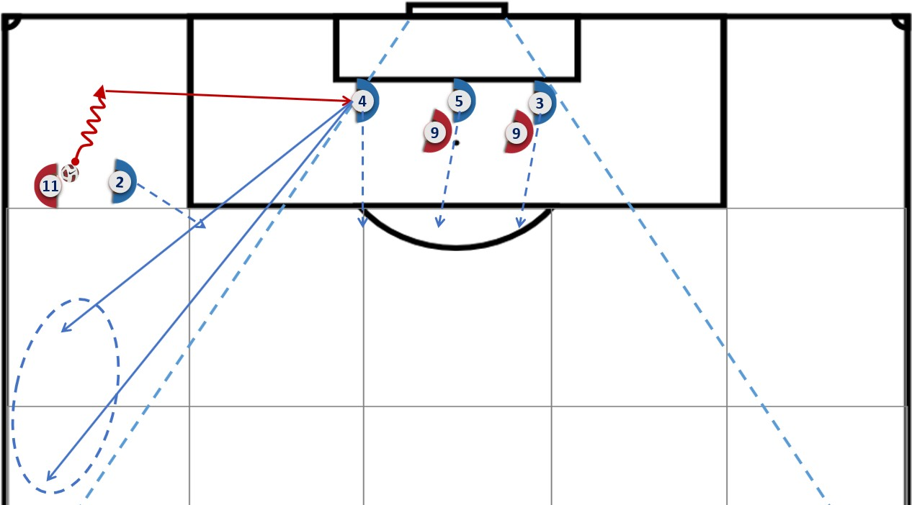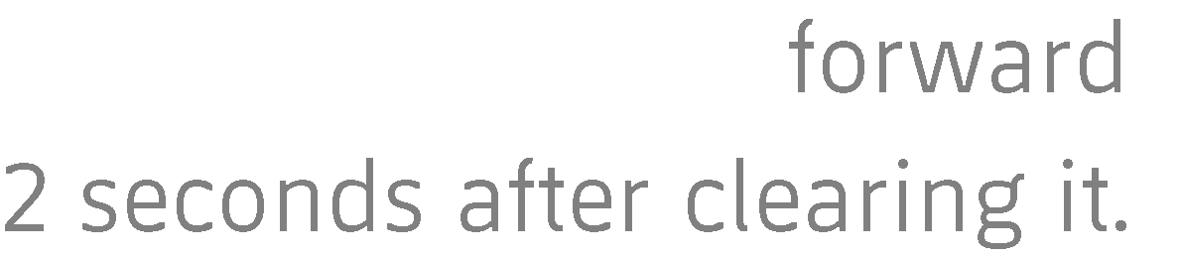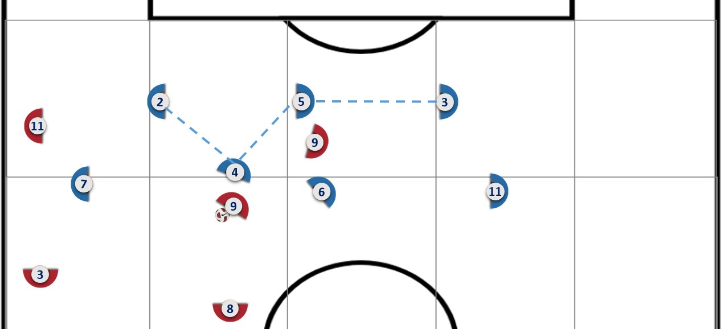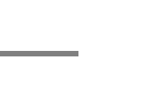

* Encroachment: forward movement at a fast pace and considerable distance. It occurs in very obvious covered ball situations. We recommend executing it with a crossover run (fast, angled position, and ready to run forward-backward).
* Adjustment Advance: forward movement at a slow pace and short distance. These are situations in which the height is adjusted and the player is ready for the next movement-depending on the pass. Situations more associated with a covered ball; but not necessarily. If a short movement is performed at a fast pace, we describe this as elastic or individual offsides. This depends on whether the behavior is individual or group.
* Hold: the line remains at the height it is at, with optimal defensive pressure to facilitate their next intervention. It is also important to recognize when you must stop, depending on the recovery limit established or the needs that each situation of play may require.
* Backward shift: backward movement at a slow pace and short distance. These are situations in which the height is adjusted, positioned to make the next move-depending on the pass. Situations most associated with an uncovered ball; but not necessarily.
* Pull back: backward movement at a fast pace and long distance. It occurs in very obvious uncovered ball situations. We recommend executing it with a crossover run, meaning a fast, angled position, and ready to run forward-backward.

These movements are determined by the concepts of covered and uncovered ball. It is essential not to confuse a covered ball with a pressured ball, or an uncovered ball with an unpressured ball. The key, mainly, will be in the opponent's possibilities of passing back and/or an inside pass in progression-which involves getting past a line, elimination of players, among others. Forward movements are associated with the covered ball, while the backward movements are associated with uncovered ball. However, it is important to note that, depending on where the defensive line is positioned, one or the other movement can be used, so each situation must be contextualized. In this regard, there may be adjustment reversals in situations of covered balls.

Covered and uncovered ball situations are specified below. It is important to note that the table is designed under covered ball conditions, adding the uncovered ball situations that may arise from each of them. Any covered ball condition that occurs, even if there are also uncovered ball conditions, will turn the situation into a covered ball context.

# Table 1: Covered and uncovered ball situations

|  |  |
| --- | --- |
| **Covered ball (inside/back pass impossible)** | **Uncovered ball (inside/back pass possible)** |
| Pressure on the player in possession | Getting past 1st defender |
| Pass behind (unloading, mainly long) | Face receiver with space and time |
| Defensive line numerical superiority (mark/cover) | Equality/lower defensive line (protect) |
| Ball times (pass transfers) | Moments prior to reception with space and time |
| No threat of breaking through the defensive line | Threat of breaking through the defensive line |
| Possessor far from line, difficulty activating behind | Possessor close to line, possible to activate behind |
| Imprecise control, not based on tactical intent | Precise control, based on tactical intent |
| Handling with supporting foot distanced from the ball | Handling with supporting foot close to the ball (pass) |
| Receive from behind (possessor pressured, no turn) | Receiver from behind is able to turn (face the ball) |
| Possessor not oriented to be able to progress | Possessor oriented to be able to progress (look) |
| Last 20-25 m (encroach in event of possible outside shot) | Situation to arrive before 20-25 m (without outside shot) |

Source: prepared by the author.

The defensive line will be able to function flexibly if covered and uncovered ball conditions and the various vertical movements that can be performed as a functional unit are dominate. But it will mainly exist if developments such as: transitions, sub-phase changes or context within the same phase of game that do not imply change of possession, are dominate between the conditions of covered and uncovered ball, and between the different vertical movements, adjusting the timing in each change of direction/movement; while maintaining the behavior of the line as functional unit.

Covered and uncovered ball conditions are visual stimuli that can be identified by all members of the line. This facilitates coordinated behavior and timing in movements.

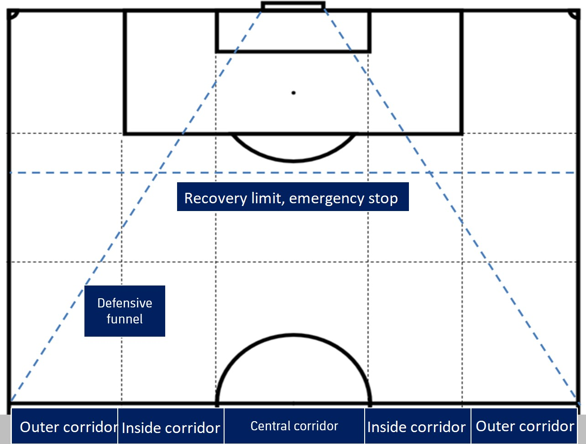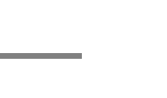



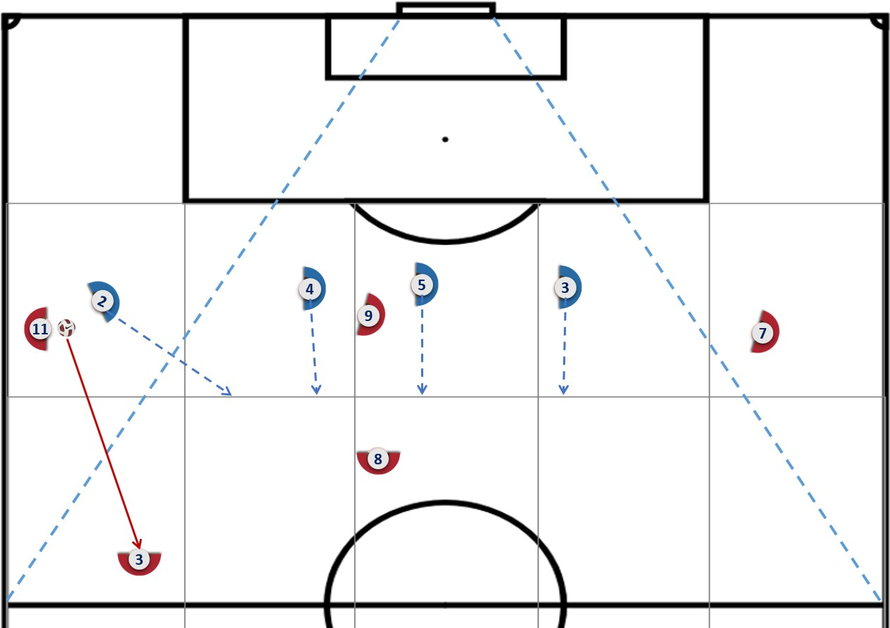



midfield line to keep P4 and P5 center-backs in the funnel. If this help does not exist, the 1st center-back P4 will provide emergency cover if there is a stolen or 50/50 ball, leaving the defensive funnel. If the defender is being beaten and the possessor controls the ball, the defender must avoid leaving the funnel-waiting inside. They will be able to cover but they must assess whether more advantage is gained by this action or by staying inside the defensive funnel, holding up the play. If the line stays balanced, the swapping of the beaten P2 full-back is guaranteed, and the distance to the goal is still far. The shorter the distance from the goal itself, the more priority will be given to keeping the P4-P5 center-backs in the defensive funnel and central corridor.

# Figure 8: Emergency coverage of 1st center-back P4

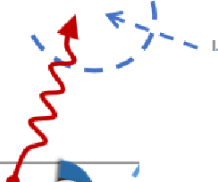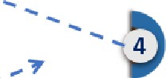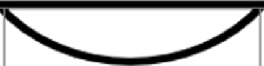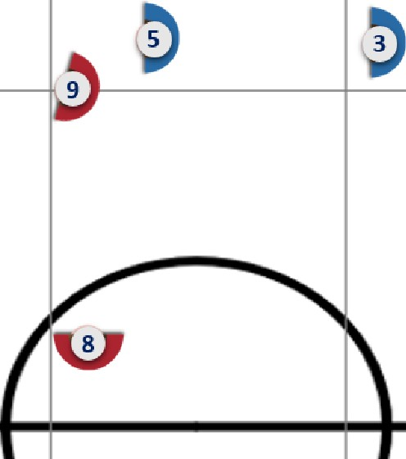

*I*

\

_,.*I*

\

*I*

*I*

*I*

*I*

'''

*I*

*I*

'

*I*

'

*I*

' '

*I*

.... - ...

*I*

'

*I*

'

*I*

'

*I*

I

'

*I*

'

*I*

'

*I*

''

*I*

'

*I*

1 **2 *r***

''

**7**

" *I*

*I*

*I*

'

*I*

*I*

'

' \

'

*I*

*I*

*I*

'

*I*

*I*

'' '

''

Source: prepared by the author.

* Diagonal defensive-shape recovery trajectories in the defensive funnel and timing of the advance on the possessor, recovery limit in situations where the possessor handles the ball inside the defensive funnel, within the central or inside corridors, the line recovers its shape. Then, the players close down to the axis placing the possessor and the last defender along the length of the line-full­ back P2-P3 with completed line, one of the center-backs, P4-P5 may be last in line if the line is incomplete-with a diagonal defensive-shape recovery trajectory in the direction of the longitudinal axis; while remaining inside the defensive funnel. In addition, once the line reaches the recovery limit, the nearest-or otherwise assigned-defender advances on the possessor to avoid

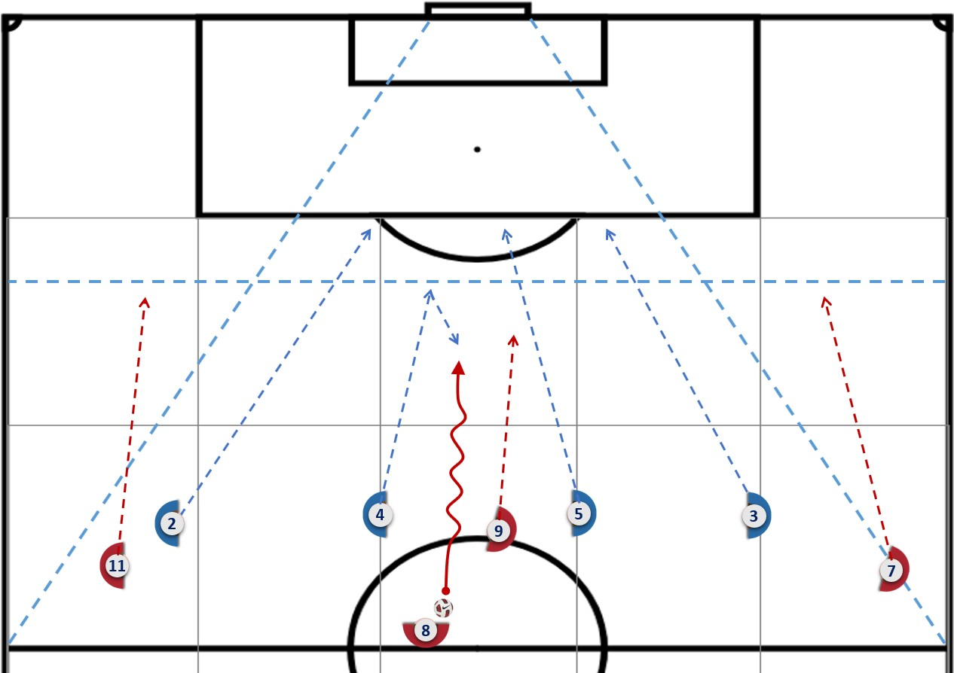



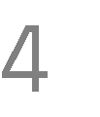



**Figure 10: Staggered line 3-1**

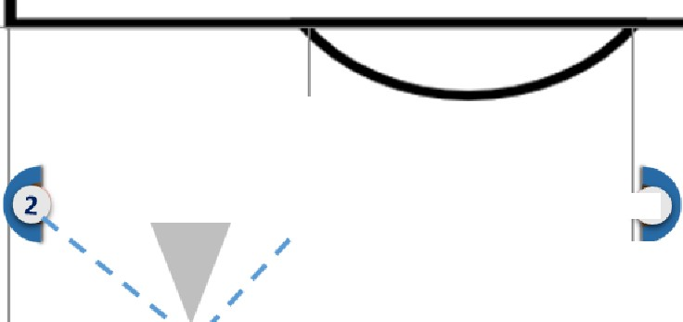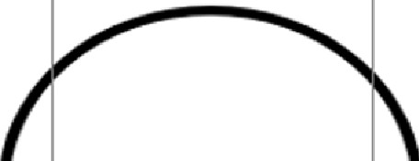

**0** 3

**7**

**4**

Source: prepared by the author.

* Incomplete line 3+1: advance of the 1st defender P4 where their shadow zone has no influence on the defensive line, where there is a very deep advance or confrontation where there can be an extension on its same axis or shadow zone. In this situation, the adjustment of the 3 players that remain on the line will not depend on the location of the 1st defender P4 that has advanced-since they have no influence on the defensive line. Defenders who remain on the line will behave as an independent functional unit and try to achieve line balance from their locations and behaviors. It is an incomplete line situation, 3+1, or 3+0, if the 1st defender that advances is beaten. In this case, the 3+1 situation can be structured on 3 or 4 axes, which will not depend on the staggered player, but on the 3 defenders who remain on the line and try to keep it balanced, managing to adequately defend the whole width and prioritizing spaces according to rival threats and game orientation. In order to achieve this balance, the P4-P5 defenders may or may not be on the same axis, but it will not be so important to be located on different axes as the 1st staggered P4 defender since the coverage distances-and consequently the return distances of the staggered one-will be long, and the interval distances of the players on the incomplete line will be prioritized.

