1. An electric heater draws 3.5 A from a 110 V source. What is the resistance of the

heating element? 31.4 Ohms

2. What current flows when 12 V are applied across a 68 ohm resistor? 0.17A

3. If the current in a circuit equals 0 A, it is likely that the circuit is broken.

4. Three resistors of 100 ohm, 140 ohm, and 80 ohm are placed in a series circuit.

1. Find the equivalent resistance. 320 Ohms
2. If you were to place these three resistors in parallel, what would the equivalent resistance be? 33.73 Ohms

5. By how much is the resistance reduced if you change the circuitry of three 20 ohm

resistors in series to three 20 ohm resistors in parallel? 9 times less

6. Re-draw the schematic diagram below, and then find the equivalent resistance of the circuit.

Let R1 = 8.0 ohm, R2 = 6.0 ohm, R3 = 7.0 ohm, R4 = 6.0 ohm and R5 = 4.5 ohm. Total <11 ohms

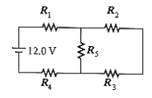

7. The equivalent resistance of the circuit below is 60.0 ohm. If R1 = 45.0 ohm, R2 = 5.0 ohm, R3 = 5.0 ohm and R4 = 45.0 ohm, find the resistance of R.

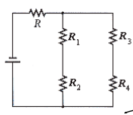

12. Three resistors are connected in parallel – an 80ohm resistor, a 16.0ohm resistor, and a 20ohm resistor, and then joined in series to a 12.0ohm resistor from a battery source with a potential difference of 24V.

a. Draw a schematic diagram for this circuit.

b. Calculate the equivalent resistance and the net current in the circuit.

c. Find the current and potential difference in each resistor.