SubSystem: Sales

ERD :

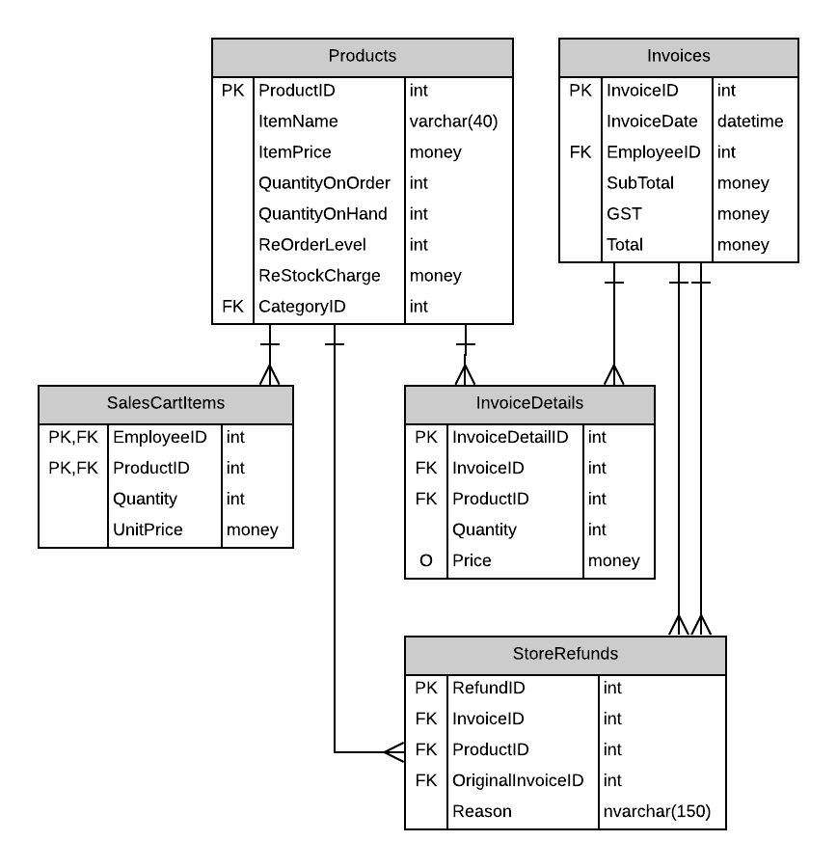

# Possible UX Interface

Screen design(s) :

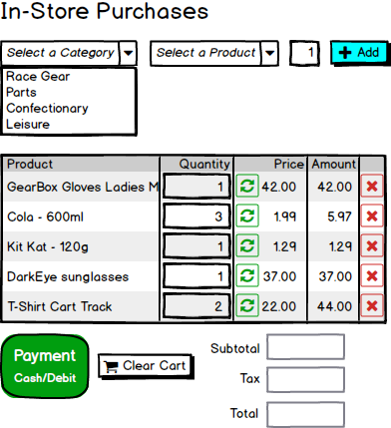

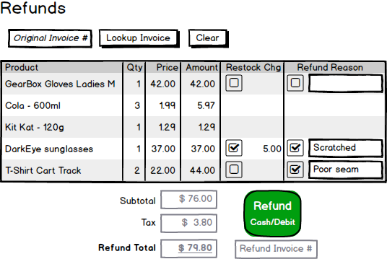

|  |  |  |
| --- | --- | --- |
| **Controls** | | **Events** |
| CategoryDDL | | None / wired via ObjectDataSource |
| **BBL Class(es) and Method (s)** | | |
| CategoryController | List<SelectionList>Category_List   * Retrieve a list of Categories, use in population dropdown list for Categories. | |
| **SQL Table(s): (C,R,U,D)** | | **Entities/DTOs/POCOs** |
| Categories(R) | | SelectionList(P) |

# Event and Wiring Summations **In-Store Purchase**

|  |  |  |
| --- | --- | --- |
| **Controls** | | **Events** |
| ProductDDL | | None / wired via ObjectDataSource |
| **BBL Class(es) and Method (s)** | | |
| ProductController | List<SelectionList>Products_List   * Retrieve a list of Products, use in population dropdown list for Products. | |
| **SQL Table(s): (C,R,U,D)** | | **Entities/DTOs/POCOs** |
| Products (R) | | SelectionList(P) |

|  |  |  |
| --- | --- | --- |
| **Controls** | | **Events** |
| QuantityDDL | | None / wired via ObjectDataSource |
| **BBL Class(es) and Method (s)** | | |
| ProductController |  | |
| **SQL Table(s): (C,R,U,D)** | | **Entities/DTOs/POCOs** |
| Products (R) | |  |

|  |  |  |
| --- | --- | --- |
| **Controls** | | **Events** |
| Add | | Add_OnClick   * Collect Category and Product information * Send to BLL for adding product to the cart list * Refresh product list |
| **BBL Class(es) and Method (s)** | | |
| CategoryProductController | Void Add_ProducttoProductList(string productname, intitemid)   * Add item to shopping cart list * Display Item in the shopping cart | |
| **SQL Table(s): (C,R,U,D)** | | **Entities/DTOs/POCOs** |
| Products (R) | |  |

|  |  |  |
| --- | --- | --- |
| **Controls** | | **Events** |
| QuantityRefreshDDL | | None / wired via ObjectDataSource |
| **BBL Class(es) and Method (s)** | | |
| SalesCartItemController | void Quantity_Refresh(int itemid, int quantity)   * Changes the quantity of an item in the shopping cart. * Find the item and update the quantity. * SaveChanges. | |
| **SQL Table(s): (C,R,U,D)** | | **Entities/DTOs/POCOs** |
| SalesCartItems (U) | |  |

|  |  |  |
| --- | --- | --- |
| **Controls** | | **Events** |
| Delete | | Delete_OnClick   * Collect itemid * Send to BLL for removing the items from the shopping cart * Refresh cart |
| **BBL Class(es) and Method (s)** | | |
| CategoryProductController | Void Delete_ProductItem(int itemid)   * Find item to remove. * Remove the item. * Refresh cart list. | |
| **SQL Table(s): (C,R,U,D)** | | **Entities/DTOs/POCOs** |
| SalesCartItems (D) | |  |

|  |  |  |
| --- | --- | --- |
| **Controls** | | **Events** |
| SubTotalDDL, TaxDDL, TotalDDL | | OnClick |
| **BBL Class(es) and Method (s)** | | |
| InvoiceController | * Label for SubTotal. * Label for Tax. * Label for Total. * Calculate and Display Total | |
| **SQL Table(s): (C,R,U,D)** | | **Entities/DTOs/POCOs** |
| Invoices (R) | |  |

|  |  |  |
| --- | --- | --- |
| **Controls** | | **Events** |
| PaymentDDL | | Payment_OnClick |
| **BBL Class(es) and Method (s)** | | |
| SalesCartItemController | void Payment_Click(object sender, EventArgs e)  TRX   * A single complete transaction * The invoice results are to remain on the screen. * The invoice number will be created. | |
| **SQL Table(s): (C,R,U,D)** | | **Entities/DTOs/POCOs** |
| SalesCartItems (R) Invoices(R) InvoiceDetails(R) | | Invoice(P) |

|  |  |  |
| --- | --- | --- |
| **Controls** | | **Events** |
| ClearDDL | | Clear_OnClick() |
| **BBL Class(es) and Method (s)** | | |
| SalesCartItemController | * void Clear_Cart() * Empty Cart and prepare the screen for a new sale * SaveChanges. | |
| **SQL Table(s): (C,R,U,D)** | | **Entities/DTOs/POCOs** |
| SalesCartItems (R) | |  |

**Refunds**

|  |  |  |
| --- | --- | --- |
| **Controls** | | **Events** |
| LookUpDDL | | LookUp_OnClick   * Call BLL to look up invoices * Retrieve and Display Invoice Information |
| **BBL Class(es) and Method (s)** | | |
| InvoiceController | List<ProductInvoice> List_InvoiceDetails()   * Retrieve Invoice Details for DDL | |
| **SQL Table(s): (C,R,U,D)** | | **Entities/DTOs/POCOs** |
| Products (R), Invoices(R), InvoicesDetails(R) | | ProductInvoice (P) |

|  |  |  |
| --- | --- | --- |
| **Controls** | | **Events** |
| RefunReasonDDL | | OnClick |
| **BBL Class(es) and Method (s)** | | |
|  | * Add reason to return the item * Can not return product if there is no reason provided | |
| **SQL Table(s): (C,R,U,D)** | | **Entities/DTOs/POCOs** |
| StoreRefunds(R) | |  |

|  |  |  |
| --- | --- | --- |
| **Controls** | | **Events** |
| ClearRefundDDL | | Clear_OnClick() |
| **BBL Class(es) and Method (s)** | | |
| InvoiceController | * void Clear_Invoice() * Clear the screen. * SaveChanges. | |
| **SQL Table(s): (C,R,U,D)** | | **Entities/DTOs/POCOs** |
| Invoices (R) InvoicesDetails(R) | |  |

|  |  |  |
| --- | --- | --- |
| **Controls** | | **Events** |
| SubTotalDDL, TaxDDL, TotalRefundDDL | | OnClick |
| **BBL Class(es) and Method (s)** | | |
| InvoiceController | * Label for SubTotal. * Label for Tax. * Label for RefundTotal. * Calculate and Display Refund Total | |
| **SQL Table(s): (C,R,U,D)** | | **Entities/DTOs/POCOs** |
| Invoices (R) | |  |

|  |  |  |
| --- | --- | --- |
| **Controls** | | **Events** |
| RefundDDL | | Refund_OnClick |
| **BBL Class(es) and Method (s)** | | |
| SalesCartItemController | void Refund_Click(object sender, EventArgs e)  TRX   * A single complete transaction * The invoice results are to remain on the screen along with Invoice number. | |
| **SQL Table(s): (C,R,U,D)** | | **Entities/DTOs/POCOs** |
| Invoices(R) InvoiceDetails(R), Products(U,R),StoreRefunds(R,U) | | Invoice(P) |