**Assignment 1**

**Q1. Use Case Diagram**

The Use Case Diagram consists of three actors, the TV Viewer, the Service Admin (for repairs and maintenance) and TV Set.

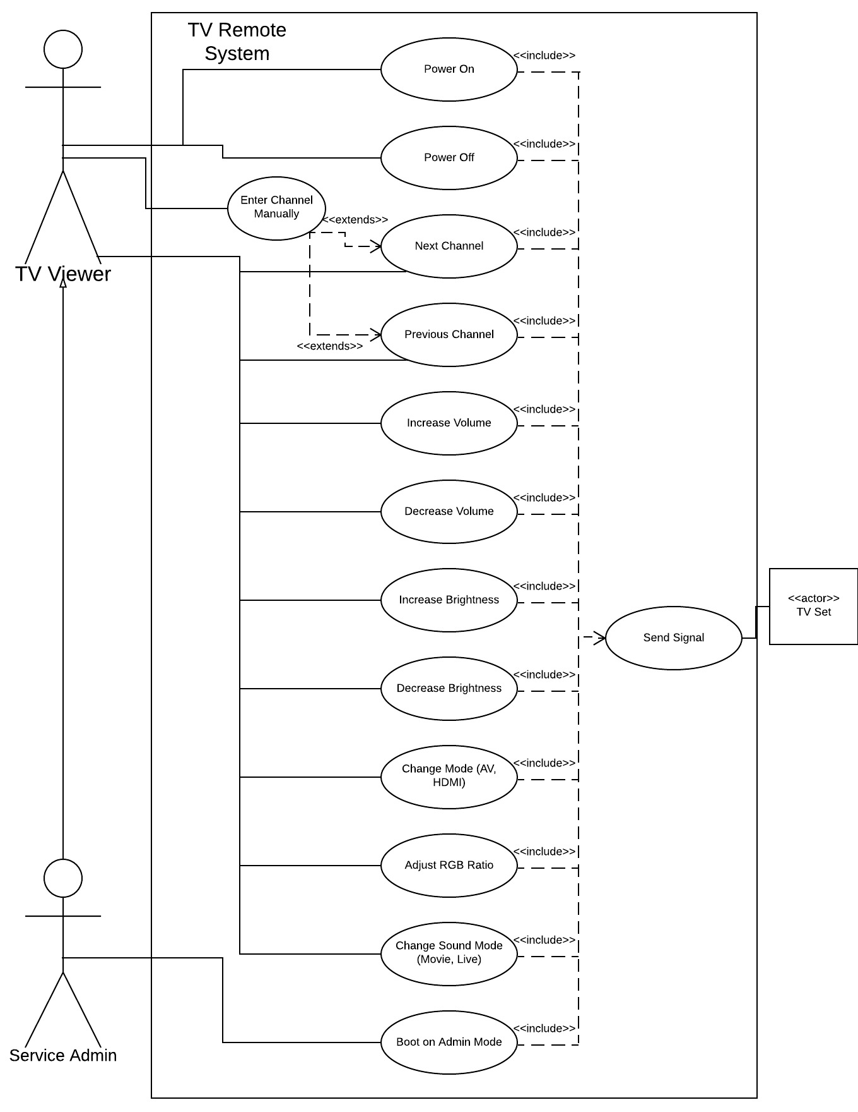

**Q2. Activity Diagram**

The Activity Diagram represents an Antivirus System. It is assumed that the antivirus system has to be activated before it can perform any tasks

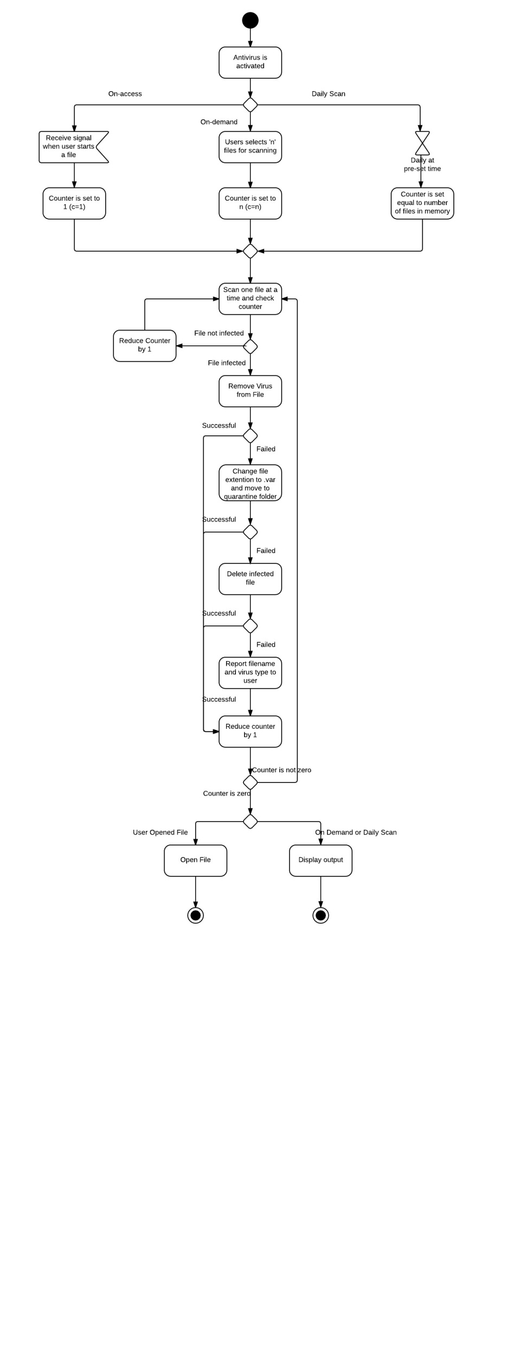.

**Q3. Sequence Diagram**

The Sequence Diagram represents the process of deletion of a movie from the database. The actors are DBAdministrator and Movie Database. The DBA performs the tasks using the Database.

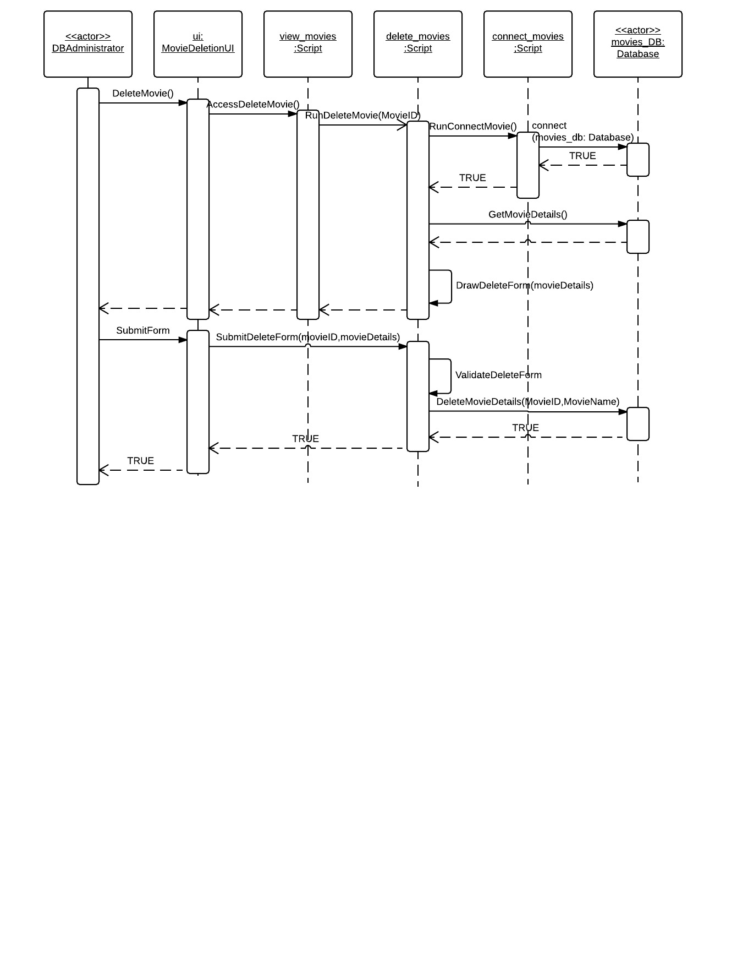

**Q4. Class Diagram**

The Class Diagram represents the scenario of Internal Medicine Group (IMG).

