**Assignment 2**

**Question 1:**

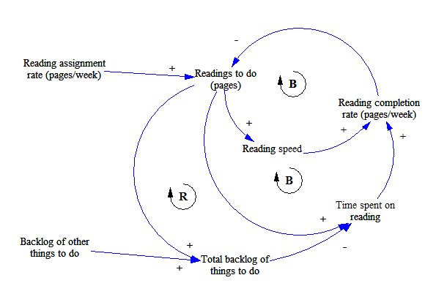

**Figure 1: Question 1**

The above causal loop diagram represents students reading workload. It consists of seven variables which are related to each other in several ways. The two constant variables which are not affected by any other variables are ‘Reading assignment rate’ and ‘Backlog of other things to do’. The smallest and the first loop is a balancing loop since the product of plus, plus and minus is minus. When the reading to do (pages)’ increase it positively impacts the reading speed of the reader. Higher reading speed positively impacts reading completion rate. However, if the reader increases the reading completion rate it decreases the Reading to do pages. The second loop outside the first one is again a balancing loop since the product of plus, plus and minus is minus. The user will always increase the time spent on reading when the reading to do pages increase. Similarly, the time spent on reading positively impacts the reading completion rate. Like before, if the reader increases the reading completion rate it decreases the Reading to do pages. The final and the third loop is a reinforcing loop since the product of plus, minus, plus and minus is plus. There is a constant input of backlog of other things to do on total backlog of things to do. The reading to do (pages) will positively impact the total backlog of things to do. However, if the total backlog of things to do increases, the time spent on reading will be decreased as the user will spend some time in eliminating the other backlogs too. The other two relations are similar to the above loops.

**Question 2:**

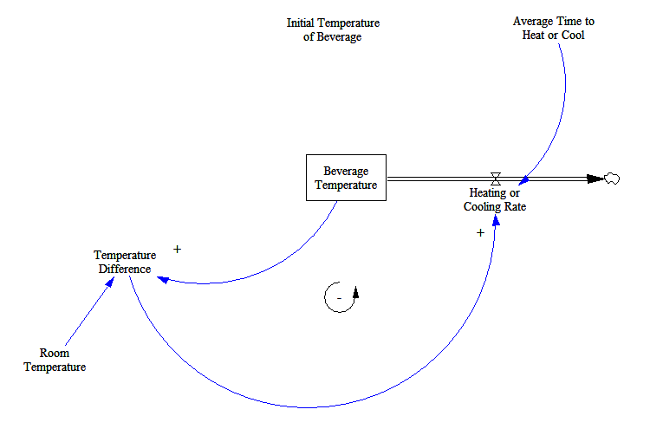

**Figure 2: Question 2**

The above model shows us the behavior of the temperature of beverage in accordance with the room temperature. It shows how the beverage will adjust itself to match the room temperature over time. In the above diagram, Room Temperature (70F) and Average time to cool (5 minutes) are our constants as given in the question. Also, Initial Temperature of Beverage is a constant but we change it based on our simulation (40F or 90F). Temperature Difference would be Beverage Temperature minus Room Temperature. The Beverage Temperature would just emit Heating or Cooling Rate which internally is calculated as Temperature Difference divided by Average Time to cool. The final simulation output at the two given temperatures is shown in Figure 3.

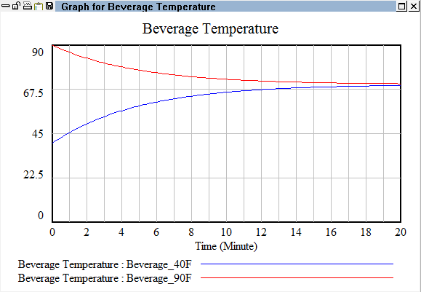

**Figure 3: Question 2 Graph**

The dynamic model above contains only one feedback loop. Increase in the beverage temperature as a positive effect on the Temperature Difference. Also, rise in the temperature difference would positively increase the heating or cooling rate. However, higher the heating or cooling rate, more temperature will leave the beverage temperature and hence will have a negative effect. Thus, the system archetype is a Feedback loop i.e. Negative Loop. Also, the behavior of the graph is as expected. If the initial temperature is at 40F, it eventually rises to the room temperature over time and if the initial temperature is at 90F it eventually cools down to the room temperature. Also, the curve of the beverage from 40F to 70F is steeper since the difference between temperatures is 30 as compared to 20 of beverage cooling.

This behavior can be called as Goal Seeking behavior where the final goal is reaching the room temperature. The beverage cooling down is also called an exponential decay. The beverage heating up can be called Asymptotic Growth. Goal seeking behavior loops are usually made of four main things and our model closely resonates these four things i.e. State of the System (Initial Temperature/Beverage Temperature), Goal Desired State (Room Temperature), Discrepancy (Temperature Difference) and Corrective Action (Heating or cooling rate).

**Question 3:**

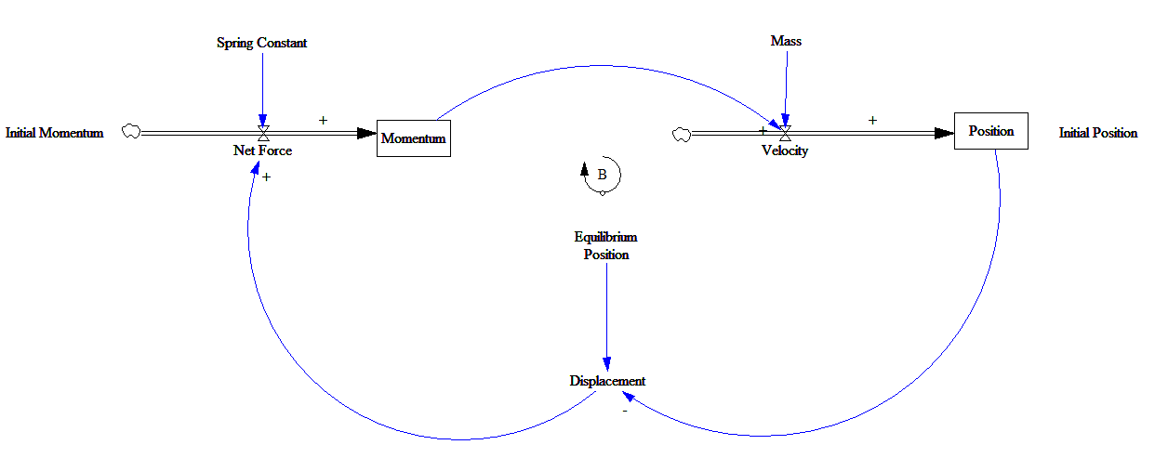

**Figure 4: Question 3**

The above model represents various relations between measures and contributors of Force, Momentum, Velocity and so on. The relationships are clearly explained in the provided excerpt and can be described as follows. Momentum is together formed by three things, Initial Momentum that gives it a positive value, the Spring force that acts upon Net Force positively and both collectively have a positive impact on Momentum. Momentum and Mass together have a positive effect on Velocity. Further Velocity acts positively on Position. Position is also acted upon by a constant Initial position from where it gains the initial value defined in the excerpt. Change in position inversely affects displacement, they are negatively related. Displacement is constantly affected by the Equilibrium position which tries to regulate displacement. The cycle completes as displacement acts upon Net Force.

The loop from Momentum and back which includes, Velocity, Position, Displacement and Net Force is Feedback type in nature since every variable has a positive effect on the next one except position to displacement. The multiplication of every variable in the loop is negative. This means there is only one feedback loop in the Dynamic model.

All the above graphs are oscillatory in nature. Oscillation is observed only when there is a delay. This delay is mainly due to the nature of the spring. These late responses make the system overshoot it's goal i.e. coming to rest. Observing closely, each of the graphs start from a different value since there was an initial value assigned to them.

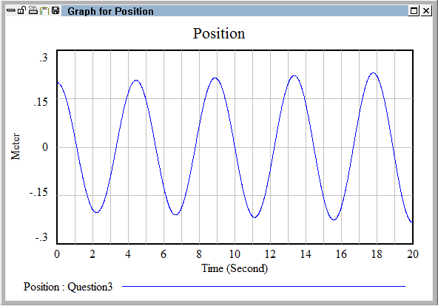

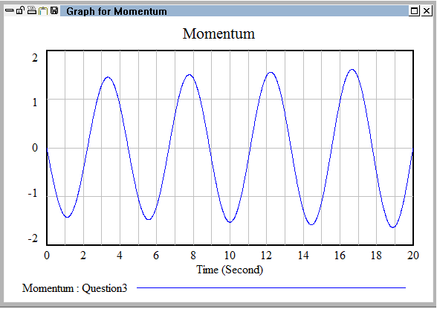

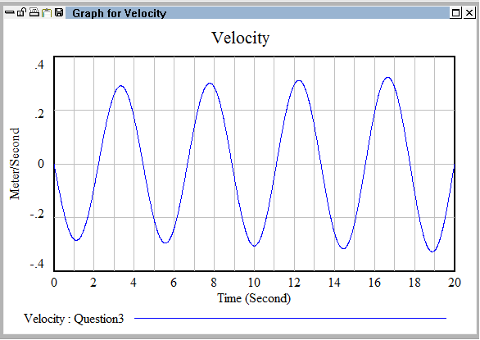

All the above graphs are oscillatory in nature. Oscillation is observed only when there is a delay. This delay is mainly due to the nature of the spring. These late responses make the system overshoot its goal i.e. coming to rest. Observing closely, each of the graphs start from a different value since there was an initial value assigned to them.