# A Major Project Proposal Report on

**Holiday Wanders**

Submitted in Partial Fulfillment of the Requirements for the Degree of

**Bachelor of Engineering in Information Technology**

Under Pokhara University

Submitted by:

**Abik Gurung, 171403**

**Siraj KC, 171441**

**Prasiddha Shakya, 171429**

Under the supervision of

**Roshan Chitrakar**

Date:

May 19, 2022

 **Department of Information Technology**

**NEPAL COLLEGE OF**

**INFORMATION TECHNOLOGY**

Balkumari, Lalitpur, Nepal

**Table of contents**

**Acknowledgement**……………………………………………3

**Abstract**…………………………………………………… 4

1. **Introduction**………………………………………… 5
   1. Problem Statement……………………………………….…… 5
   2. Objectives………………………………………………………6
   3. Significance of study…………………………………………...6
   4. Scope and Limitations………………………………………….7
2. **Methodology**……………………………………….…8
   1. Software Development Life Cycle…………………………...8
      1. System Analysis…………………………………….9
      2. System Design………………….……...…………….9
      3. Coding…………………………………………….…9
      4. Testing………………………………………….…….9
3. **List of Figures**………………………………………….………10

Use Case………………………………………………………….….10

1. **Literature Study/Review**……………………………….11
2. **Project Task and Time Schedule**…………………………....12
3. **Reference**……………………………………………. 13

**ACKNOWLEDGEMENT**

We would like to thanks Nepal College of Information Technology for providing us opportunity to create project under project III.

In performing our assignment, we had to take the help and guideline from respected persons, who deserve our greatest gratitude. The completion of this assignment gives us much pleasure. We would like to show our gratitude **Prof. Roshan Chitrakar** for giving us a good guideline to creating a project.

We would also like to expand our deepest gratitude to all my colleagues who helped us for helping throughout the project.

Team Member

Abik Gurung

Siraj KC

Prasiddha Shakya

**ABSTRACT**

Our project “Travel Wanders” is a web based recommendation application which helps individual to find the best tourist spot place available in the user desired location. Choosing a tourist destination from the information available is one of the most complex tasks for tourists when making travel plans, both before and during their travel. With the development of a recommendation system, tourists can select, compare and make decisions almost instantly. This system is based on the idea that people who like similar place in the past are likely to agree again in the future for tourist destination. Thus user can find their interested location in short time, without searching on many pages. There are many methods to recommend the item (tourist spot) for our project we recommendation system. The project will use recommendation model.

**Keyword: Web Application, Recommendation System, Multi agent Simulation, Database, Tourist destination.**

1. **INTRODUCTION**

Our project “Travel Wanders” is a web based recommendation application. This system helps to view the best tourist destination through online and recommend different destination that are of user interest. Recommender system is defined as a decision making strategy for users under complex information environments. Recommendation systems are often used to recommend the product to the end user that ultimately increases the selling rate. It is mostly used by online web application. It has the ability to predict whether a particular user would prefer an item or not based on the user’s profile. Recommender systems are beneficial to both service provider and users. We will provide an interface to the tourists for viewing the different types of travel packages, destinations, booking system, trip reviews, nearby places, map view. Etc.

­Tourist can find the tourism information on blogs, forums, websites of points of interest etc. However, information overflow can occur on the internet as there is still a lack of focus on the use of recommender technology in the tourism field. During a trip, tourists need to be able to obtain information in a timely manner whenever there are any changes in their planned trip.

**1.1 PROBLEM STATEMENT**

In the present days, there are many different destinations to visit but it is much difficult to choose the best destination to visit. The destination also depends upon many factors such as time, money, desired interest. There are many people who love to visit historical place while other like to visit natural sites (national parks). Some of people even like to be alone in nature through hiking and trekking, while other want know about other cultural art by travelling. Thus, it is difficult to point the different location to visit that they are interested according to their time and money.

While in the traveller agency perspective they need to provide the best location (item) to the costumers to enhance profit in business. Thus to increase the profit rate the tourist guide must show the location, which they are interested. If the person doesn’t get the destination place in easy and convenient way then they may not come next time to the same agency. So it is also main challenges for tourist agency to provide the best location.

The existing pattern in holiday location destiny allocation process is too time consuming as well. There is also lack of data security too. This system provides stable database and time and effort is less with comparison to the existing pattern. As this system work online, there is no need of paper and files.

* 1. **PROJECT OBJECTIVES**

The main objectives of Food Ordering and Delivery system are given below:

1. To develop web application that shows different tourist destination place.
2. To recommend the tourist spot in user interest.
3. Allow the user to give rating for the tourist destination they visit.
4. To predict the best tourist destination place.
5. User can select particular place to view its details
   1. **SIGNIFICANCE OF THE STUDY**

This study is conducted to benefit the following:

**Students**: This study may serve as a guide and reference for the students undertaking similar studies.

**Administrators and Staffs**: This study might encourage them to actually believe in the implementation of this project on a wider basis.

**Future Researchers:** This research will be a useful reference for the researchers who would plan to make any related study, precisely the standard underlying the Bachelor of Engineering in Information Technology programs.

* 1. **SCOPE AND LIMITATION**

**Scope:**

* This system allows the user to view the different tourist destination place.
* This system will identify the items (destination location) that are most like by the user.
* It can be used by any person willing to visit new places.
* This system can be implemented by any travelling agency.

**Limitation:**

* User wrong review will result in wrong suggestion.
* Recommendation depends on user rating.

**2. METHODOLOGY**

**2.1 Software Development Life Cycle**

The framework we will be using for developing this project is Incremental model. This model combines linear sequential model with the iterative prototype model. New functionalities will be added as each increment is developed. The phases of the linear sequential model are: Analysis, Design, Coding and Testing. The software repeatedly passes through this phase in iteration and an increment is delivered with progressive changes.

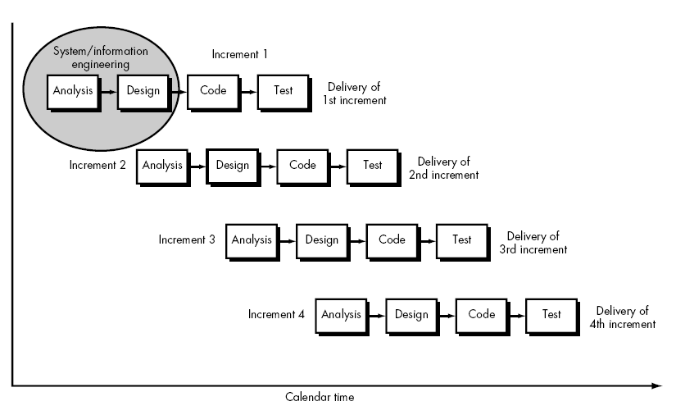

* + 1. **System Analysis**

It is the process of studying a procedure or business in order to identify its goal, purpose, to create systems and procedures that will achieve them in an efficient way. This step involves breaking down the system in different pieces and drawing to analyze the situation, analyzing project goal, breaking need to be created and attempting to engage users so that definite requirements can be defined.

* + 1. **System Design**

It involves defining of the architecture, modules, interfaces, and data for a system to satisfy specified requirements. Systems design could be seen as the application of systems theory to product development. The output of this stage will describe the system as a collection of modules or subsystems.

* + 1. **Coding**

After the above process we move to the main part that will be coding. It is the process that leads original formation of computing problem to executable computer programs. Modular and subsystem programming code will be accomplished during this stage.

* + 1. **Testing**

It is carried out at the end of process. The designed site will be tested to make sure that it works efficiently and satisfies user requirements. In this phase many processes of testing are carried out. Change may be found evitable in some cases which must be analyzed with precaution. Unit testing and module testing is done in this stage.

1. **List of Figures**

**Use Case**

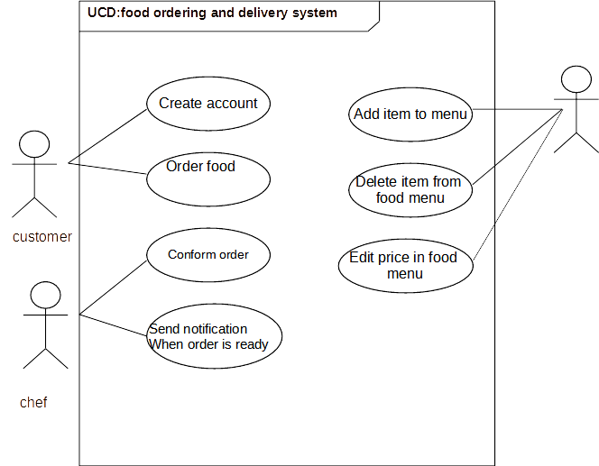

1. **Literature Study/Review**
2. Recommendation system as a core part of the project is seen to be implemented in lot of fields. Recommender systems like amazon.com (for books), moviefinder.com (for movies) are found.
3. **Tripadvisor.com** – It questions about product reviews of a community of users and suggest different location and hotel to user.
4. Alongside a recommender this project is also an informative site about different places in Nepal. Similar information providing sites like Lonely Planet, Trip Advisor are available but they are global portal and hence not specific for Nepal. They just have information about famous and most frequently visited placed but does not focus on places which need to be focused and explored. And as they are global portal they don’t aim specifically on Nepalese Tourism industry only. As an effort for making more specific, localized, and only for Nepal dedicated portal, we extended the idea to be more confined to Nepal. Thus we decided to make the system that give information about the local area of Nepal, which need to be explored.
5. **Project Task and Time Schedule**

**Time Allocation**

|  |  |  |  |  |  |  |
| --- | --- | --- | --- | --- | --- | --- |
| Weeks(W)  Tasks | W1 | W2 | W3 | W4 | W5 | W6 |
| Requirement Analysis  System Design  Coding  Testing and Debugging  Documentation |  |  |  |  |  |  |

Task completed

Task under processing

Fig: Time Distribution

**6. REFRENCES**

* Software Engineering: A PRACTITIONER’S APPROACH - Roger S. Pressmen
* <https://docs.mongodb.com/guides/>
* <https://www.google.com>