**Lab1 (20pts)**

Complete the problems listed below using python expressions. Each problem must be completed at the python interactive shell (IDLE). Submit a screen shot showing the command entered for each problem and the result of the command. The solutions for multiple problems can be captured in one screen shot. Compile and submit your screen shots into a word document (screen shots must be copied and pasted into the word document (**Submission with any other format will not be graded**). When submitting the word document, name your document as follows:

firstInitial_lastName_wk1_lab1.doc.

e.g. p_saweh_wk1_lab1.doc

1. Define a variable (intAge) and use 25 as the value of the variable (.5pt)
2. Write a python expression that creates a variable (strAge) which contains a string copy of intAge value (1pt)
3. Define a list (grades1) that contains 10 letter grades. The value of a letter grade can be A, B, C, D, or E. Display the items in grades1 (1pt)
4. Create a list, grades2, and populate it with the items from grades1 (.5pt)
5. Display the second to last value in grades2 (1pt)

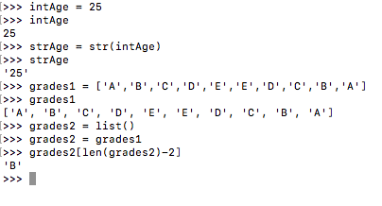

1. Use a constructor to create a float value, 50.99, and store the value in a variable (price). Display the value of price (1pts)
2. Create a float copy of the value stored in intAge and store it into a variable, fAge (1pt)
3. (5pts) Define a string variable (longWord) and set it to “Pseudopseudohypoparathyroidism”. Write Boolean expressions for the following:
   1. The first character of longWord is ‘p’
   2. The first and second to last characters of longWord are not the same
   3. The first 10 characters of longWord equal ‘Pseudooidsm’
   4. The last character of longWord is ‘m’ and it is not ‘P’
   5. The number of ‘s’ in longWord is four and the number of ‘s’ is less than the sum of the number ‘p’ and ‘a’ in longWord **(use one expression)**
4. Write an expression that stores a substring (first 15 characters) of longWord in a variable shortWord (1pt)
5. Write a Boolean expression for the following (2pts):
   1. The remainder of dividing the product of 100, 5, and 3 by 7 is not the same as the square of the sum of the values in lst divided 10

lst = [3, 5, 7, 6]

**Note:** Use one expression for this problem

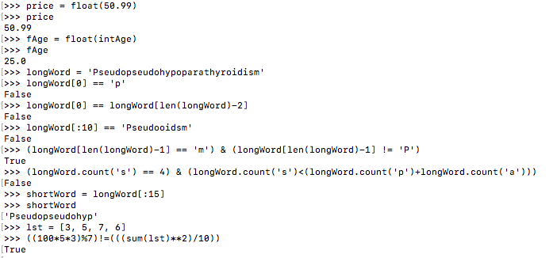

1. Use one of python’s built-in functions to add the values stored in prices. (1pt)

prices = [2.5, 11.99, 13.99, 6.25, 0.99, 24.96]

1. Create a list, subPrices, and populate it with the second, third, and fourth items from prices (1pt)
2. Write an expression that replaces ‘eudohypop’ in longWord with ‘udoehyppo’ . Explain why the expression executed successfully or why it did not execute successfully . (1pts)
3. Write python **expressions** that set the second item in prices to 12.99 and the last item to 1.99 (1pt). Use negative index
4. Write a Boolean **expression** that checks whether the second item in prices is the same as the second item in subPrices or is the fourth item in prices higher than the last item in subPrices. **One expression must be used for this problem (2pts)**

