**Folder Structure Overview:**

1. **Controllers**: Contains API controllers responsible for handling HTTP requests.
2. **Data**: Contains database context and configurations.
3. **DTOs (Data Transfer Objects)**: Contains classes for transferring data between layers.
4. **Migration**: Contains Entity Framework Core migrations.
5. **Models**: Contains entity classes that map to database tables.
6. **Repositories**: Contains repository interfaces and their implementations for data access logic.
7. **Services**: Contains business logic and service classes.
8. **Database** : Contains the tables

**Architecture Diagram**

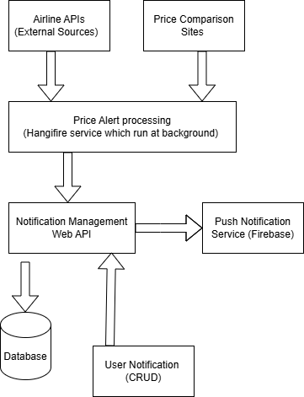

**API Details**

