
Department of Computer Science and Engineering

DAA Project
General State Space Search Framework
Session: Jan-May 2017

PROJECT BY
Shardul Singh - 01FB15ECS276
Shreyas G Miraj - 01FB15ECS285
Shreyas V Patil - 01FB15ECS286
SEMESTER & SECTION : IV – E
ACKNOWLEDGEMENT

We would like to thank Sir for his valuable input and providing us with the necessary help and direction without which we would not have been able to complete this project. His thoughts and ideas helped us improve upon our project and its implementation.

General Framework for solving State Space Search Problems

AIM - To create a general framework for solving state space search problems.

Introduction

State space search is a process used in several fields of computer science to find solutions to problems with a given set of states, with known initial and final states, and a set of transition rules between states that allow the program to move from one state to another upon meeting certain conditions.
By creating a general framework, we hope to use our program to demonstrate solving a few well known problems such as the n-queens problem, 8 puzzle,.

Implementation

The above program is created in C programming language. A simple graph theory approach is taken in creation of the software, using concepts such as breadth first/depth first searching of graph nodes, and the program illustrates how many analytical problems can be solved by systematically searching through all possible paths of states that can be taken to achieve a final state, if at all possible.
It uses breadth first through a FIFO Queue. The Queue does not accept repeated states (to avoid infinite loops). The Queue stores nodes of the search tree and so when a solution is found it can print out the solution by tracing rear up the tree to the first NODE. This lends itself to a recursive display algorithm.

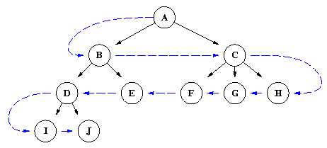

Every unexpanded node is present at front of the queue .Its possible and problem constraint satisfying states are generated. If no they are not already present in queue then they are added. Then the front points to next state in the queue and it goes on until either a solution is found which indicated by queue becoming empty.

APPLICATIONS

The applications of this program can be very widespread, since this base code can be used in a variety of application, including and not exclusive to artificial intelligence problem solving (e.g. Chat bots, maze solving) and game design.

