**A Project Report**

**On**

**ECO-FRIENDLY STATIONERY ITEMS**

**Presented By:**

**Amrita Sutar 210543181007**

**Bhushan Chaudhari 210543181015**

**Rohan Patil 210543181063**

**Shubham Patil 210543181065**

**Guided By,**

**Mrs.Harshita**

**ACKNOWLEDGEMENT**

This project “ECO-FRIENDLY STATIONERY ITEMS” was truly a great learning experience for us and we are submitting this work to Infoway Technologies Pvt Ltd : Advanced Computing Training School. We are very glad to mention Mrs. Harshita for her valuable guidance to work on this project. Her guidance and support helped us to overcome various obstacles and intricacies during the course of project work.

Our heartfelt thanks goes to Mrs. Ulka Joshi, our Course Coordinator, E-DAC who gave all the required support and kind coordination to provide all the necessities.

**From,**

Amrita Sutar 210543181007

Bhushan Chaudhari 210543181015

Rohan Patil 210543181063

Shubham Patil 210543181065

**Introduction:**

This system is named as Eco-Friendly Stationary items. This system is made to keep in mind that user can buy eco-friendly stationary via online mode. The admin can manage only his account and also can manage website for checking items availability on website, the registered user like admin, consumer can only manage his own account for buying these items. This system helps in maintaining the balance of the nature somehow and consumer can get these eco-friendly items easily.

A different module is there for admin to check the customers details if their job requires. Admin and consumer all have a different interface and different privileges according to their need.

Like a consumer can only manage his account and cannot see any details of other consumer, admin can see the details of all the consumer’s accounts and admin can manage all the accounts of the consumer.

This system also has the feature to delete consumer’s account in case a consumer never logged in or not purchased any product since long period of time as admin can see date when customer registered.

**Implementation Technologies:**

1. **Spring Boot Framework:**

Spring Boot is a project that build on the top of Spring Framework. It provides an easier and faster way to set up, configure, and run both simple and web-based applications.

It is a Spring Module that provides the RAD (Rapid Application Development) feature to the Spring Framework. It is used to create a stand-alone spring based application that we can just run because it needs minimal spring configuration.

**1.1 Features of Spring Boot Framework:**

* **Web Development:**

It is well suited module for web application development. We can easily create a self-contained HTTP server using embedded servers like Tomcat.

* **Spring Application:**

It is a class which provides the convenient way to bootstrap a spring application which can be started from main method. We can call start our application just by calling a static run() method.

* **Application Events and Listeners:**

Spring Boot uses events to handle variety of tasks. It allows us to create factories file that are used to add listeners. We can refer it by using Application Listener key.

* **Admin Support**

Spring Boot provides the facility to enable admin related features for the application. It is used to access and manage application remotely. We can enable it by simply using spring.application.admin.enabled property.

* **Properties Files**

Spring Boot provides rich set of Application Properties. So, we can use that in properties file of our project. Properties file is used to set properties like: server.port = 8080 and many others. It helps to organize application properties.

* **Logging**

Spring Boot uses Common logging for all internal logging. Logging dependencies are managed by default. We should not change logging dependencies, if there is no required customization is needed.

* **Security**

Spring Boot applications are spring based web applications. So, it is secure by default with basic authentication on all HTTP endpoints. A rich set of Endpoints are available for develop a secure Spring Boot application.

**1.2 Advantages of Spring Boot Framework:**

**1. It creates stand-alone Spring applications that can be started using Java -jar.**

**2. It tests web applications easily with the help of different Embedded HTTP servers such as Tomcat, Jetty, etc. We don't need to deploy WAR files.**

**3. It provides opinionated 'starter' POMs to simplify our Maven configuration.**

**4. It provides production-ready features such as metrics, health checks, and externalized configuration.**

**5. There is no requirement for XML configuration.**

**6. It offers a CLI tool for developing and testing the Spring Boot application.**

**7. It offers the number of plug-ins.**

**8. It also minimizes writing multiple boilerplate codes (the code that has to be included in many places with little or no alteration), XML configuration, and annotations.**

**9. It increases productivity and reduces development time.**

* 1. **Hibernate**

Hibernate is a Java framework that simplifies the development of Java application to interact with the database. It is an open source, lightweight, ORM (Object Relational Mapping) tool. Hibernate implements the specifications of JPA (Java Persistence API) for data persistence.

* **ORM Tool:**

An ORM tool simplifies the data creation, data manipulation and data access. It is a programming technique that maps the object to the data stored in the database. The ORM tool internally uses the JDBC API to interact with the database.

* **JPA:**

Java Persistence API (JPA) is a Java specification that provides certain functionality and standard to ORM tools. The javax.persistence package contains the JPA classes and interfaces.

**1.4 MySQL**

MySQL, the most popular Open Source SQL database management system, is developed, distributed, and supported by Oracle Corporation.

* 1. **.1 Features of MySQL:**
* **MySQL is a database management system.**

A database is a structured collection of data. It may be anything from a simple shopping list to a picture gallery or the vast amounts of information in a corporate network. To add, access, and process data stored in a computer database, you need a database management system such as MySQL Server. Since computers are very good at handling large amounts of data, database management systems play a central role in computing, as standalone utilities, or as parts of other applications.

* **MySQL databases are relational.**

A relational database stores data in separate tables rather than putting all the data in one big storeroom. The database structures are organized into physical files optimized for speed. The logical model, with objects such as databases, tables, views, rows, and columns, offers a flexible programming environment.

* **MySQL software is Open Source.**

Open Source means that it is possible for anyone to use and modify the software. Anybody can download the MySQL software from the Internet and use it without paying anything.

* **The MySQL Database Server is very fast, reliable, scalable, and easy to use:**

MySQL Server was originally developed to handle large databases much faster than existing solutions and has been successfully used in highly demanding production environments for several years. Although under constant development, MySQL Server today offers a rich and useful set of functions. Its connectivity, speed, and security make MySQL Server highly suited for accessing databases on the Internet.

* **MySQL Server works in client/server or embedded systems:**

The MySQL Database Software is a client/server system that consists of a multithreaded SQL server that supports different back ends, several different client programs and libraries, administrative tools, and a wide range of application programming interfaces (APIs).

1. **Technology Used**

* **Back End:**

Framework Spring Boot

ORM Tool Hibernate

Database MySQL

Build Tool Maven

Language Java

* **Front End:**

HTML

CSS

JavaScript

Bootstrap

1. **Architecture Diagram:**

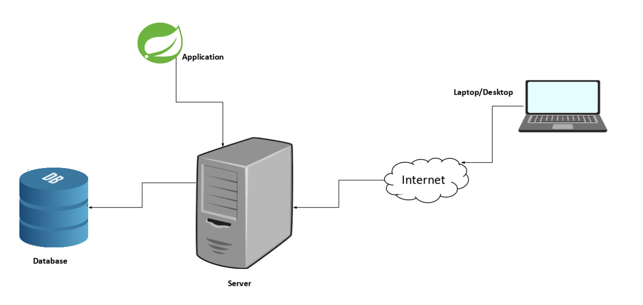

**Figure 1: Architecture Diagram**

1. **ER Diagram:**

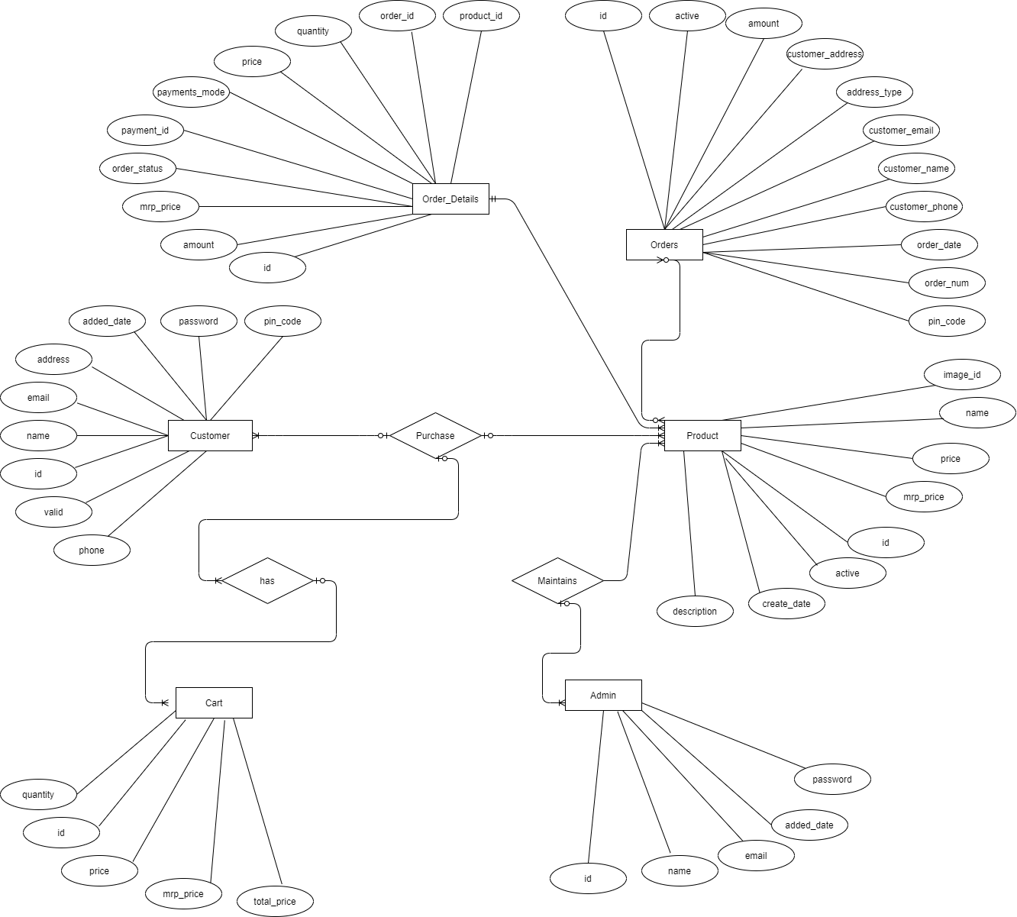

Figure 2: ER Diagram

1. **Database Tables:** 
   1. **Admin Table :**

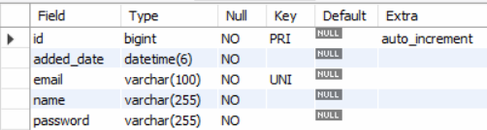

* 1. **Customer Table :**

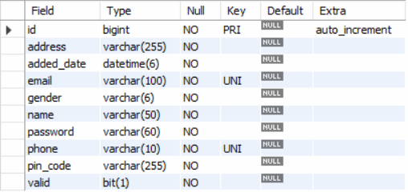

* 1. **Cart Table :**

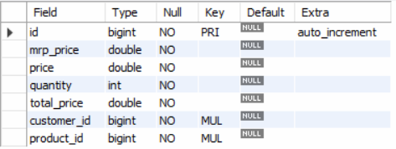

* 1. **Products Table :**

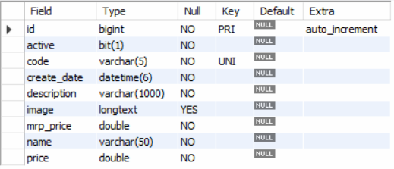

* 1. **Order Table:**

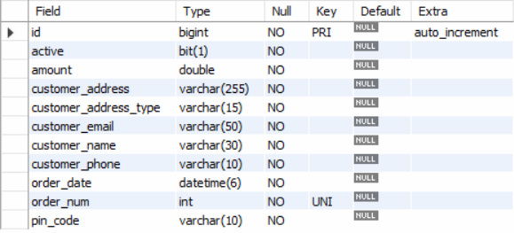

* 1. **Order_Details Table:**

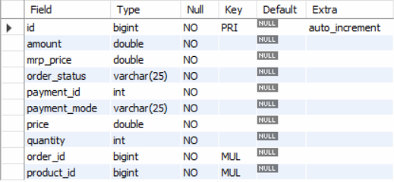

* 1. **Contact Table:**

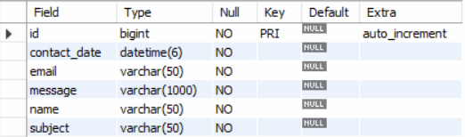

1. **UML Diagrams:**

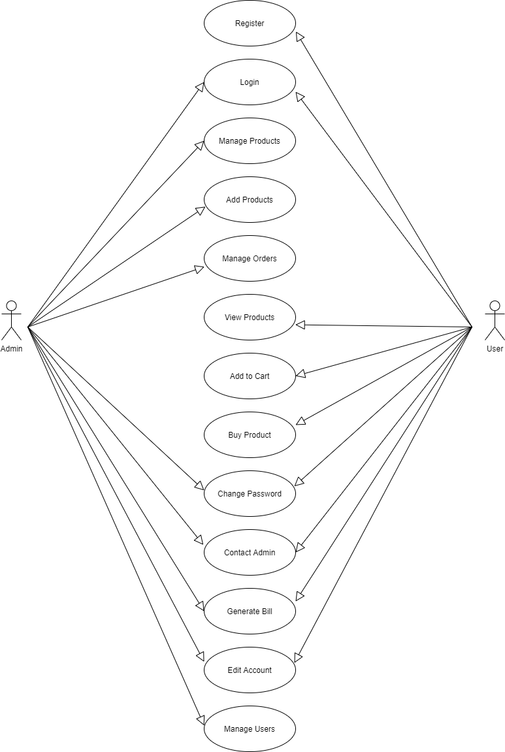

Figure 3: Use Case Diagram

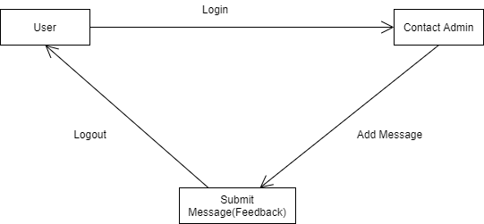

Figure 4: Collaboration Diagram

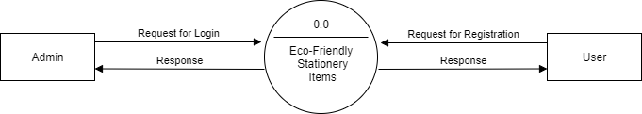

**Figure 5: DFD Diagram**

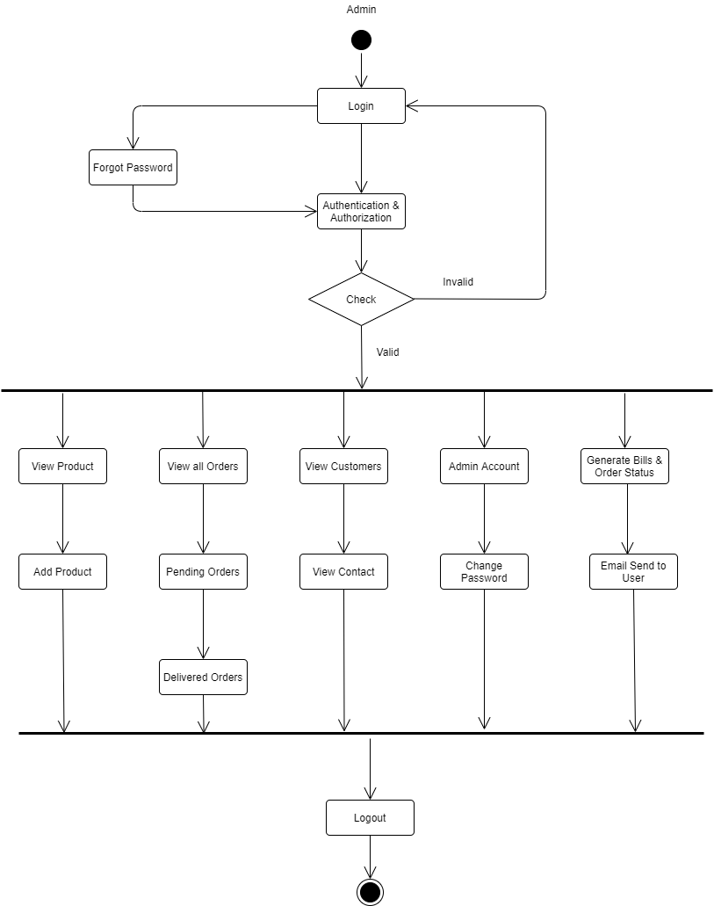

Figure 6: Admin Activity Diagram

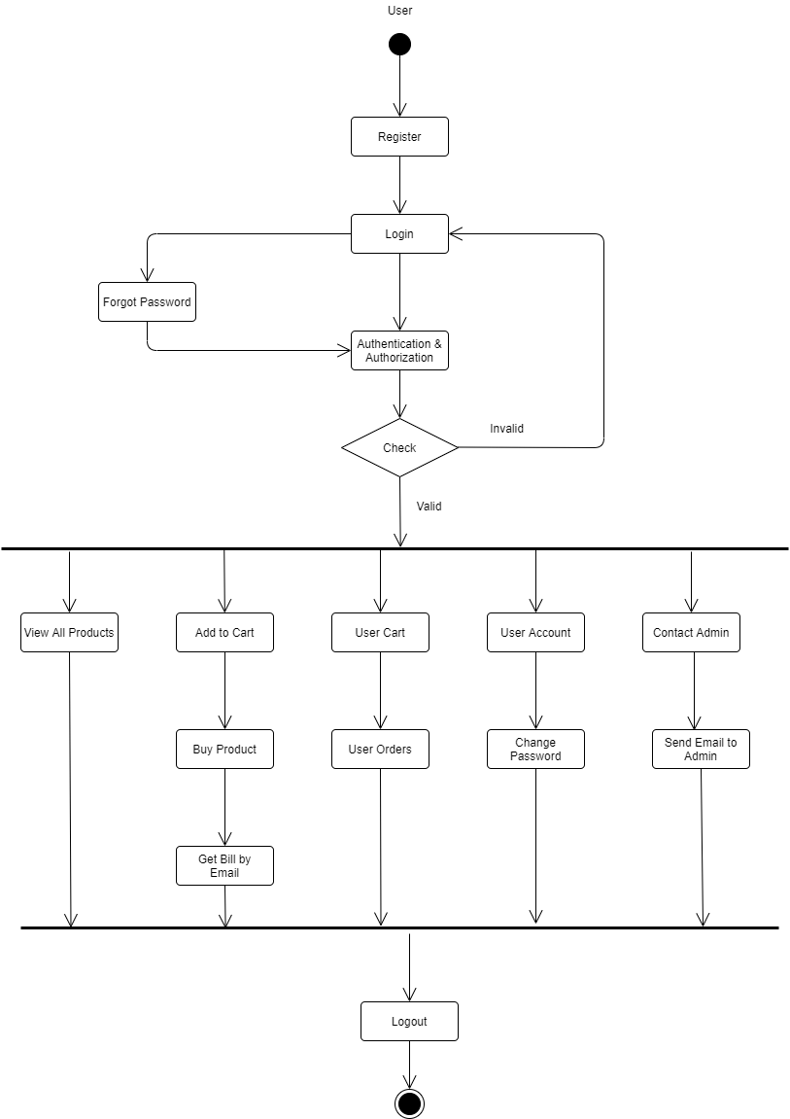

Figure 7: User Activity Diagram

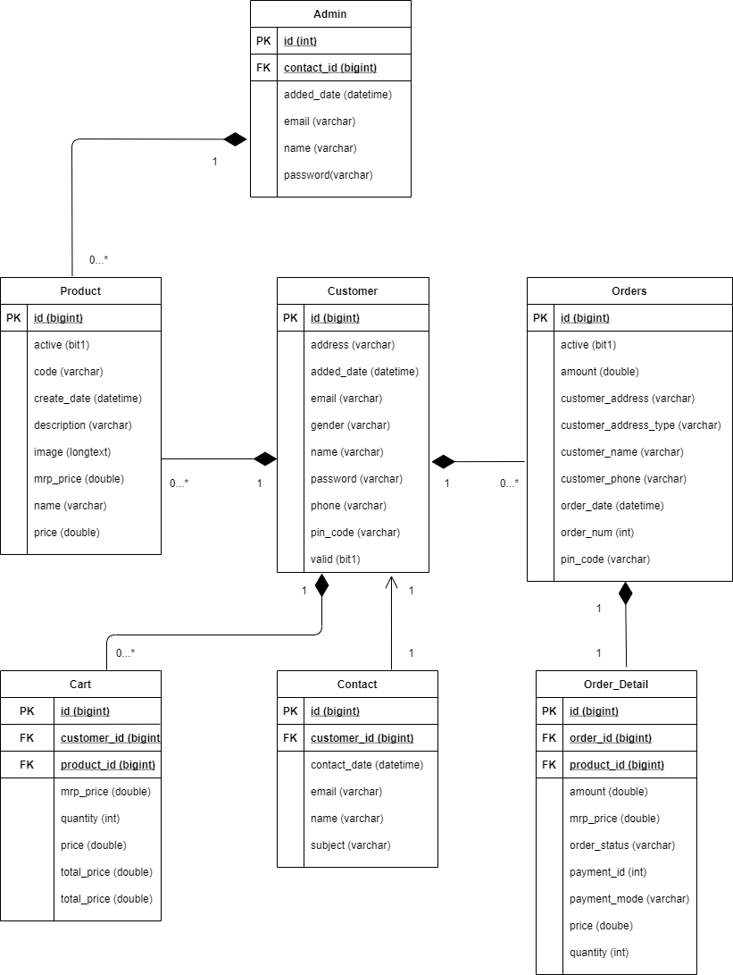

Figure 8: Class Diagram

1. **End to End Flow of Application:**

* **Admin: Mainline Sequence**

**1. Admin:** Enter Admin Email-Id and Password.

**2. System:**

1. Display the Admin Home page where admin can see top 10 pending orders and can

Change status of orders.

2. Admin can add products, view products and change the status of product to

Active-Inactive.

3. View number of consumers and can delete them.

4. View list of users who contacted.

5. Can update Admin account, change password.

6. Can see delivery, payment report by searching particular order Id.

* **User: Mainline Sequence**

**1. Customer:** Enter consumer Email-Id and Password

**2. System:**

1. Display the User Home page where consumer can see first 8 products and all

available products on All Products tab.

2. View information about store and can contact to Admin.

3. Can update User account, change password.

4. Consumer can view products added in cart, buy products and view all orders history.

**8. Future Scope of Project:**

The scope of the proposed system is to provide best possible web application for user to buy these available eco-friendly stationery items.

In future we are going to provide or available daily needed products for users as per their requirements.

The objective behind this system is to invent a system widely acceptable for buying eco-friendly products which are rarely known to users or easily not available.

We are recommending, bring awareness among people to use these environment friendly products through Social Media Marketing.

We are going to add online payment gateway in future, currently this system only works on COD payment method.

**9. Conclusion:**

This software has large variety of handpicked eco-friendly stationery items. The User Interface of it is very friendly and can be easily used by anyone. It also decreases the amount of time to find this rarely available stationery items and user can buy this items at their door steps. Thus, it saves human efforts and resources.

**10. References**:

1. www.w3school.com

2. https://www.uniformjunction.com/search/eco%20friendly%20stationary

3. https://docs.oracle.com/en/java/javase/16/docs/api/index.html

**Thank You!**