1. Install Device Explorer
   1. Device Explorer: <https://github.com/Azure/azure-iot-sdk-csharp/tree/master/tools/DeviceExplorer>
   2. Download MSI: <https://github.com/Azure/azure-iot-sdk-csharp/releases>

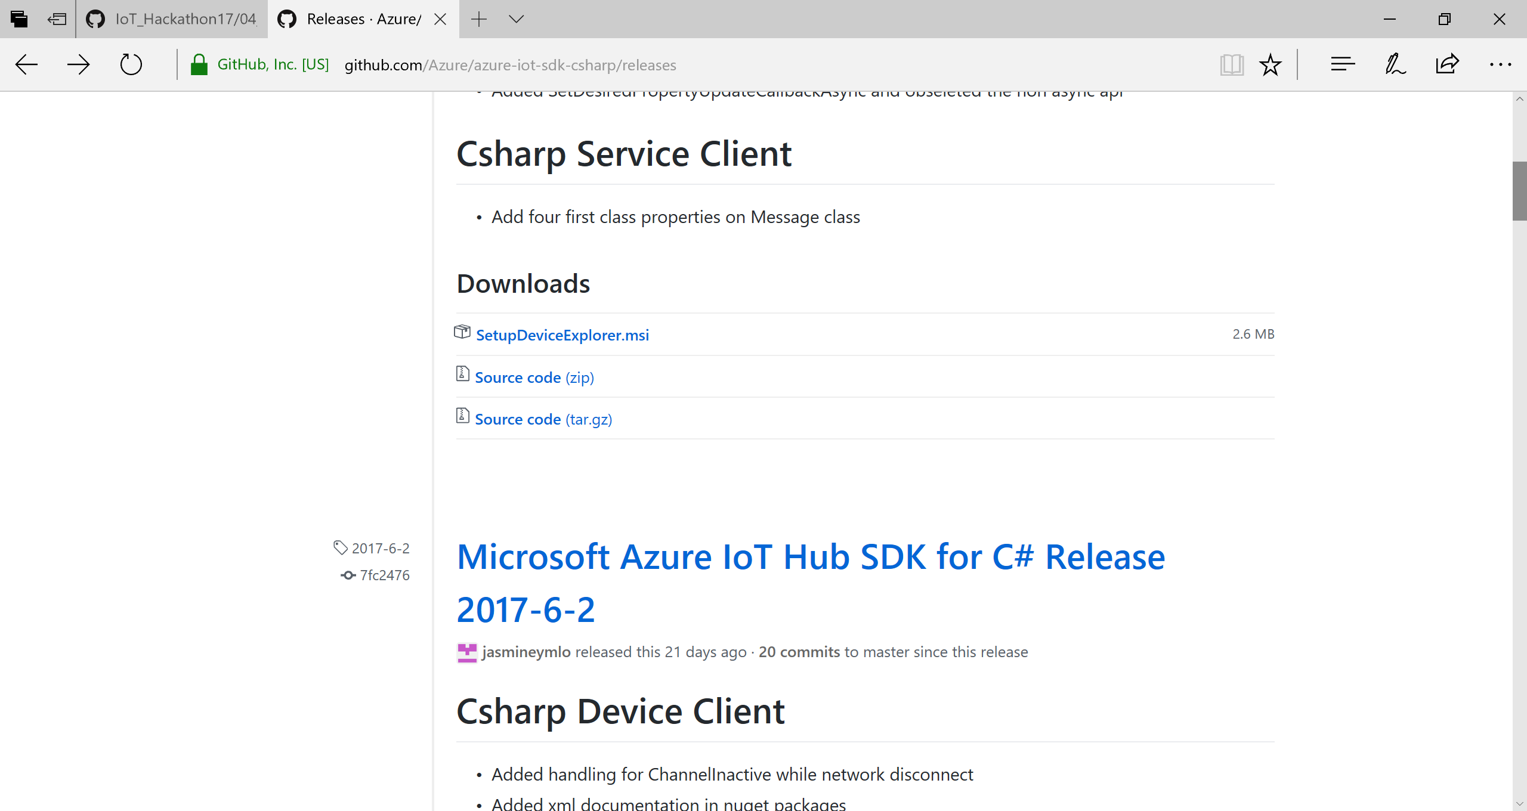

1. Open <http://portal.azure.com>
2. Select your MSDN Subscription as per below:

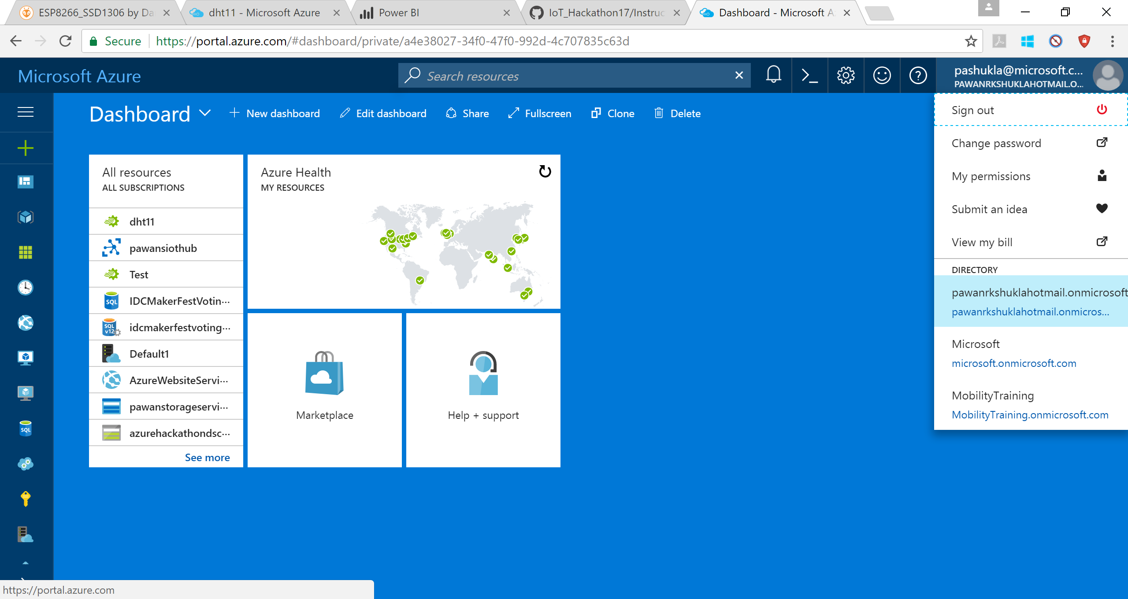

1. Create IoT Hub
   1. Click on + icon put “iot Hub” in search box and click on “IoT Hub”
   2. Click on “Create” as per below 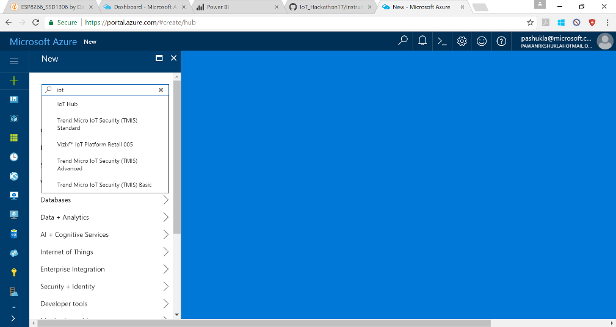
   3. 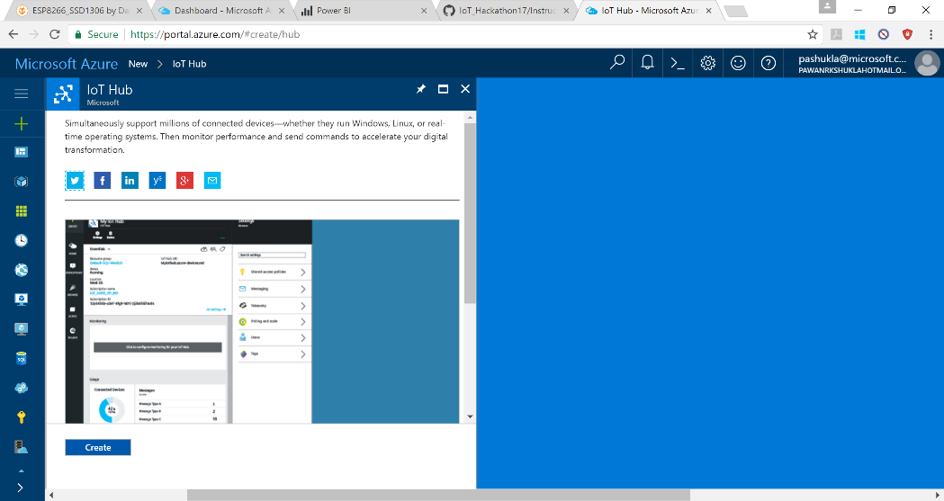Select Any IoT Hub name (1) and Pricing Tier (2)
   4. 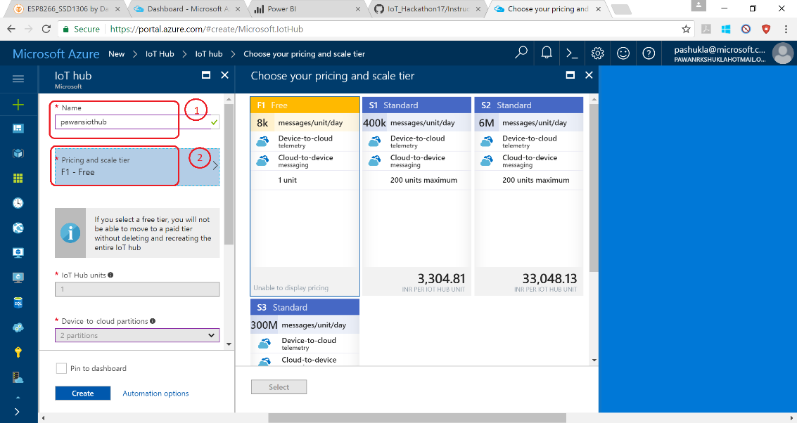Select Subscription (3) and create/select Resource group (4) and Click Create:

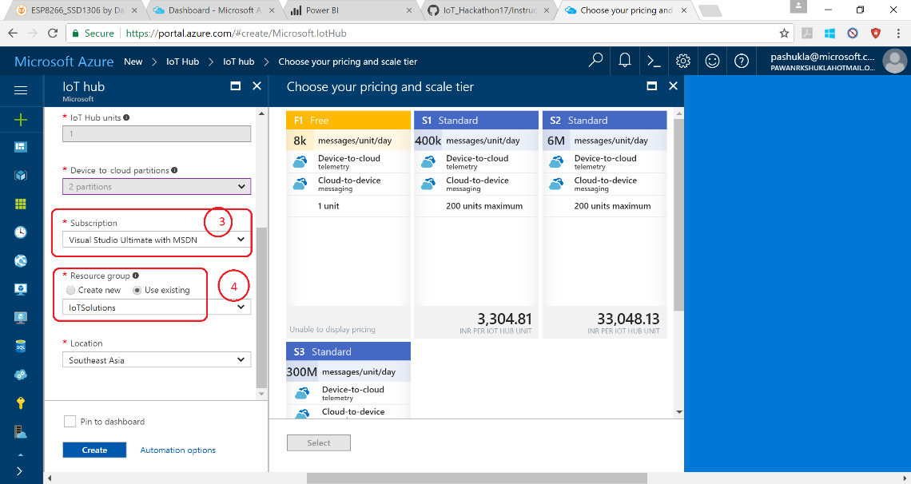

* 1. Deployment Successful:

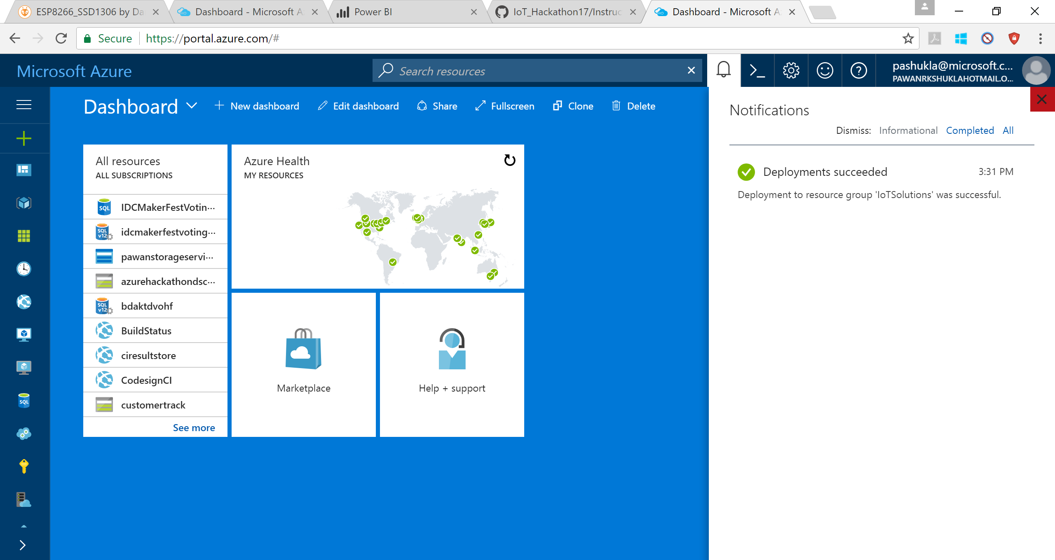

* 1. Go to new IoT Hub

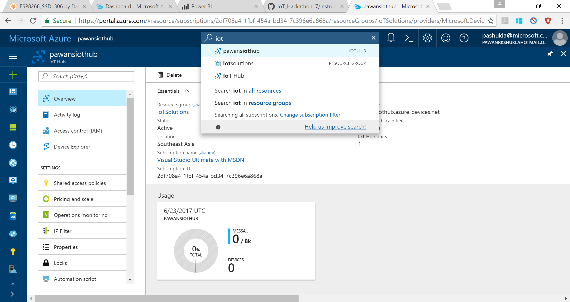

1. Create Devices
   1. Click on Device Explorer (1) and click Add (2)

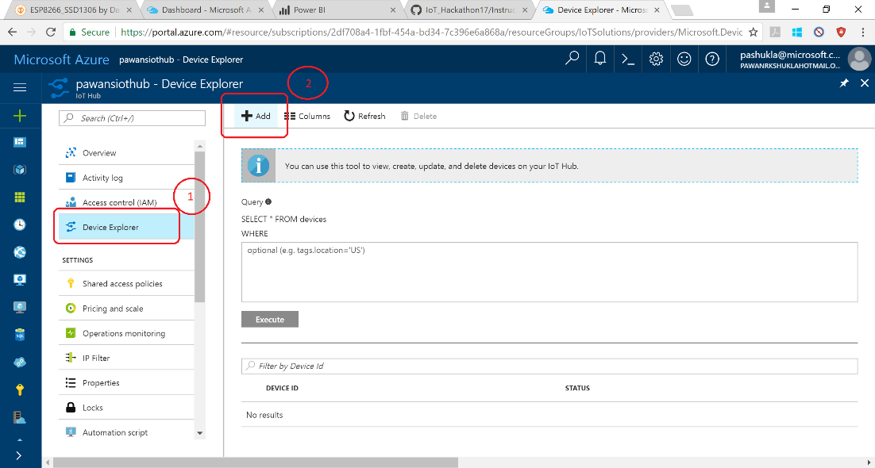

* 1. Give Device Id (1) and Save (2)

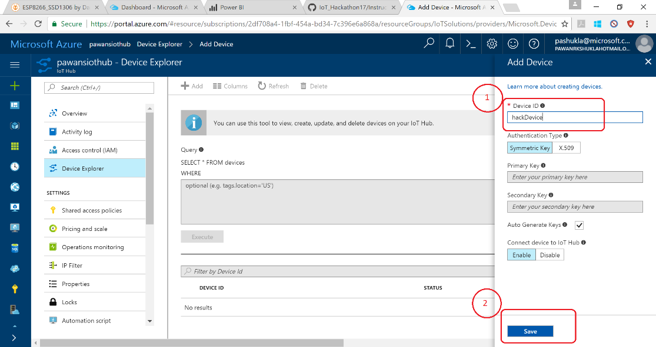

1. Get Shared Access Signature (SAS)
   1. Device Explorer <https://github.com/Azure/azure-iot-sdk-csharp/tree/master/tools/DeviceExplorer>
   2. Download: <https://github.com/Azure/azure-iot-sdk-csharp/releases>



* 1. Get IoT Hub Connection string

Click in Sequence: (1)> (2) > Copy connection string – primary key (3)

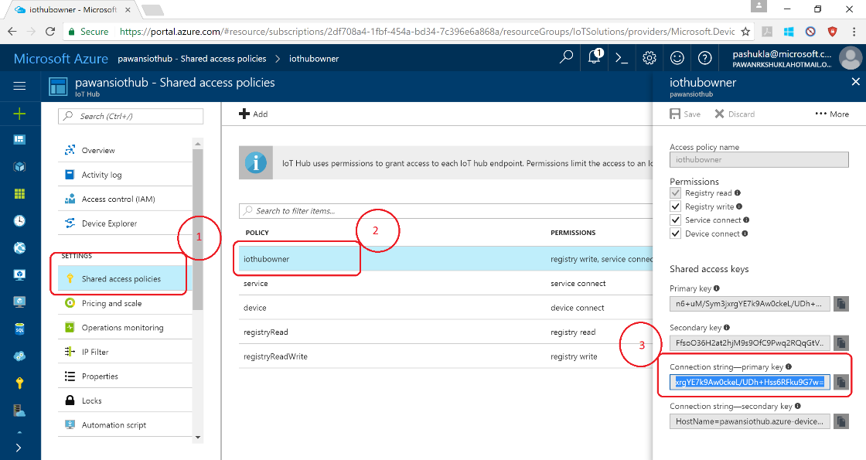

* 1. Follow Sequence
     + 1. Select tab
       2. Past connection string -primary
       3. Click update
       4. Click Generate SAS
       5. Copy SAS

