CW2 : Object detection task

**Subtask1 :** **The Viola-Jones Object Detector**

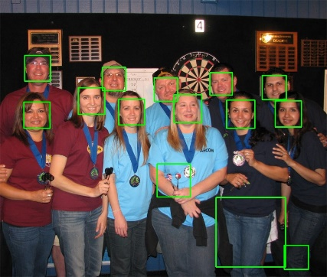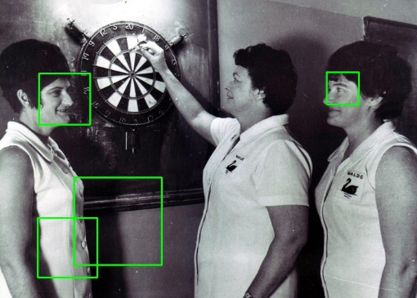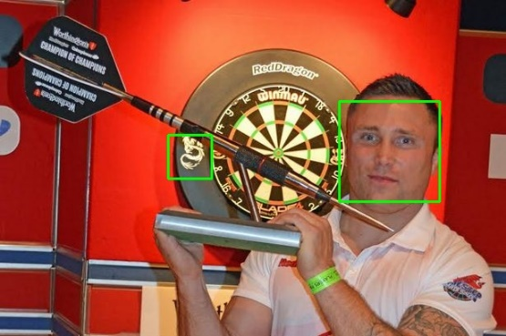

Figure 1 : face detectors of picture 4,5,13,14,15

These five pictures are detected using frontalface.xml.The TPRS of picture 5 and 15 are calculated by following:

TPR = TP/TP+FN Dart5 : TPR = 1; Dart15:TPR = 0.6667 The difficulty during calculating TPRs is it is hard to determine which is true positive. It is hard to decide if it is the positive one when a bound box is drawn around a part of face. And the reason why it is challenging for computer is that the colours of skin, facial expressions, light .etc, which have great impact on the accuracy of detection.

It is always possible to achieve a 100% TPR because the Viola-Jones face detector always can identify every part of the image such that every object is detected. But the accuracy may be low , eg, some non-facial parts also marked as face, which leads to high false positive rate(FPR). A better detector should have 100% TPR and low FPR.

There are several rules created in order to calculate F1 score: 1.A face only considered valid only if the mouth and eyes are visible and it must be a human face. 2.The bound box must circle out the eyes and the mouth fully and the size of box cannot be larger than 1.5x dimensions. F1 score can be calculated using formula: F1 = 2TP/(2TP+FN+FP) -> dart15 : F1 = 0.57; dart 5 : F1 = 0.88 We can also use ground truth to ensure true positive by calculating the overlap area between detected faces and setting ground truth.

**Subtask2 :** **Building & Testing your own Detector**

|  |  |  |
| --- | --- | --- |
|  | TPR | FPR |
| Stage 0 | 1 | 1 |
| Stage 1 | 1 | 0.0187 |
| Stage 2 | 1 | 0.00151 |

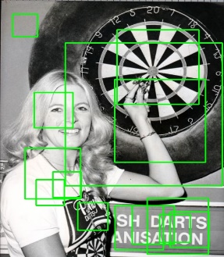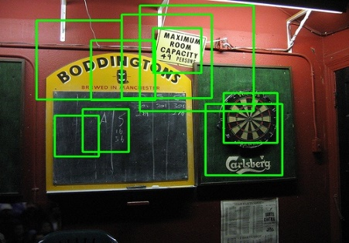There are three different stages during training. TPR and FPR is shown in the following table. In training process, only positive images are used so that all TPRs are 1 which means all objects are detected. At stage 0, all pictures are classified as positive so that FPR is 1. At stage 1 and 2, only few of negative images are classified as positive, thus the FPR is low. The accuracy is improved stage by stage during training and finally a classifier is generated, cascade.xml. And following images use this classifier to detect.

Table 1 : TPR and FPR in training

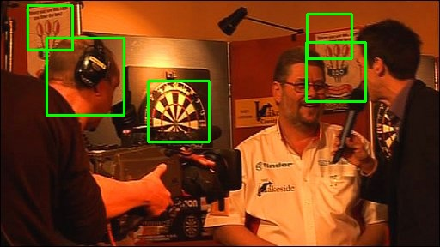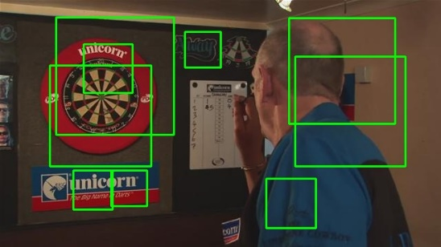

Figure 2: detectors using cascade.xml

The F1 score of all testing images are calculated below. F1 score looks at more factors ,thus it is more important in measuring the performance.

As shown in the table, F1 score is low, because many non-darts areas are detected as dart as well. And the TPR in testing data is lower than it in training data(high FPR).Even though there is high accuracy of classifier in training data due to table 1,but it cannot ensure high performance in testing data.

|  |  |  |  |
| --- | --- | --- | --- |
|  | F1 Score |  | F1 score |
| Dart1 | 0.18 | Dart9 | 0.142 |
| Dart2 | 0.2 | Dart10 | 0.113 |
| Dart3 | 0.2 | Dart11 | 0.33 |
| Dart4 | 0.095 | Dart12 | 0.2 |
| Dart5 | 0.11 | Dart13 | 0.18 |
| Dart6 | 0 | Dart14 | 0.068 |
| Dart7 | 0.045 | Dart15 | 0.25 |
| Dart8 | 0.041 |  |  |

**Subtask3 :** **Integration of shape detectors**

