# Online Music Store

Contents

Online Music Store 1

Functionalities 2

Logins 2

Pages and Flow 2

Administrator role page flow 2

User role page flow 9

## Functionalities

1. Home Page/Landing Page
2. Login Page with logout functionality
3. Product List Page
4. Shopping Cart page
5. Add Products page

## Logins

Role: Administrator

Username: admin  
Password: admin

Role: User

Username: user1  
password: pass1

Username: user2  
password: pass2

Username: user3  
password: pass3

## Pages and Flow

### Administrator role page flow

Home Page/Landing Page before login by administrator: Login icon is displayed at the top right

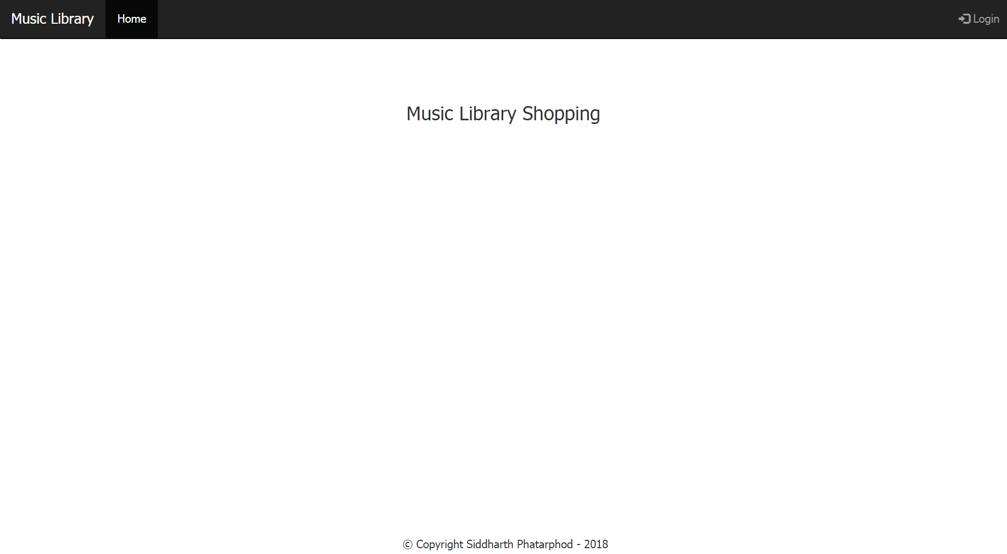

Login Page: Administrator must enter his username and password and click on Login button.

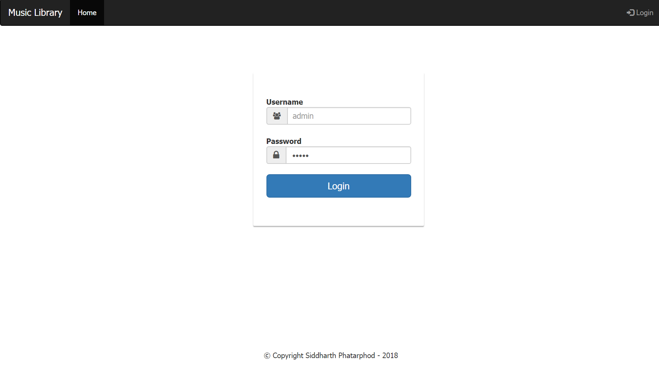

Wrong username/password displays appropriate message:

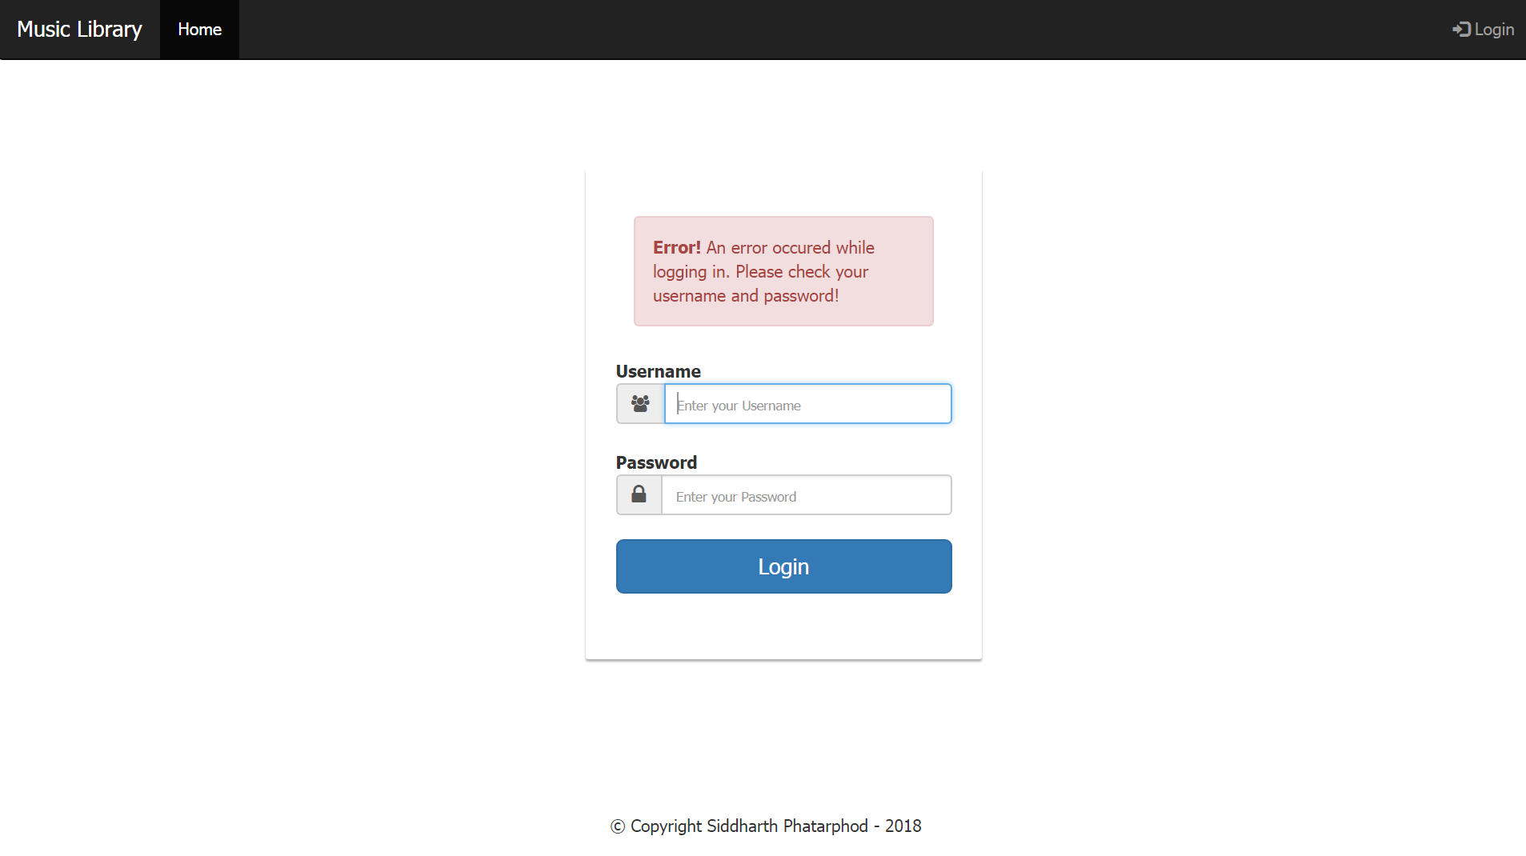

Blank username/password followed by login button click also displays the appropriate message:

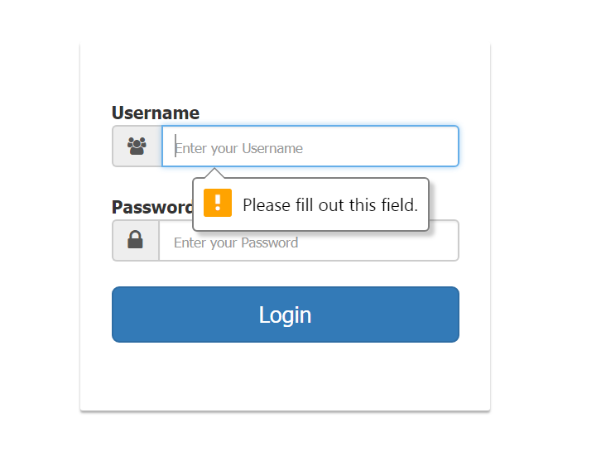

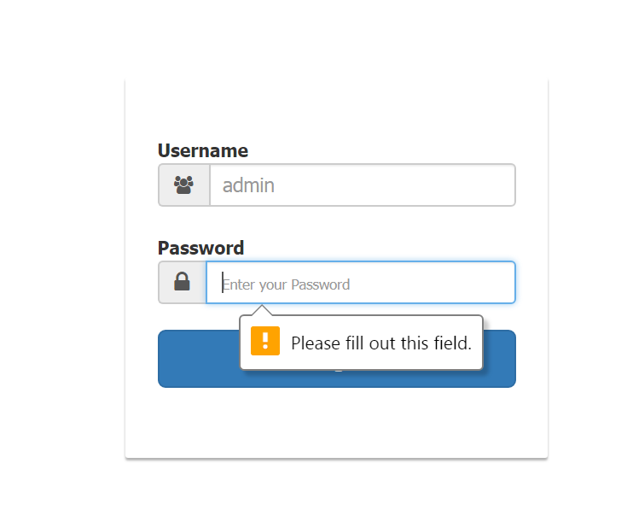

Home Page/Landing Page after login by administrator: Successful login by admin takes administrator to the home page/landing page. Welcome username message and Logout icons are displayed at the top right.

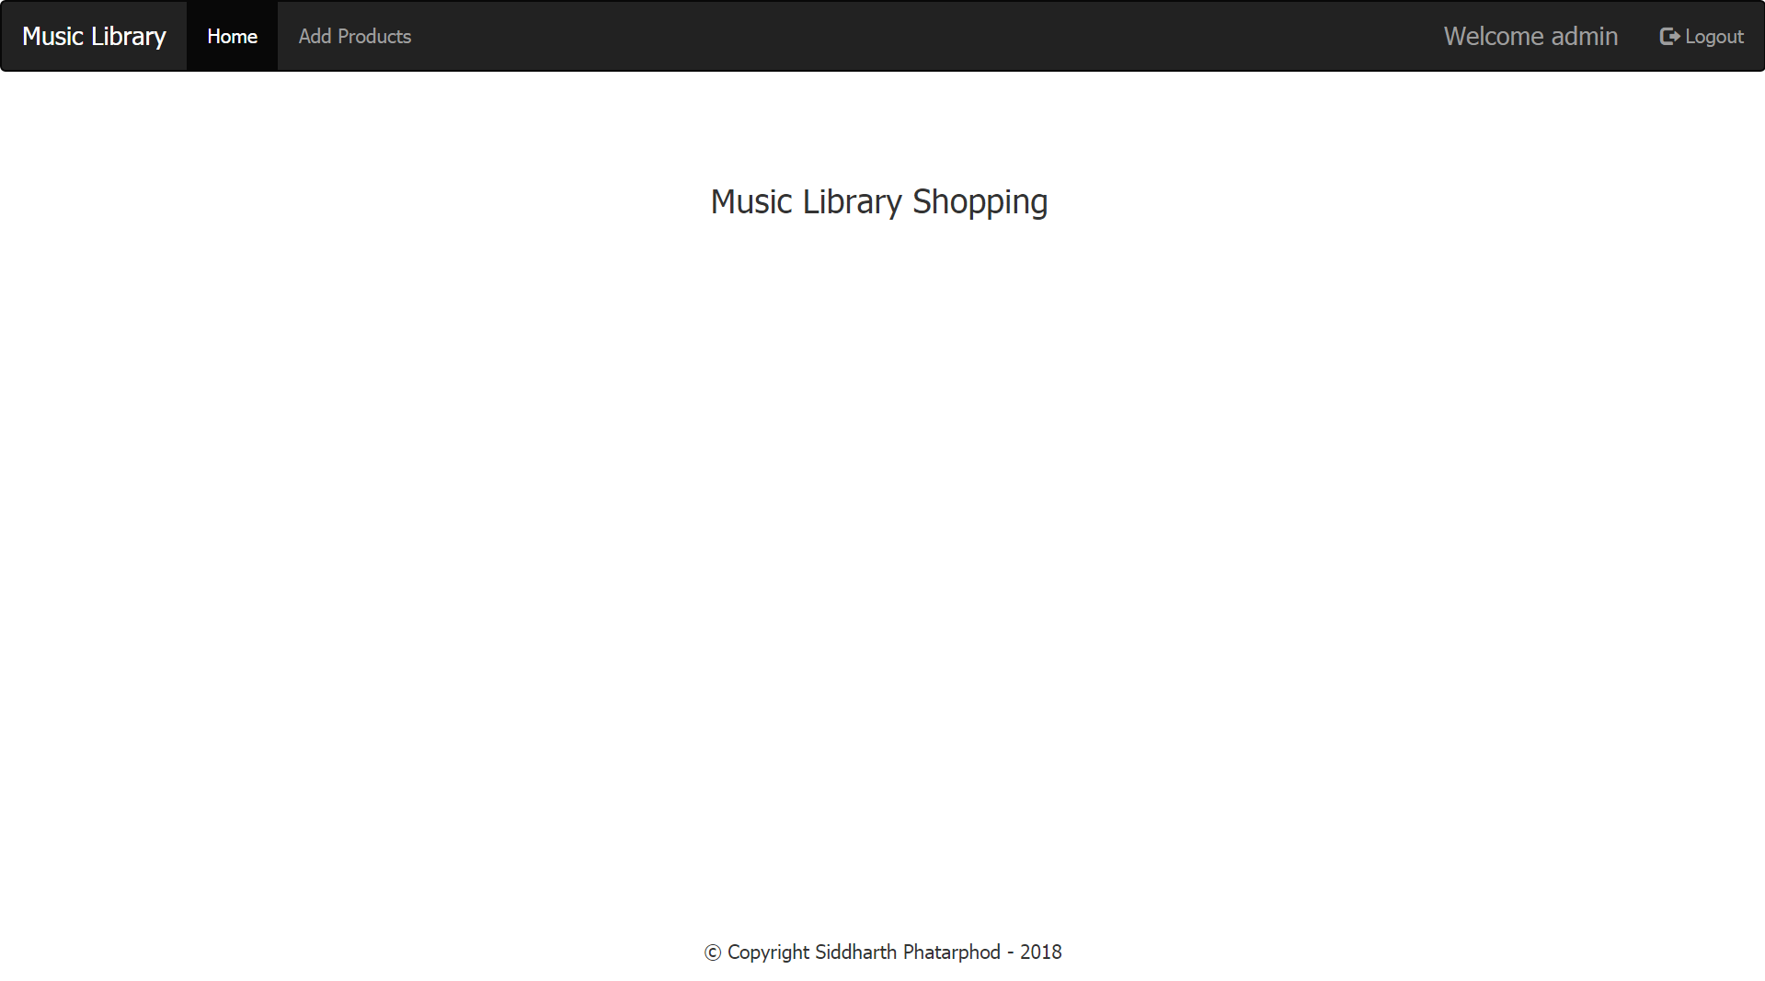

Add Products page available only to administrator: Admin can add new tracks and delete existing ones from the list available on the same page.

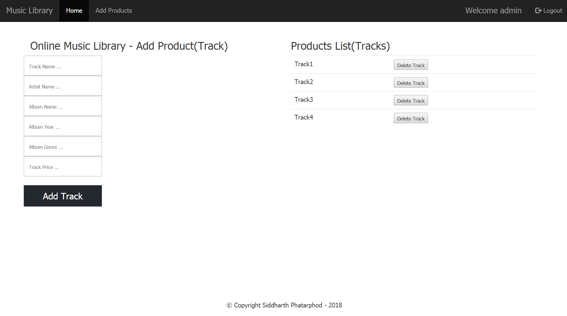  
Fields are mandatory with max lengths set. In case a field is left blank an appropriate message is displayed.

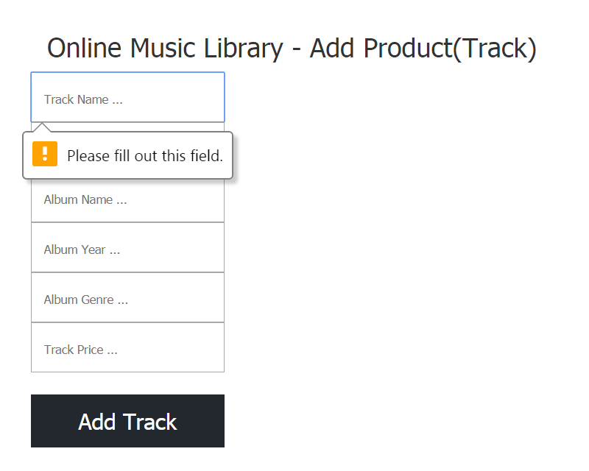

Delete Track functionality: Admin must confirm track deletion for the track to be deleted, after which track gets deleted successfully

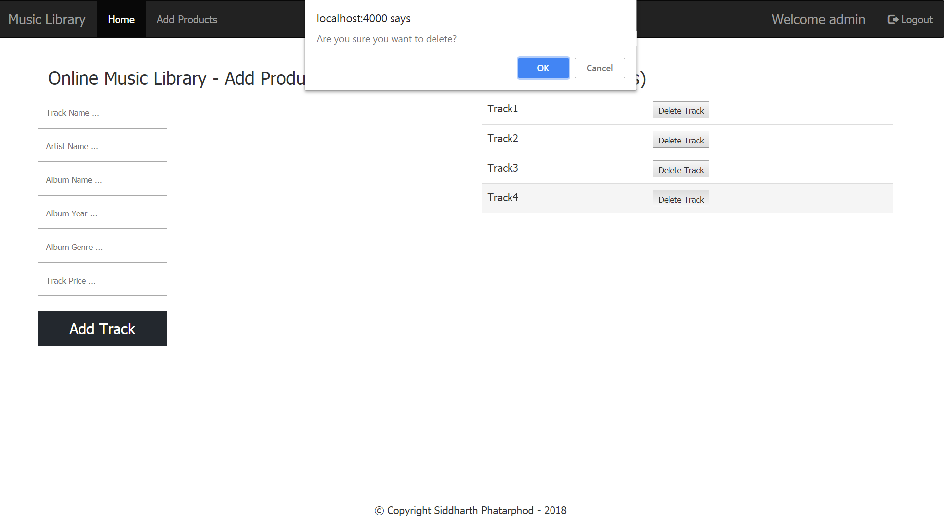 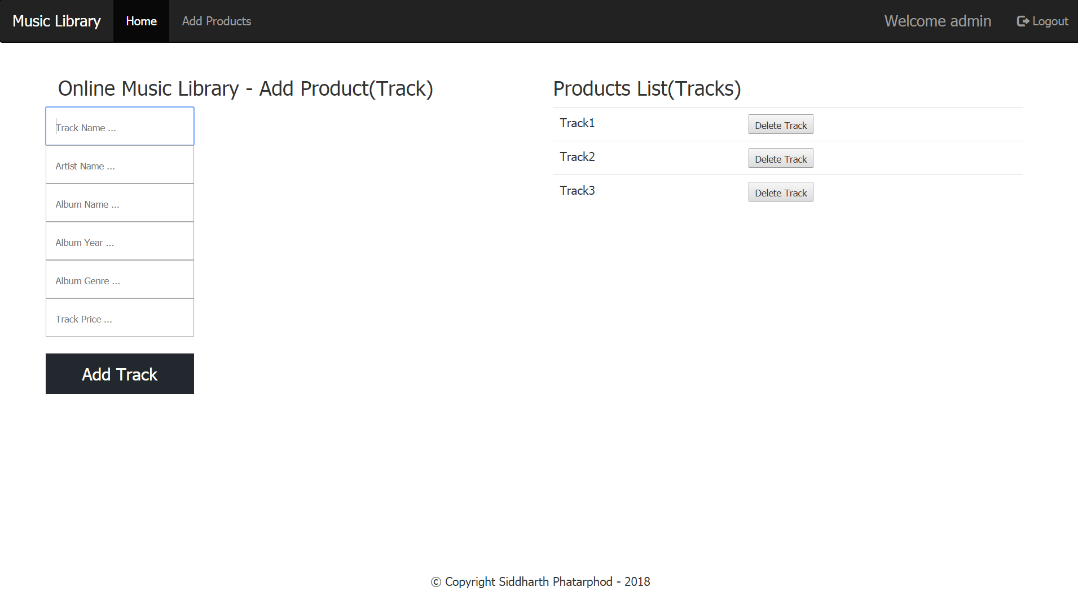

Logout functionality: Clicking on the logout icon/link logs out the admin and you are redirected to the Home Page/Landing Page.

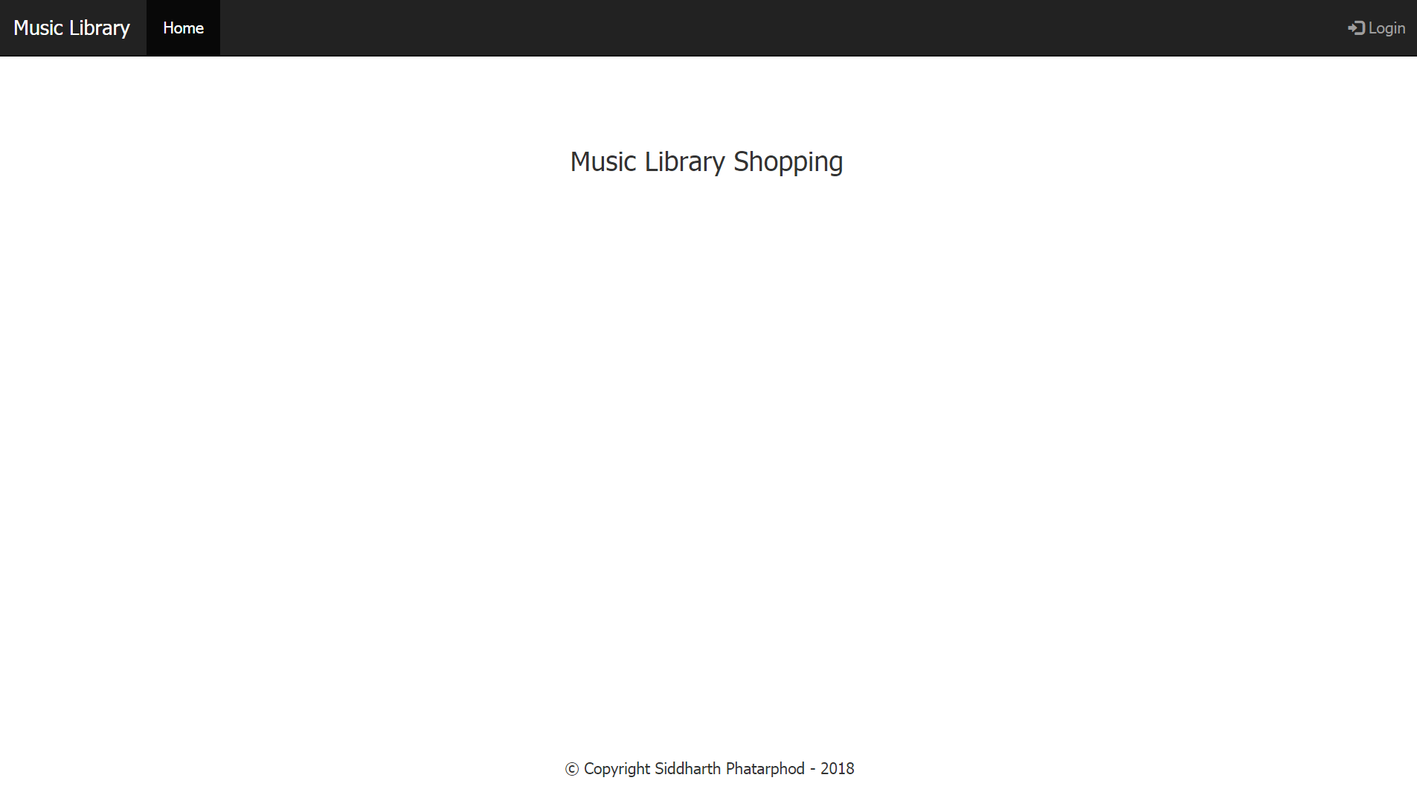

### User role page flow

Home Page/Landing Page before login by administrator: Login icon is displayed at the top right



Login Page: User must enter his username and password and click on Login button.

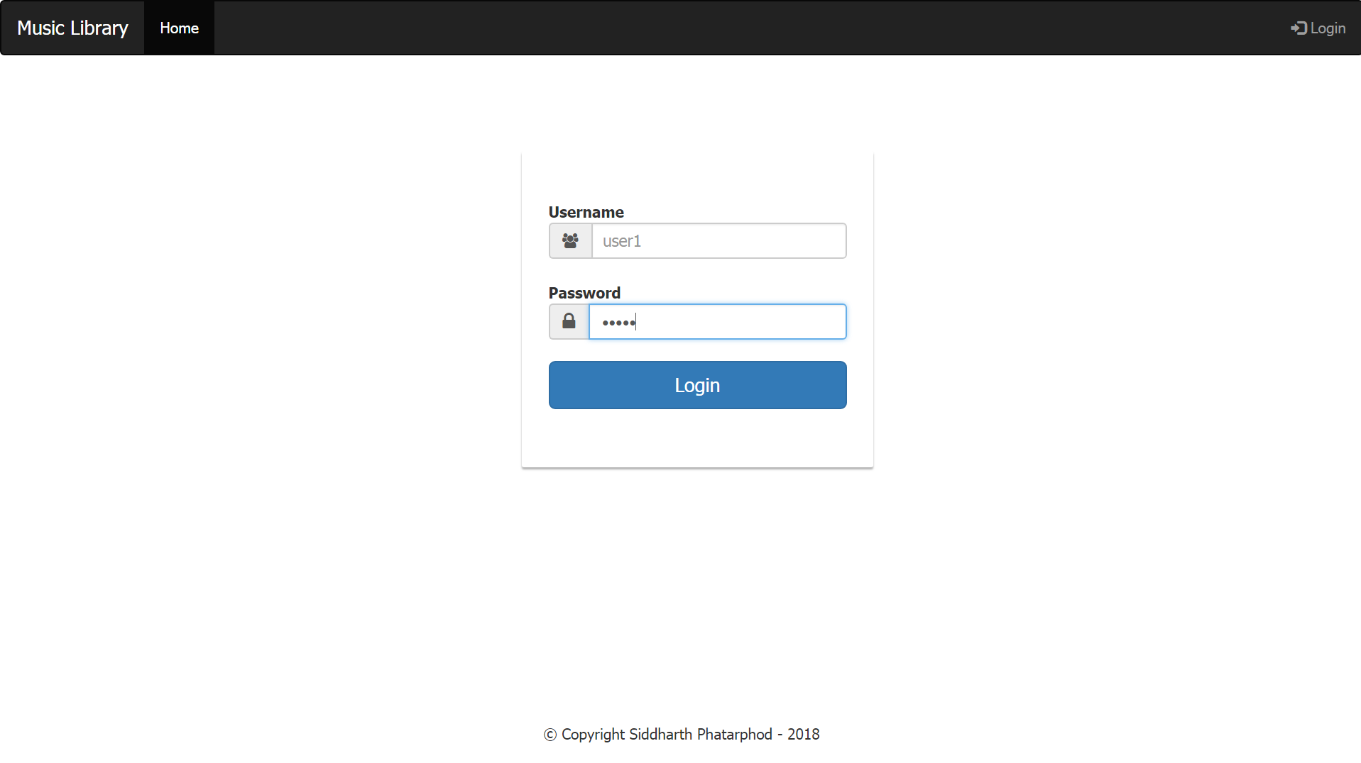

Wrong username/password displays appropriate message:



Blank username/password followed by login button click also displays the appropriate message:



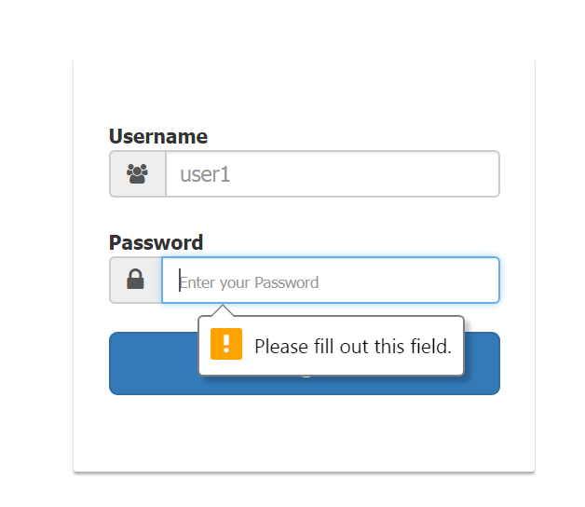

Home Page/Landing Page after login by user: Successful login by user takes user to the home page/landing page. Welcome username message and Logout icons are displayed at the top right.

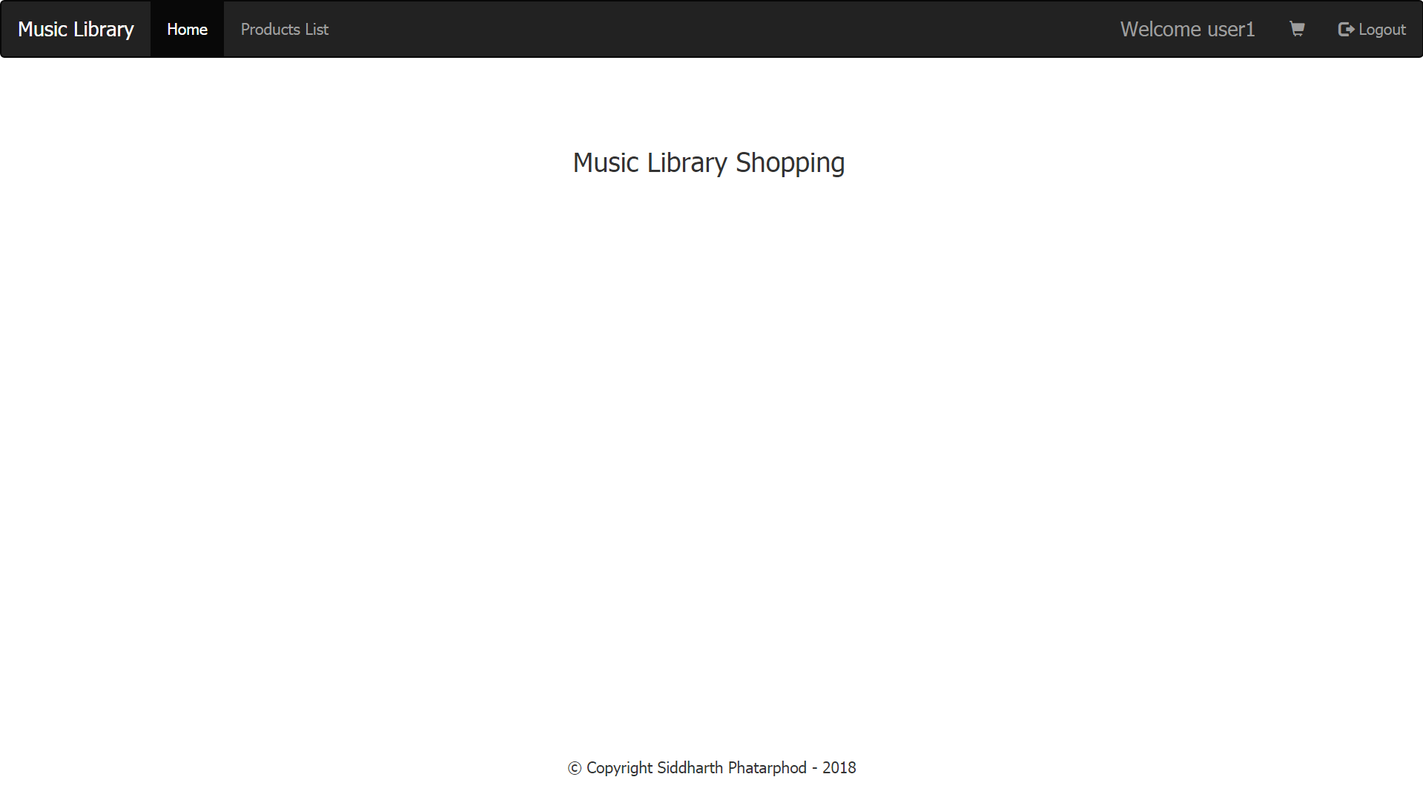

Products list page available only to user: User can add existing products(tracks) to the shopping cart

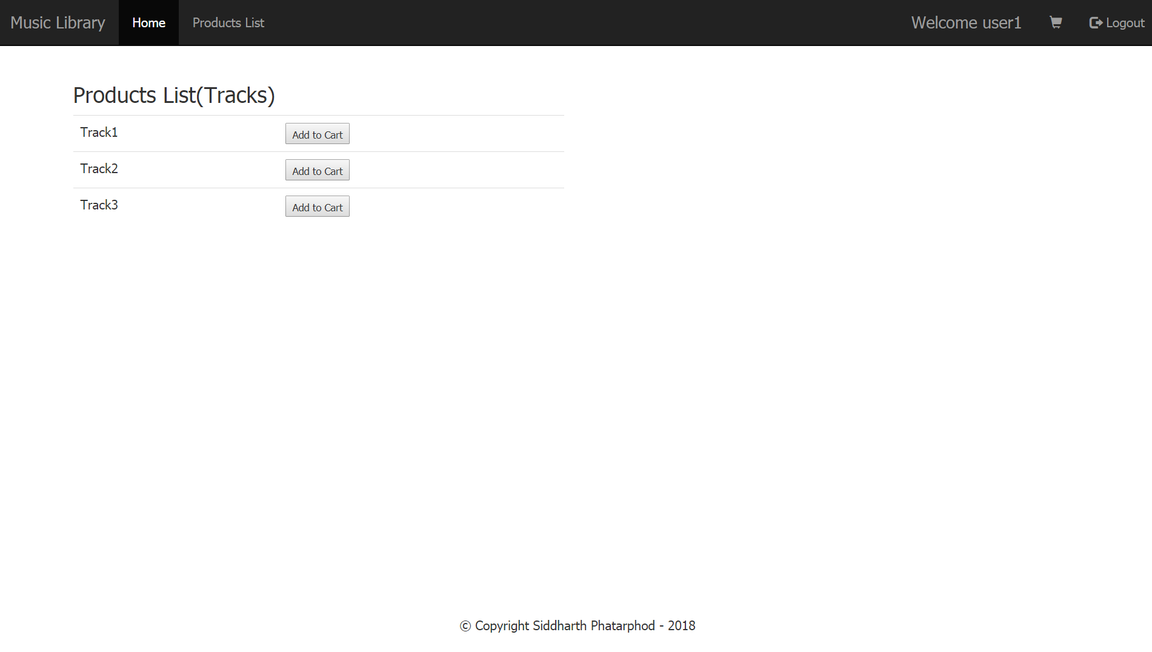

Shopping Cart page: Adding a track takes the user to his shopping cart page from where the user can delete a product(track) or change the quantity. Minimum quantity is kept at 1.

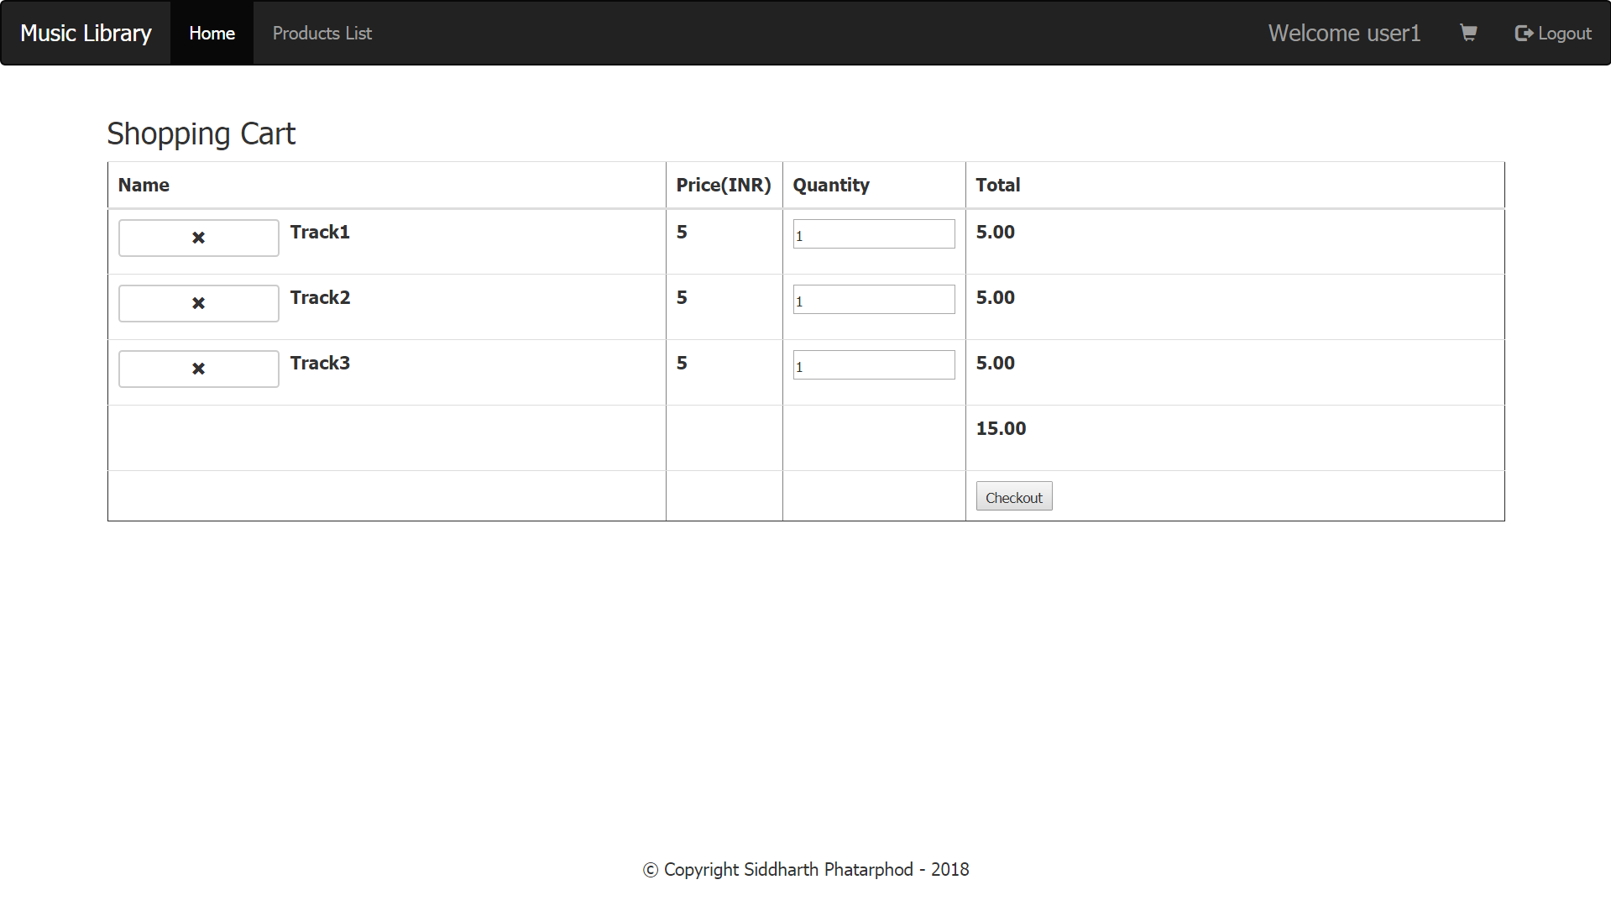

Changing the quantity affects the subtotals and the grand total

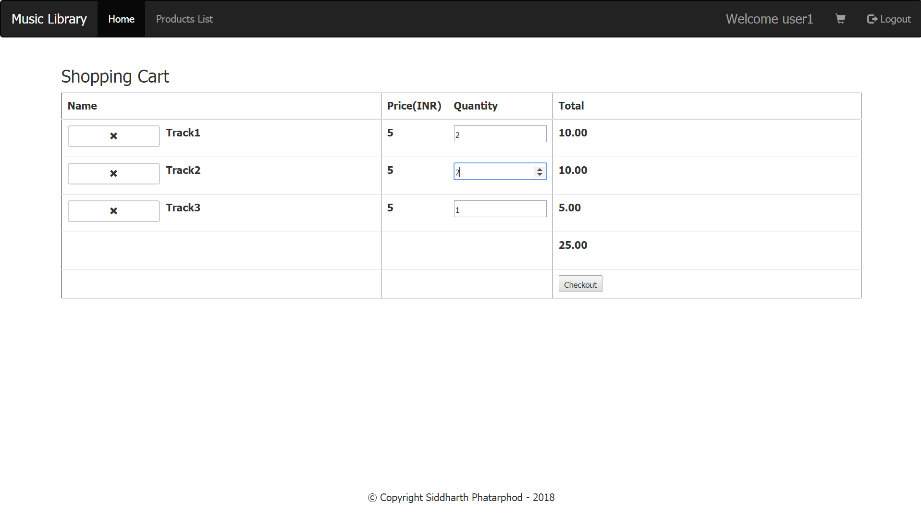

From here the user can either checkout or logout. His cart persists in the database. Each cart is unique to the user. In case there are no items in the shopping cart(e.g. user2 in this case) an appropriate message is displayed that the cart is empty.

