Mastering Agentic AI Certification: Week 5 – Project
Fine-Tune a Support Ticket Router
Submitted by: Punit Singh

Install Dependencies

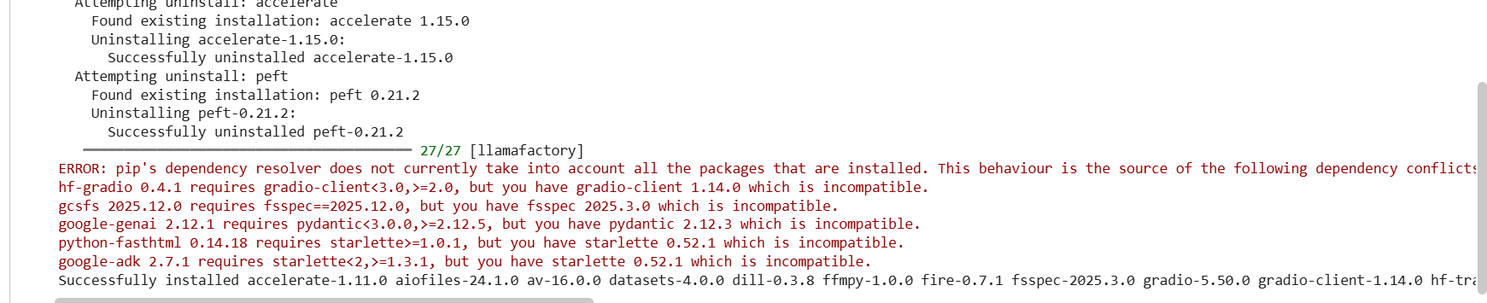
Prepare Support Ticket Dataset (INPUT REQUIRED)
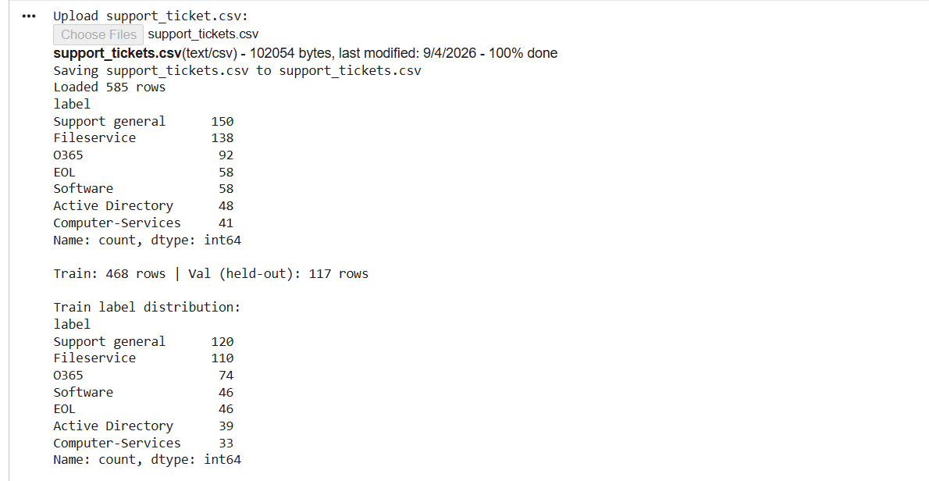
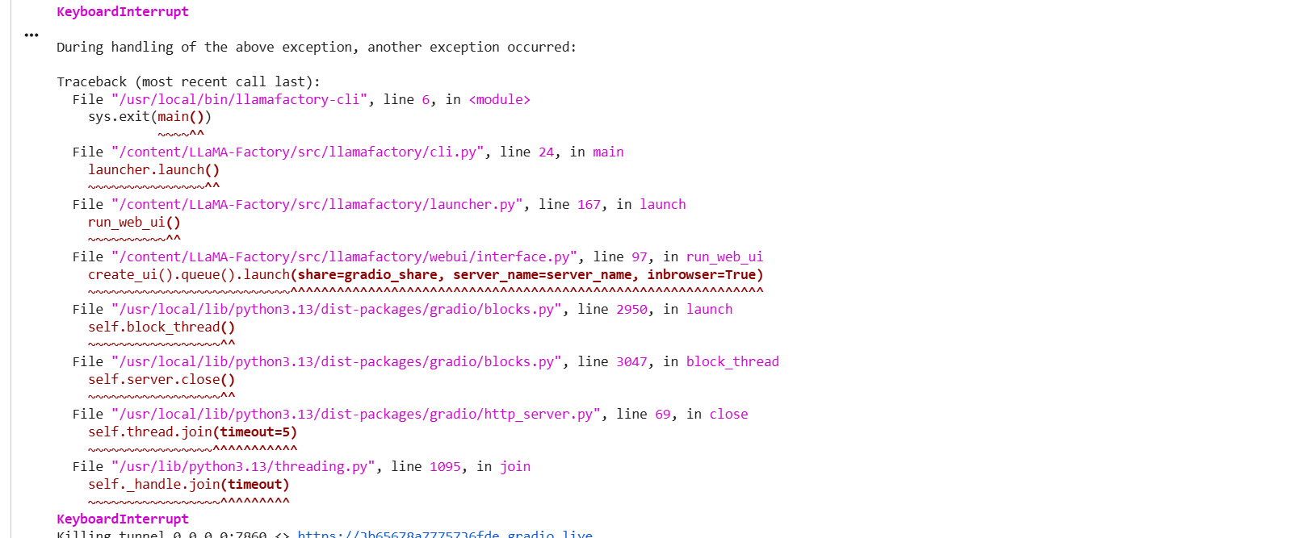
Review Training — Loss Curve (INPUT REQUIRED)
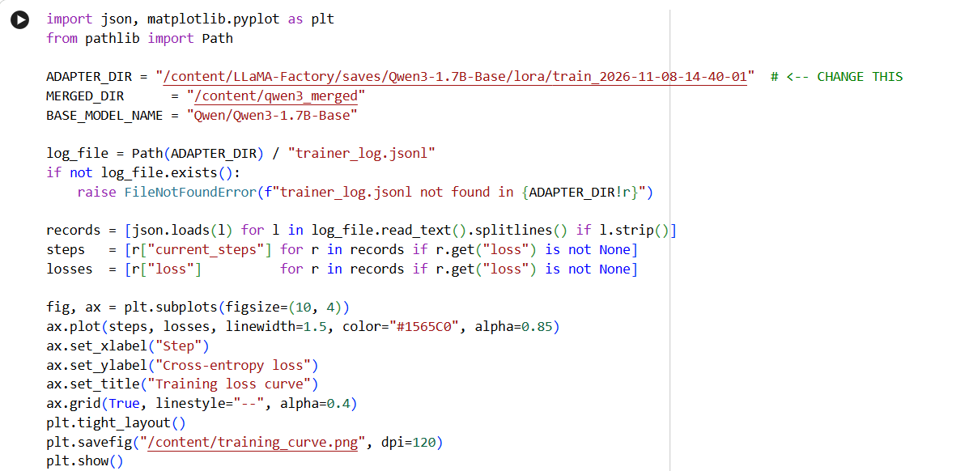

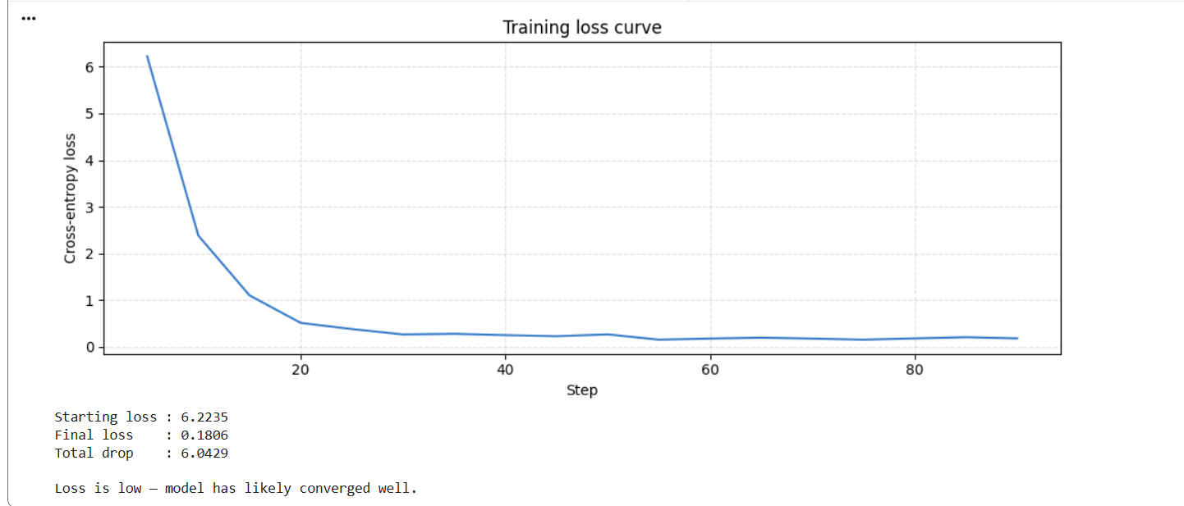

Define classify() and Smoke Test the Merged Model
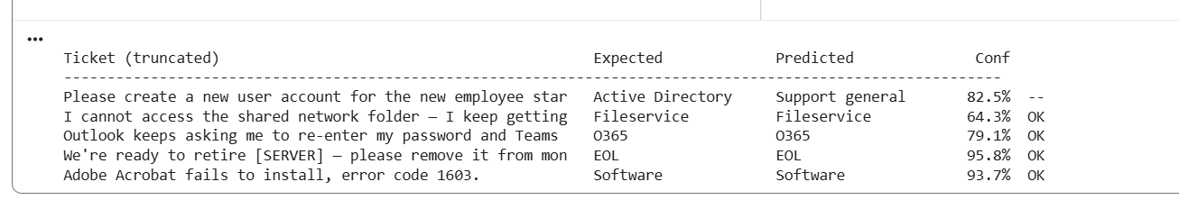
Evaluate the Fine-tuned Model on the Validation Split

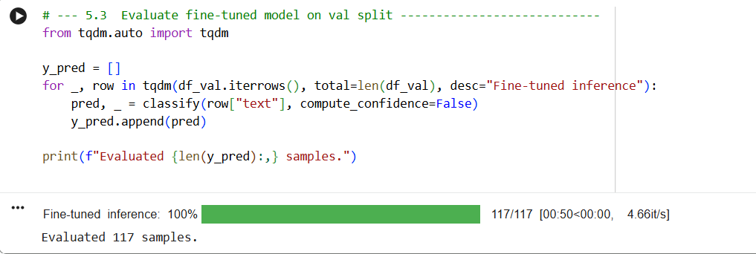

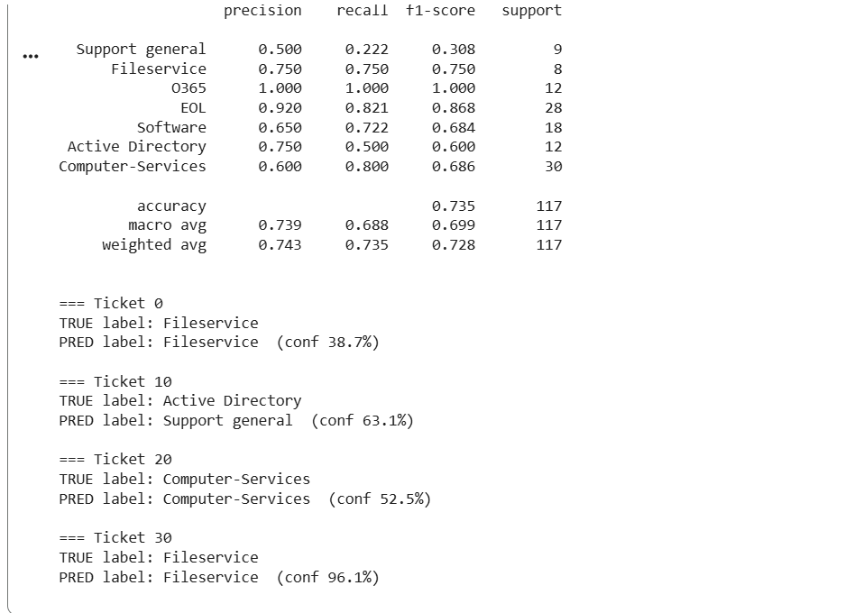

Confusion matrix

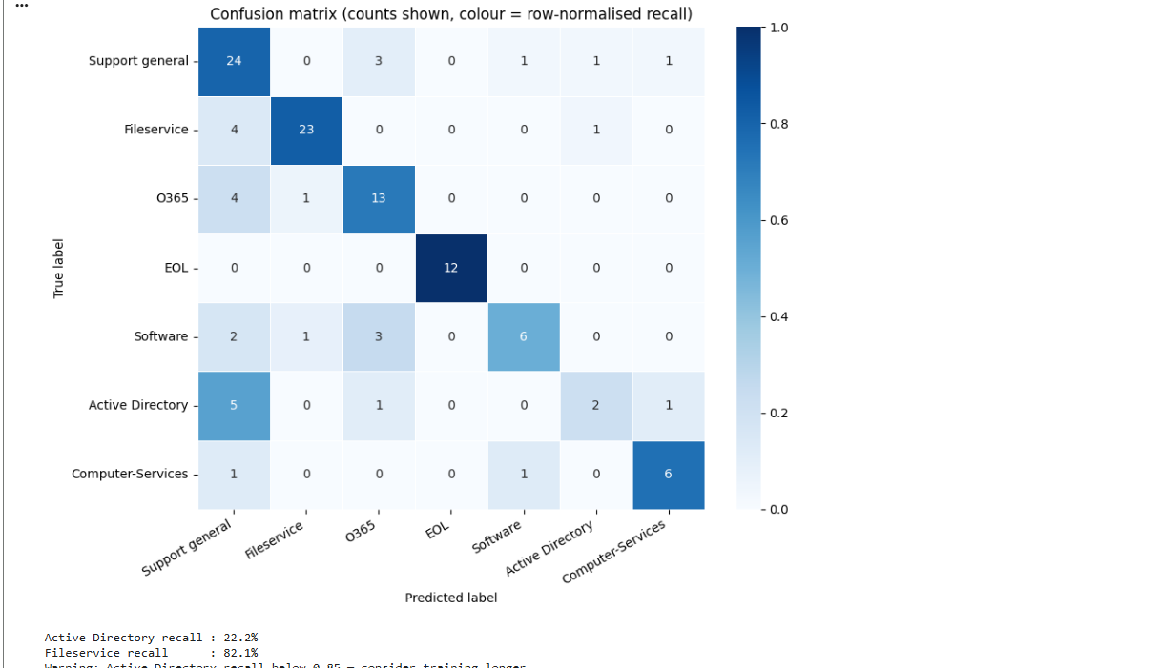

Baseline vs Fine-tuned Comparison



