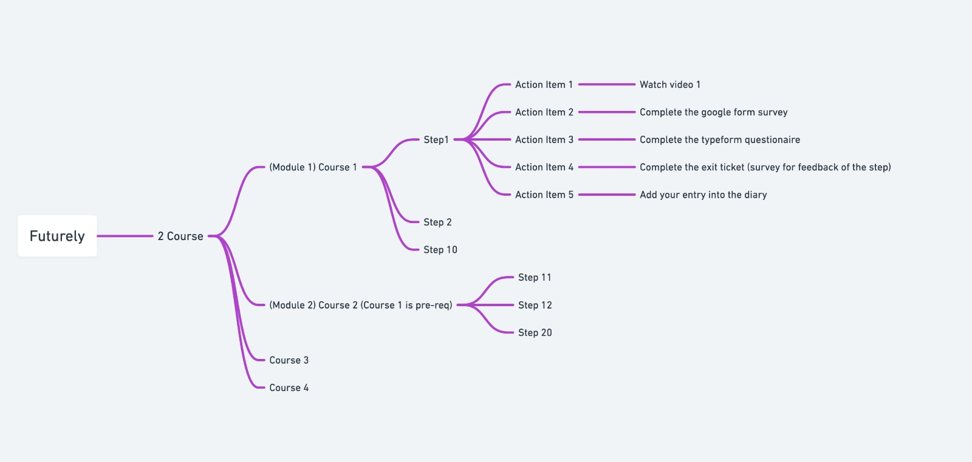

Course : Modules : Steps : Action Items

One course(Subject) may have multiple modules (sub parts of the subject) , Each Module may have multiple steps(chapters) , Each steps may have multiple action item (Learning Material and Exercises),

Each Action Item →Learning material, Dairy (Exercise, MCQ, etc) etc

For Example :

Course → **Programming Language**

Modules : **C**, C++, Python, Django

Steps : Topics of C language → Like **Introduction** , Control Statements etc

Action Item:

1. Introduction Watch Video (History of C Language)
2. course learning material
3. Exercise ( Question Answers)
4. Interview Questions etc
5. Assignments

Course

|  |  |  |  |
| --- | --- | --- | --- |
| Course ID (Primary Key) | Course Title | Description (Brief about course) | total_modules  Number of modules (Auto calculation based on module creation) otherwise Structure created as per described total modules |
| BG Image |  |  |  |

Modules

|  |  |  |  |
| --- | --- | --- | --- |
| Module ID(Primary Key) | Course ID( Foreign Key) | Module Title | Description |
|  | Number of Steps | BG Image | duration |

Note: If we multiple modules for one course , Each of them can be completed in sequence ( One after another)

Steps

|  |  |  |  |
| --- | --- | --- | --- |
| Step ID (Primary Key) | Module ID (Foreign Key) | Step Title | Description |
| BG Image | Number of action Items | Duration (Days) |  |

Each Step get completed in sequence

Action Type

|  |  |  |  |
| --- | --- | --- | --- |
| SNO | datatype |  |  |

Action Items

|  |  |  |  |
| --- | --- | --- | --- |
| Action Item ID | Step ID | Action title | Type (documents, videos, Question-Answers etc) |

Action Item Data Type Files (Course Material and resources)

|  |  |  |  |  |
| --- | --- | --- | --- | --- |
| ID | Action Item Id | Document Title | Documents File |  |

Document can be viewed frame by frame , or can be downloaded by student

Action Item Data Type Links (Course Material and resources)

|  |  |  |  |  |
| --- | --- | --- | --- | --- |
| ID | Action Item Id | Document Title | Link |  |

Action Item Data Type (Dairy )

|  |  |  |  |
| --- | --- | --- | --- |
| Data Id | Action Item ID | Question |  |
|  |  |  |  |

Course Active Status (Something related to co-hort) – If any entry is here that describes course and module is active to purchase

|  |  |  |  |  |  |  |
| --- | --- | --- | --- | --- | --- | --- |
| co-hort ID |  | Module ID | Co-hort Name | Starting Date | Price | Duration |
|  |  |  |  |  |  |  |

Step Activation(If step duration does not works for us ) we can manually allot date to active Step

|  |  |  |  |
| --- | --- | --- | --- |
| co-hort ID | Step ID | Duration | Starting Date |

**Students Section**

**Students** **Payment Section**

|  |  |  |  |
| --- | --- | --- | --- |
| Student ID | Information Product Purchased | Payment | Date |

**Student Profile**

Once Payment is done , co-hort id will get linked with student automatically

Student Course Mapping

|  |  |  |  |
| --- | --- | --- | --- |
| StuCourse ID(PK) | Student ID (FK) | Co-hort ID(FK) |  |

If any student have purchased multiple courses , Multiple courses get displayed into my courses

**Student-Course/Module/Step/Action Item Tracker (Progress Bar)**

**Course/Module Tracker**

|  |  |  |  |  |
| --- | --- | --- | --- | --- |
| module_track_id(PK) | StuCourse ID(FK) | Module ID(FK) | Is completed | is_locked |

Total % of completion get calculated on the behalf of completed steps

**Steps Tracker**

|  |  |  |  |  |
| --- | --- | --- | --- | --- |
| Step_track_id | module_track_id | Step ID | Is completed | is_locked |

Step will get completed , once all the actions items are completed and the next step will get unlocked with status(is_completed=Yes).

Want to confirm : When will action Items get loaded into Tracker Table :- AT initial time or when it unlocked from steps tracker

**Action Item Tracker**

|  |  |  |  |
| --- | --- | --- | --- |
| Action_item_track_id | Step_trackId | ActionItem ID | Is completed |

Each ActionItem Contains data based on Action Item Type

ActionItem Files

|  |  |  |  |  |
| --- | --- | --- | --- | --- |
| id | Action_item_track_id | ActionItemFIlesID | Uploaded File | Status |

ActionItem Links

|  |  |  |  |
| --- | --- | --- | --- |
| id | Action_item_track_id | ActionItemLinks ID | Status |

Action Item Dairy

|  |  |  |  |  |
| --- | --- | --- | --- | --- |
| id | Action_item_track_id | Action Item Dairy ID | Answer | Status |

**Students Section : Planning Part 2**

**Students** **Payment Section**

|  |  |  |  |  |
| --- | --- | --- | --- | --- |
| Payment ID | Student ID | Information Product Purchased | Payment | Date |

**Student Profile**

Once Payment is done , co-hort id will get linked with student automatically

Student cohort Mapping

|  |  |  |  |
| --- | --- | --- | --- |
| Stu-Cohort ID(PK) | Student ID (FK) | Co-hort ID(FK) |  |

If any student have purchased multiple courses , Multiple courses get displayed into my courses

While Student Mapping -> Automapping the step_status with stu-cohort , all the action Items related to steps will get mapped automatically to the Action Item tracker.

**Student-Course/Module/Step/Action Item Tracker (Progress Bar)**

**Steps Tracker**

|  |  |  |  |  |
| --- | --- | --- | --- | --- |
| Step_track_id | Stu-Cohort ID(PK) | Step Status ID |  |  |

Step will get completed , once all the actions items are completed and the next step will get unlocked with status(is_completed=Yes).

Want to confirm : When will action Items get loaded into Tracker Table :- AT initial time or when it unlocked from steps tracker

**Action Item Tracker**

|  |  |  |  |
| --- | --- | --- | --- |
| Action_item_track_id | Step_trackId | ActionItem ID | Is completed |

Each ActionItem Contains data based on Action Item Type

ActionItem Files

|  |  |  |  |  |
| --- | --- | --- | --- | --- |
| id | Action_item_track_id | ActionItemFIlesID | Uploaded File | Status |

ActionItem Links

|  |  |  |  |
| --- | --- | --- | --- |
| id | Action_item_track_id | ActionItemLinks ID | Status |

Action Item Dairy

|  |  |  |  |  |
| --- | --- | --- | --- | --- |
| id | Action_item_track_id | Action Item Dairy ID | Answer | Status |

**Courses Modules Pages:**

1. Available courses (Display all courses that are available and not purchased yet)
   1. Title, Description , Duration, Dates to start that course, price
   2. (Here we need to check all courses from cohort , and display only that are not presented in student-cohort mapper)
2. My courses
   1. Display courses that are mapped with student cohort mapper
   2. Later on we need to display the completed courses also
3. Courses overview:
   1. When any course get selected from available course , in this page we need to display the details of selected course with some demo content (like Introduction video , or any other content)
   2. Information get displayed from cohort and step-status
   3. From here course can be purchased also
4. Exercise Page
   1. When any course gets selected from My Courses , then control is redirected over here.
   2. From step tracker
   3. Here we required unlocked steps information , and locked step information along with co-hort rank.
5. ActionItem
   1. From Exercise page to here
   2. Depending upon the type of action item , we need to display the page accordingly . (Ex: Files option, Links, Dairy)
   3. From action item tracker-> action Item