**Figure 1: data in COLUMN Format**

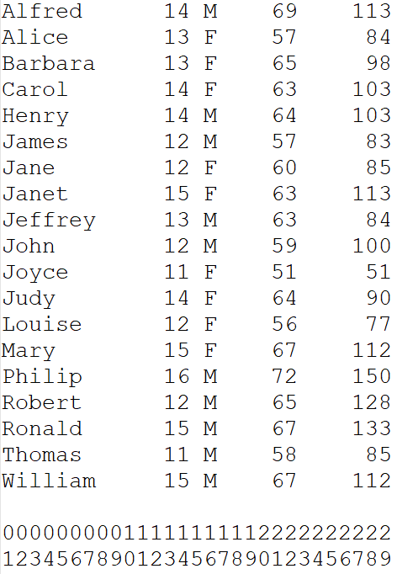

Column Index (not part of the data)

**Figure 2: Data in COLUMN Format /w Missing Data**

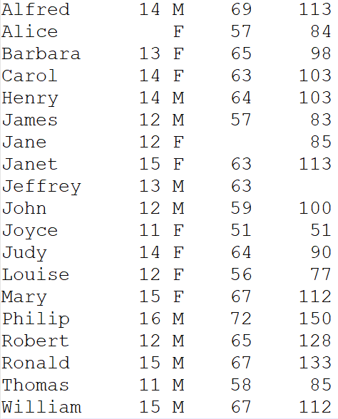

**Figure 3: Data in LIST Format /w SPACE Delimiter**

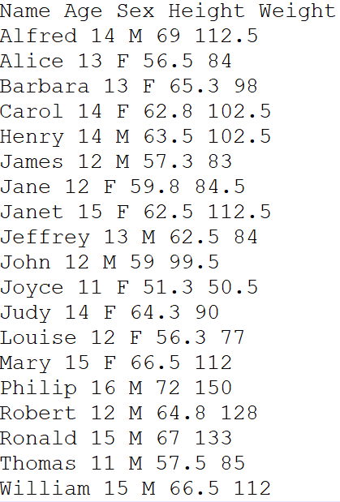

Header Row

**Figure 4: Data in LIST Format /w TAB Delimiter**

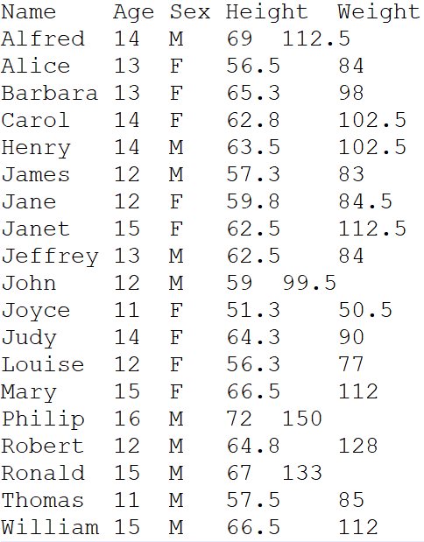

**Figure 5: Data in LIST Format /w TAB Delimiter & Date Variables**

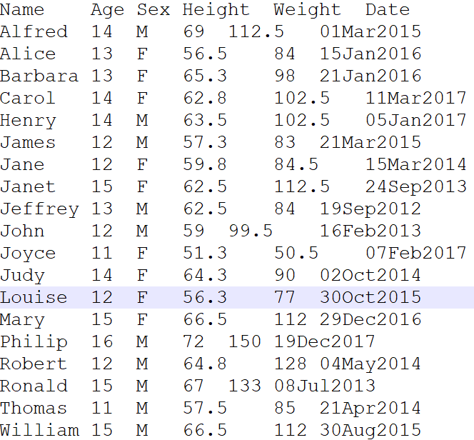

**Figure 6: Data in LIST Format /w COMMA Delimiter (CSV)**

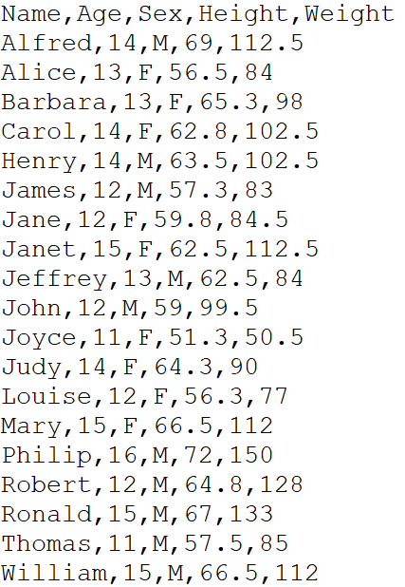

**Figure 7: Data in EXCEL Format**

