Customers of private hospitals in the Thai health system
Who they are, how they use care, how they judge quality — and what it means for regulating private hospitals
People’s Voice Survey (Thailand) • Population Confidence and Quality of the Health System
P. Sitthirat et al. • 2,017 adult respondents; 1,518 with a classifiable usual source of care • Edition of 14 September 2026

Summary
Thailand’s People’s Voice Survey asks every respondent where they usually go first when they are ill. Crossing the sector of that usual source with its setting divides the 1,518 respondents who named one into four groups: public primary care (n = 634), public hospital outpatient or emergency care (n = 615), private clinics and pharmacies (n = 142), and private hospitals (n = 127). This report profiles the last of these against the other three, with public hospital users as the comparison throughout — the closest counterfactual, since both groups use hospital outpatient care.
Six findings stand out.
- They are a salaried middle, not an affluent elite. Only 4.7% of regular private-hospital users report a household income of ฿60,000 or more per month — no more than public primary care users. What distinguishes them is coverage: 69.8% hold Social Security, against 16.8% of public hospital users, and insurance coverage is the reason they most often give for choosing their facility (33.9%). Low cost is almost never cited (1.6%). Whether they were actually assigned to those providers cannot be determined — registration, payer and employment are not measured.
- Faster walk-in access, but scheduled care queues much as it does in the public sector. They wait less at the facility (25.2% wait an hour or more, against 44.1%) and walk in more often. But among the 44 who booked ahead, 65.9% still waited a month or more to be seen, against 72.8% of public hospital appointment-holders. The advantage is concentrated in walk-in, same-day service rather than in scheduled care.
- The quality difference is in service process, not perceived clinical competence. Nine of eleven experience items differ after adjustment, led by satisfaction with waiting time (aOR 3.54, +26.9 percentage points), the provider knowing the patient’s history (3.16, +26.6 pp) and ease of getting an appointment (3.28, +23.8 pp). The two perceived-competence items do not differ: provider knowledge and skill 1.38 (0.83–2.31) and equipment readiness 1.11 (0.69–1.78). None of the eleven measures objective clinical quality.
- There is no preventive-service gap between private and public hospital users. On all eight screening and prevention items, private-hospital users are indistinguishable from public hospital users after adjustment. The one robust preventive finding concerns pharmacies: blood-pressure measurement is 70.0% among people whose usual source is a pharmacy, against 96.9–98.4% in every other group.
- Self-reported admission is substantially higher, and unexplained. 29.1% report an overnight admission in the past year — aOR 2.42 (1.35–4.31), +14.2 pp — in the group reporting the best health, with chronic illness adjusted for. The questionnaire never records where an admission happened, so this cannot show that it occurred at a private hospital or that it was unnecessary. It is the finding most worth pursuing with claims data.
- A good personal experience and insecurity about serious illness coexist. No system-level difference is detectable after adjustment, including health security (aOR 1.27, 0.80–2.01). That interval is compatible with anything from a modest decrease to a doubling, so it is not evidence that provider type is unrelated to confidence. What the data show directly is that 14.2% of private-hospital users rate their own facility very good or excellent while remaining unsure they could get and afford care if seriously ill.

Data and methods
The Thai People’s Voice Survey covers 2,017 adults aged 18 or over across all 13 health regions, with one province sampled per region, subdistricts selected by probability proportional to size, and quota-based convenience recruitment at the final stage. The achieved sample tracks the plan closely — planned 686 municipal and 1,314 non-municipal, achieved 697 and 1,320, with every region within six respondents of target — but the sex quota was not met (42.8% male against 50% planned). Estimates are unweighted and describe the achieved sample.
Provider groups cross the sector of the usual source of care (Q14) with its setting (Q15). "Secondary" is not used as a label: Q15 separates hospital outpatient and emergency departments from non-hospital settings, which does not establish whether a hospital is secondary or tertiary. 488 respondents report no usual source of care and 11 are unclassifiable — 6 non-profit providers, 2 sector "other", 3 setting "other".
Adjusted comparisons use logistic regression on provider group plus age band, sex, education, household income, municipality, coverage scheme, self-rated health and chronic illness, with cluster-robust standard errors on the 107 sampled subdistricts. Each result is reported as an adjusted odds ratio and as the average marginal predicted probability with a percentage-point difference, because an odds ratio is not a probability ratio. Benjamini–Hochberg adjustment is applied within each pre-declared outcome family, and null results are retained.
Three cautions apply throughout, and are the reason several statements below are more guarded than they might otherwise be. These are associations, not effects: respondents are not allocated to providers, insurance routing is an obvious selection mechanism, and adjustment narrows but does not remove it. Most measures are not attributable to a provider — screening, admission, medical error and discrimination record no facility, and the visit-experience items describe the most recent visit, which is the usual source of care for 84.3% of private-hospital users but only 64.1% of private clinic and pharmacy users. And several items carry no recall period at all: screening, error, discrimination and unmet need are lifetime or unbounded reports, not 12-month rates.
Table 1. Cohort flow from the full sample to the four-group comparison.
Exclusions are mutually exclusive and separately identified. The three public respondents whose setting was "other" are why the sector total of 1,252 exceeds the four-group public total of 1,249.
Step | n
Respondents in the cleaned export | 2017
consented | 2017
No usual source of care (Q13 = no) | 488
Has a usual source of care (Q13 = yes) | 1529
excluded: non-profit provider | 6
excluded: sector "other" | 2
excluded: setting "other" | 3
Four-group analysis cohort | 1518
public primary care | 634
public hospital OPD/ER | 615
private clinic/pharmacy | 142
private hospital OPD/ER | 127

1. Who uses private hospitals
The four groups differ sharply, but not along the axis usually assumed. Private-hospital users are the most urban group (49.6%) and among the most educated — 62.2% hold a diploma or a bachelor’s degree. Their household income sits in the middle of the distribution rather than at the top: 46.5% report ฿30,000–59,999 per month, but only 4.7% report ฿60,000 or more, no more than public primary care users, and a single respondent in the group reports the top income band.
The defining characteristic is the coverage scheme. Social Security covers 69.8% of private-hospital users against 16.8% of public hospital users, while only 26.2% hold Universal Coverage against 79.5% in public primary care. Private health insurance is more common in this group (31.5%) but is held by a minority — and ownership is not evidence of use at any visit.
They also report better health (92.1% good or better) and higher patient activation (88.2%). One correction is worth making explicitly: it is private clinic and pharmacy users, not private-hospital users, who report the least chronic illness (16.2% against 32.3%) and marginally better self-rated health.
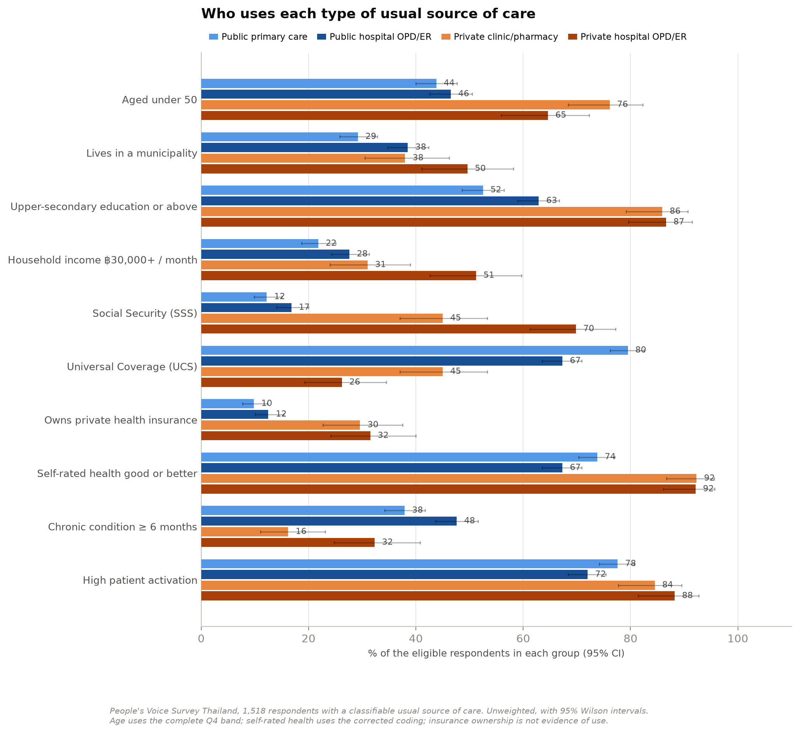
Figure 1. Demographic, coverage and health profile by type of usual source of care.
Bars show the percentage of eligible respondents in each group with a 95% Wilson interval. Age uses the complete Q4 band, which is observed for all 2,017 respondents; exact age (Q3) is missing for 308 and is not used here.
Table 2. Profile by type of usual source of care.
Cells are n/N (% ; 95% CI) for binary measures and n/N (%) within distributions. Denominators vary where a variable has missing values — sex excludes 15 refusals, the coverage scheme excludes 20 "don’t know" answers. p-values are Pearson chi-square across the four groups.
Measure | Public  primary care | Public  hospital OPD/ER | Private  clinic/pharmacy | Private  hospital OPD/ER | p | Denominator
Age band (Q4, complete for all) |  |  |  |  | <0.001 | see rows below
18-29 | 80/634 (12.6) | 83/615 (13.5) | 36/142 (25.4) | 19/127 (15.0)
30-39 | 97/634 (15.3) | 97/615 (15.8) | 42/142 (29.6) | 28/127 (22.0)
40-49 | 101/634 (15.9) | 106/615 (17.2) | 30/142 (21.1) | 35/127 (27.6)
50-59 | 138/634 (21.8) | 122/615 (19.8) | 20/142 (14.1) | 30/127 (23.6)
60-69 | 140/634 (22.1) | 110/615 (17.9) | 9/142 (6.3) | 13/127 (10.2)
70-79 | 56/634 (8.8) | 77/615 (12.5) | 4/142 (2.8) | 2/127 (1.6)
80+ | 22/634 (3.5) | 20/615 (3.3) | 1/142 (0.7) | 0/127 (0.0)
Sex (Q5) |  |  |  |  | 0.490 | see rows below
female | 354/625 (56.6) | 326/613 (53.2) | 82/141 (58.2) | 66/126 (52.4)
male | 259/625 (41.4) | 276/613 (45.0) | 56/141 (39.7) | 60/126 (47.6)
other | 12/625 (1.9) | 11/613 (1.8) | 3/141 (2.1) | 0/126 (0.0)
Municipal residence | 185/634 (29.2; 25.8-32.8) | 237/615 (38.5; 34.8-42.4) | 54/142 (38.0; 30.5-46.2) | 63/127 (49.6; 41.1-58.2) | <0.001 | all in group
Education (Q8) |  |  |  |  | <0.001 | see rows below
below primary | 54/634 (8.5) | 42/615 (6.8) | 2/142 (1.4) | 1/127 (0.8)
primary | 151/634 (23.8) | 110/615 (17.9) | 7/142 (4.9) | 7/127 (5.5)
lower secondary | 96/634 (15.1) | 76/615 (12.4) | 11/142 (7.7) | 9/127 (7.1)
upper secondary/voc | 149/634 (23.5) | 124/615 (20.2) | 28/142 (19.7) | 31/127 (24.4)
diploma/high voc | 60/634 (9.5) | 69/615 (11.2) | 29/142 (20.4) | 28/127 (22.0)
bachelor or above | 124/634 (19.6) | 194/615 (31.5) | 65/142 (45.8) | 51/127 (40.2)
Household income (Q51) |  |  |  |  | <0.001 | see rows below
<10k | 137/634 (21.6) | 120/615 (19.5) | 15/142 (10.6) | 3/127 (2.4)
10-30k | 359/634 (56.6) | 325/615 (52.8) | 83/142 (58.5) | 59/127 (46.5)
30-60k | 109/634 (17.2) | 142/615 (23.1) | 33/142 (23.2) | 59/127 (46.5)
60-100k | 27/634 (4.3) | 20/615 (3.3) | 6/142 (4.2) | 5/127 (3.9)
100k+ | 2/634 (0.3) | 8/615 (1.3) | 5/142 (3.5) | 1/127 (0.8)
Main public scheme (Q6) |  |  |  |  | <0.001 | see rows below
CSMBS | 51/629 (8.1) | 97/612 (15.8) | 14/140 (10.0) | 5/126 (4.0)
SSS | 77/629 (12.2) | 103/612 (16.8) | 63/140 (45.0) | 88/126 (69.8)
UCS | 500/629 (79.5) | 412/612 (67.3) | 63/140 (45.0) | 33/126 (26.2)
other public | 1/629 (0.2) | 0/612 (0.0) | 0/140 (0.0) | 0/126 (0.0)
Owns private health insurance | 62/634 (9.8; 7.7-12.3) | 77/615 (12.5; 10.1-15.4) | 42/142 (29.6; 22.7-37.5) | 40/127 (31.5; 24.1-40.0) | <0.001 | all in group
Self-rated health good or better | 468/634 (73.8; 70.3-77.1) | 414/615 (67.3; 63.5-70.9) | 131/142 (92.3; 86.7-95.6) | 117/127 (92.1; 86.1-95.7) | <0.001 | all in group
Mental health good or better | 551/634 (86.9; 84.1-89.3) | 509/615 (82.8; 79.6-85.5) | 135/142 (95.1; 90.2-97.6) | 119/127 (93.7; 88.1-96.8) | <0.001 | all in group
Chronic condition >= 6 months | 240/634 (37.9; 34.2-41.7) | 293/615 (47.6; 43.7-51.6) | 23/142 (16.2; 11.0-23.1) | 41/127 (32.3; 24.8-40.8) | <0.001 | all in group
High patient activation | 492/634 (77.6; 74.2-80.7) | 443/615 (72.0; 68.4-75.4) | 120/142 (84.5; 77.7-89.5) | 112/127 (88.2; 81.4-92.7) | <0.001 | all in group

1.1 Who is the main target population?
A natural summary of the profile above would be "under 50, urban, with Social Security". Tested directly, only one part of that holds up. Table 2a scores candidate target definitions on two things: precision — the rate of private-hospital use within the group, calculated over all 2,017 respondents — and reach, the share of all 127 private-hospital users the group contains. The average rate is 6.3%.
Social Security on its own is the strongest single marker: it covers 23.5% of respondents but contains 69.3% of all private-hospital users, at a rate of 18.6% — three times the average. Adding "under 50" makes the target worse rather than better: the rate falls to 16.8% and reach to 49.6%. Adding "municipal" raises precision to 22.2% but halves reach, because half of all private-hospital users live outside municipalities. The full combination of all three has a rate of 18.8% — no better than Social Security alone — while capturing only 19.7% of users.
Income is the better second marker. Social Security members with a household income of ฿30,000 or more have the highest rate of the definitions in Table 2a, 25.6% (index 406), and still account for 34.6% of users.
Table 2a. Candidate target definitions compared on precision and reach.
Rate = private-hospital users ÷ everyone in the group, over all 2,017 respondents (people with no usual source of care count as non-users). Share = users in the group ÷ all 127 users. Index = rate ÷ 6.3% × 100. Scheme is coverage ownership, not registration or payment.
Target definition | % of pop. | Users (n) | Rate % | CI low | CI high | Share of users % | Index
Everyone (reference) | 100.0 | 127 | 6.3 | 5.3 | 7.4 | 100.0 | 100
Under 50 | 55.0 | 82 | 7.4 | 6.0 | 9.1 | 64.6 | 117
Municipal (urban) | 34.6 | 63 | 9.0 | 7.1 | 11.4 | 49.6 | 144
Under 50 + municipal | 19.5 | 37 | 9.4 | 6.9 | 12.7 | 29.1 | 150
Income 30k and over | 27.4 | 65 | 11.8 | 9.3 | 14.7 | 51.2 | 187
Owns private insurance | 15.1 | 40 | 13.2 | 9.8 | 17.4 | 31.5 | 209
Social Security | 23.5 | 88 | 18.6 | 15.3 | 22.3 | 69.3 | 295
Social Security + under 50 | 18.6 | 63 | 16.8 | 13.4 | 20.9 | 49.6 | 267
Social Security + municipal | 9.2 | 41 | 22.2 | 16.8 | 28.7 | 32.3 | 352
Social Security + under 50 + municipal (the starting hypothesis) | 6.6 | 25 | 18.8 | 13.1 | 26.3 | 19.7 | 299
Social Security + income 30k and over | 8.5 | 44 | 25.6 | 19.6 | 32.6 | 34.6 | 406
Social Security OR owns private insurance | 33.4 | 106 | 15.7 | 13.2 | 18.7 | 83.5 | 250
Age is the trap. Under-50s have a higher rate overall (7.4% against 5.0%), but that is because Social Security members are mostly working-age. Within Social Security, members aged 50 and over are at least as likely to use a private hospital — 25.3% (95% CI 17.7–34.6) against 16.8% (13.4–20.9) — and under Universal Coverage the two age groups are essentially equal. When every characteristic is considered at once, Social Security (aOR 6.95, +13.3 percentage points), household income of ฿30,000 or more (5.54, +7.1 pp) and owning private insurance (1.94, +4.0 pp) each mark private-hospital users independently; being under 50 does not (0.73, 0.43–1.25), and municipal residence is suggestive but not statistically clear (1.69, 0.93–3.07).
Table 2b. Rate of private-hospital use by age, area and coverage scheme, ranked.
All 16 combinations. Cells with fewer than 30 people are flagged and should be read as indicative only. Cumulative columns show how much of the user population is captured working down the list. Heat-shaded n × n matrices for nine pairs of characteristics are in "Target segmentation - private hospital users.xlsx".
Segment | Rank | People | Users | Rate % | Share % | Cumul. share % | Small cell
50 and over + Municipal (urban) + Social Security | 1 | 52 | 16 | 30.8 | 12.6 | 12.6
50 and over + Non-municipal (rural) + Other / don't know | 2 | 4 | 1 | 25.0 | 0.8 | 13.4 | yes
50 and over + Non-municipal (rural) + Social Security | 3 | 47 | 9 | 19.1 | 7.1 | 20.5
Under 50 + Municipal (urban) + Social Security | 4 | 133 | 25 | 18.8 | 19.7 | 40.2
Under 50 + Non-municipal (rural) + Social Security | 5 | 242 | 38 | 15.7 | 29.9 | 70.1
Under 50 + Municipal (urban) + Civil servant | 6 | 33 | 4 | 12.1 | 3.1 | 73.2
50 and over + Municipal (urban) + Universal Coverage | 7 | 214 | 9 | 4.2 | 7.1 | 80.3
Under 50 + Municipal (urban) + Universal Coverage | 8 | 223 | 8 | 3.6 | 6.3 | 86.6
50 and over + Municipal (urban) + Civil servant | 9 | 35 | 1 | 2.9 | 0.8 | 87.4
50 and over + Non-municipal (rural) + Universal Coverage | 10 | 482 | 9 | 1.9 | 7.1 | 94.5
Under 50 + Non-municipal (rural) + Universal Coverage | 11 | 398 | 7 | 1.8 | 5.5 | 100.0
Under 50 + Non-municipal (rural) + Civil servant | 12 | 66 | 0 | 0.0 | 0.0 | 100.0
50 and over + Non-municipal (rural) + Civil servant | 13 | 71 | 0 | 0.0 | 0.0 | 100.0
Under 50 + Non-municipal (rural) + Other / don't know | 14 | 10 | 0 | 0.0 | 0.0 | 100.0 | yes
Under 50 + Municipal (urban) + Other / don't know | 15 | 4 | 0 | 0.0 | 0.0 | 100.0 | yes
50 and over + Municipal (urban) + Other / don't know | 16 | 3 | 0 | 0.0 | 0.0 | 100.0 | yes
The practical answer is therefore that the main users of private hospitals are Social Security members, best sharpened by household income rather than by age or area. The largest single pool by volume — under-50 Social Security members living outside municipalities, 29.9% of all users — would be missed entirely by a target defined as urban. As throughout, holding a scheme does not show that the respondent is registered with or paid by it at the private hospital.

2. Why they go there, and how they get in
Asked for the single main reason they use their regular facility, private-hospital users name insurance coverage most often (33.9%) — the same answer, at almost exactly the same rate, as public hospital users (33.3%). Short waiting time comes second (25.2%), a reason cited by only 1.5% of public hospital users. Proximity, the dominant consideration in public primary care (56.5%), matters least to them (18.9%). Low cost is effectively absent as a motive (1.6%).
Private clinic and pharmacy users look different again: 47.9% cite short waiting time and only 6.3% cite insurance, which fits a pattern of convenience-driven, largely self-financed episodic care. The two private groups are not one market.
A stated reason together with a scheme distribution is consistent with insurance routing, and in Thailand Social Security members register with a contracted main hospital that may be public or private. But this survey cannot confirm the mechanism: it does not ask where anyone is registered, who paid for any visit, or whether the respondent is currently in salaried employment.
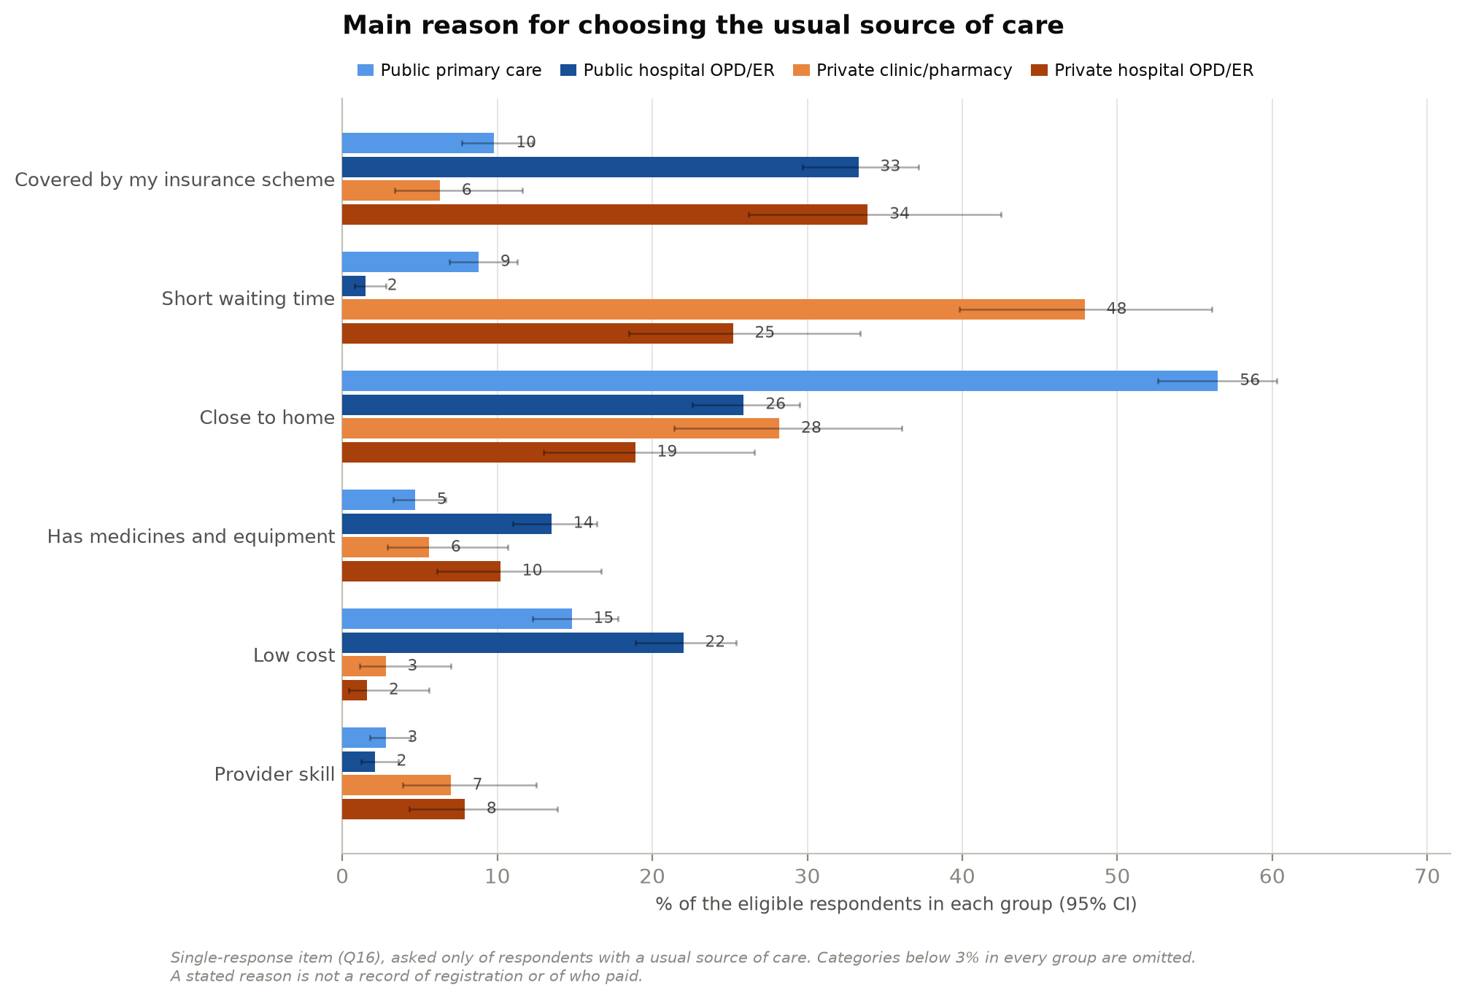
Figure 2. Main reason for choosing the usual source of care (single response, Q16).
Asked only of respondents with a usual source of care. Categories below 3% in every group are omitted from the figure and retained in Table 3.
Access differs sharply in one direction and not in another. Private-hospital users are seen faster at the facility: 55.9% within half an hour against 27.0% of public hospital users, and 25.2% wait an hour or more against 44.1%. No respondent in either private group reported waiting four hours or more, a wait 2.4% of public hospital users described. They are also more likely to walk in without an appointment (65.4% against 50.4%).
But among the minority who booked ahead — 44 respondents in the private-hospital group — 65.9% still waited a month or more between booking and being seen, and a quarter waited three to six months. The comparable public hospital figure is 72.8%. Scheduled care queues in both sectors; the private advantage is concentrated in walk-in, same-day service. Both waiting items are recorded as ordered categories, not as measured durations.
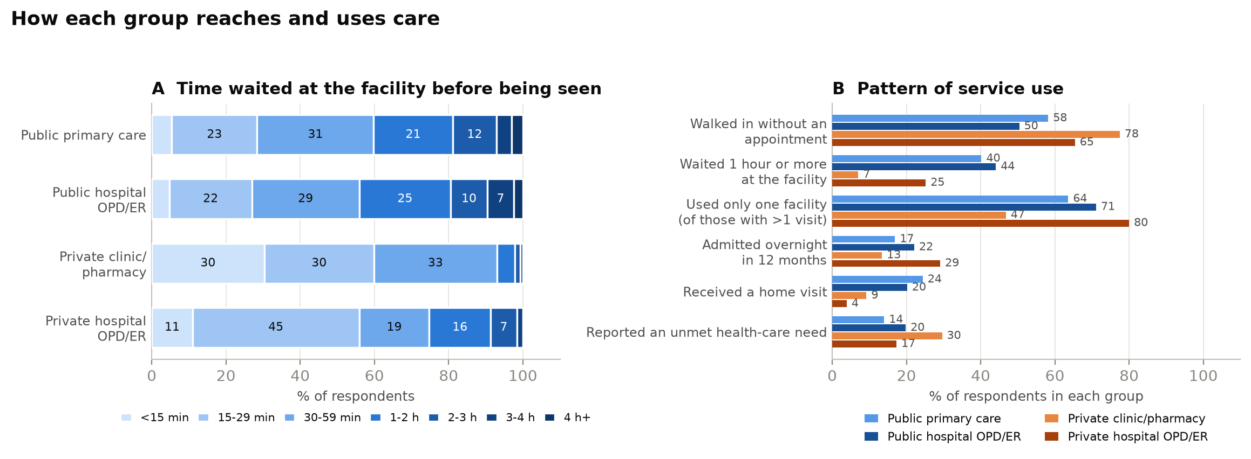
Figure 3. Waiting time at the facility and pattern of service use.
Panel A: distribution of reported waiting time before being seen at the most recent visit (Q37); segments below 7% are unlabelled. Panel B: selected indicators, % of each group.
Table 3. Reason for choosing the usual source of care, appointments and waiting.
Q36 (booking-to-appointment wait) is a structural skip asked only of appointment-holders: n = 265, 305, 32 and 44 respectively. Q36 and Q37 are ordered categories; no duration was measured.
Measure | Public  primary care | Public  hospital OPD/ER | Private  clinic/pharmacy | Private  hospital OPD/ER | p | Denominator
Main reason for choosing usual source (Q16) |  |  |  |  | <0.001 | see rows below
close to home | 358/634 (56.5) | 159/615 (25.9) | 40/142 (28.2) | 24/127 (18.9)
covered by my insurance scheme | 62/634 (9.8) | 205/615 (33.3) | 9/142 (6.3) | 43/127 (33.9)
low cost | 94/634 (14.8) | 135/615 (22.0) | 4/142 (2.8) | 2/127 (1.6)
medicines & equipment | 30/634 (4.7) | 83/615 (13.5) | 8/142 (5.6) | 13/127 (10.2)
only facility in area | 11/634 (1.7) | 10/615 (1.6) | 2/142 (1.4) | 1/127 (0.8)
other | 0/634 (0.0) | 0/615 (0.0) | 0/142 (0.0) | 1/127 (0.8)
provider skill | 18/634 (2.8) | 13/615 (2.1) | 10/142 (7.0) | 10/127 (7.9)
short waiting time | 56/634 (8.8) | 9/615 (1.5) | 68/142 (47.9) | 32/127 (25.2)
staff respect | 5/634 (0.8) | 1/615 (0.2) | 1/142 (0.7) | 1/127 (0.8)
Most recent visit by appointment (Q35) | 265/634 (41.8; 38.0-45.7) | 305/615 (49.6; 45.7-53.5) | 32/142 (22.5; 16.4-30.1) | 44/127 (34.6; 26.9-43.3) | <0.001 | all in group
Waiting time at facility (Q37) |  |  |  |  | <0.001 | see rows below
<15 min | 34/634 (5.4) | 29/615 (4.7) | 43/142 (30.3) | 14/127 (11.0)
15-29 min | 146/634 (23.0) | 137/615 (22.3) | 42/142 (29.6) | 57/127 (44.9)
30-59 min | 199/634 (31.4) | 178/615 (28.9) | 47/142 (33.1) | 24/127 (18.9)
1-2 h | 135/634 (21.3) | 152/615 (24.7) | 7/142 (4.9) | 21/127 (16.5)
2-3 h | 75/634 (11.8) | 60/615 (9.8) | 2/142 (1.4) | 9/127 (7.1)
3-4 h | 26/634 (4.1) | 44/615 (7.2) | 1/142 (0.7) | 2/127 (1.6)
4 h+ | 19/634 (3.0) | 15/615 (2.4) | 0/142 (0.0) | 0/127 (0.0)
Waited 1 hour or more (Q37) | 255/634 (40.2; 36.5-44.1) | 271/615 (44.1; 40.2-48.0) | 10/142 (7.0; 3.9-12.5) | 32/127 (25.2; 18.5-33.4) | <0.001 | all in group
Booking-to-appointment wait (Q36, appointment-holders only) |  |  |  |  | <0.001 | see rows below
same/next day | 8/265 (3.0) | 10/305 (3.3) | 4/32 (12.5) | 5/44 (11.4)
2d-<1wk | 14/265 (5.3) | 21/305 (6.9) | 12/32 (37.5) | 2/44 (4.5)
1-<2wk | 23/265 (8.7) | 25/305 (8.2) | 3/32 (9.4) | 4/44 (9.1)
2wk-<1mo | 21/265 (7.9) | 27/305 (8.9) | 4/32 (12.5) | 4/44 (9.1)
1-<2mo | 32/265 (12.1) | 46/305 (15.1) | 4/32 (12.5) | 14/44 (31.8)
2-<3mo | 60/265 (22.6) | 73/305 (23.9) | 2/32 (6.2) | 2/44 (4.5)
3-<6mo | 92/265 (34.7) | 79/305 (25.9) | 1/32 (3.1) | 11/44 (25.0)
6mo+ | 15/265 (5.7) | 24/305 (7.9) | 2/32 (6.2) | 2/44 (4.5)
Waited 1 month or more for the appointment (Q36) | 199/265 (75.1; 69.6-79.9) | 222/305 (72.8; 67.5-77.5) | 9/32 (28.1; 15.6-45.4) | 29/44 (65.9; 51.1-78.1) | <0.001 | all in group

3. How they use services
Private-hospital users make a median of two outpatient visits a year and concentrate that contact. Among respondents with more than one visit in the past twelve months — the only group for whom the question is informative, since a single visit is one facility by arithmetic — 80.0% used just one facility, the highest of the four groups, against 71.1% of public hospital users, 63.6% in public primary care and 46.8% among private clinic and pharmacy users. 92.9% made their most recent visit in the sector of their usual source. This is a settled relationship rather than occasional private use.
Community-facing services run the other way. Only 3.9% received a home visit, against 24.4% in public primary care — a reminder that the outreach arm of the Thai system is a public primary care function that private hospital registration does not replace. Unmet need is reported by 17.3%, and is not significantly different from public hospital users after adjustment. Financial distress is rare across the board and lowest in the two private groups.
Table 4. Service utilisation, unmet need and adverse experience.
Perceived medical error (Q28a) and felt discrimination (Q28b) are lifetime reports with no facility attribution; they cannot be assigned to any provider. Q20 (one facility) was fielded to everyone with at least one visit; the figure quoted in the text restricts to respondents with more than one visit (n = 1,238), because a single visit is one facility by arithmetic.
Measure | Public  primary care | Public  hospital OPD/ER | Private  clinic/pharmacy | Private  hospital OPD/ER | p | Denominator
Outpatient visits, past 12 months (Q18) |  |  |  |  | <0.001 | see rows below
0 | 50/634 (7.9) | 22/615 (3.6) | 33/142 (23.2) | 14/127 (11.0)
1-2 | 216/634 (34.1) | 240/615 (39.0) | 47/142 (33.1) | 53/127 (41.7)
3-5 | 257/634 (40.5) | 238/615 (38.7) | 48/142 (33.8) | 37/127 (29.1)
6+ | 111/634 (17.5) | 115/615 (18.7) | 14/142 (9.9) | 23/127 (18.1)
All visits at one facility (Q20; respondents with >1 visit) | 329/517 (63.6; 59.4-67.7) | 382/537 (71.1; 67.2-74.8) | 44/94 (46.8; 37.0-56.8) | 72/90 (80.0; 70.6-87.0) | <0.001 | all in group
Admitted overnight, past 12 months (Q26) | 107/634 (16.9; 14.2-20.0) | 136/615 (22.1; 19.0-25.6) | 19/142 (13.4; 8.7-20.0) | 37/127 (29.1; 21.9-37.6) | 0.001 | all respondents
Any home visit (Q22) | 155/634 (24.4; 21.3-27.9) | 124/615 (20.2; 17.2-23.5) | 13/142 (9.2; 5.4-15.0) | 5/127 (3.9; 1.7-8.9) | <0.001 | all in group
Any telemedicine (Q23) | 57/634 (9.0; 7.0-11.5) | 36/615 (5.9; 4.3-8.0) | 12/142 (8.5; 4.9-14.2) | 10/127 (7.9; 4.3-13.9) | 0.205 | all in group
Unmet health-care need (Q29) | 89/634 (14.0; 11.5-17.0) | 122/615 (19.8; 16.9-23.2) | 42/142 (29.6; 22.7-37.5) | 22/127 (17.3; 11.7-24.8) | <0.001 | all in group
Main reason for unmet need (Q30) |  |  |  |  | <0.001 | see rows below
cost | 21/634 (3.3) | 18/615 (2.9) | 4/142 (2.8) | 9/127 (7.1)
distance | 50/634 (7.9) | 16/615 (2.6) | 5/142 (3.5) | 3/127 (2.4)
no medicines/equipment | 2/634 (0.3) | 5/615 (0.8) | 2/142 (1.4) | 0/127 (0.0)
other | 395/634 (62.3) | 381/615 (62.0) | 73/142 (51.4) | 66/127 (52.0)
provider skill | 0/634 (0.0) | 5/615 (0.8) | 0/142 (0.0) | 0/127 (0.0)
staff disrespect | 2/634 (0.3) | 2/615 (0.3) | 1/142 (0.7) | 0/127 (0.0)
symptoms mild | 116/634 (18.3) | 112/615 (18.2) | 46/142 (32.4) | 42/127 (33.1)
waiting time | 48/634 (7.6) | 76/615 (12.4) | 11/142 (7.7) | 7/127 (5.5)
Borrowed/sold assets for care, ever (Q31) | 35/634 (5.5; 4.0-7.6) | 48/615 (7.8; 5.9-10.2) | 6/142 (4.2; 2.0-8.9) | 5/127 (3.9; 1.7-8.9) | 0.151 | all in group
Perceived medical error, ever (Q28a) | 39/634 (6.2; 4.5-8.3) | 25/615 (4.1; 2.8-5.9) | 7/142 (4.9; 2.4-9.8) | 5/127 (3.9; 1.7-8.9) | 0.362 | all in group
Felt discriminated against, ever (Q28b) | 64/634 (10.1; 8.0-12.7) | 67/615 (10.9; 8.7-13.6) | 13/142 (9.2; 5.4-15.0) | 5/127 (3.9; 1.7-8.9) | 0.117 | all in group
Provider group at most recent visit (Q32/Q33) |  |  |  |  | <0.001 | see rows below
public primary care | 470/627 (75.0) | 66/614 (10.7) | 19/141 (13.5) | 4/127 (3.1)
public hospital OPD/ER | 108/627 (17.2) | 516/614 (84.0) | 10/141 (7.1) | 5/127 (3.9)
private clinic/pharmacy | 38/627 (6.1) | 15/614 (2.4) | 91/141 (64.5) | 11/127 (8.7)
private hospital OPD/ER | 11/627 (1.8) | 17/614 (2.8) | 21/141 (14.9) | 107/127 (84.3)
Reason for most recent visit (Q34) |  |  |  |  | <0.001 | see rows below
check-up/prevention | 85/634 (13.4) | 57/615 (9.3) | 11/142 (7.7) | 17/127 (13.4)
chronic follow-up | 193/634 (30.4) | 244/615 (39.7) | 18/142 (12.7) | 34/127 (26.8)
new/urgent problem | 335/634 (52.8) | 290/615 (47.2) | 102/142 (71.8) | 75/127 (59.1)
other | 21/634 (3.3) | 24/615 (3.9) | 11/142 (7.7) | 1/127 (0.8)

3.1 Preventive and screening services
This comparison was missing from the earlier analysis, which compared respondents who have a usual source of care with those who do not — a different question. Asked directly, the answer is a null result that matters.
After adjustment and multiplicity control, private-hospital users do not differ from public hospital users on any of the eight items: every Benjamini–Hochberg adjusted p-value exceeds 0.4. Blood pressure, blood sugar, lipids, dental, vision, mental-health service receipt, breast examination and cervical screening are all statistically indistinguishable between the two hospital-based groups.
The one robust difference sits elsewhere. Private clinic and pharmacy users report less blood-pressure measurement (aOR 0.15, 0.04–0.48; −11.2 pp), and splitting that group shows the deficit is entirely a pharmacy phenomenon: 70.0% among pharmacy users against 97.6% among private-clinic users and 96.9% among private-hospital users. The same pattern appears for blood sugar (30.0% against 59.8%) and lipids (28.3% against 53.7%). Combining clinics with pharmacies into one "private primary" category obscures this, and the two should be reported separately.
Respondents with no usual source of care at all sit below every group — blood pressure 66.4%, blood sugar 43.6%, lipids 39.3% — which is the contrast the Thai report’s existing analysis captures.
Two constraints govern how far this can be read. Q27 carries no recall period in the fielded instrument, so these are lifetime reports rather than 12-month rates; and the questionnaire never records where a service was delivered. Every row should be read as "respondents with this usual source reported higher or lower receipt" — not that the provider delivered it, and not that private provision caused uptake. Blood-pressure measurement is near-universal in three of four groups and the full model did not converge; a simplified specification is reported and labelled rather than forcing an estimate.
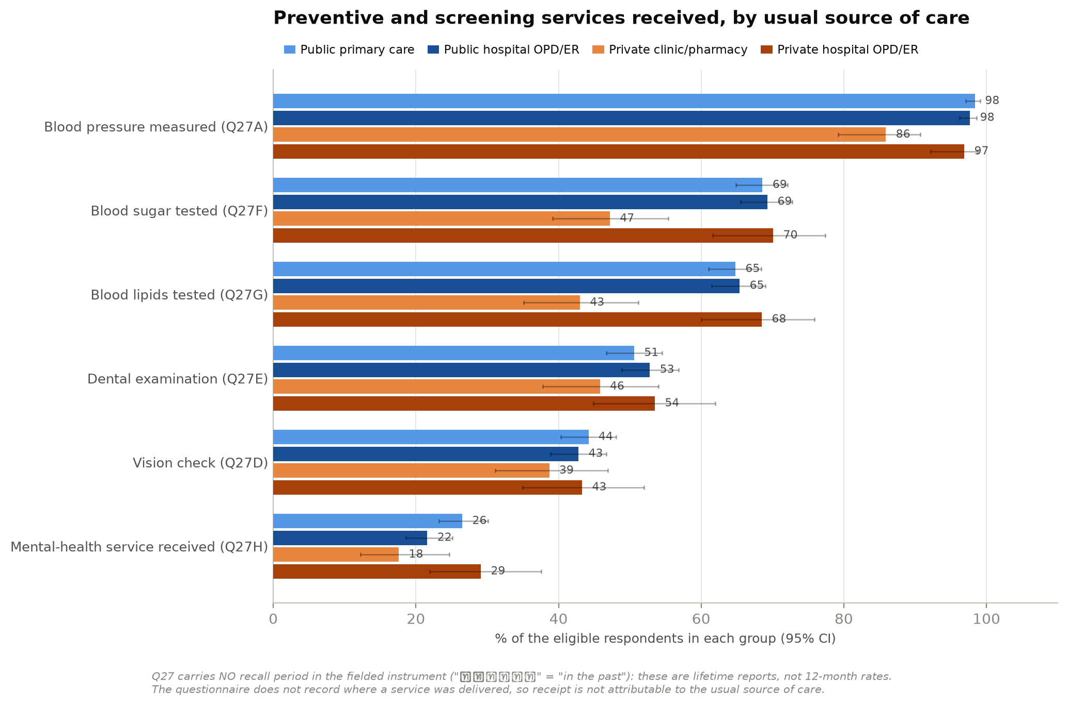
Figure 4. Preventive and screening services received, by usual source of care.
Bars show the percentage with a 95% Wilson interval. Breast examination and cervical screening are reported over women only and appear in Table 5 rather than here.
Table 5. Adjusted odds of receiving each service, reference public hospital OPD/ER.
Adjusted for age band, sex, education, income, municipality, coverage scheme, self-rated health and chronic illness, with cluster-robust standard errors. Breast and cervical screening are restricted to women and drop sex from the covariate set. "Diff (pp)" is the difference in average predicted probability — the quantity to read for magnitude. Bold marks BH-adjusted p < 0.05.
Outcome | Group | aOR (95% CI) | p | p (BH within family) | Diff (pp) | events | group n
Blood pressure measured (Q27A) | public primary care | 1.66 (0.51–5.39) | 0.401 | 0.743 | 0.9 | 616 | 625
Blood pressure measured (Q27A) | private clinic/pharmacy | 0.15 (0.04–0.48) | 0.002 | 0.029 | -11.224 | 121 | 141
Blood pressure measured (Q27A) | private hospital OPD/ER | 0.65 (0.21–1.99) | 0.454 | 0.743 | -1.171 | 122 | 126
Blood sugar tested (Q27F) | public primary care | 1.08 (0.79–1.48) | 0.613 | 0.864 | 1.435 | 428 | 625
Blood sugar tested (Q27F) | private clinic/pharmacy | 0.58 (0.34–1.00) | 0.05 | 0.324 | -10.193 | 66 | 141
Blood sugar tested (Q27F) | private hospital OPD/ER | 1.12 (0.59–2.12) | 0.72 | 0.864 | 2.061 | 89 | 126
Blood lipids tested (Q27G) | public primary care | 1.07 (0.78–1.47) | 0.695 | 0.864 | 1.169 | 404 | 625
Blood lipids tested (Q27G) | private clinic/pharmacy | 0.62 (0.36–1.04) | 0.072 | 0.324 | -9.214 | 60 | 141
Blood lipids tested (Q27G) | private hospital OPD/ER | 1.32 (0.67–2.59) | 0.419 | 0.743 | 4.979 | 87 | 126
Dental examination (Q27E) | public primary care | 1.00 (0.74–1.35) | 0.995 | 0.995 | 0.025 | 314 | 625
Dental examination (Q27E) | private clinic/pharmacy | 0.72 (0.45–1.16) | 0.175 | 0.526 | -7.96 | 64 | 141
Dental examination (Q27E) | private hospital OPD/ER | 0.82 (0.53–1.28) | 0.382 | 0.743 | -4.816 | 68 | 126
Vision check (Q27D) | public primary care | 1.20 (0.90–1.61) | 0.223 | 0.575 | 4.184 | 274 | 625
Vision check (Q27D) | private clinic/pharmacy | 1.12 (0.67–1.86) | 0.669 | 0.864 | 2.523 | 55 | 141
Vision check (Q27D) | private hospital OPD/ER | 1.01 (0.54–1.92) | 0.964 | 0.995 | 0.333 | 55 | 126
Mental-health service received (Q27H) | public primary care | 1.38 (0.99–1.93) | 0.056 | 0.324 | 5.578 | 163 | 625
Mental-health service received (Q27H) | private clinic/pharmacy | 1.03 (0.55–1.95) | 0.919 | 0.995 | 0.52 | 25 | 141
Mental-health service received (Q27H) | private hospital OPD/ER | 1.83 (0.85–3.92) | 0.122 | 0.439 | 11.038 | 37 | 126
Breast examination/mammogram (Q27B) — women only | public primary care | 1.32 (0.92–1.88) | 0.128 | 0.493 | 6.236 | 167 | 354
Breast examination/mammogram (Q27B) — women only | private clinic/pharmacy | 1.27 (0.66–2.47) | 0.473 | 0.818 | 5.465 | 35 | 82
Breast examination/mammogram (Q27B) — women only | private hospital OPD/ER | 0.96 (0.46–2.02) | 0.918 | 0.918 | -0.862 | 28 | 66
Cervical screening (Q27C) — women only | public primary care | 1.30 (0.90–1.89) | 0.164 | 0.493 | 5.986 | 170 | 354
Cervical screening (Q27C) — women only | private clinic/pharmacy | 1.14 (0.57–2.25) | 0.711 | 0.853 | 2.905 | 37 | 82
Cervical screening (Q27C) — women only | private hospital OPD/ER | 1.27 (0.58–2.80) | 0.546 | 0.818 | 5.474 | 36 | 66
Table 6. Blood pressure and other services, splitting private clinics from pharmacies.
The five-group split is descriptive only; pharmacy n = 60 and private clinic n = 82.
Measure | Public  primary care | Public hosp.  OPD/ER | Private  clinic | Private  pharmacy | Private hosp.  OPD/ER | p
Blood pressure measured | 624/634 (98.4; 97.1-99.1) | 601/615 (97.7; 96.2-98.6) | 80/82 (97.6; 91.5-99.3) | 42/60 (70.0; 57.5-80.1) | 123/127 (96.9; 92.2-98.8) | <0.001 †
Blood sugar tested | 435/634 (68.6; 64.9-72.1) | 426/615 (69.3; 65.5-72.8) | 49/82 (59.8; 48.9-69.7) | 18/60 (30.0; 19.9-42.5) | 89/127 (70.1; 61.6-77.4) | <0.001
Blood lipids tested | 411/634 (64.8; 61.0-68.4) | 402/615 (65.4; 61.5-69.0) | 44/82 (53.7; 42.9-64.0) | 17/60 (28.3; 18.5-40.8) | 87/127 (68.5; 60.0-75.9) | <0.001
Dental examination | 321/634 (50.6; 46.7-54.5) | 325/615 (52.8; 48.9-56.8) | 47/82 (57.3; 46.5-67.5) | 18/60 (30.0; 19.9-42.5) | 68/127 (53.5; 44.9-62.0) | 0.011
Vision check | 280/634 (44.2; 40.3-48.1) | 263/615 (42.8; 38.9-46.7) | 40/82 (48.8; 38.3-59.4) | 15/60 (25.0; 15.8-37.2) | 55/127 (43.3; 35.0-52.0) | 0.051
Mental-health service received | 168/634 (26.5; 23.2-30.1) | 133/615 (21.6; 18.6-25.1) | 19/82 (23.2; 15.4-33.4) | 6/60 (10.0; 4.7-20.1) | 37/127 (29.1; 21.9-37.6) | 0.015

4. How they rate quality
The eleven items covering the most recent visit are grouped here into five domains — access and process, interpersonal treatment, continuity, perceived competence and readiness, and a global rating. The grouping is an interpretive framework for reading the results, not a validated scale, and no factor analysis was forced on 127 people.
Nine of eleven items differ after adjustment and multiplicity control. The largest differences are satisfaction with waiting time (aOR 3.54, +26.9 pp), the provider knowing the patient’s history (3.16, +26.6 pp), ease of getting an appointment (3.28, +23.8 pp) and time spent in the consultation (2.91, +24.0 pp). Interpersonal items follow: courtesy of other staff (2.52), involvement in decisions (2.13), respect (2.00) and clear explanation (1.92).
The two items that speak to competence do not differ. Provider knowledge and skill is aOR 1.38 (0.83–2.31) and equipment and supplies ready is 1.11 (0.69–1.78); neither is significant before or after adjustment for multiple testing. Public hospital users in fact rate their providers’ knowledge (48.5%) above almost everything else about the visit.
That shape is the central quality finding, and it needs stating carefully. Respondents are not reporting that private hospitals are clinically better; they are reporting that private hospitals are faster, more attentive, more personal and easier to navigate. Equally, none of the eleven items measures objective clinical quality — all are patient perceptions of a single visit, and the overall-experience item is not an independent measure of clinical competence. The public sector’s perceived weakness, read through its own users’ eyes, is service process.
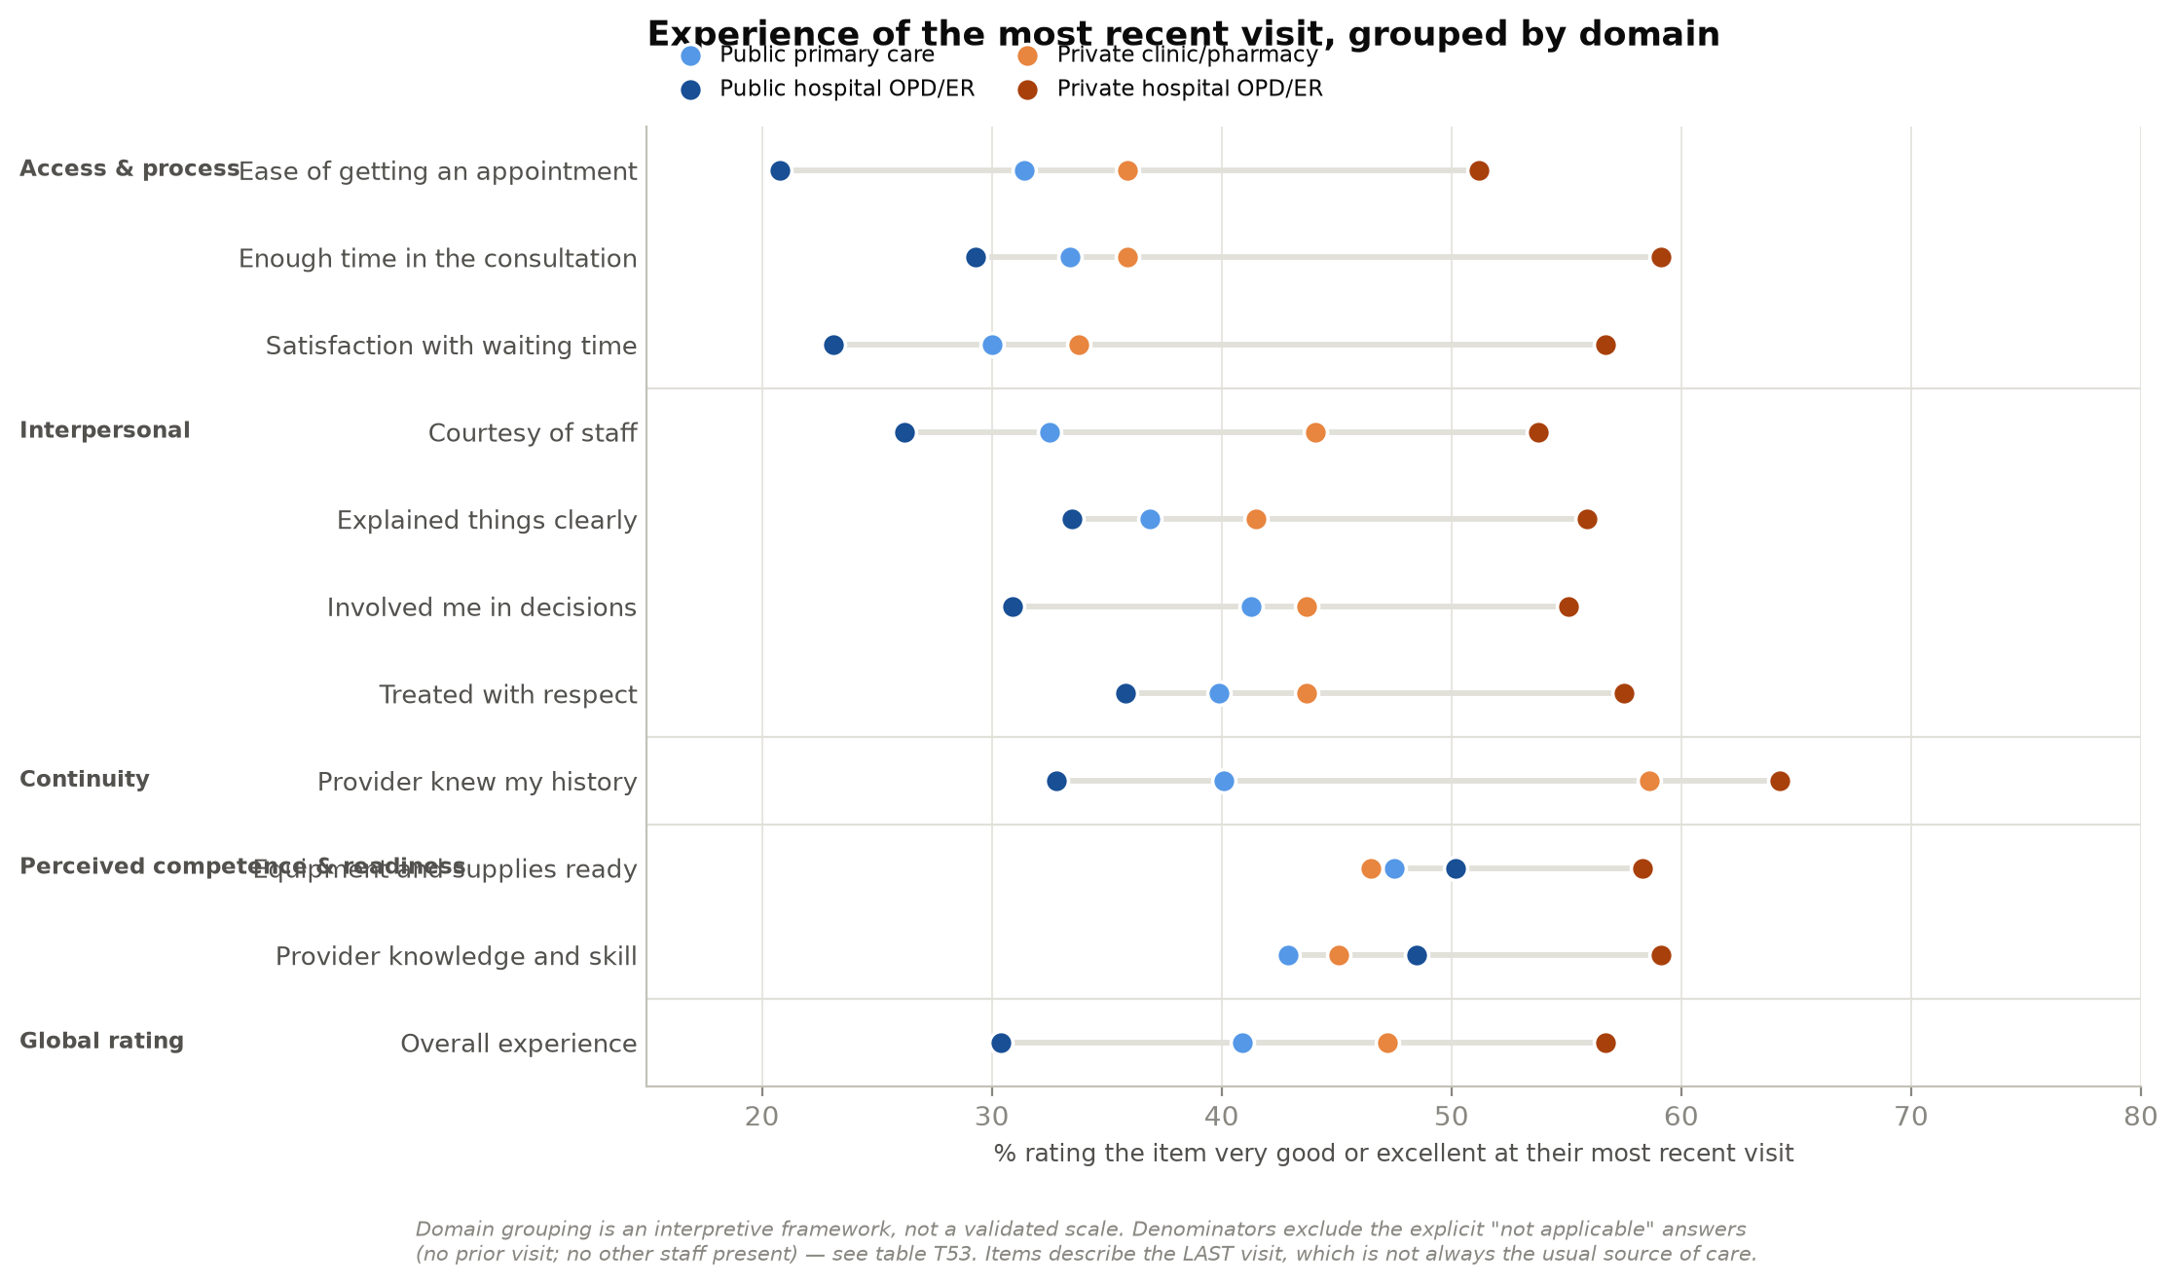
Figure 5. Experience of the most recent visit, grouped by domain.
Markers show the percentage rating each item very good or excellent. Denominators exclude the explicit not-applicable answers and therefore differ by item and group.
Two things qualify the comparison. First, denominators move by group: nearly a third of private clinic and pharmacy users answered "no prior visit" to the continuity item, against 11.8% of private-hospital users, which shifts their estimate on that item from 58.6% of those who rated it to 40.8% of the whole group. Second, these items describe the most recent visit, which is the usual source of care for 84.3% of private-hospital users but only 64.1% of private clinic and pharmacy users. Re-attributing every item to the actual last-visit provider, and restricting to respondents whose usual and last-visit provider agree, both preserve the pattern.
Table 7. Structural "not applicable" answers, which change the denominator by group.
These are explicit response options in the fielded instrument — "no prior visit / don’t know" on Q38e, "no other staff present" on Q38j, "cannot evaluate" on Q40 — not item non-response.
Item | Not-applicable answer | Public  primary care | Public  hospital OPD/ER | Private  clinic/pharmacy | Private  hospital OPD/ER
Provider knew my history | no prior visit / did not know | 78/634 (12.3) | 57/615 (9.3) | 43/142 (30.3) | 15/127 (11.8)
Courtesy of staff | no other staff involved | 65/634 (10.3) | 55/615 (8.9) | 24/142 (16.9) | 8/127 (6.3)
Q40a maternal | cannot evaluate | 96/634 (15.1) | 121/615 (19.7) | 23/142 (16.2) | 20/127 (15.7)
Q40b child | cannot evaluate | 83/634 (13.1) | 98/615 (15.9) | 21/142 (14.8) | 17/127 (13.4)
Q40c chronic | cannot evaluate | 66/634 (10.4) | 59/615 (9.6) | 13/142 (9.2) | 10/127 (7.9)
Q40d mental health | cannot evaluate | 94/634 (14.8) | 128/615 (20.8) | 23/142 (16.2) | 16/127 (12.6)

Table 8. Adjusted odds of rating each experience item very good or excellent.
Reference is public hospital OPD/ER. Covariates as in Table 5; cluster-robust standard errors. Bold marks BH-adjusted p < 0.05 within the 11-item family.
Outcome | aOR (95% CI) | p | p (BH within family) | Diff (pp) | events | group n
Global rating — Overall experience | 2.24 (1.33–3.77) | 0.002 | 0.008 | 17.805 | 72 | 126
Perceived competence & readiness — Provider knowledge and skill | 1.38 (0.83–2.31) | 0.214 | 0.282 | 7.787 | 75 | 126
Perceived competence & readiness — Equipment and supplies ready | 1.11 (0.69–1.78) | 0.674 | 0.695 | 2.41 | 74 | 126
Interpersonal — Treated with respect | 2.00 (1.21–3.31) | 0.007 | 0.016 | 15.744 | 73 | 126
Continuity — Provider knew my history | 3.16 (1.91–5.25) | 0.0 | 0.0 | 26.596 | 72 | 112
Interpersonal — Explained things clearly | 1.92 (1.21–3.06) | 0.006 | 0.015 | 14.715 | 71 | 126
Interpersonal — Involved me in decisions | 2.13 (1.25–3.62) | 0.005 | 0.015 | 16.88 | 70 | 126
Access & process — Enough time in the consultation | 2.91 (1.77–4.78) | 0.0 | 0.0 | 24.037 | 75 | 126
Access & process — Satisfaction with waiting time | 3.54 (2.08–6.04) | 0.0 | 0.0 | 26.869 | 72 | 126
Interpersonal — Courtesy of staff | 2.52 (1.48–4.30) | 0.001 | 0.004 | 19.928 | 64 | 118
Access & process — Ease of getting an appointment | 3.28 (1.88–5.72) | 0.0 | 0.0 | 23.754 | 65 | 126

5. What it means for confidence in the system
The experience premium stops at the clinic door. No system-level contrast is detectable after adjustment and multiplicity control: health security (aOR 1.27, 0.80–2.01), confidence in getting good care (1.19), confidence in affording it (1.34), the direction of the system over two years (1.34), endorsement of the current system (0.80), the rating of the public system (1.23), and whether government listens to the public (0.88). The higher rating of the private system (1.62, 0.95–2.77) does not survive Benjamini–Hochberg adjustment within this family.
None of that establishes equality. The interval for health security is compatible with anything from a modest decrease to a doubling, and a cross-sectional survey cannot test whether the quality of an encounter produces confidence in a system. The honest statement is that this survey does not detect a difference by provider group.
What the data do show directly is more interesting. A good personal experience and insecurity about serious illness routinely coexist: 14.2% of private-hospital users rate their own facility very good or excellent while remaining unsure they could both get and afford care if seriously ill, against 11.5% of public hospital users. Health security is instead strongly associated with patient activation (aOR 1.78, 1.31–2.43) — a characteristic of the respondent rather than a feature of the provider.
It is also worth noting which group is most positive about the public system. Public primary care users rate it high more often than anyone else, rate the government’s COVID-19 management highest, and are the only group in which a majority is confident the system takes public opinion into account. Public hospital outpatient users — not private-sector customers — are consistently the least satisfied group in this report, and they are the second largest.
Table 9. Confidence in and evaluation of the health system, by provider group.
Health security is Q41a and Q41b jointly, both conditioned on "if you were seriously ill". The Q40 public primary care items carry an explicit "cannot evaluate" option, so their denominators are smaller.
Measure | Public  primary care | Public  hospital OPD/ER | Private  clinic/pharmacy | Private  hospital OPD/ER | p | Denominator
Confident of good care if seriously ill (Q41a) | 534/634 (84.2; 81.2-86.9) | 480/615 (78.0; 74.6-81.1) | 108/142 (76.1; 68.4-82.3) | 105/127 (82.7; 75.2-88.3) | 0.017 | all in group
Confident of affording care if seriously ill (Q41b) | 443/634 (69.9; 66.2-73.3) | 400/615 (65.0; 61.2-68.7) | 92/142 (64.8; 56.6-72.2) | 94/127 (74.0; 65.8-80.9) | 0.101 | all in group
Health security (Q41a AND Q41b) | 430/634 (67.8; 64.1-71.3) | 388/615 (63.1; 59.2-66.8) | 88/142 (62.0; 53.8-69.5) | 91/127 (71.7; 63.3-78.8) | 0.112 | all in group
Health-security state (four-way decomposition) |  |  |  |  | 0.134 | see rows below
can get & afford | 430/634 (67.8) | 388/615 (63.1) | 88/142 (62.0) | 91/127 (71.7)
can get, cannot afford | 104/634 (16.4) | 92/615 (15.0) | 20/142 (14.1) | 14/127 (11.0)
cannot get, can afford | 13/634 (2.1) | 12/615 (2.0) | 4/142 (2.8) | 3/127 (2.4)
neither | 87/634 (13.7) | 123/615 (20.0) | 30/142 (21.1) | 19/127 (15.0)
Government listens to the public (Q41c) | 395/634 (62.3; 58.5-66.0) | 318/615 (51.7; 47.8-55.6) | 71/142 (50.0; 41.9-58.1) | 67/127 (52.8; 44.1-61.2) | <0.001 | all in group
System improved over 2 years (Q45) | 183/634 (28.9; 25.5-32.5) | 177/615 (28.8; 25.3-32.5) | 59/142 (41.5; 33.8-49.8) | 46/127 (36.2; 28.4-44.9) | 0.008 | all in group
System works well / minor change only (Q46) | 269/634 (42.4; 38.6-46.3) | 293/615 (47.6; 43.7-51.6) | 57/142 (40.1; 32.4-48.4) | 52/127 (40.9; 32.8-49.6) | 0.154 | all in group
Public system quality very good/excellent (Q42) | 149/634 (23.5; 20.4-27.0) | 98/615 (15.9; 13.3-19.0) | 22/142 (15.5; 10.5-22.3) | 21/127 (16.5; 11.1-24.0) | 0.003 | all in group
Private system quality very good/excellent (Q43) | 302/634 (47.6; 43.8-51.5) | 269/615 (43.7; 39.9-47.7) | 75/142 (52.8; 44.6-60.8) | 72/127 (56.7; 48.0-65.0) | 0.025 | all in group
Government COVID-19 management (Q47) | 140/634 (22.1; 19.0-25.5) | 72/615 (11.7; 9.4-14.5) | 23/142 (16.2; 11.0-23.1) | 22/127 (17.3; 11.7-24.8) | <0.001 | all in group
Public maternal care (Q40a) | -- | -- | -- | -- | -- † | all in group
Public child care (Q40b) | -- | -- | -- | -- | -- † | all in group
Public chronic care (Q40c) | -- | -- | -- | -- | -- † | all in group
Public mental-health care (Q40d) | -- | -- | -- | -- | -- † | all in group
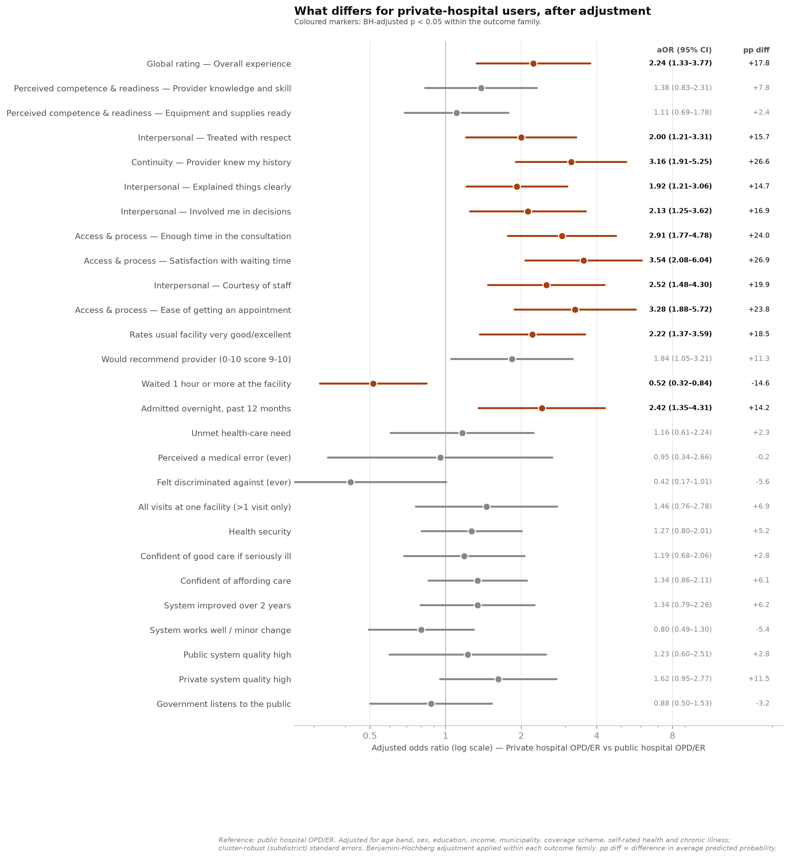
Figure 6. Adjusted differences for private-hospital users, across all outcome families.
Reference is public hospital OPD/ER. Coloured markers mark Benjamini–Hochberg adjusted p < 0.05 within the outcome family. "pp diff" is the difference in average predicted probability, which is the quantity to read for magnitude — not the odds ratio.

6. Admission: the one finding this survey cannot resolve
Private-hospital users report an overnight admission in the past twelve months at 29.1%, against 22.1% of public hospital users, 16.9% of public primary care users and 13.4% of private clinic and pharmacy users. The difference survives full adjustment including chronic illness (aOR 2.42, 1.35–4.31; +14.2 pp), and adding unmet need and visit volume does not remove it. It is the largest adjusted difference outside the experience ratings, in the group reporting the best health.
Three things follow, and only three. The association is real in these data. It is not explained by need as this survey measures it — though that is a weak instrument, since Q11 is a non-specific chronic-illness indicator rather than a diagnosis, and no disease-specific information exists. And it cannot be attributed to a private hospital at all: Q26 records that an admission happened, never where it happened.
It does not demonstrate overuse, supplier-induced demand, or a reimbursement effect. It is a signal that warrants investigation with claims and clinical information, by facility, payer and case mix.
Table 10. Admission: sensitivity to the specification.
Each block is a separate model on the same cohort. Chronic illness is already in the base covariate set. Where the analytic n changes, that is a change of sample, not only of adjustment.
Specification | Group | aOR | lo | hi | p | Diff (pp) | n
Base specification | public primary care | 0.87 | 0.594 | 1.273 | 0.473 | -1.812 | 1505
Base specification | private clinic/pharmacy | 1.052 | 0.538 | 2.055 | 0.883 | 0.682 | 1505
Base specification | private hospital OPD/ER | 2.417 | 1.354 | 4.314 | 0.003 | 14.172 | 1505
+ chronic illness already in base (shown for clarity) | public primary care | 0.87 | 0.594 | 1.273 | 0.473 | -1.812 | 1505
+ chronic illness already in base (shown for clarity) | private clinic/pharmacy | 1.052 | 0.538 | 2.055 | 0.883 | 0.682 | 1505
+ chronic illness already in base (shown for clarity) | private hospital OPD/ER | 2.417 | 1.354 | 4.314 | 0.003 | 14.172 | 1505
+ unmet need and visit volume | public primary care | 0.903 | 0.614 | 1.329 | 0.606 | -1.285 | 1505
+ unmet need and visit volume | private clinic/pharmacy | 1.16 | 0.577 | 2.33 | 0.677 | 1.986 | 1505
+ unmet need and visit volume | private hospital OPD/ER | 2.577 | 1.37 | 4.849 | 0.003 | 14.812 | 1505

7. Coverage, financing and who these patients actually are
The reviewer’s question about how private-hospital patients pay cannot be answered with this instrument, and that is worth stating plainly rather than approximating. The survey records coverage ownership (Q6, Q7) and one general habit item about paying out of pocket in some situations. It never asks who paid for any specific visit or admission, how much, whether a copayment applied, or whether private insurance was actually used. Nor does it record employment status or the provider a respondent is registered with.
What can be shown is the overlap of entitlements. Of the 127 regular private-hospital users, 66 (52.0%) hold Social Security without private insurance, 22 (17.3%) hold both, 33 (26.0%) hold Universal Coverage and 5 (3.9%) hold the civil-servant scheme. Owning private insurance is not evidence of having used it; holding a scheme other than Social Security does not make someone a self-payer; and citing "low cost" as a reason is not evidence of having received free care.
Table 11. What the instrument does and does not record about money.
The distinction between coverage ownership and payment at an encounter is the single largest evidence gap for private-hospital oversight.
Concept | Measured? | Variable | Caveat
Public scheme eligibility/ownership (Q6) | YES | scheme | Ownership of an entitlement, not use of it
Private insurance ownership (Q7.1) | YES | priv_ins_owned | Ownership only; never linked to an encounter
Employer-purchased insurance (Q7.2) | YES | employer_ins_owned | Ownership only
Pays out of pocket in some situations (Q7.4) | PARTIAL | insr_oop | General habit, not a specific encounter or amount
Registered / contracted provider | NO | -- | Cannot establish that SSS members were assigned to their provider
Payer at the most recent visit | NO | -- | The reviewer's payment question is unanswerable with these data
Out-of-pocket amount / copayment | NO | -- | No expenditure item anywhere in the instrument
Employment status | NO | -- | SSS membership is not evidence of current salaried employment
Borrowed/sold assets for care, ever (Q31) | YES | borrowed_ever | Lifetime recall; not attributed to any provider
Table 12. Observed profiles of regular private-hospital users.
Declared subgroups, not clusters. No unsupervised clustering was applied to 127 respondents and no names, biographies, expenditure amounts or motivations are invented. Cells are n/N (%).
Characteristic | SSS member,  no private insurance | SSS member,  also owns private insurance | UCS member | CSMBS member
n | 66 | 22 | 33 | 5
% of private-hospital users | 52.0 | 17.3 | 26.0 | 3.9
Median age band | 40-49 | 30-39 | 60-69 | 30-39
Female | 36/66 (55) | 12/22 (55) | 14/32 (44) | 3/5 (60)
Municipal | 29/66 (44) | 12/22 (55) | 17/33 (52) | 5/5 (100)
Upper-secondary + | 61/66 (92) | 19/22 (86) | 26/33 (79) | 4/5 (80)
Income 30k+ | 37/66 (56) | 7/22 (32) | 15/33 (45) | 5/5 (100)
Chose provider for insurance coverage | 29/66 (44) | 7/22 (32) | 6/33 (18) | 1/5 (20)
Chose provider for short wait | 10/66 (15) | 3/22 (14) | 17/33 (52) | 2/5 (40)
Admitted overnight | 25/66 (38) | 4/22 (18) | 7/33 (21) | 1/5 (20)
Unmet need | 5/66 (8) | 5/22 (23) | 11/33 (33) | 0/5 (0)
Borrowed for care (ever) | 2/66 (3) | 3/22 (14) | 0/33 (0) | 0/5 (0)
Rates facility very good/excellent | 41/66 (62) | 8/22 (36) | 21/33 (64) | 3/5 (60)
High activation | 58/66 (88) | 17/22 (77) | 31/33 (94) | 5/5 (100)
Health secure | 43/66 (65) | 17/22 (77) | 25/33 (76) | 5/5 (100)
One further boundary matters. Regular private-hospital users are not a sample of the private-hospital market. A different and overlapping population — respondents whose most recent visit was to a private hospital (n = 202) — is 58.4% Social Security rather than 69.3%, and reports admission at 20.8% rather than 29.1%. Episodic private-hospital use during a recall period is not measurable at all, because Q32 and Q33 capture only the single most recent visit. Nothing in this report describes cash-paying patients, inpatients as a population, or international patients.

8. Thailand in international context
The comparison usually drawn between Thailand and India is between two different indicators. The widely quoted 84.1% for India is confidence in getting good-quality care, taken from Figure 2A of Kruk et al. (2024). India’s health security — confidence in both getting and affording care — is 69.2%, and the 15-country average is 48.8%.
On that indicator Thailand is 64.4% (95% CI 62.2–66.4): 15.6 percentage points above the multi-country average and 4.8 points below India. The premise that Thailand sits notably low on health security is not supported by the source data.
The measure is respondents’ confidence that, if they became seriously ill, they could obtain good-quality care and afford it. It is subjective and conditioned on a hypothetical. A lower value does not demonstrate worse financial protection, access or clinical outcomes. India’s age eligibility, geographic coverage, fieldwork dates, survey mode, weighting and uncertainty could not be verified from the materials available, so differences in expectations, sample composition, timing, mode or translation remain hypotheses to investigate rather than demonstrated causes of the remaining gap. Objective indicators — catastrophic and impoverishing health expenditure, effective coverage, unmet need from household surveys — could triangulate the finding, but they measure different things and cannot replace it.
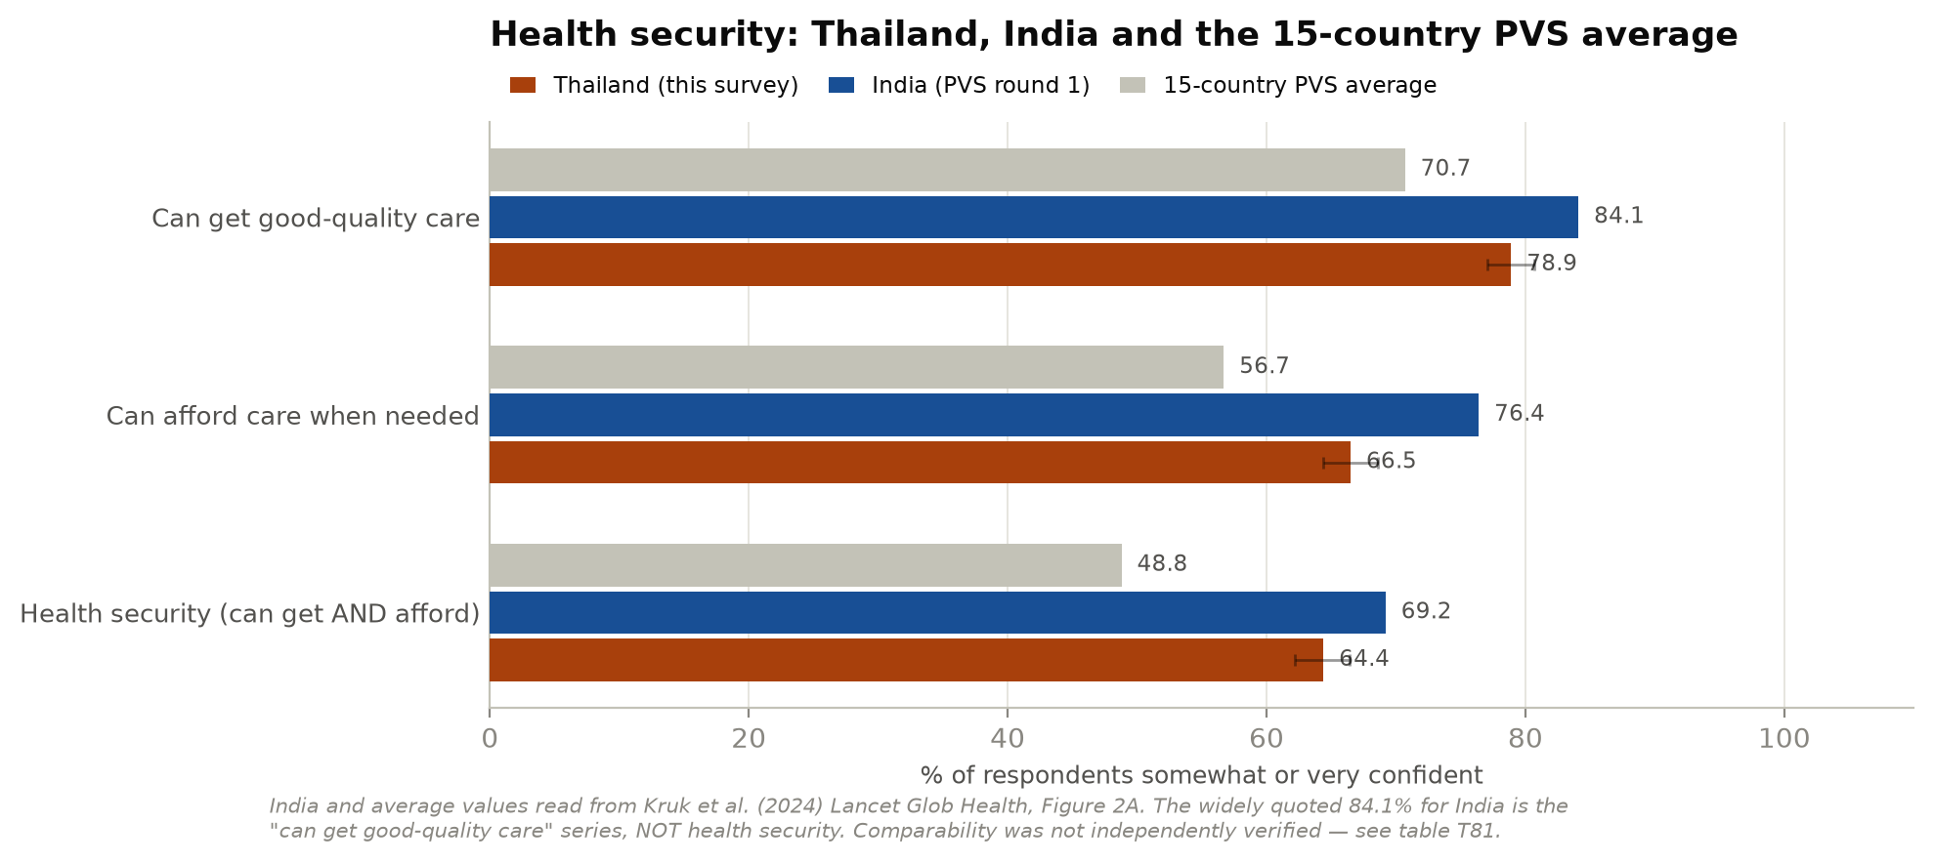
Figure 7. Health security: Thailand, India and the 15-country PVS average.
India and average values read from Kruk et al. (2024) Lancet Global Health, Figure 2A. Thailand’s intervals are Wilson 95% intervals on the unweighted achieved sample.

9. What this suggests
Taken together, the findings point in a consistent direction, and it is not the direction the public debate about private hospitals usually assumes.

The private sector here is an extension of public financing, not an alternative to it
Seven in ten regular private-hospital users hold Social Security; insurance coverage is the reason they most often give for choosing their provider; low cost is almost never mentioned; and their household incomes are middling rather than high. Read alongside the fact that Social Security members register with a contracted main hospital that may be public or private, the most economical explanation is that a large part of what looks like private purchasing is scheme-assigned registration. This survey cannot prove that — it never asks where anyone is registered — but any account that treats private-hospital growth as discretionary buying by the affluent will misidentify both who these patients are and what would change their behaviour. The policy lever is the contract, not the price.

The gap that public hospitals need to close is a service gap, not a clinical one
Users of private hospitals report better experiences on waiting, scheduling, consultation length, continuity and interpersonal treatment — differences of 15 to 27 percentage points — while reporting no detectable difference in the provider’s knowledge and skill or in the readiness of equipment and supplies. This is a claim about perceptions, not about clinical outcomes, and it cuts both ways: it gives no support to the idea that private hospitals are clinically superior, and it locates the public sector’s perceived weakness precisely. For public hospital outpatient departments — the group that is consistently least satisfied on almost every measure in this report — the improvement agenda indicated here is waiting, appointment access, consultation time and continuity of records, rather than equipment or staff competence.

Prevention is not where the public–private difference lies
On eight screening and prevention items, private-hospital users and public hospital users are statistically indistinguishable. If there is a prevention concern in these data it attaches to pharmacies used as a regular first contact, where blood-pressure measurement runs about twenty-seven points below every other group, and to the 488 respondents with no usual source of care at all, who sit lowest on every item. Both are questions about primary care coverage, not about private hospitals. A practical implication for the analysis itself: clinics and pharmacies should not be reported as a single "private primary" category, because combining them conceals this.

Higher admission is the finding that should drive the next piece of work
It is the largest adjusted difference outside the experience ratings, it appears in the group reporting the best health, and it survives adjustment for chronic illness, unmet need and visit volume. It is also the finding this survey is least able to interpret, because the questionnaire never records where an admission occurred. Whether it reflects lower admission thresholds, case mix the survey cannot see, or the incentives facing contracted providers is not answerable here and is answerable with claims data. Of everything in this report, this is the item most worth the cost of linkage.

Better encounters do not appear to add up to confidence in the system
Private-hospital users rate their own provider markedly higher and are no more confident about the health system, its direction, or their own health security. A substantial minority in every group rates their own facility highly while remaining unsure they could get and afford care if seriously ill, and health security tracks patient activation — a characteristic of the person — more visibly than it tracks provider type. The cautious reading is that improving the experience of individual encounters, which the private sector demonstrably does on these measures, is not by itself a route to population confidence. The design cannot test that causal claim, and the confidence intervals are wide enough to accommodate a real difference this survey was too small to detect.

And the largest gap is that nobody was asked about money
No question in this instrument identifies who paid for any encounter, how much, whether a copayment applied, or whether private insurance was used. For a programme of work aimed at regulating private hospitals — where price transparency, billing practice and patient liability are central — that is the binding constraint. It is straightforward to fix in a future round.

Candidate questions for private-hospital oversight
The following follow from the findings above. None is a proven effective policy, and none describes what Thai law currently requires — current or study-period rules must be verified from authoritative sources before being asserted.
- Contracted-provider experience by payer. Most regular private-hospital users arrive holding a public entitlement. Should contracted-provider performance be monitored separately by payer? Needs registration records, contract terms and claims data.
- Service-process standards, monitored separately from clinical ones. The measured differences are in waiting, appointment access, consultation time and continuity. Service-process standards could be monitored separately from clinical standards, using standardised patient-experience items in routine licensing returns.
- Two distinct waiting indicators. The wait at the facility and the wait to obtain an appointment behave very differently and should be published as two indicators. This survey records ordered categories, not durations; facility administrative data would be needed.
- Admission rates, investigated with claims and clinical data. Higher self-reported admission in the healthiest group is the priority for follow-up, by facility, payer and case mix. The survey cannot establish where an admission occurred or whether it was necessary.
- Patient payment and billing transparency — currently unmeasurable. A payer and out-of-pocket module, or claims linkage, is required before patient-payment or billing-transparency questions can be answered at all.
- Complaints and adverse events, linked to a facility. Perceived medical error and felt discrimination are recorded without a facility identifier and without a recall window, so neither can be attributed to any provider. Linking complaint and incident reporting to a facility identifier would make them measurable.
- The preventive role of pharmacies. Pharmacies serving as a regular first contact show markedly lower preventive-service receipt. What preventive role, if any, should attach to that? Needs pharmacy service-scope data.

Limitations
Final recruitment was quota-based convenience within PPS-selected subdistricts, so selection probabilities are unknown, no valid design weights exist, and no conventional response rate can be computed — no recruitment disposition records were located. Matching the sampling plan on region, municipality and age is a useful check but is not evidence that selection bias is absent, and the sex quota was not met. Because one province was sampled per health region, province-level strata are single-PSU and design-based variance is not estimable at that level; the subdistrict-clustered standard errors used here are an approximation, not design-based inference. All estimates are unweighted.
The private-hospital group contains 127 respondents and the private clinic and pharmacy group 142 (82 clinic, 60 pharmacy), so intervals are wide and several contrasts are indeterminate rather than null. Benjamini–Hochberg adjustment is applied within each outcome family and both raw and adjusted p-values are reported; no outcome was dropped for being null. Adjustment addresses measured confounding only — it does not address the convenience selection, the unmeasured insurance-routing mechanism, or sparse cells, and adjusted estimates are not automatically a more reliable guide to which differences are real.
All measures are self-reported, most without a recall window and none validated against records. The design is cross-sectional, so every provider-group result is an association rather than an effect. Several things are simply not measured: who paid for any encounter and how much, employment status, the registered or contracted provider, the facility at which an admission occurred, and health literacy — the instrument contains no literacy item, and patient activation and education are different constructs that should not stand in for it. The two expectation vignettes (Q48, Q49) were fielded but analysed in no report, and remain the only direct route to the expectations arm of the PVS framework.

About this edition
This edition consolidates the original subgroup analysis with a subsequent audit of the cohort definition, variable coding, denominators, attribution and inference, and supersedes the earlier draft of the same title. Substantive changes to previously reported numbers include a corrected self-rated-health coding (78.8% rather than 54.9% report good or better health), corrected age denominators, recall periods taken from the fielded instrument rather than from the report text, explicit handling of "not applicable" response codes, sex-restricted denominators for breast and cervical screening, and the addition of cluster-robust standard errors, marginal predicted probabilities and multiplicity adjustment. Two results reported as significant in the earlier draft do not survive: perceived provider knowledge and the rating of the private system.
The analysis code is in src/pvs/. Regenerated tables and figures are written to output/; the approved September release is preserved in results/2026-09/. Every figure and table here is generated from the analysis exports; no value is typed independently.

References
1. Kruk ME, Kapoor NR, Lewis TP, et al. Population confidence in the health system in 15 countries: results from the first round of the People’s Voice Survey. Lancet Glob Health. 2024;12(1):e100–e111.
2. Lewis TP, Kapoor NR, Aryal A, et al. Measuring people’s views on health system performance: design and development of the People’s Voice Survey. PLoS Med. 2023;20(12):e1004294.

