3. Show violation of Primary key, Unique, Not null, and default key constraints through insertion.

Ans.

create database movie1;

use movie1;

create table movie2(movie_id int primary key, movie_name varchar(45) unique, budget int not null, lead_role_gender varchar(45) default "male");

insert into movie2(movie_id, movie_name, budget) values(123, "Valimai", 50000);

insert into movie2(movie_id, movie_name, budget) values(123, "polladavan", 30000);

insert into movie2(movie_id, movie_name, budget) values(123, "Valimai", 50000);

insert into movie2(movie_id, movie_name, budget) values(124, "Valimai", 60000);

insert into movie2(movie_id, movie_name) values(125, "commander");

insert into movie2(movie_id, movie_name, budget, lead_role_gender) values(131, "wonder_woman", 80000,"female");

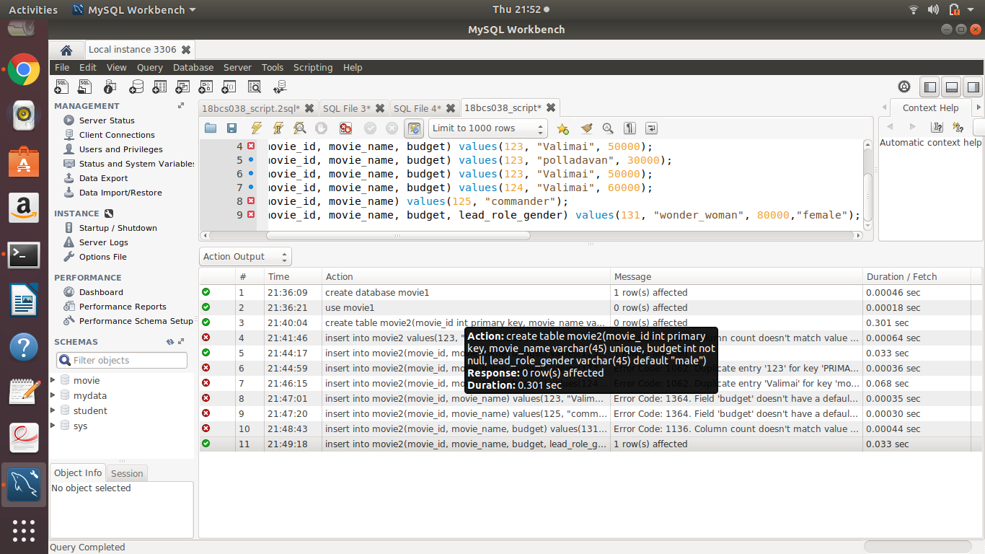

5. Insert tuples into the table and see how foreign key constraint works if you try to insert into the dependent table first.

Ans.

create database d4;

create table movie4(movie_id int primary key, movie_name varchar(45) unique, budget int not null, lead_role_gender varchar(45) default "male");

create table songs1(movie_id int, song_name varchar(45), singer varchar(45), composer varchar(45), foreign key(movie_id) references movie4(movie_id));

insert into songs1 values(123, "Dil_bechara", "Mariam", "ar_rahman");

