1. Inner Join 3 queries

Ans.

1. select title, genre, rating, director_name, no_of_movies from movies1 inner join director on movies1.director_id=director.director_id where no_of_flops<=8;

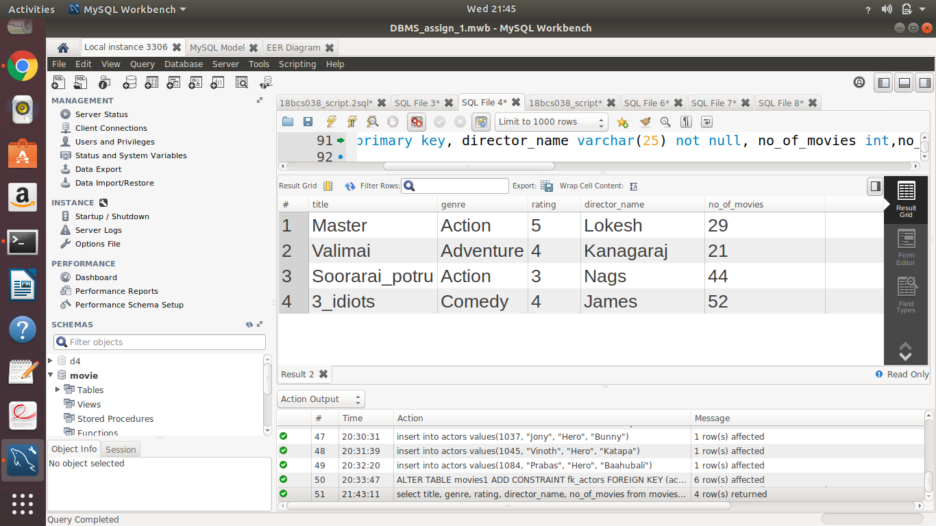

1. select title,genre,producer_name,no_of_films,rating from movies1 inner join producer on movies1.producer_id=producer.producer_id where producer.budget in(select max(producer.budget)from producer);

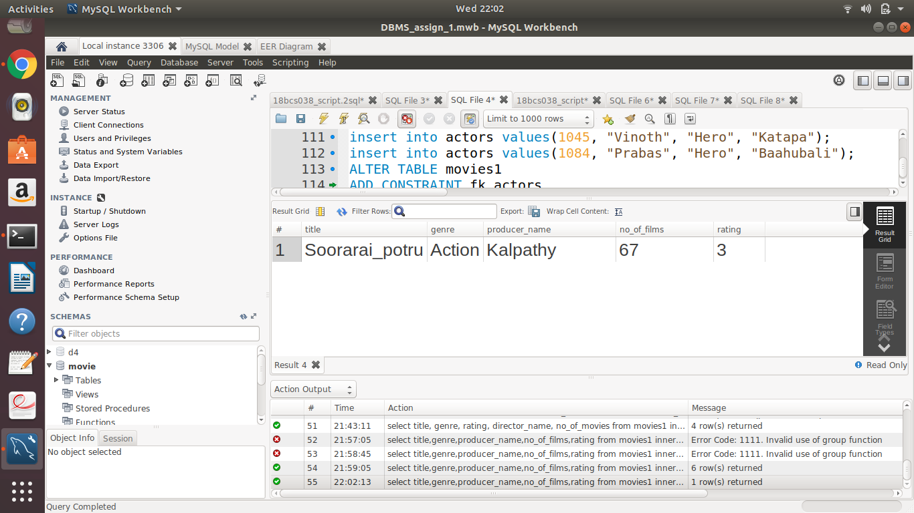

1. select title,actor_name,director_name,producer_name from (((movies1 inner join actors on movies1.actor_id=actors.actor_id and actors.actor_name like 'J%') inner join director on movies1.director_id=director.director_id) inner join producer on movies1.producer_id=producer.producer_id);

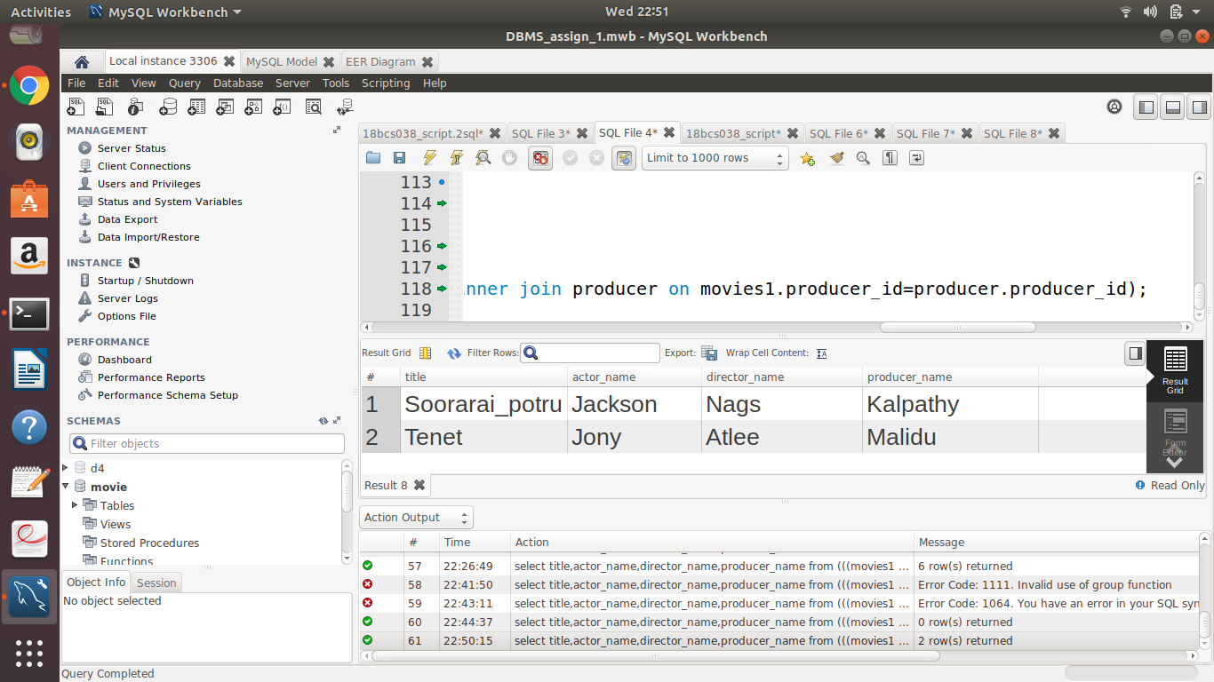

2. Left Outer Join 3 queries

Ans.

1. select actor_name,type_of_role,title,genre from actors left outer join movies1 on actors.actor_id=movies1.actor_id order by actor_name;

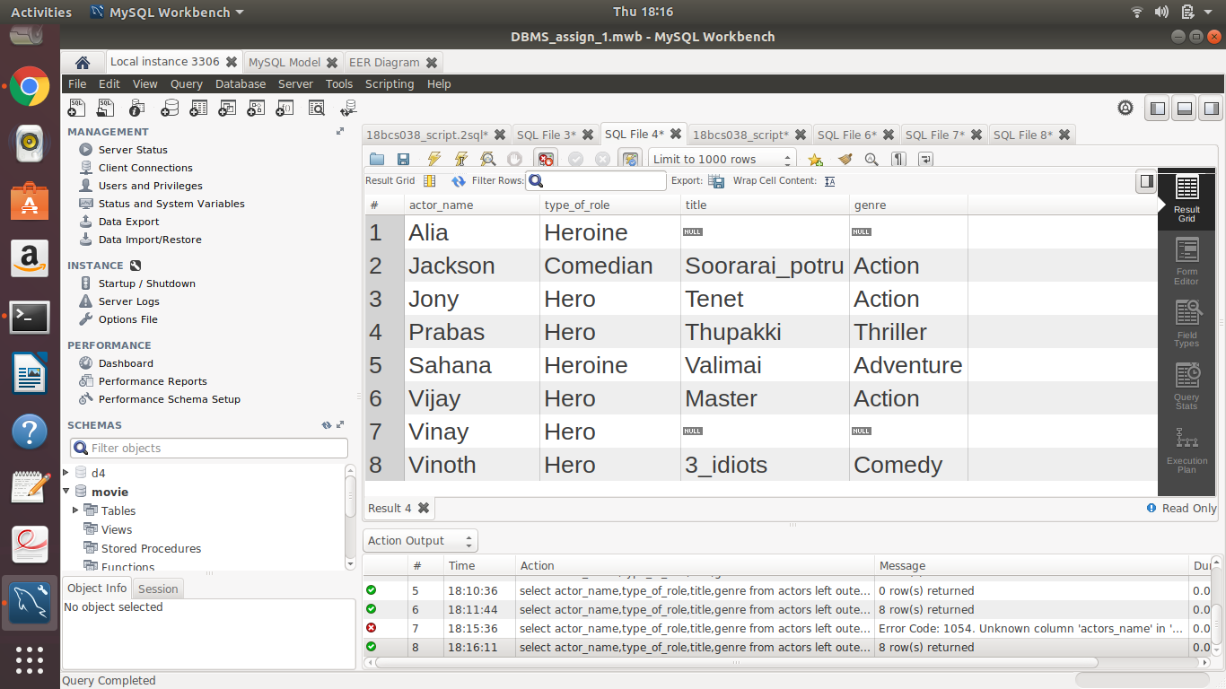

1. select title,producer_name,director_name as movie_info from((movies1 left outer join producer on movies1.producer_id=producer.producer_id and producer.budget>70000)left outer join director on movies1.director_id=director.director_id and director.no_of_movies>20);

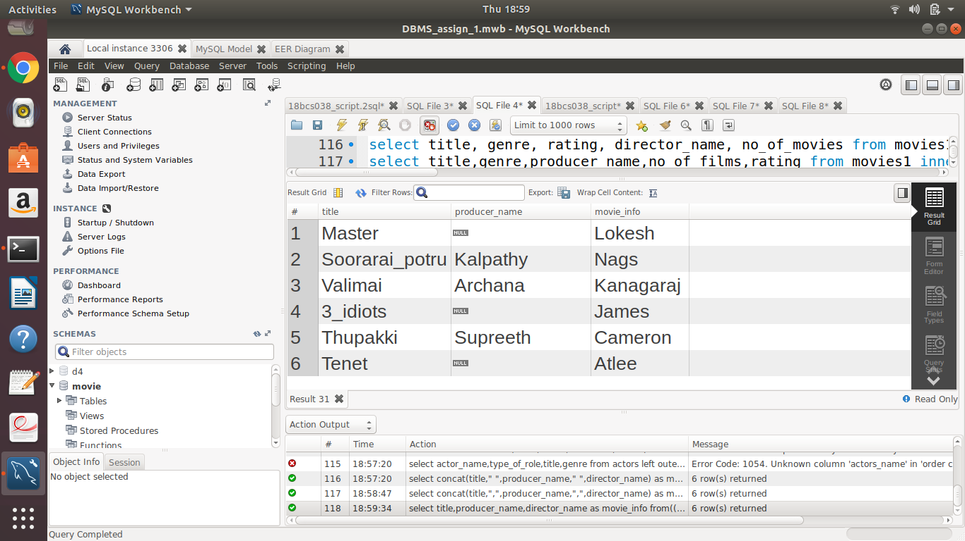

1. select distinct title,song_name,actor_name,director_name from(((movies1 left outer join songs on movies1.movie_id=songs.movie_id and songs.movie_id=123)left outer join actors on movies1.actor_id=actors.actor_id)left outer join director on movies1.director_id=director.director_id);

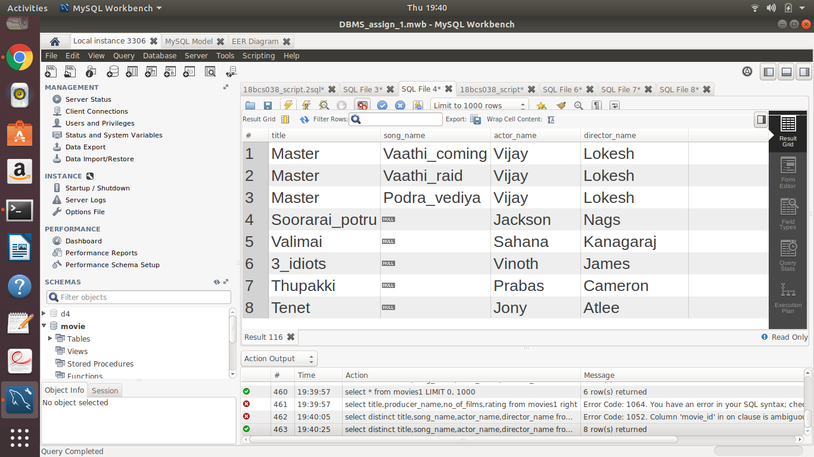

3. Left Outer Join 3 queries

Ans.

1. select title,producer_name,no_of_films,rating from movies1 right outer join producer on movies1.producer_id=producer.producer_id and producer.no_of_films between 20 and 50;

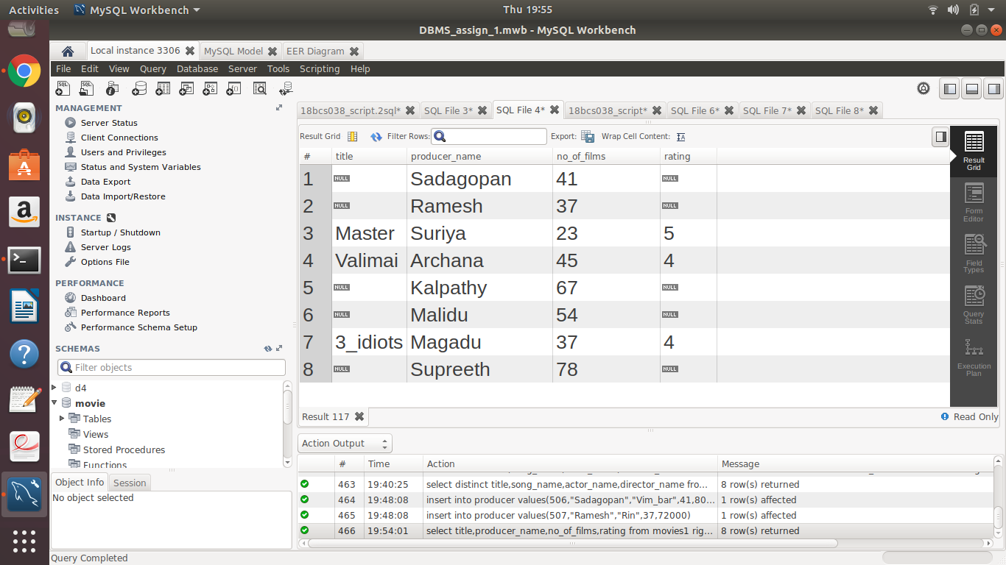

1. select title,actor_name,type_of_role,producer_name from((movies1 right outer join actors on movies1.actor_id=actors.actor_id and actors.type_of_role = "Hero")right outer join producer on movies1.producer_id=producer.producer_id);

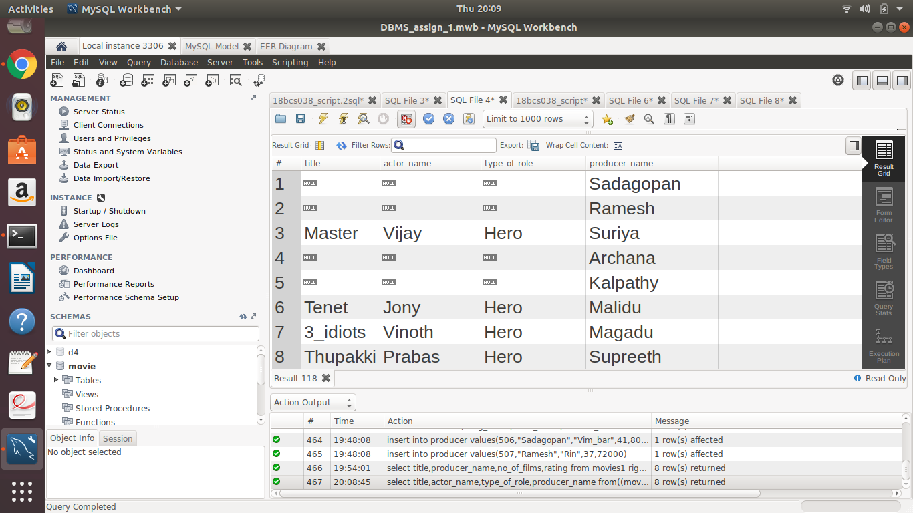

1. Select title,song_name,actor_name,director_name,producer_name from((((movies1 right outer join songs on movies1.movie_id=songs.movie_id)right outer join actors on movies1.actor_id=actors.actor_id) right outer join director on movies1.director_id=director.director_id)right outer join producer on movies1.producer_id=producer.producer_id)where movies1.genre="Action" order by movies1.title desc;

