TaoChronos: A Reliable Agent for Knowledge Discovery in Traditional Chinese Medicine
Authors: [Author 1]^{1,*}, [Author 2]¹, … [Corresponding author]^{1,*}
¹ IMPF-AI (医哲未来人工智能研究院), [address]. *Corresponding author: [e-mail].

Abstract
Large language models can mine the classical literature of traditional Chinese medicine (TCM), but their claims may misquote the texts, misread negations and conditions, count copies of one text as independent testimony, equate historical with modern diseases, and resist checking without hindsight. We present TaoChronos, an agent for knowledge discovery from Chinese medical classics in which models and rules only propose, deterministic validators grade and human experts alone approve. Every claim must quote a dated witness verbatim and be stated by that quote. On 966 witnesses (123 million characters, 475 BCE–1949), TaoChronos rejected 180 of 180 corrupted quotations, kept 19 of 19 safety invariants, each broken when its safeguard was removed, and read 82 of 84 held-out hard interpretive cases correctly. In a blind temporal benchmark, rankings from earlier texts anticipated links later physicians wrote (precision@10 0.168 versus 0.134 for popularity and 0.054 for chance; P = 2.4 × 10⁻¹⁶).

Introduction
The classical literature of traditional Chinese medicine (TCM) is one of the longest written records of clinical observation. For two thousand years physicians wrote down findings, prescriptions and outcomes, and copied, annotated, abridged and contested one another’s texts. The record has yielded medicines: the low-temperature extraction of qinghao that led to artemisinin was suggested by a fourth-century prescription in Ge Hong’s Zhouhou beiji fang¹, and arsenic, a mineral drug of the tradition, became a cure for acute promyelocytic leukaemia². Literature-based discovery has long held that connections no single text states can be found by joining what different texts say³, and machine reading of the modern scientific literature can anticipate findings years before they are published^{4–6}. The TCM classics, however, are unlike a modern literature. A passage survives in witnesses that differ character by character; its date is often a range, and the commentaries on it accumulated over centuries; a name meant different things in different periods; and most of what later books say was copied from earlier ones.
Large language models (LLMs) have entered this field quickly. ZhongJingGPT, introduced in 2023 as the first large language model dedicated to TCM, fine-tuned general-purpose models on instructions constructed from TCM expert knowledge^{7,8}, alongside Chinese medical models such as HuatuoGPT and Zhongjing^{9,10}; benchmarks now test such models on TCM and classical Chinese^{11,12}, pretrained models read the classical corpus¹³, and LLMs help build knowledge graphs from the ancient medical literature^{14,15} beside databases that link herbs, compounds, targets and symptoms from modern sources^{16–18}. More broadly, LLMs encode clinical knowledge¹⁹, and LLM agents now search and synthesize the literature, call tools, plan experiments, and propose and test hypotheses^{20–29}. In these systems the reliability of what is asserted rests largely on the model. LLMs can state fluent claims with fabricated or unsupported citations^{30–32}; retrieval augmentation and atomic fact checking reduce such errors but do not rule them out^{33,34}, and the discoveries of agentic systems are usually judged afterwards, by experts or by experiments, rather than by checks built into the system. On historical medical texts the failure modes are specific (Table 1): a quotation altered by one character; a true quotation read as stating what it denies; five copies of one clause counted as five testimonies; an ancient disease name equated with a modern diagnosis; an association called ‘lost’ that a later book still states; an agent grading its own work; and a ‘prediction’ tested on books the system had already read. Tools for the digital humanities restore, date and contextualize ancient texts^{35–38}, but do not make discoveries under such controls.
We argue that in this domain reliability must be a property of the agent’s architecture rather than of its model. It should be impossible, not merely unlikely, for the agent to commit a misquotation, to grade its own work, to mistake a finished run for an accepted finding, or to see the future when its foresight is tested. TaoChronos (道乃久) is built on this principle, which we call deterministic harness, stochastic intelligence: everything that must be trustworthy — state, permissions, verification, stopping and acceptance — is deterministic code, and intelligence, whether a language model or a rule-based procedure standing in for one, may only propose. This paper makes four contributions.
- An agent architecture that separates proposal from verdict. Sixteen agents, a Director and fifteen specialists, work on an event-sourced research object through a permissioned tool mesh. Every event carries the principal that emitted it, and the reducer refuses an event that principal may not emit, so agents propose, validators grade and only a human expert approves. Lifecycle hooks require every claim to quote its passage verbatim and to be stated by that quote; nine epistemic gates (G0–G8) grade sources, readings, independence of testimony and falsification; and an executable research contract, fixed before the first task, decides whether a research is accepted, so that finishing the tasks never counts as success (Fig. 1, Table 1).
- A dated, layered and licence-tracked corpus of the Chinese medical classics. It holds 966 witnesses of 761 works (about 123 million characters in 2.05 million passages, 475 BCE–1949), each passage with its book, edition, locator, date range, textual layer, transcription source and licence. Commentaries and later additions are dated apart from the text they annotate, independent transcriptions are kept as separate witnesses, and an openly licensed canon, defined by the tradition’s own citation network, runs in a web browser together with a deterministic study layer for philology and the history of formulas, drugs and terms (Figs. 2 and 6).
- A three-layer evaluation of reliability and research value. Safety invariants are run as probes against the agent and checked by mutation; hard interpretive cases are scored with unsafe errors counted apart, on a held-out split fixed before the first run and in blind rounds; and a blind temporal benchmark asks whether what the agent ranks from the past anticipates what later physicians wrote, with every read path bounded in time so that leakage is counted rather than assumed (Figs. 4 and 5, Table 2).
- Guarded translation to modern medicine and complete transparency. An ancient–modern bridge projects the findings of a passage into the Human Phenotype Ontology³⁹ with typed relations and reports phenotypic similarity, never a retrospective diagnosis; modern evidence is typed by study design and population, and real-world-data queries are compiled from checked specifications, never written by a model⁴⁰. A complete research run is released with its replayable event log and an analysis of its failures that were reported, not repaired (Fig. 3, Supplementary Fig. 1).
Every result in this paper was obtained with the deterministic procedures alone, without calling a language model. The numbers therefore measure the floor the architecture guarantees whichever model is plugged in.

Results

An agent in which proposal and verdict are separated
A scientist’s question becomes a research contract: its focus terms, forbidden equivalences (for example 消渴 = diabetes mellitus), discovery tracks, required gates, acceptance criteria and stop rule, hashed before the first task (Fig. 1a). The Director plans each round and chooses, among fifteen specialists, the agents the kernel spawns: a Curator who freezes the scope, a Philologist (readings, variants and collation), a Semanticist (period-bound senses), an Extractor (claims with verbatim spans), Lineage and Scholar agents (citation, transcription and the textual history of the focus terms), an Evidence agent, a Pattern Miner running five discovery engines (D1, lost knowledge; D2, concept drift; D3, formula evolution; D4, hidden associations; D5, contradictions), a Statistician, an Evolution analyst, a Hypothesis agent, a Skeptic, a Meta-reviewer, and two agents for the translation to modern medicine (Supplementary Table 4). An agent is configuration, not code: a specification names its permissions, tools, context view, output schema, model tier and budget, and a deterministic procedure and a language model produce the same typed output, which one commit function verifies.
Every change to the research is a typed event in an append-only log, and the reducer is the only code that changes state. Each event carries its principal (kernel, human, validator or agent), set from an identity object and never by the emitter; the reducer checks it against an authority table of 61 event types (Fig. 1b, Supplementary Table 7). Agents may plan, read, extract, propose and review; only validators grade gates, scores, rankings and the contract; only a human expert may approve or reject a hypothesis (gate G7) or steer a research; an objection is closed only by a validator’s passing re-run of its check or by an expert, never by a model. Each of the 85 tools needs one of eight permissions, and every call passes a scope guard before it runs and a result firewall after it, so material withheld from a research does not exist for its agents (Supplementary Tables 5 and 6). Claims pass three commit hooks: provenance (the harness, not the producer, locates the quote in its passage), semantic support (the quote must state the claim’s relation) and an anachronism guard. Gates G0–G8 grade the source, transcription, philology, sense, claim provenance, independent source families, falsification, expert approval and, for cross-space hypotheses only, modern biomedical evidence (Supplementary Table 2). At the end of a run a validator judges every hypothesis against the contract on its current version: the research is accepted, needs an expert, is inconclusive or exhausted its budget, and individual hypotheses may be rejected (Supplementary Table 3). Every claim can be walked back through a provenance chain, in the sense of the W3C PROV model⁴¹, to the words of a witness, its edition, its transcription and its licence (Fig. 1c).

A dated, layered corpus spanning two millennia
The corpus joins transcriptions from ten sources (Fig. 2a, Supplementary Table 13). Admission keeps historical texts and removes contemporary publications, works of contemporary physicians and modern annotated editions; de-duplication against more trusted sources uses normalized 12-character shingles, while independently collated transcriptions are kept as separate witnesses. Dating is layer-aware: main text, commentaries, editors’ notes and later additions are dated apart, and a witness that cannot be dated is counted as Qing (1644–1911), never earlier. The store holds 966 witnesses of 761 works, about 123 million characters in 2.05 million passages, from the Warring States to the Republican period (Fig. 2b). Of the 966 witnesses, 537 are dated to a single year; the basis of every date is recorded, from curation by the editors (329) and the year in the book’s record (204) to signed prefaces (139) and the author’s life (116); 104 are undated and counted as Qing (Fig. 2c). Normalization of variant and simplified forms is used for matching only; the transcription is never altered.
The tradition’s own citations define its canon. An influence score combines the works that cite a work, the periods in which it is cited, its citations, its witnesses and its inclusion in the Siku quanshu (Fig. 2d). The openly licensed texts of 533 of the 535 ranked works form a web corpus of 553 witnesses (10.46 million characters, 168,278 passages) that runs in the browser, whole for the first classics and by chapters for the rest (Fig. 2e). Catalogue records of 10,001 printed and manuscript copies in eleven digitized collections link 179 works to physical witnesses (Supplementary Fig. 4).

One research question, end to end
We put one question to the agent on the open canon corpus: 肾气丸的组成与主治如何随时代演变？ (How did the composition and indications of Shenqi wan change over time?), with Shenqi wan and Liuwei dihuang wan as focus terms and 消渴 = diabetes forbidden (Fig. 3a). The contract required verbatim quotations and at least two evidence records from at least two independent source families, gates G0–G6 to pass on the current version of each hypothesis (G4–G6 strictly), no open hard or critical objection, rival explanations addressed and expert review before publication; the run would stop after two rounds or when new evidence added less than 5%. The scope held 273 books and 1,620 passages naming a focus term.
The run planned 30 tasks in three rounds and wrote 678 events (agents 442, validators 103, kernel 133); it called 143 tools, none refused, and no language model (Fig. 3b). It extracted 935 claims and recorded 80 evidence and 13 counter-evidence records. Of 14 hypotheses proposed in round 1, the Skeptic kept 2, sent 11 back to be narrowed and rejected 1, raising 102 objections (Fig. 3c, Supplementary Table 10). The run stopped after round 2, which added no evidence. The contract’s verdict (Fig. 3d,e): four hypotheses wait for an expert. Two meet every criterion a machine can check — that restlessness (烦躁) with strangury (淋) is a characteristic indication of Liuwei dihuang wan, resting on two independent families of Qing books (H1), and that the dominant sense of 中风 shifted from wind attack to stroke between the Ming and the Qing (H2) — and two (H3, H4) rest in part on a quotation that does not clearly state its claim, a judgement the contract leaves to an expert. Nine were inconclusive, all short of two independent source families; the clearest case, the association of copious drinking and urine with Shenqi wan (H5), rests on six books that all carry one clause of the Jingui yaolüe — the clause of Fig. 1c — or copy or cite it. One hypothesis, that heat (热) and counterflow qi (上气), associated before 960, were not linked afterwards (R1), was rejected because three later books state the link. A second run wrote the same report. The report, the event log and every hypothesis and objection are released (Supplementary Data 1 and 2, Supplementary Tables 9 and 10).
Reading every hypothesis against its evidence found six failure modes (Supplementary Fig. 1). The independence gate merges books linked by any transcription or rephrasing link, closed transitively, and so put 36 of the 46 books that supplied evidence, and 233 of the 553 books of the corpus, into one source family; with transcription links only, four hypotheses that failed G5 would rest on two or three families, although for two of them (H5, H13) the evidence is indeed copies of one clause. The rules read two findings of one list as an association: R1 rests on 口熱 and 上氣 in the Maijing’s list of the kidney channel’s illnesses, and the later books that refuted it copy the same list. The evidence for the drift of 中风 includes passages that do not name 中风 at all, and the three drift hypotheses (H2–H4) failed their own permutation tests (P = 0.66, 0.89 and 0.98); narrowing them to ‘exploratory’ closed the objection, which is how they reached the expert’s queue. Three contradictions (H9–H11) rest on Xue Ji’s records of treatments that failed, read as doctrine, and his notes in his editions of earlier works carry the dates of those works. Hypotheses that share their evidence were not merged, and because the open corpus keeps 8 of the 24 chapters of the work of 1119 that first records Liuwei dihuang wan, the earliest composition found was of 1564. We report these failures unrepaired. None led the contract to accept a hypothesis, and the largest made the independence gate stricter rather than looser; but they show that ‘waits for an expert’ is a queue, not a finding, and why the final judgement, gate G7, belongs to an expert.

Quotations stay verbatim, boundaries hold and hard readings stay safe
On 60 random passages, every verbatim quotation was accepted and every quotation with one character replaced, of random characters or of the right words at a shifted span was rejected (240 of 240 decisions; Fig. 4a); variant spellings were accepted after normalization. Every claim and evidence record committed in a demonstration run was verbatim, with a mean provenance chain of 7.8 levels.
Nineteen invariants (the boundaries the agent promises) were run as probes against the intact agent and against six variants, each with one boundary removed at run time, in the manner of mutation testing⁴². All 19 held on the intact agent; each removal broke the invariant named for its boundary and no other, so 127 of 133 cells held (Fig. 4b). In three cases a second safeguard limited the damage: without the scope guard, the tool it no longer refused returned nothing of the withheld passage; forged expert approvals reached the log but not the state; and without the bound checks two of five impossible evidence records were verified.
Hard interpretive cases test readings that a verbatim quotation does not protect: an inverted relation, a prohibition beside a prescription, a consequence that is a warning rather than a cure, a view the author reports or rejects, an omitted condition, mixed witnesses, a disputed date and a textual crux. Of 107 such cases in eight classes, 23 were used to write the rules and 84 were held out, the split fixed before the first run. The agent read 82 of the 84 held-out cases correctly (0.976; Fig. 4c). Both errors were unsafe: a clause in which most commentators place the formula Dahuang mudan tang before the prohibition 不可下也, and a doubted word (里水) in the Yuebi jia zhu tang clause, neither stated in a form the crux harvest reads. Accuracy was measured in four blind rounds, each on cases written before the rules that first read them (Fig. 4d). The first scored 43 of 53, with four unsafe errors; general rules (a report governs until its author answers it; a 者-clause followed by an action is a condition; an intervention named by 之 is read through its pronoun) raised the second to 30 of 32. The third round introduced textual cruxes and scored 7 of 10, three unsafe; a registry of 127 cruxes harvested from the commentaries by rules for transposition, emendation, interpolation, omission and doubt raised the fourth to 5 of 5. On 25,000 passages of the full corpus, this second, independent reader found 71 rule claims contradicted by their own quotes; fixing the extractor at the source left 12, which the commit hook refuses.

Rankings computed from the past anticipate the links later physicians wrote
To ask whether the agent’s discoveries have research value without relying on experts’ hindsight, we split the full corpus at two cutoffs, 1127 and 1368, into passages written wholly before and wholly after each; passages that may have been written on either side belong to neither (Fig. 5a). The rules were written before the first run. For every disease or symptom with 150–6,000 past and at least 300 future passages, the formulas and drugs of its past graph not yet linked to it were ranked, and a candidate came true when claims in two or more later books linked it to the topic. In 189 topic–cutoff pairs at least one of the 29,467 candidates came true (1,314 in all; base rate 4.5%). Adamic–Adar⁴³, the ranking engine D4 uses, reached a precision@10 of 0.168 (95% confidence interval 0.152–0.185) and a mean average precision of 0.199, against 0.134 and 0.143 for popularity and 0.054 and 0.092 for chance (Fig. 5b). It ranked above popularity in 149 pairs and below it in 39 (two-sided sign test, P = 2.4 × 10⁻¹⁶), at each cutoff (Fig. 5c). Common neighbours scored as well as Adamic–Adar within the intervals. Examples of anticipated links include 消渴 (wasting-thirst) with Zhuling tang and Gegen, 胸痹 (chest impediment) with Gualou shi, and 霍乱 (sudden turmoil) with dried ginger. No passage outside the past view was read.
The whole pipeline was then run on the past view at 1368 for two development and four held-out topics, and its structured predictions were judged by later books (Fig. 5d). Of 25 held-out predictions, lost associations stayed absent in 4 of 9, association rules held in 1 of 7, and hidden associations came true in 4 of 8, of which two were new. The checks on arguments from silence rejected two wrong ‘lost’ and two already-written ‘hidden’ associations and no discovery, raising the share of surviving predictions that were discoveries, true and new, from 7 of 23 to 7 of 19 (0.37; 95% CI 0.19–0.59). The verdict is modest: the ranking anticipates later links well above popularity and chance, while the pipeline’s hypotheses, judged one by one, come true about as often as not. Re-run with identical rules on the open canon corpus, the benchmark had 51 pairs with a true link (109 among 10,115 candidates; 28 pairs with a single one): Adamic–Adar still ranked above popularity (37 of 51, P = 0.0018) but could not be told from chance (19 better, 32 worse, P = 0.092) (Supplementary Fig. 3, Supplementary Tables 11 and 12). The benchmark needs the full corpus.

The study layer recovers history written into the texts
The deterministic study layer answers the questions scholars ask of the literature daily, and on the open canon corpus it recovers results the history of medicine already holds (Fig. 6). The share of works writing 山药 rather than 薯蓣 switches between 1000 and 1200, after naming taboos on the names of the Tang emperor Daizong (762) and the Song emperor Yingzong (1063), and 元参 replaces 玄参 between 1600 and 1800, after the taboo on the Kangxi emperor’s name (1662) (Fig. 6a,b). Passages on warm disease (温病) per 10,000 passages stay between 21 and 36 from the Han to the Ming and rise to 61 in the Qing (Cochran–Armitage z = 7.30, P = 2.8 × 10⁻¹³), when the doctrine of warm diseases grew into a school of its own (Fig. 6c). Drug pairs that co-occur beyond chance in 4,554 compositions (1,184 pairs; one-sided Fisher exact tests, Benjamini–Hochberg q < 0.05⁴⁴) form communities found without formula names; of the twelve largest, the five whose drugs hold together most tightly are the cores of classical formulas — 乳香, 没药 and 血竭 of Qili san, 大戟, 甘遂 and 芫花 of Shizao tang, 水蛭, 虻虫, 桃仁 and 大黄 of Didang tang, 连翘, 薄荷 and 栀子 of Liangge san, and 牛黄, 麝香, 冰片, 朱砂 and 雄黄 of Angong niuhuang wan — while liquorice, in 43% of compositions, joins none (Fig. 6d); on the full store all seven textbook pairs tested were significant with lift above 1.5. Of 1,446 citations between 78 physicians, 569 (39%) cite Zhang Ji, the author of the Shanghan lun (Fig. 6e).

Generalization and the bridge to modern medicine
Where rules were written with examples, held-out data show how far they transfer (Supplementary Fig. 2, Table 2). Hard interpretive readings fell from 1.00 on development cases to 0.98 on held-out cases, entity recognition in 24 types from an F1 of 0.99 to 0.78, and lost-text reconstruction from a precision of 0.86 on a constructed lost work to 0.32 on the real Qianjin yaofang. A punctuation model learned from editorially punctuated texts placed sentence boundaries with an F1 of 0.767 on 55 held-out works (rules, 0.235) and 0.780 on unpunctuated Siku texts, changing no character. Ablations showed which components carry the results: without the sense route of retrieval the earliest attestation of a term was found for 4 of 6 terms instead of 6, without sense resolution contradictions were typed right in 10 of 12 pairs instead of 12, and without the Skeptic a rejected hypothesis survived review; the agents’ context views were 94% smaller than a naive dump of the research state (8,427 against 142,388 tokens).
The ancient–modern bridge reads the findings of a passage — negated, optional, conditional or after treatment — into 168 ancient phenotypes projected onto 213 terms of the Human Phenotype Ontology, each with a relation type (exact, broader, partial overlap, historical semantic shift, no modern equivalent and others), and compares them with 64 modern disease profiles at qualitative levels that are never probabilities. On 12 passages drawn at random from 65 clinical works and annotated before the reader ran on them, it found findings with a precision of 0.938 and a recall of 0.732 (F1 0.822). A presentism guard handled 24 of 24 translation cases correctly, refusing equations, retrospective diagnoses and modern names a translation adds while letting careful comparisons pass; modern records are typed by design and population, and a cross-level guard refuses animal, cell or computational work read as efficacy in people (7 of 7). Asked for passages resembling diabetes mellitus, the bridge returns the Waitai miyao and the ‘three wastings’ of the Jingyue quanshu at a high level and the 消渴 of the Jingui yaolüe at a moderate one; asked for malaria, it also returns the alternating chills and fever of the Shanghan lun — a resemblance of a pattern to a disease, which is why the bridge reports resemblance and never diagnosis.
TaoChronos also runs as a conversation agent in the browser (Pyodide) on the open canon corpus, where a user’s chosen model answers through 79 tools and the page checks every cited passage word for word (verbatim, misquoted or no such passage). The same tools read a user’s own records, such as a clinic’s prescriptions or case notes, made anonymous as they are read and never recorded; this path was not evaluated here. Conversation records were not used in this study.

Discussion
TaoChronos shows that the reliability of an agent for knowledge discovery from historical medical texts can be designed and measured rather than hoped for. The checks that make it reliable are not instructions to a model; they are code a model cannot route around. A misquotation cannot be committed, an agent cannot approve its own hypothesis, a finished run is not an accepted finding, and a test of foresight cannot read the future. Each boundary was measured by removing it and watching its invariant break, and the readings that verbatim quotation does not protect were measured on cases held out before the rules were written. We think this inversion — the model’s output as untrusted input to deterministic checks, rather than the model as the judge of its own output — is what high-stakes uses of agents in medicine need.
The design complements TCM language models. ZhongJingGPT and its successors carry knowledge of TCM in their weights^{7,10}; TaoChronos carries none, but holds whatever a model proposes to the witnesses. A domain model can serve as the proposer inside the harness, where its claims meet the same provenance, support, independence and anachronism checks as the rules’ and its discoveries face the same contract. Because the kernel names no classic text, vendor or database, the same architecture could serve other written medical traditions — Kampo, Ayurveda or the Greek and Arabic corpora — and other literatures in which copies, commentaries and changes of meaning entangle the evidence.
The blind temporal benchmark offers a way to evaluate discovery without asking experts to judge novelty with hindsight. Its conclusion is deliberately narrow. Rankings from the past anticipated what later physicians wrote, well above popularity and chance, in line with link prediction on modern literatures^{6,45}; but anticipation is not influence or efficacy, both sides were read by the same rule extractor, and about a third of the pipeline’s surviving predictions were discoveries. On the open subset the benchmark could not separate the ranking from chance. For digital medicine the lesson is that a classical text can suggest what to study, as it did for artemisinin¹, and that provenance, independence and the absence of hindsight decide whether the suggestion deserves attention. TaoChronos never turns a suggestion into advice: the bridge reports resemblance, modern evidence must come from people to pass gate G8, and dosage or clinical advice is refused.
The study has limits. First, most gold sets were written by the authors with the rules they test; they are regression tests of intended behaviour, and only held-out and real-corpus results estimate generalization, some on small samples (12 bridge passages; 84 interpretive cases). Expert-annotated gold on the full corpus is needed. Second, every number was obtained with rules alone; model-assisted modes are implemented, with recorded and replayable responses, but not evaluated here. Third, the end-to-end run exposed an over-merging of source families that makes the independence gate too strict, and a narrowing that lets hypotheses whose own test failed reach the expert as ‘exploratory’; judging independence per claim, from the passages that support it, and treating a hypothesis’s failed test as a hard objection are the fixes we propose. Fourth, the full corpus cannot be redistributed because some sources forbid it; the open canon corpus reproduces the end-to-end run and the study layer but is too small for the temporal benchmark, whose full-corpus values are documented runs. Fifth, levels, verdicts and gates are ordinal labels, not calibrated probabilities, and the 64 disease profiles need clinical review. Sixth, the transcriptions were not collated by this project, Siku texts carry Qing alterations, and undated texts can only be placed ‘Qing or earlier’. Finally, an alias-aware search added since met six or seven of ten pre-specified acceptance checks on its held-out set, depending on the profile, and is reported as such.
Reliability, in this sense, is not a claim that the agent is right. It is a guarantee about what the agent cannot do, a record from which every conclusion can be rebuilt, and a measure of how often its proposals deserve a scholar’s time. We release the code, the open corpus, the evaluation suites, every figure’s source data and the complete record of a research run, findable and reusable in the sense of the FAIR principles⁴⁶, so that each of these can be checked.

Methods

Corpus construction
Transcriptions were taken from the Kanseki Repository (the medical section of the Siku quanshu, 100 works, CC BY-SA 4.0), JiCheng (中醫笈成, 816 of 857 edited texts; CC0 1.0 for its editorial work), CMETA (數位中醫校書郎, 11 editions collated against page images, CC BY 4.0), the Tōa Igaku Kyōkai (7 texts, local research use only), Wikisource (18 works new after de-duplication of 627, CC BY-SA 4.0), McGill University Library (5 works, public domain) and three further collections (Supplementary Table 13). Every text is pinned in a lock file by repository, commit, file hashes and licence; texts are never committed to the repository unless their licence allows redistribution. Admission screens out, in order, reviewed decisions, works composed from 1949, titles that mark a modern edition or a contemporary physician, a density of modern years, units and institutions, annotation apparatus and modern editors’ source marks; each excluded text is catalogued with its class and evidence. De-duplication ranks sources by trust and records a candidate sharing enough normalized 12-character shingles with an admitted work as its copy; McGill, CMETA and Tōa Igaku Kyōkai transcriptions are kept as independent witnesses.
Each work’s catalogue entry gives its authors, composition date range and layer rules: double-column notes as a commentary layer, marked notes (for example the Song editors’ 新校正云 of 1068 in the Suwen), indented commentary, chapters and sections added later (the seven Yunqi chapters inserted by Wang Bing in 762), and mixed layers dated by the latest, with the older text’s date kept as its citation date. Front matter is dated separately; undated prefaces are placed at the end of the imperial era. Dates follow, in order of precedence, curated overrides, the Kanripo catalogue, the book’s own record (years, reign eras, dynasties), dated prefaces parsed with a table of eras, another witness of the work and the author’s other dated works; an undatable witness is placed in the Qing, never earlier. Passages keep book, edition, volume, chapter, section and, where available, page and line, the date range, the layer, the transcription source and the licence. Normalization of variant, simplified and taboo forms is used for indexing and matching only.

Canon and the open web corpus
The influence of a work is 10 log₂(1 + citing works not older than it) + 2 × (periods in which it is cited) + 2 log₂(1 + citations) + 3 log₂(1 + witnesses) + 6 × (inclusion in the Siku quanshu), computed on the citation network the study layer resolves. The openly licensed witnesses of the 535 ranked works (533 have one) form the web corpus used for Figs. 2e, 3 and 6 and Supplementary Fig. 3 (553 witnesses, 10.46 million characters, 168,278 passages): a work’s first witness kept up to 350,000 characters for ranks 1–10, then 50,000 (to rank 40), 25,000 (to rank 120) and 12,000, whole where shorter and by sampled chapters otherwise, and second and third witnesses for the ten highest-ranked works.

Claims, readings and the claim hypergraph
The Extractor turns a passage into claims: hyperedges such as indicated_for(formula: 五苓散 | pulse: 浮, symptom: 小便不利, symptom: 微热, disease: 消渴), each with a verbatim quotation, a character span for every argument, negations, optional findings, conditions and adverse outcomes, and a temporal context. Unpunctuated text is read through a machine-segmented view whose spans map back to the source, and such claims carry a lower extraction confidence. At commit the provenance validator relocates every quotation in its passage (verbatim, or after length-preserving variant normalization) and refuses one that cannot be found. The semantic-support reader then decides whether the quotation states the claim: the nearest cue governs each intervention, the consequence decides between warning and recommendation, an intervention named by 之 is read through its pronoun, each argument is read with its negation, and a statement frame records the speaker, the stance (asserted, reported or rejected), conditions, negations and time. A claim its quotation contradicts is refused. Textual cruxes are harvested from the commentaries in the store by rules for markers of transposition, emendation, interpolation, omission and doubt (a statement must name words the clause has, or two commentators must doubt it); a claim that rests on doubted words reads as ambiguous.

The agent harness
The research object holds all scientific state and is changed only by the reducer applying typed events. Each agent task runs in a transaction whose events are validated on the state their predecessors build and appended at commit as one batch; a crash before the commit marker leaves a torn tail that is discarded, and the task is re-run. The state hash covers scientific fields only, so reruns, resumed runs and parallel runs give the same hash. Agents act through a view bound to their identity and read a frozen state view; capability handles are scoped to the research’s reading scope, and withheld tiers (hold-out, confirmation, expert-only) stay withheld. Every tool call passes permission, argument schema, budget and hooks, and leaves a receipt (tool, version, actor, principal, hashes of arguments and result) whose hash chain the run manifest records. Code written by a model runs only in a namespace sandbox (no network, read-only root) and reaches tools through the scheduler. A model call sees a compiled context view, never the whole research object, and its estimated cost is reserved in a budget ledger before it is made. In hybrid mode the procedure drafts and a model may improve the draft; if the model fails, the draft is committed and the fallback recorded. The Cognitive Model Router prefers, where models are configured, a different model for the Skeptic than for the Hypothesis agent.

Discovery engines, hypotheses and falsification
D1 finds associations of a drug or formula with a finding or disease attested before a pivot year (960 by default) and absent afterwards although both concepts remain in use, with the probability of no later co-occurrence had the early rate persisted, leave-one-family-out and a family bootstrap. D2 compares the contexts of a term across periods by Jensen–Shannon divergence with a max-statistic permutation test over all period boundaries and Benjamini–Hochberg correction across terms, a count-based counterpart of studies of semantic change⁴⁷. D3 compares compositions, with taboo renamings and processing variants merged, into formula families. D4 mines association rules (support, confidence, lift, Fisher exact P, Benjamini–Hochberg) and ranks unlinked candidates by Adamic–Adar on the clique expansion of positive hyperedges only. D5 compares claims about one subject on etiology, origin, cold and heat, treatment and findings, and labels oppositions apparent, conditional, differential or contradictory. Hypotheses carry verbatim evidence, structured predictions (absent after, link appears, co-occurrence after, herb retained, sense shift and others), rival explanations and a warrant. The Skeptic tries to refute every hypothesis before it is believed⁴⁸. It checks provenance, anachronism, contested readings, homonymy, transcription dependence, single sources, coverage, corrected statistics and, for arguments from silence, explicit supported statements anywhere in the scope (restated after the pivot for D1, attested for D4), which are hard, critical objections. Objections follow a state machine (raised, resolution proposed, closed); a model can only propose a resolution. A revision is restricting (qualifiers only, the parent’s support carried over) or substantive (it needs its own support).

Gates and the research contract
Gates are computed by validators on the version of each hypothesis they judge (Supplementary Table 2). G5 counts independent source families: clusters of witnesses of one work or author or linked by transcription or rephrasing. G6 fails while a critical objection is open. G7 is set only by a human expert’s approval or rejection, and a gate event carrying G7 is refused from any principal. G8 applies to hypotheses that cross into biomedicine: records in people must support the claim, and contradicting modern evidence fails it. The contract’s acceptance criteria (minimum support, semantic support, source dependence, falsification review, open hard and critical objections, rival explanations addressed, gates on the current version and expert review) each record their judge, what was observed, what was required and the state an unmet criterion leads to (Supplementary Table 3).

Evaluation
TaoChronos-Eval has 40 suites in three layers (Supplementary Note 1, Supplementary Table 1). Invariants are probes run against the agent under test; for the mutation matrix each of six boundaries (scope guard, result firewall, semantic-support hook, reducer authority over G7, evidence-bound checks and publish guard) was removed by deleting its check at run time and all 19 probes were run on each variant. The 107 interpretive cases are verbatim quotations of the demonstration or full corpus with one correct reading; unsafe errors (a contradicted claim read as supported, a reported view read as the author’s, a dropped condition, a mixed witness verified, a disputed order asserted, a possibly later text put before a cutoff) are counted apart. Cases whose misses prompted a general change were moved to development, and the change was measured on a new held-out round written before it ran; held-out misses were reported, not patched. Quotation checks drew 60 random passages and four probes each (verbatim; one character replaced; random characters; verbatim at a shifted span). Collation and stemma recovery were tested on artificial traditions copied down a known stemma, as in benchmarks of computer-assisted stemmatology⁴⁹.
For the temporal benchmark, corpus.on_side(cutoff, side) exposes only passages whose whole date range lies on one side of the cutoff, with every read path, including full-text search and the study layer’s queries, bounded in SQL. Topics were the diseases and symptoms of the lexicon with 150–6,000 past and at least 300 future passages (future passages read up to 6,000 per topic, sampled by passage-identifier hash); candidates were the formulas and drugs of the topic’s past positive-claim graph not linked to it, the lexicon’s 254 weak one-character entries excepted (a change made after the first run, which gave the same ordering); a candidate came true when positive claims of at least two later books linked it to the topic. Precision@k pools hits over pairs (Wilson intervals⁵⁰); mean average precision has a 999-resample bootstrap interval; chance is the mean of 20 random rankings; paired comparisons use two-sided exact sign tests of average precision with ties excluded. End-to-end predictions were judged strictly (a later claim of the association’s own relation whose quotation supports it). Development topics (消渴, 中风) were inspected while the absence checks were built; held-out topics (胸痹, 霍乱, 虚劳, 痰饮) were fixed before them and only aggregates were examined. Any passage read outside the past view would have been counted as leakage.

Study-layer analyses
Name switches (Fig. 6a,b) are the share of works per century writing each name; the switch interval is where the preferred name changes. Term frequencies (Fig. 6c) are passages per 10,000 by period with Wilson intervals and a two-sided Cochran–Armitage test for trend⁵¹. Drug pairs (Fig. 6d) count a composition repeated in copies of one work once, test pairs present in at least ten works with one-sided Fisher exact tests and Benjamini–Hochberg control, and rank significant pairs by normalized pointwise mutual information⁵²; groups are communities of the graph of strong pairs (significant, NPMI ≥ 0.3, at least ten works), and the panel shows the five of the twelve largest with the highest mean NPMI among their significant pairs. Citations (Fig. 6e) are resolved from explicit attributions to physicians; links whose cited physician lived after the citing one (five links, 28 citations) were omitted as chronologically impossible.

The ancient–modern bridge, modern evidence and real-world data
The bridge normalizes the passage, matches written forms longest first (one-character forms only at clause boundaries), bounds each finding (negated, optional, conditional, after treatment) and reads the passage’s course, population and the period-bound sense of each historical term. Each disease profile is scored by specificity-weighted coverage of its typical findings, the share of the description it explains, matching through the HPO hierarchy, conflicts and compatibility; qualitative levels follow rules over the matched findings, and every cap that applies (no required finding, support only from what a name implies, a formula’s indications) is reported. All 213 HPO identifiers were checked against release 2026-09-01. Modern records are typed by publication type, MeSH headings, title and abstract; network-pharmacology⁵³ and docking studies are typed as computational, never as efficacy; real-world-data questions become a study specification validated against the database’s vocabulary and compiled into one fixed, parameterized, read-only query over the OMOP Common Data Model, evaluated here on a synthetic database only.

Software and reproducibility
TaoChronos is written in Python (≥3.11; the kernel depends only on PyYAML) and checked by 645 test functions and an architecture policy on allowed imports. Every figure, table and supplementary item of this paper is rebuilt from the repository by paper/make_all.sh, which builds the open corpus store, runs taochronos eval on the demonstration corpus (40 suites, 47 s), the study layer and the end-to-end case on the open corpus, and the mutation matrix; values that need the full corpus store are transcribed from the documented runs in docs/evals.md and marked.

Use of large language models
[Declare here, as the journal requires, any use of large language models in preparing this manuscript. No language model was called in any analysis reported in this paper.]

Data availability
The open canon corpus (corpus/web), the demonstration corpus, the catalogues of all sources with their licences and the image-witness records are in the repository; the attribution and licence of each source are in corpus/web/ATTRIBUTION.md. The full corpus store is not redistributed because some of its sources forbid redistribution; it is rebuilt from the sources with the commands in docs/data.md, pinned by corpus/sources.lock.yaml. Source data for every figure are in paper/figures/source_data. The Discovery Report and event log of the end-to-end run are Supplementary Data 1 and 2. No patient data were used; the real-world-data path was tested on a synthetic OMOP database.

Code availability
The code is available at https://github.com/psknlr/TaoChronos [licence to be added]; the version used for this paper is [release tag / commit]. A web deployment runs at https://chat.impf.ai/.

Acknowledgements
We thank the editors and volunteers of the Kanseki Repository, 中醫笈成, 數位中醫校書郎 CMETA, Wikisource, McGill University Library and the Tōa Igaku Kyōkai, whose transcriptions made this work possible. [Funding.]

Author contributions
[To be completed, e.g. in CRediT form: conceptualization, software, data curation, formal analysis, writing.]

Competing interests
[To be completed. IMPF-AI operates the web deployment of TaoChronos; please also declare any relationship with ZhongJingGPT.]

References
1. Tu, Y. The discovery of artemisinin (qinghaosu) and gifts from Chinese medicine. Nature Medicine 17, 1217–1220 (2011).
2. Wang, Z.-Y. & Chen, Z. Acute promyelocytic leukemia: From highly fatal to highly curable. Blood 111, 2505–2515 (2008).
3. Swanson, D. R. Fish oil, Raynaud’s syndrome, and undiscovered public knowledge. Perspectives in Biology and Medicine 30, 7–18 (1986).
4. Tshitoyan, V. et al. Unsupervised word embeddings capture latent knowledge from materials science literature. Nature 571, 95–98 (2019).
5. Sourati, J. & Evans, J. A. Accelerating science with human-aware artificial intelligence. Nature Human Behaviour 7, 1682–1696 (2023).
6. Krenn, M. et al. Forecasting the future of artificial intelligence with machine learning-based link prediction in an exponentially growing knowledge network. Nature Machine Intelligence 5, 1326–1335 (2023).
7. Kang, Y. et al. ZhongJingGPT: An expert knowledge-guided language model for traditional Chinese medicine. Tsinghua Science and Technology https://doi.org/10.26599/TST.2025.9010046 (2025) doi:10.26599/TST.2025.9010046.
8. CMLM-ZhongJing team. CMLM-ZhongJing: The first-ever traditional Chinese medicine large language model. (2023).
9. Zhang, H., Chen, J., Jiang, F., et al. HuatuoGPT, towards taming language model to be a doctor. in Findings of the association for computational linguistics: EMNLP 2023 10859–10885 (2023).
10. Yang, S. et al. Zhongjing: Enhancing the Chinese medical capabilities of large language model through expert feedback and real-world multi-turn dialogue. in Proceedings of the AAAI conference on artificial intelligence vol. 38 (2024).
11. Yue, W. et al. TCMBench: A comprehensive benchmark for evaluating large language models in traditional Chinese medicine. (2024) doi:10.48550/arXiv.2406.01126.
12. Zhou, B., Chen, Q., Wang, T., Zhong, X. & Zhang, Y. WYWEB: A NLP evaluation benchmark for classical Chinese. in Findings of the association for computational linguistics: ACL 2023 3294–3319 (2023).
13. Wang, D., Liu, C., Zhao, Z., et al. GujiBERT and GujiGPT: Construction of intelligent information processing foundation language models for ancient texts. (2023) doi:10.48550/arXiv.2307.05354.
14. Li, H. et al. TCMRD-KG: Innovative design and development of rheumatology knowledge graph in ancient Chinese literature assisted by large language models. Frontiers in Pharmacology 16, 1535596 (2025).
15. Xiang, S., Lin, H., Cai, F. & Jiang, Z. Integrating knowledge graphs with ancient Chinese medicine classics: Challenges and future prospects of multi-agent system convergence. Chinese Medicine https://doi.org/10.1186/s13020-025-01226-7 (2025) doi:10.1186/s13020-025-01226-7.
16. Ru, J., Li, P., Wang, J., et al. TCMSP: A database of systems pharmacology for drug discovery from herbal medicines. Journal of Cheminformatics 6, 13 (2014).
17. Wu, Y., Zhang, F., Yang, K., et al. SymMap: An integrative database of traditional Chinese medicine enhanced by symptom mapping. Nucleic Acids Research 47, D1110–D1117 (2019).
18. Fang, S. et al. HERB: A high-throughput experiment- and reference-guided database of traditional Chinese medicine. Nucleic Acids Research 49, D1197–D1206 (2021).
19. Singhal, K. et al. Large language models encode clinical knowledge. Nature 620, 172–180 (2023).
20. Yao, S. et al. ReAct: Synergizing reasoning and acting in language models. in International conference on learning representations (ICLR) (2023). doi:10.48550/arXiv.2210.03629.
21. Boiko, D. A., MacKnight, R., Kline, B. & Gomes, G. Autonomous chemical research with large language models. Nature 624, 570–578 (2023).
22. Bran, A. M. et al. Augmenting large language models with chemistry tools. Nature Machine Intelligence 6, 525–535 (2024).
23. Gottweis, J. et al. Towards an AI co-scientist. (2025) doi:10.48550/arXiv.2502.18864.
24. Swanson, K., Wu, W., Bulaong, N. L., Pak, J. E. & Zou, J. The Virtual Lab of AI agents designs new SARS-CoV-2 nanobodies. Nature 646, 716–723 (2025).
25. Huang, K. et al. Automated hypothesis validation with agentic sequential falsifications. in Proceedings of the 42nd international conference on machine learning vol. 267 25372–25437 (2025).
26. Skarlinski, M. D. et al. Language agents achieve superhuman synthesis of scientific knowledge. (2024) doi:10.48550/arXiv.2409.13740.
27. Asai, A. et al. Synthesizing scientific literature with retrieval-augmented language models. Nature 650, 857–863 (2026).
28. Lu, C. et al. Towards end-to-end automation of AI research. Nature 651, 914–919 (2026).
29. Wang, L. et al. A survey on large language model based autonomous agents. Frontiers of Computer Science 18, 186345 (2024).
30. Ji, Z. et al. Survey of hallucination in natural language generation. ACM Computing Surveys 55, 1–38 (2023).
31. Gao, T., Yen, H., Yu, J. & Chen, D. Enabling large language models to generate text with citations. in Proceedings of the 2023 conference on empirical methods in natural language processing 6465–6488 (2023). doi:10.18653/v1/2023.emnlp-main.398.
32. Thirunavukarasu, A. J. et al. Large language models in medicine. Nature Medicine 29, 1930–1940 (2023).
33. Lewis, P. et al. Retrieval-augmented generation for knowledge-intensive NLP tasks. in Advances in neural information processing systems 33 (NeurIPS 2020) 9459–9474 (2020).
34. Min, S. et al. FActScore: Fine-grained atomic evaluation of factual precision in long form text generation. in Proceedings of the 2023 conference on empirical methods in natural language processing 12076–12100 (2023). doi:10.18653/v1/2023.emnlp-main.741.
35. Assael, Y., Sommerschield, T., Shillingford, B., et al. Restoring and attributing ancient texts using deep neural networks. Nature 603, 280–283 (2022).
36. Assael, Y., Sommerschield, T., Cooley, A., et al. Contextualizing ancient texts with generative neural networks. Nature 645, 141–147 (2025).
37. Sturgeon, D. Unsupervised identification of text reuse in early Chinese literature. Digital Scholarship in the Humanities 33, 670–684 (2018).
38. Sturgeon, D. Digitizing premodern text with the Chinese Text Project. Journal of Chinese History 4, 486–498 (2020).
39. Köhler, S. et al. The Human Phenotype Ontology in 2021. Nucleic Acids Research 49, D1207–D1217 (2021).
40. Hripcsak, G. et al. Observational Health Data Sciences and Informatics (OHDSI): Opportunities for observational researchers. Studies in Health Technology and Informatics 216, 574–578 (2015).
41. World Wide Web Consortium. PROV-DM: The PROV Data Model. https://www.w3.org/TR/2013/REC-prov-dm-20130430/ (2013).
42. Jia, Y. & Harman, M. An analysis and survey of the development of mutation testing. IEEE Transactions on Software Engineering 37, 649–678 (2011).
43. Adamic, L. A. & Adar, E. Friends and neighbors on the Web. Social Networks 25, 211–230 (2003).
44. Benjamini, Y. & Hochberg, Y. Controlling the false discovery rate: A practical and powerful approach to multiple testing. Journal of the Royal Statistical Society: Series B (Methodological) 57, 289–300 (1995).
45. Liben-Nowell, D. & Kleinberg, J. The link-prediction problem for social networks. Journal of the American Society for Information Science and Technology 58, 1019–1031 (2007).
46. Wilkinson, M. D. et al. The FAIR guiding principles for scientific data management and stewardship. Scientific Data 3, 160018 (2016).
47. Hamilton, W. L., Leskovec, J. & Jurafsky, D. Diachronic word embeddings reveal statistical laws of semantic change. in Proceedings of the 54th annual meeting of the association for computational linguistics 1489–1501 (2016). doi:10.18653/v1/P16-1141.
48. Popper, K. R. The Logic of Scientific Discovery. (Hutchinson, London, 1959).
49. Roos, T. & Heikkilä, T. Evaluating methods for computer-assisted stemmatology using artificial benchmark data sets. Literary and Linguistic Computing 24, 417–433 (2009).
50. Wilson, E. B. Probable inference, the law of succession, and statistical inference. Journal of the American Statistical Association 22, 209–212 (1927).
51. Armitage, P. Tests for linear trends in proportions and frequencies. Biometrics 11, 375–386 (1955).
52. Bouma, G. Normalized (pointwise) mutual information in collocation extraction. in Proceedings of the biennial GSCL conference 2009 31–40 (2009).
53. Hopkins, A. L. Network pharmacology: The next paradigm in drug discovery. Nature Chemical Biology 4, 682–690 (2008).

Figure legends
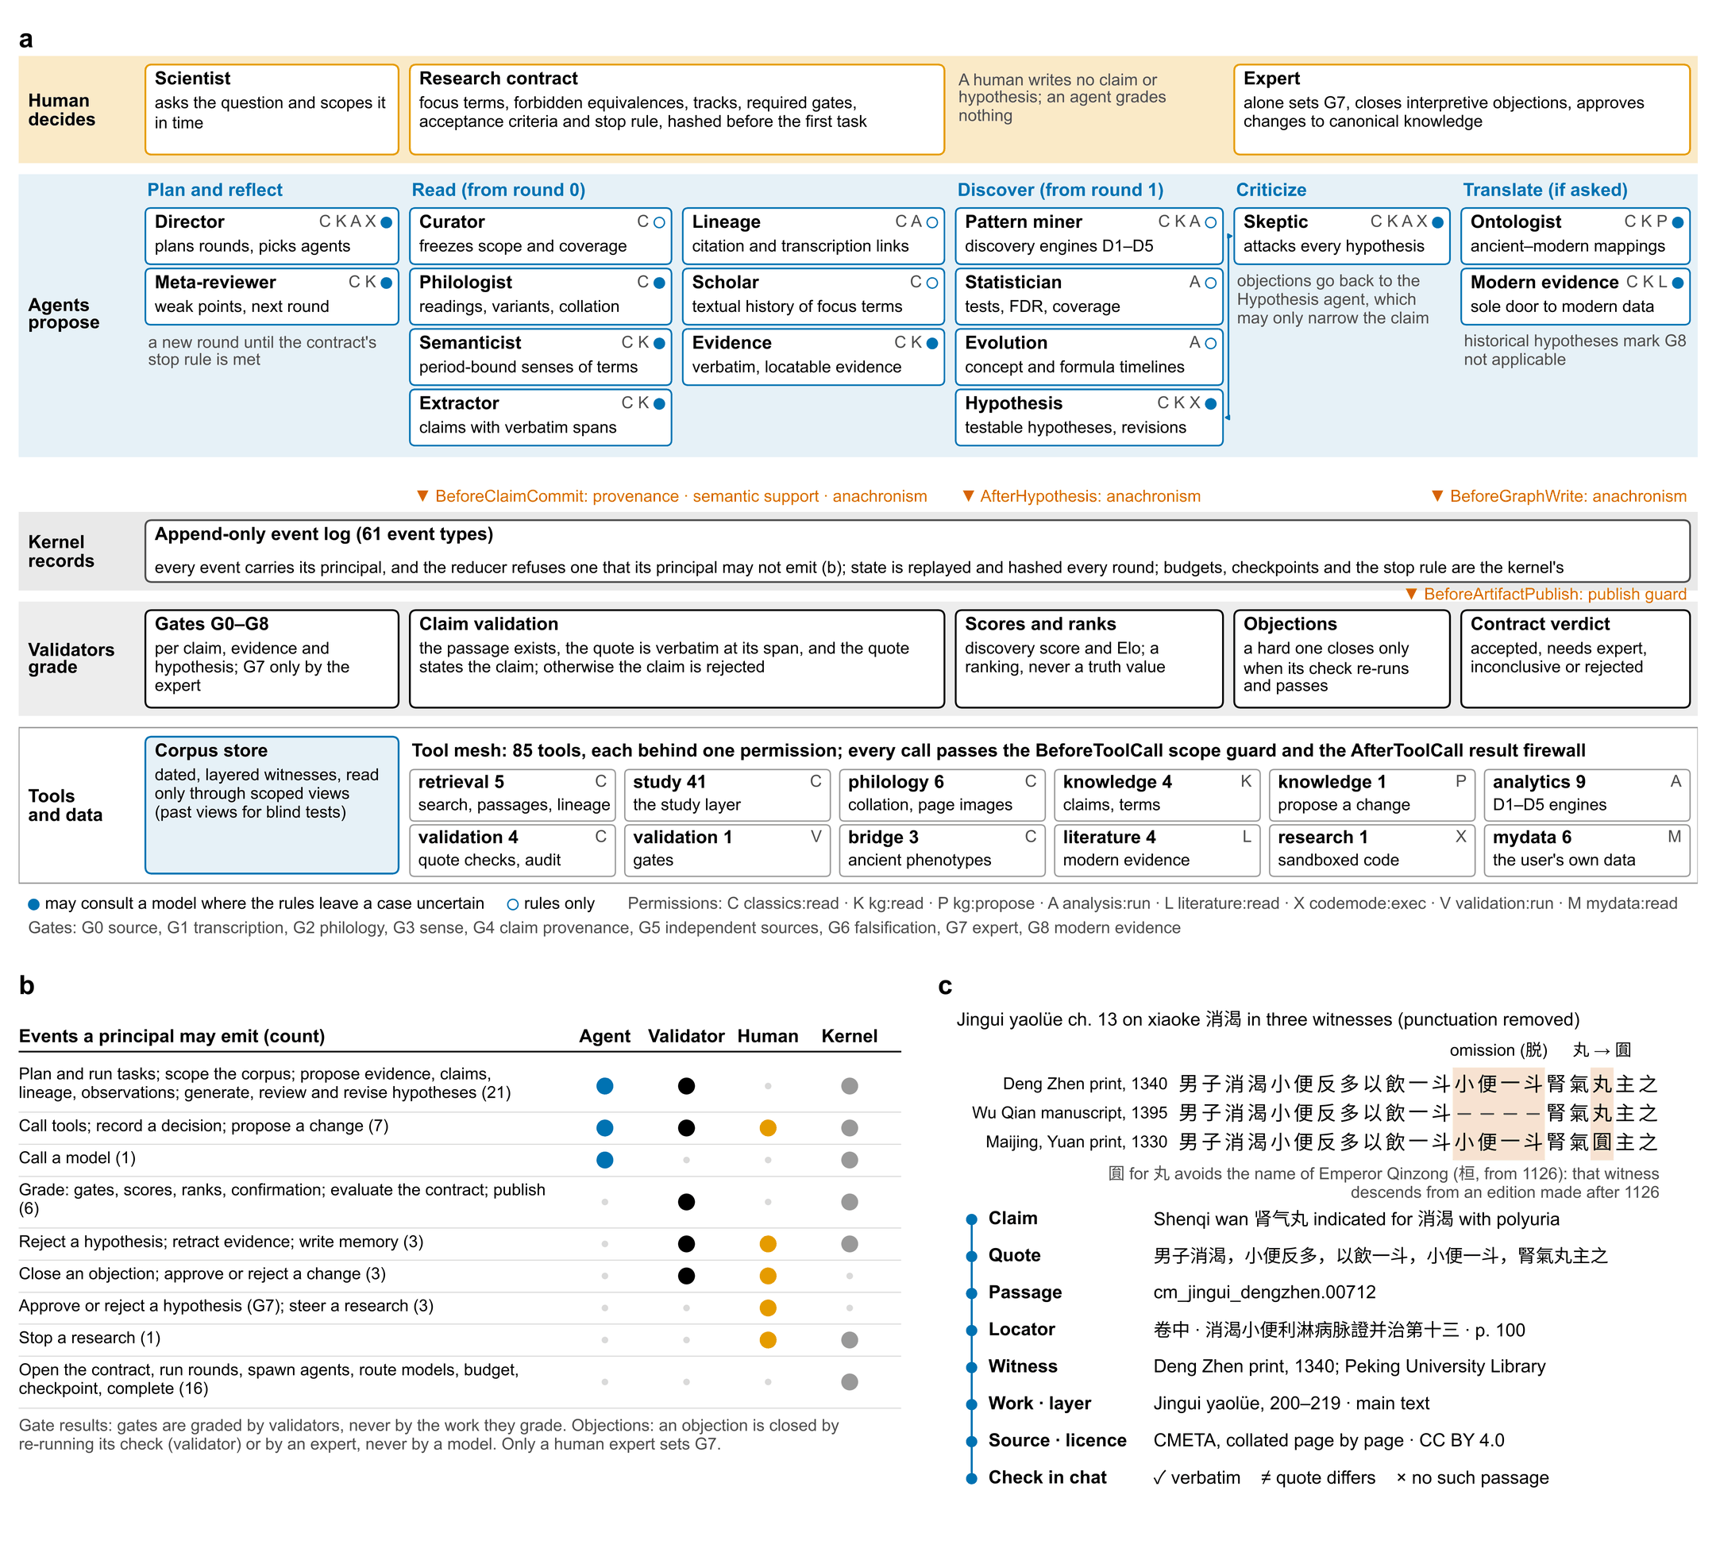
Fig. 1 | TaoChronos (道乃久): agents propose, validators grade, experts decide. a, The harness as configured (web-canon profile), by principal (rows) and by the stage of a research round (columns). A scientist’s question becomes a research contract, hashed before the first task. The Director plans each round and picks, from fifteen specialists, the agents the kernel spawns; each reads only through the research’s scoped view and calls only the tools its permissions allow (letters). Filled circles, agents that may consult a language model where their rules leave a case uncertain (Fig. 3 called none). The Skeptic’s objections return to the Hypothesis agent, which may only narrow a claim. Every write is an event in the log. Hooks (vermillion) refuse a tool call or result outside the research’s scope, a claim whose quote is not verbatim or contradicts it, an equation of a historical with a modern concept, and a report on versions the contract never judged. Validators alone grade claims, gates G0–G6 and G8, scores and the contract’s verdict, and close a hard objection only by re-running its check; the expert alone sets G7. b, Event authority: the principals allowed to emit each group of the 61 event types (number of types); the reducer refuses any other event. c, One clause of the Jingui yaolüe (chapter 13) in three witnesses, aligned character by character: the Deng Zhen print (1340), the Wu Qian manuscript (1395), which lacks 小便一斗, and the Yuan print of the Maijing (1330), which writes 圎 for 丸, a Song taboo form that dates its exemplar after 1126; shaded, variant positions. Below, the provenance chain of the first witness from claim to licence; the conversation client checks every cited passage (✓ verbatim, ≠ quotation differs, × no such passage). CMETA, 數位中醫校書郎. Agents, tools and permissions: Supplementary Tables 4–8.
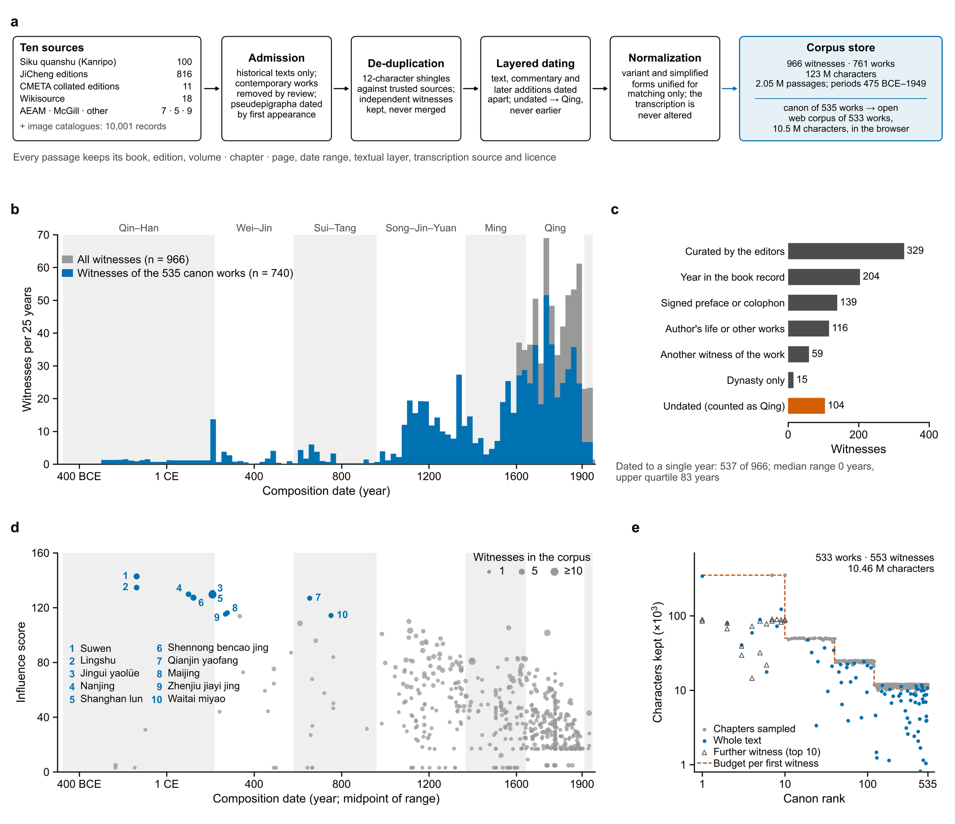
Fig. 2 | A dated, layered corpus spanning two millennia, and the canon its citations define. a, Construction of the corpus. Transcriptions from ten sources pass admission (historical texts only), de-duplication against more trusted sources (normalized 12-character shingles; independently collated transcriptions are kept as separate witnesses), layer-aware dating (main text, commentaries, editors’ notes and later additions dated apart; undated material counted as Qing, never earlier) and normalization used for matching only. b, Witnesses per 25-year bin by composition date; each witness counts once, its weight spread evenly over its date range (n = 966; blue, the 740 witnesses of the 535 canon works). Bands mark the analysis periods; the last, unlabelled band is the Republican period (1912–1949). c, Basis on which each witness was dated; the 104 undated witnesses are counted as Qing (vermillion), never earlier. d, Influence score of the 535 canon works against the midpoint of their composition range; point area, witnesses in the corpus (capped at 10). Score = 10 log₂(1 + citing works not older than it) + 2 × periods in which it is cited + 2 log₂(1 + citations) + 3 log₂(1 + witnesses) + 6 × inclusion in the Siku quanshu; the ten highest (blue) are keyed by rank. Later works have had fewer chances to be cited: the score describes what the corpus cites, not a verdict on the tradition. e, Characters kept for each witness of the open web corpus against the canon rank of its work (log–log). Dashed line, the budget of a work’s first witness (350,000 characters for ranks 1–10, then 50,000, 25,000 and 12,000); blue, texts kept whole; triangles, second and third witnesses of the ten highest-ranked works. Data: corpus catalogues (corpus/catalog) and the web corpus pack (corpus/web).
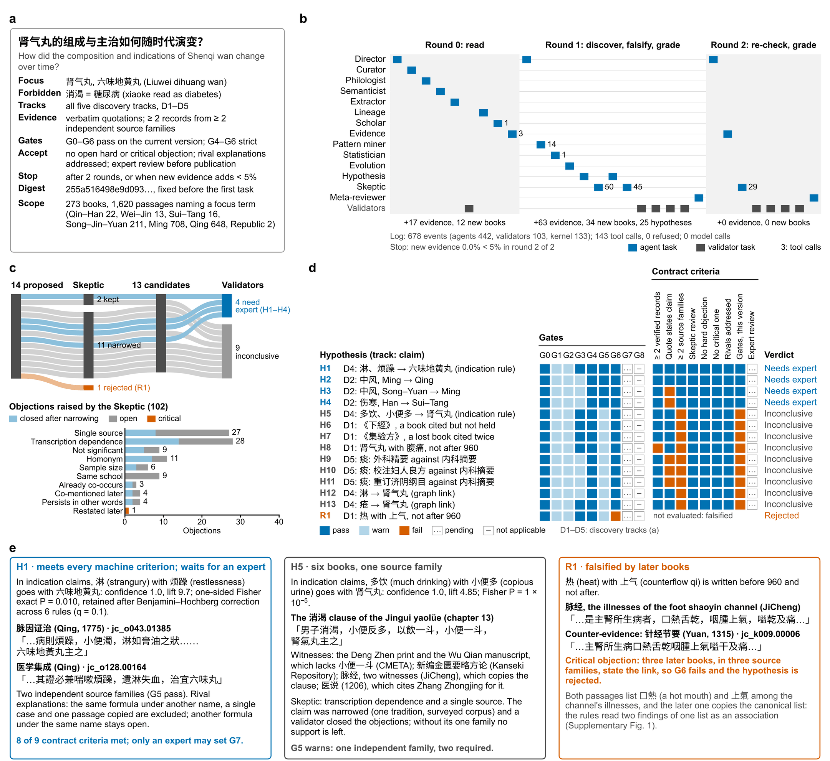
Fig. 3 | One research question, end to end. a, The question, put to the harness on the open canon corpus (web-canon profile; rules only, no model called), and the contract fixed before the first task. b, The 30 tasks in the order the Director planned them over three rounds: agent tasks (blue), validator tasks (grey); numbers, tool calls. Below each round, the evidence records, new books and hypotheses it added; the run stopped after the last round the contract allowed, which added no evidence. c, The 14 hypotheses proposed in round 1: the Skeptic kept 2, sent 11 back to be narrowed and rejected 1; validators then judged the 13 candidates. Below, the Skeptic’s 102 objections by check: closed by a validator once the claim was narrowed, left open, or critical. d, The final hypotheses against the gates and the contract’s criteria. H1 and H2 meet every criterion a machine can check; H3 and H4 rest in part on a quotation that does not clearly state its claim, which the contract leaves to an expert. Nine fail on independent sources (G5): passage reuse, closed transitively, puts 36 of the 46 evidence books into one source family (Supplementary Fig. 1). e, Three outcomes with their verbatim evidence. H1 waits for an expert. H5 rests on six books of one family: the 消渴 clause of the Jingui yaolüe, its witnesses and copies. R1 is rejected because three later books state the link; they copy the canonical list of the kidney channel’s illnesses that the earlier passage holds, and the rules read two findings of one list as an association. A second run writes the same report; report, event log, hypotheses and objections: Supplementary Data 1–2 and Supplementary Tables 9–10. D1–D5, discovery tracks: lost knowledge, concept evolution, formula evolution, hidden associations, contradictions.
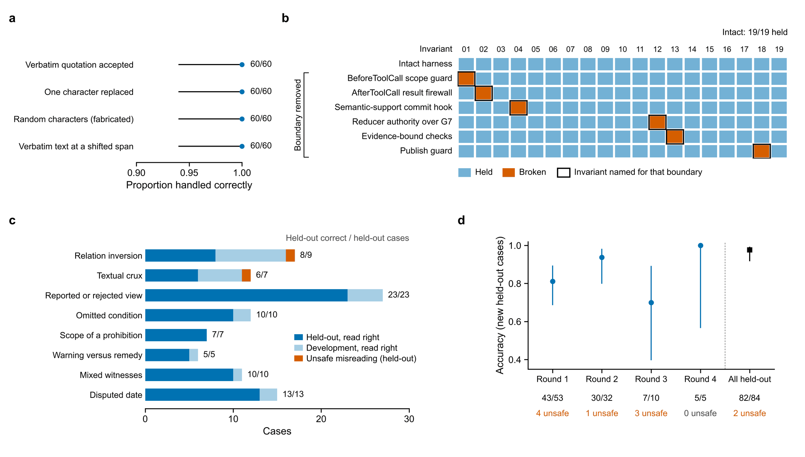
Fig. 4 | Quotations stay verbatim, the harness’s boundaries hold, and hard readings stay safe. a, Quotation checks on 60 random passages of the demonstration corpus: verbatim quotations accepted; quotations with one character replaced, of random characters, or verbatim at a shifted span rejected. Dots, proportions; lines, Wilson 95% confidence intervals. b, Nineteen invariants (I01–I19) run as probes on the intact harness and on six variants, each with one boundary removed by deleting its check at run time. Every removal broke the invariant named for its boundary (outlined) and no other; 127 of 133 cells held. In three cases a second safeguard limited the damage: without the scope guard the tool it no longer refused returned nothing of the withheld passage; forged G7 events reached the log but not the state; without the bound checks two of five impossible evidence records verified. c, 107 hard interpretive cases in eight classes, each a verbatim quotation with one correct reading (development, 23 cases used to write the rules; held-out, 84). Numbers, held-out cases read correctly. Both errors were unsafe, a reading that commentators dispute accepted as supported (the Dahuang mudan tang clause and the 里水 of the Yuebi jia zhu tang clause); they are reported, not patched. d, Accuracy in four blind rounds, each on new cases written before the rules that first read them, and on all held-out cases under the current rules. Lines, Wilson 95% confidence intervals; below, correct/total and unsafe errors. Data: taochronos eval on the demonstration corpus (a, c), paper/figures/mutation_matrix.py (b) and docs/evals.md (d).
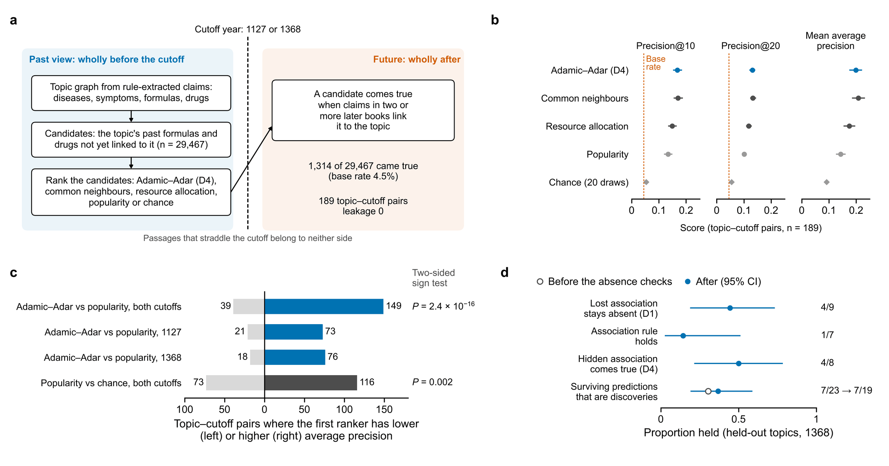
Fig. 5 | Rankings computed from the past anticipate the links later physicians wrote. a, Blind temporal benchmark on the full corpus. At each cutoff (1127, 1368) the store splits into passages dated wholly before and wholly after it; passages that straddle it belong to neither side. For every disease or symptom of the lexicon with 150–6,000 past and at least 300 future passages, the formulas and drugs of its past graph not yet linked to it are ranked; a candidate comes true when claims in two or more later books link it to the topic. b, Precision at 10 and 20 and mean average precision of five rankers over the 189 topic–cutoff pairs in which at least one link came true. Dots, means; lines, 95% confidence intervals; chance, 20 random rankings; dashed line, base rate (4.5%). c, Paired comparisons of average precision over topic–cutoff pairs; two-sided sign tests, one tie excluded. d, Predictions of the whole pipeline run on the past view at 1368 for four held-out topics (胸痹, 霍乱, 虚劳, 痰饮): proportion borne out by later books, with Wilson 95% confidence intervals. Open circle, before the absence checks, which rejected two wrong ‘lost’ and two already attested ‘hidden’ associations and no discovery. No passage outside the past view was read (leakage 0). Values of the full-corpus run documented in docs/evals.md; the full store is not distributed, and Supplementary Fig. 3 repeats the benchmark on the open corpus.
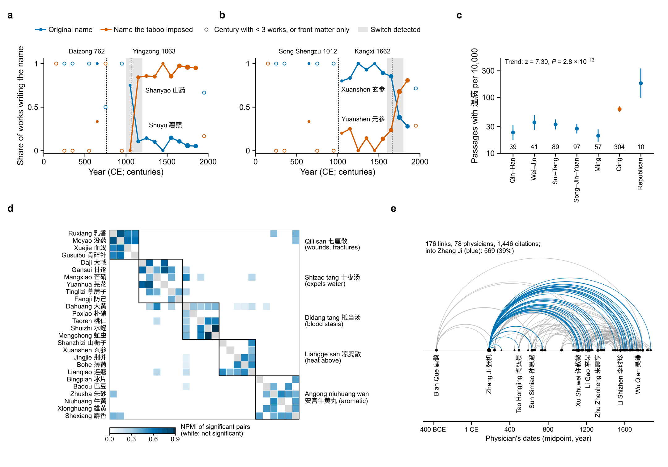
Fig. 6 | On the open canon corpus, the study layer recovers history written into the texts. All panels are computed by the deterministic study layer on the open web corpus (533 works, 168,278 passages). a, b, Share of works per century writing an original drug name and the name a naming taboo imposed: 薯蓣 and 山药 (a), 玄参 and 元参 (b). Dashed lines, the years from which the names were avoided: Tang Daizong (李豫, 762) and Song Yingzong (赵曙, 1063) in a; the Song ancestor Shengzu (赵玄朗, 1012) and the Kangxi emperor (玄烨, 1662) in b; shading, the switch interval the tool detected; marker area, works in the century; open markers, centuries with fewer than three works or only undated front matter dated conservatively to 1911. A work writing both names counts for both. c, Passages mentioning 温病 (warm disease) per 10,000 passages by period, with Wilson 95% confidence intervals; numbers, passages with the term. Two-sided Cochran–Armitage test for trend across the ordered periods. d, Normalized pointwise mutual information (NPMI) of drug pairs co-occurring significantly in 4,554 compositions (a composition repeated in copies of one work counted once; pairs in at least ten works tested; one-sided Fisher exact test, Benjamini–Hochberg q < 0.05; 1,184 pairs). Groups are communities of the strong pairs (NPMI ≥ 0.3), found without formula names; shown (outlined) are the five of twelve whose drugs hold together most tightly (mean NPMI of their significant pairs). Each holds the core of a classical formula (right); liquorice (甘草), present in 43% of compositions, joins none. e, Citations between physicians: arcs join citing and cited physicians placed at the midpoints of their dates; width ∝ √citations; blue, citations of Zhang Ji (张机). Five links whose cited physician lived after the citing one (28 citations) are omitted as chronologically impossible.

Tables
Table 1 | Eight ways an agent can go wrong on the classical literature, the mechanism that stops each in TaoChronos, and the measured evidence that it does
Failure mode | Example in the classics | Mechanism in TaoChronos | Evidence in this study
Fabricated or altered quotation | A quote with one character changed, or the right words at the wrong place | The harness, not the producer, locates every quote in its passage at commit (verbatim, or after length-preserving variant normalization); the conversation client checks every cited passage | 180/180 corrupted quotations rejected, 60/60 verbatim accepted; 100% of committed claims verbatim (Fig. 4a)
True quote, false reading | 「不可发汗，宜桂枝汤」 (a prohibition beside a prescription); 「或曰…余曰非也」 (a view the author rejects) | Semantic-support hook reads each claim’s statement frame (speaker, stance, conditions, negations) and refuses a claim its quote contradicts; a registry of textual cruxes harvested from commentaries makes doubtful clauses read as ambiguous | Held-out hard cases 82/84, 2 unsafe; four blind rounds (Fig. 4c,d)
Copies counted as independent testimony | Five witnesses of one clause of the Jingui yaolüe and its copy in the Maijing | Gate G5 counts independent source families (author and transcription clusters), not books; the Skeptic checks transcription dependence and single sources | H5 held inconclusive on one family (Fig. 3e); an over-merging of families reported (Supplementary Fig. 1)
Anachronism (presentism) | Xiaoke 消渴 read as diabetes mellitus; shanghan 伤寒 read as typhoid | Anachronism guard at claim, hypothesis and graph-write hooks; the contract’s forbidden equivalences; the ancient–modern bridge states phenotypic similarity with typed relations, never a retrospective diagnosis | Statements 10/10, mappings 8/8, translations 24/24; agent-asserted equivalence blocked
Arguments from silence | An association called lost after 960 that a later book still states | The Skeptic searches the whole scope for explicit, supported statements; one later statement refutes a loss and any statement refutes a hidden link, as hard, critical objections no rewording can close | 2 wrong lost and 2 already-written hidden associations rejected, and no discovery (Fig. 5d); R1 rejected (Fig. 3)
Self-grading and premature acceptance | A model closing its own objection, setting expert approval, or a finished run taken as an accepted finding | Every event carries its principal and the reducer refuses an event its principal may not emit (61 types); only validators grade, only a human sets G7; an executable contract judges acceptance | 19/19 invariants held; each of 6 boundaries removed broke its invariant and no other (Fig. 4b)
Hindsight in testing foresight | A ‘prediction’ made after reading the books that later confirm it | Time-machine views bounded in SQL on every read path; passages that straddle the cutoff belong to neither side; leakage counted, not assumed | Leakage 0; precision@10 0.168 against 0.134 (popularity) and 0.054 (chance)† (Fig. 5)
Irreproducible runs | A result that cannot be rerun or audited step by step | Append-only event log replayed and hashed every round; tool-call receipts in a hash chain; recorded model responses replayed exactly | Resume after a crash at 4 of 4 points reaches the same state; reruns and parallel runs identical; the end-to-end report rewritten identically
Every mechanism is deterministic code that runs whether a language model or a rule produced the output; all evidence was measured with the rules alone (no model called).
†Needs the full corpus store, which is not distributed; values from docs/evals.md. Other values were reproduced by taochronos eval on the demonstration corpus.
Table 2 | Evaluation of TaoChronos across its three layers
Layer | Suite | Data | Metric | Development or constructed | Held-out or real corpus
Boundaries | Invariants | 19 probes of the harness under test | Held | 19/19 | Each of 6 boundaries removed breaks its invariant
Readings | Hard interpretive cases | 107 cases in 8 classes | Accuracy (unsafe errors) | 23/23 (0) | 82/84 = 0.976 (2)
Research value† | Link anticipation | 189 topic–cutoff pairs; 29,467 candidates | Precision@10 | – | 0.168 (popularity 0.134; chance 0.054); higher average precision than popularity in 149 of 189, P = 2.4 × 10⁻¹⁶
 | End-to-end predictions | Held-out topics, cutoff 1368 | Discoveries among survivors | 1/8 | 7/19 = 0.37; leakage 0
Verification | Fabricated quotations | 60 quotations × 4 probes | Handled correctly | – | 60/60 in every probe; variant spellings accepted
 | Provenance | Committed claims and evidence | Verbatim | – | 100%; mean chain depth 7.8 levels
 | Claim extraction | 42 gold hyperedges | Precision / recall | 1.00 / 0.976 | –
 | Temporal and anachronism guards | Constraints, earliest attestations, equations | Correct | 6/6 · 6/6 · 10/10 | Leakage 0; agent-asserted equivalence blocked
Deep discovery | Collation | 5 traditions copied down a known stemma | Variant-unit recall / precision | 0.998 / 0.999 | –
 | Semantic reuse | 33 typed pairs | Accuracy | 0.97 | –
 | Stratigraphy | 5 composites; the Suwen | Layer accuracy | 0.955 | Yunqi chapters 7/7 in the minor layer†
 | Lost-text fragments | Constructed lost work; Qianjin yaofang | Precision | 0.86 | 0.32†
Task specification | Punctuation | 55 held-out works (104 k characters)† | Boundary F1 | – | 0.767 (rules 0.235); characters kept 1.000
 | Drug pairs | 66,196 compositions† | Textbook pairs significant | – | 7/7, lift > 1.5
V2 | Entities (24 types) | 41 development, 25 held-out sentences | F1 | 0.991 | 0.776
 | Ancient phenotypes → HPO | 20 development cases; 12 random passages† | F1 | 0.985 | 0.822
 | Evidence audit | 19 claims | Verdicts right (false SUPPORTED) | 19/19 (0) | –
Development and constructed gold sets were written by the authors with the rules they test; they are regression tests of intended behaviour, not unbiased benchmarks. Only held-out and real-corpus columns estimate generalization.
†Needs the full corpus store, which is not distributed; values from docs/evals.md. All other values were reproduced for this paper by taochronos eval on the demonstration corpus (40 suites, 47 s).
P value from a two-sided sign test of average precision over topic–cutoff pairs. HPO, Human Phenotype Ontology.

