**Final Project**

**Calendar Manager class**

package finalproject;

/**

* @author Prashanthi sudha kosgi

* date :06/30/2017.

*

*/

import java.io.File;

import java.io.FileInputStream;

import java.io.FileOutputStream;

import java.io.IOException;

import java.io.ObjectInputStream;

import java.io.ObjectOutputStream;

public class CalendarManager {

public void saveCalendarEntry(int day, int month, int year, String entry) {

String[] entries = null;

String fileName = getFileName(month, year);

File file = new File(fileName);

if (file.exists() && !file.isDirectory())

entries = getEntries(fileName);

if (entries == null)

entries = new String[31];

entries[day - 1] = entry;

try {

ObjectOutputStream writer = new ObjectOutputStream(new FileOutputStream(fileName));

writer.writeObject(entries);

writer.close();

} catch (IOException exception) {

exception.printStackTrace();

}

}

/**

* Get the calendar entry

* @param day

* @param month

* @param year

* @return String

*/

public String retrieveCalendarEntry(int day, int month, int year) {

String fileName = getFileName(month, year);

File file = new File(fileName);

if (file.exists() && !file.isDirectory()) {

String[] entries = getEntries(fileName);

if (entries != null) {

String entry = entries[day - 1];

if (entry != null)

return entry;

else

return "No Such Entry";

} else {

return "No Such Entry";

}

}

return "No Such Entry";

}

/**

* Get entries from the file to String Array

* @param fileName

* @return

*/

private String[] getEntries(String fileName) {

try {

ObjectInputStream reader = new ObjectInputStream(new FileInputStream(fileName));

String[] entries = (String[]) reader.readObject();

reader.close();

return entries;

} catch (IOException exception) {

exception.printStackTrace();

} catch (ClassNotFoundException exception) {

exception.printStackTrace();

}

return null;

}

/**

* Create file name using month and year

* @param month

* @param year

* @return

*/

private String getFileName(int month, int year) {

String fileName = year + "-";

if (month < 10)

fileName += "0" + month;

else

fileName += month;

fileName += ".txt";

return fileName;

}

}

**User Interface class:**

package finalproject;

/**

* @author Prashanthi sudha kosgi

* date :06/30/2017.

*

*/

import java.awt.Dimension;

import java.awt.FlowLayout;

import java.awt.event.ActionEvent;

import java.awt.event.ActionListener;

import javax.swing.JButton;

import javax.swing.JComboBox;

import javax.swing.JFrame;

import javax.swing.JLabel;

import javax.swing.JTextArea;

public class UserInterface extends JFrame {

private static final long *serialVersionUID* = 1L;

private CalendarManager manager;

private JButton save, retrieve;

private JTextArea entryData;

private JLabel status;

private JComboBox<Integer> days, months, years;

// Constructor

public UserInterface() {

setTitle("Calendar Manager");

setSize(600, 400);

setLayout(new FlowLayout());

manager = new CalendarManager();

save = new JButton("Save");

retrieve = new JButton("Retrieve");

entryData = new JTextArea(20, 30);

Integer[] monthValues = { 1, 2, 3, 4, 5, 6, 7, 8, 9, 10, 11, 12 };

Integer[] yearValues = { 2015, 2016, 2017, 2018, 2019, 2020, 2021, 2022, 2023, 2024, 2025 };

Integer[] daysCount = { 31, 28, 31, 30, 31, 30, 31, 31, 30, 31, 30, 31 };

days = new JComboBox<Integer>();

months = new JComboBox<Integer>(monthValues);

years = new JComboBox<Integer>(yearValues);

add(new JLabel("Please Select Date : "));

add(new JLabel(" MONTH "));

add(months);

add(new JLabel(" DAY "));

add(days);

add(new JLabel(" YEAR "));

add(years);

for (Integer i = 1; i <= 31; i++)

days.addItem(i);

months.setSelectedIndex(0);

months.addActionListener(new ActionListener() {

@Override

public void actionPerformed(ActionEvent event) {

Integer selectedMonth = (Integer) months.getSelectedItem();

Integer selectedYear = (Integer) years.getSelectedItem();

int maximumDaysInMonth = daysCount[selectedMonth - 1];

if ((selectedYear % 400 == 0) || ((selectedYear % 4 == 0) && (selectedYear % 100 != 0)))

if (selectedMonth == 2)

maximumDaysInMonth++;

days.removeAllItems();

for (Integer i = 1; i <= maximumDaysInMonth; i++)

days.addItem(i);

}

});

retrieve = new JButton("Retrieve");

retrieve.addActionListener(new ActionListener() {

@Override

public void actionPerformed(ActionEvent event) {

Integer selectedDay = (Integer) days.getSelectedItem();

Integer selectedMonth = (Integer) months.getSelectedItem();

Integer selectedYear = (Integer) years.getSelectedItem();

entryData.setText(manager.retrieveCalendarEntry(selectedDay, selectedMonth, selectedYear));

status.setVisible(false);

}

});

add(retrieve);

JLabel entriesTitle = new JLabel("Calendar Entries");

entriesTitle.setPreferredSize(new Dimension(400, 20));

add(entriesTitle);

entryData = new JTextArea(10, 33);

add(entryData);

save = new JButton("Save");

save.addActionListener(new ActionListener() {

@Override

public void actionPerformed(ActionEvent event) {

Integer selectedDay = (Integer) days.getSelectedItem();

Integer selectedMonth = (Integer) months.getSelectedItem();

Integer selectedYear = (Integer) years.getSelectedItem();

String entry = entryData.getText();

manager.saveCalendarEntry(selectedDay, selectedMonth, selectedYear, entry);

status.setVisible(true);

}

});

add(save);

status = new JLabel("Entry Saved");

status.setVisible(false);

status.setPreferredSize(new Dimension(400, 20));

add(status);

setDefaultCloseOperation(JFrame.*EXIT_ON_CLOSE*);

setVisible(true);

}

}

**Calendar Test Class**

package finalproject;

/**

* @author Prashanthi sudha kosgi

* date :06/30/2017.

*

*/

public class CalendarTest {

public static void main(String[] args) {

//call UserInterface

UserInterface userInterface =new UserInterface();

}

}

**Output:**

1. **Without input:**

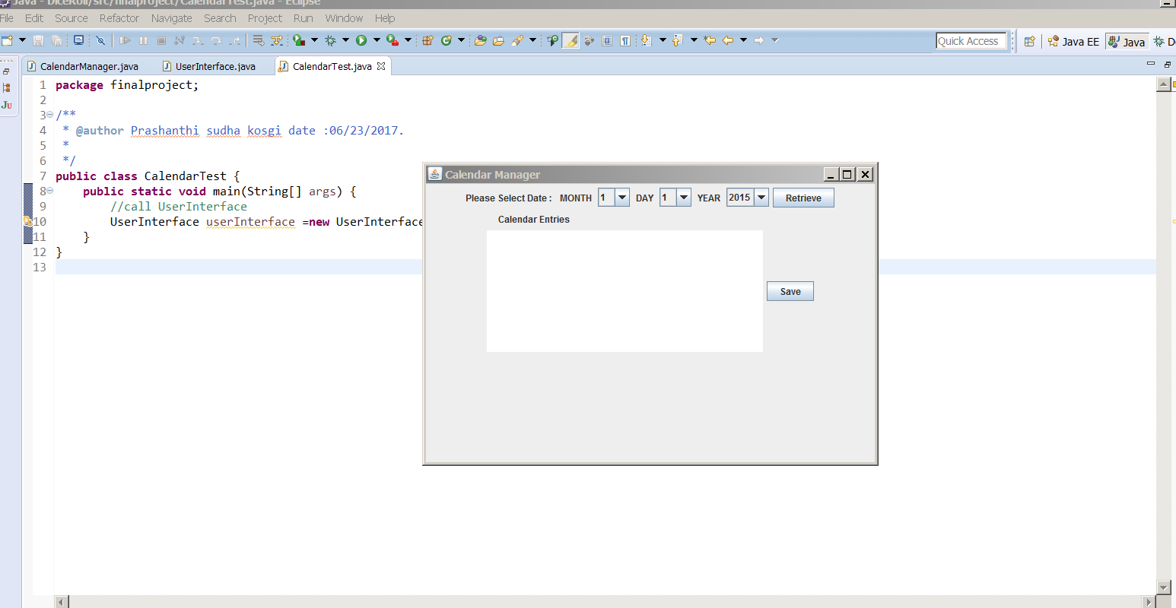

**2. Retrieving data:**

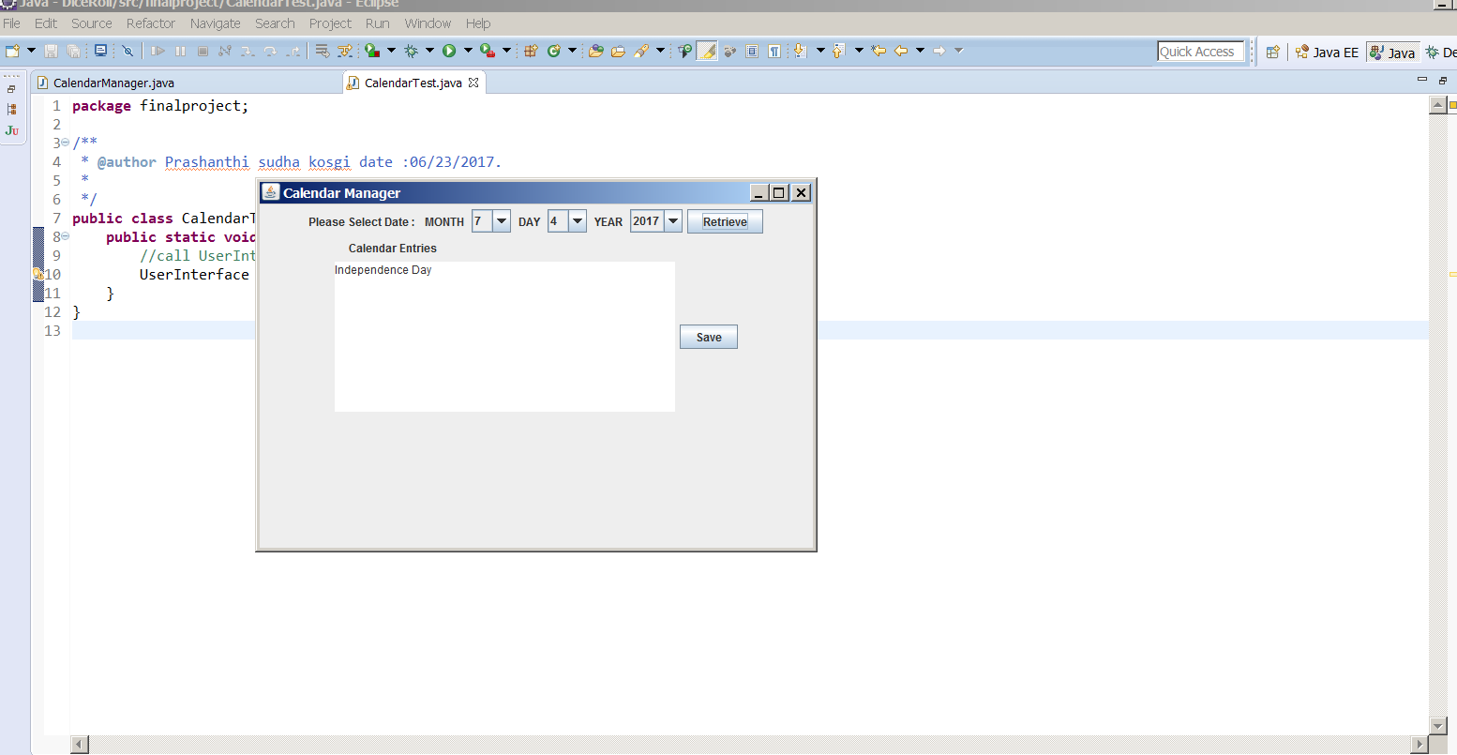

**3.Saving data:**

