**Name: Prashanthi Sudha Kosgi**

**ID: @01374492.**

**Sub: OOP- week 1**

**Program-1**

**import** java.util.Scanner;

/**

* Program1 for Arithematic Operations

* **@author** Prashanthi Sudha Kosgi

* Date : 6/2/2017

*

*/

**public** **class** ArithematicOperations {

**public** **static** **void** main(String[] args) {

Scanner input = **new** Scanner(System.***in***);

**int** integer1, integer2, integer3;

**int** sum;

**float** average;

**int** product;

System.***out***.println("Enter First integer1: ");

integer1 = input.nextInt();

System.***out***.println("Enter second integer2: ");

integer2 = input.nextInt();

System.***out***.println("Enter third integer3: ");

integer3 = input.nextInt();

// Sum of three integers

sum = integer1 + integer2 + integer3;

System.***out***.println("The sum of three integers is : " + sum);

//Average of three integers

average = (**float**) (integer1 + integer2 + integer3) / 3;

System.***out***.format("The average of three integers is %.2f%n", average);

//Product of three integers

product = integer1 * integer2 * integer3;

System.***out***.println("The product of three integers is : " + product);

// **Largest number**

**if** (integer1 > integer2 && integer1 >integer3) {

System.***out***.println("Largest of the three Integers is : " + integer1);

}

**if** (integer2 > integer1 && integer2 > integer3) {

System.***out***.println("Largest of the three Integers is : " + integer2);

}

**if** (integer3 > integer1 && integer3 > integer2) {

System.***out***.println("Largest of the three Integers is : " + integer3);

}

// //**Smallest number**

**if** (integer1 < integer2 && integer1 < integer3) {

System.***out***.println("Smallest of the three Integers is : " + integer1);

}

**if** (integer2 < integer1 && integer2 < integer3) {

System.***out***.println("Smallest of the three Integers is : " + integer2);

}

**if** (integer3 < integer1 && integer3 < integer2) {

System.***out***.println("Smallest of the three Integers is : " + integer3);

}

input.close();

}

}

**Screen shot of running program 1**

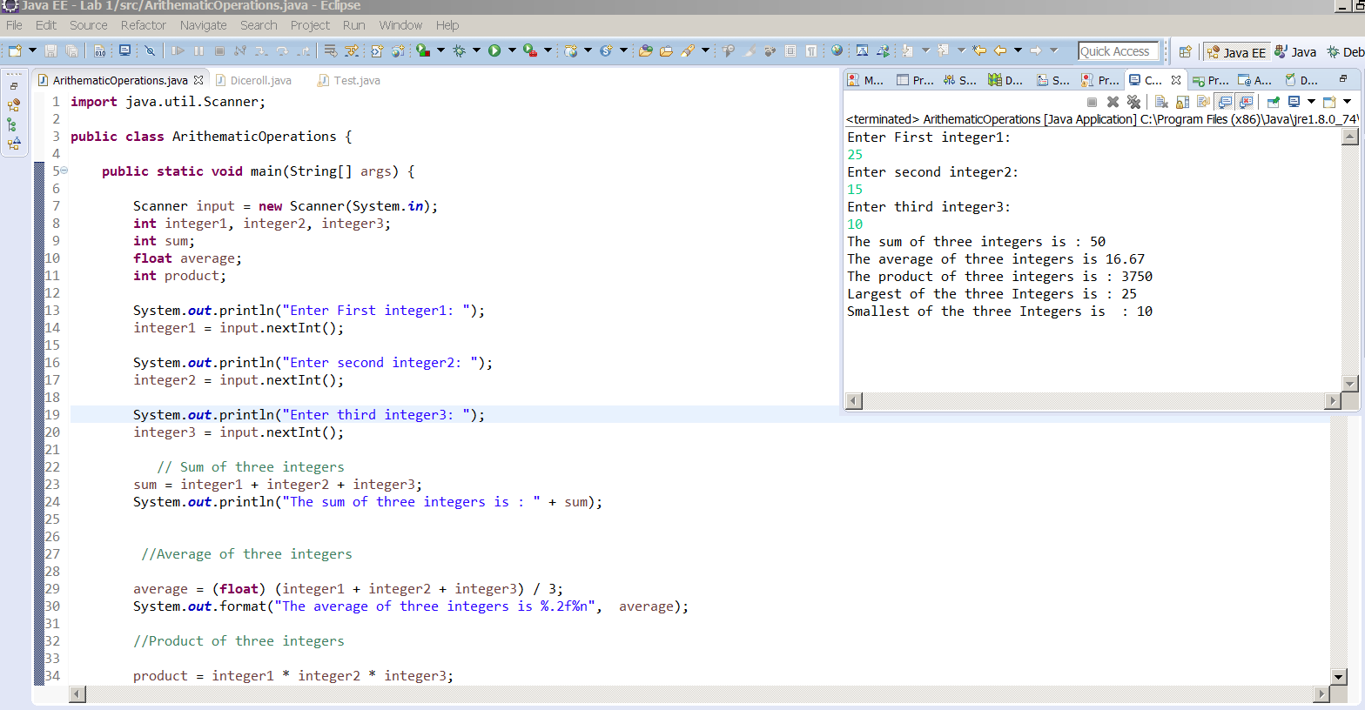

**Program 2**

**Source code**

**import** javax.swing.JOptionPane;

**import** javax.swing.JTextArea;

/**

* Program2 for dice

* **@author** Prashanthi Sudha Kosgi

* Date : 6/2/2017

*/

**public** **class** Diceroll {

**public** **static** **void** main(String args[]) {

// Get user input for number of times dice should be rolled.

String numberOfTimes = JOptionPane.*showInputDialog*("Please enter the number of times dice should roll");

**int** numOfTimesDiceRolled = Integer.*parseInt*(numberOfTimes);

// System.out.println("Number of time dice should be rolled: " + numOfTimesDiceRolled);

**int** arrRoll[] = **new** **int**[13];

// pass array and number of times dice rolled

*diceFunction*(arrRoll, numOfTimesDiceRolled);

// Display logic

JTextArea area = **new** JTextArea();

String output = "Dice Result \t No.of times sum rolled";

**for** (**int** i = 2; i < arrRoll.length; i++) {

output = output + "\n" + i + "\t " + arrRoll[i];

// System.out.println("index "+i+ " Value "+ arr[i]);

}

area.setText(output);

JOptionPane.*showMessageDialog*(**null**, area, "Number of times sum rolled", JOptionPane.***PLAIN_MESSAGE***);

}

/**

* Rolls the dices for given number of times and counts the number of each value rolled

* **@param** arr

* **@param** num

*/

**private** **static** **void** diceFunction(**int**[] arr, **int** num) {

**int** sumofDice = 0;

**for** (**int** i = 0; i < num; i++) {

**int** dice1 = (**int**) (Math.*random*() * 6 + 1);

**int** dice2 = (**int**) (Math.*random*() * 6 + 1);

sumofDice = dice1 + dice2;

// int rollnumber = i + 1;

// System.out.println(rollnumber + " roll sum :" + sumofDice);

**for** (**int** j = 2; j < arr.length; j++) {

**if** (sumofDice == j) {

arr[j] = arr[j] + 1;

}

}

}

}

}

**Screenshot of running program 2**

