Fitchburg State University

CSC 7014 Practice Computer Programming

Instructor: Nguyen Thai

Due: 10/21/2016 at 5:00 PM

Student:

**CSC 7014 Assignment 6: Palindrome**

The purpose of this assignment is to learn how to program string manipulation. Your program is to be written in the Python language. You will be graded for output correctness, code comments, code indentation, descriptive variables and source code file header completeness.

As you work through the assignment be sure to answer all questions (type your answers into this document) and take all screenshots as requested (copy them into the document). For the screenshots, you can use the Snipping Tool that is built-in to Windows to capture the important parts of the lab as highlighted in the document below. Do not delete the contents of this file. When finished, you will submit the document source code file and associated data files to the instructor via Blackboard. DO NOT SUBMIT ZIP FILES OR INDIVIDUAL IMAGES. If you have any questions or need any clarification, email the instructor *before* the deadline.

1. In this lab you are to write a program in Python called *palindrome.py* to implement the checking of a palindrome string.
2. A string is a palindrome if it reads the same forward and backward. The words “mom”, “dad” and “noon” for example, are all palindromes.
3. You are to write a function called isPalindrome() that
   * Takes in a string
   * Return True if the string is palindrome
   * Return False if the string is not palindrome
4. Here are your test cases:
   1. “madam”
   2. “moon”
   3. “Was it a cat I saw”?
5. Before coding, think how you are going to tackle this problem, and write a short description of the logic of your program.

I am going to proceed with the following steps.

1. I will create a ispalindrome() function, then I will check for valid input .
2. The extra spaces between the strings will be removed, the spaces between the string are replaced and the given string is converted to lower case.
3. Then the given string is divided in to half of its length.
4. I Will use a For loop to loop through the string for the first half.
5. Finally if condition is will be used to compare the first half of the string with second half, if both are same then the output will be true else false.
6. **INSERT YOUR DESCRIPTION HERE.**
7. First math class is imported.
8. A function ispalindrome() is created with string as input(line 12).
9. If condition is used to check for valid input.
10. The extra spaces and trailing are removed by strip() (line 18).
11. replace(' ', '') is used to remove spaces between the strings (line 19).
12. lower() is used to convert the string to lower case(line 20), next the given string is divided in to half(line 21).
13. For loop is used to loop through the string for the first half(line 24).
14. if condition is used to compare the first half of the string with second half, if both are same then the output will be true else false(line 25 to 27).
15. Test cases are written at the end to test.
16. **TAKE A SCREENSHOT** of your input and output, and paste them here. Do not paste your source code in this document.

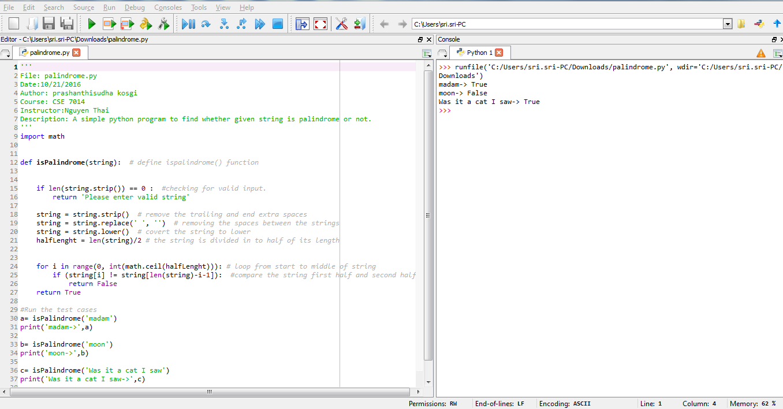

1. Submit your source code and this document to Blackboard for grading.