Fitchburg State University

CSC 7014 Practice Computer Programming

Instructor: Nguyen Thai

Due: 9/20/2016 at 7:30 PM

Student:

**CSC 7014 Assignment 2: Shapes**

The purpose of this assignment is to get you started with graphics programming. Your program is to be written in the Python language using the Turtle graphics module. You will be graded for output correctness, code comments, code indentation, and descriptive variables.

As you work through the assignment be sure to answer all questions (type your answers into this document) and take all screenshots as requested (copy them into the document). For the screenshots, you can use the Snipping Tool that is built-in to Windows to capture the important parts of the lab as highlighted in the document below. Do not delete the contents of this file. When finished, you will submit the document source code file and associated data files to the instructor via Blackboard. DO NOT SUBMIT ZIP FILES OR INDIVIDUAL IMAGES. If you have any questions or need any clarification, email the instructor *before* the deadline.

1. In this lab you are to write a program in Python called *shapes.py* to generate the following image using the Turtle graphics module:

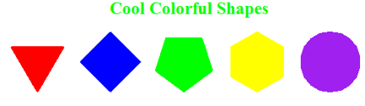

1. Set the radius to 40 units for all shapes.
2. Fill the shapes with following colors:
   * 3 sides: red
   * 4 sides: blue
   * 5 sides: green
   * 6 sides: yellow
   * Circle: purple
3. Label your image as “Cool Colorful Shapes” with green color and place it above the shapes as shown above.
4. A template of a Python program is provided to you along with this document on Blackboard.
5. **TAKE A SCREENSHOT** of your output and paste it here. Do not paste your source code in this document.
6. 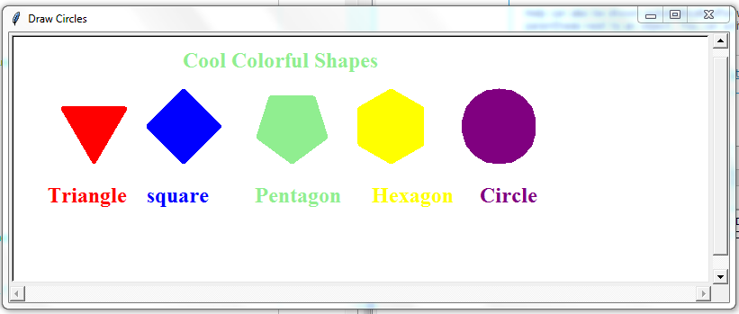
7. Submit your source code (shapes.py) and this document to Blackboard for grading.