Fitchburg State University

CSC 7014 Practice Computer Programming

Instructor: Nguyen Thai

Due: 10/7/2016 at 5:00 PM

Student:

**CSC 7014 Assignment 4: Prime Number**

The purpose of this assignment is to learn how to program functions. Your program is to be written in the Python language. You will be graded for output correctness, code comments, code indentation, descriptive variables and source code file header completeness.

As you work through the assignment be sure to answer all questions (type your answers into this document) and take all screenshots as requested (copy them into the document). For the screenshots, you can use the Snipping Tool that is built-in to Windows to capture the important parts of the lab as highlighted in the document below. Do not delete the contents of this file. When finished, you will submit the document source code file and associated data files to the instructor via Blackboard. DO NOT SUBMIT ZIP FILES OR INDIVIDUAL IMAGES. If you have any questions or need any clarification, email the instructor *before* the deadline.

1. In this lab you are to write a program in Python called *primeNumber.py* to verify whether a given integer number is a prime number.
2. An integer greater than 1 is prime if its only positive division is 1 or itself. For example, 2, 3, 5 are prime number, but 4, 6, 8 are not.
3. Design and develop a function called isPrime() with the following signature:

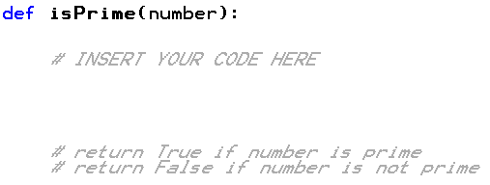

1. Write a test case to test your function, using the numbers: 21, 29, 109, 163 and 227. Print the test results to a console.
2. Before coding, think how you are going to tackle this problem, and write a short description of the logic of your program.

I am going to proceed with the following steps.

1. Will define isprime() function.
2. Initially will check a condition, for the given number is less than 2 or not.
3. If the number is less than 2 program returns false.
4. If the number is greater than 2, checks for a condition whether the given number is divisable by any number in the given range.
5. If the number is divisible by any number, then the program returns false, if the number is not divisible by any number then the program returns true.

1. **INSERT YOUR DESCRIPTION HERE.**

1.First isprime() is defined(line 12).

2. “if else” condition is used to check whether the given number is less than two or not. if the number is less than 2 then the code returns false(lines 14 to17).

3.if the number is not less than 2 then for loop is executed, for loop checks if “i” is in the range of 2 and given number(line 14).

4.”if” statement is used to check if the number is divisible by “i” or not. If the number is divisible by i then the program returns false else returns true(lines19 to 23).

1. **TAKE A SCREENSHOT** of your input and output, and paste them here. Do not paste your source code in this document. 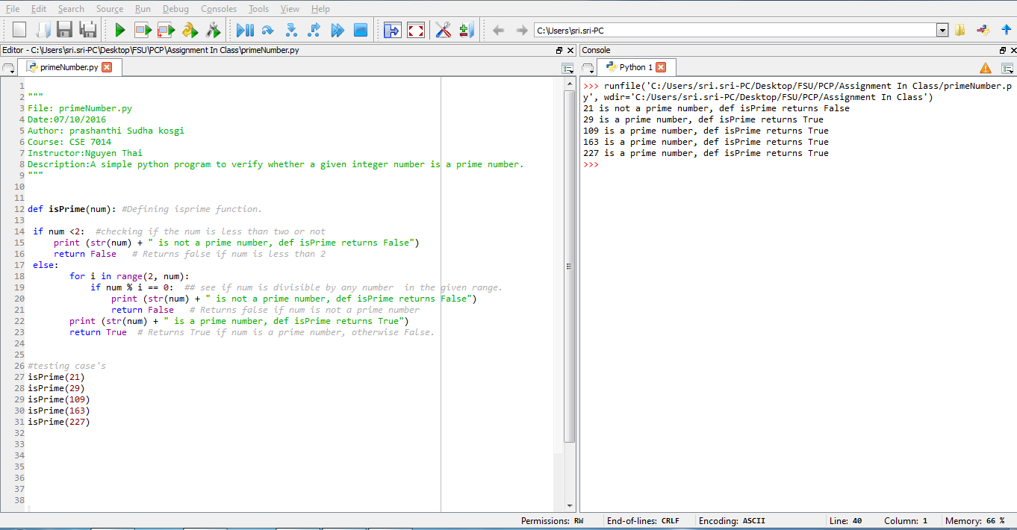
2. Submit your source code (primeNumber.py) and this document to Blackboard for grading.