**ABSTRACT**

TEAM: BYTE CODERS

The energy management is the key area to be addressed in present scenario. We know that in our country majority of the electricity consumers are domestic users. If it is possible to implement some sort of smart energy management system in domestic consumer, we can certainly raise the standard of energy conservation methods.

We here identified four problem whose solution would help the consumer in utilizing their power consumption efficiently. Firstly, One of the drawback of the state electricity board is that it bills the consumer with the total usage of the power (in units) they used in the periods of two months, but the fact is the consumer don’t know how each equipment (load) contribute to their bill and which draws the power more . Moreover there are many cases where consumer make quarrel with the officials proving it was a fake bill. The second problem is that, with present system of there is no device that help you to optimize your gadget as you optimize your smartphone. Next problem is that, now a days every home have backup powers (inverters), but still we don’t prioritize our need while we are using backup powers and the final problem is that now a day’s electricity board is providing a new system called “Grid Connected Solar PV”, were consumer with solar panels installed in their house can sell the extra energy to the grid and they are being paid for the amount of energy they have supplied, but the fact is that there is no system that can monitor and predict the efficient usage of solar power and selling of solar power.

So our Product “**GOWATTS**” is one of the system that helps the consumer to efficiently utilize the power consumption. The solution for the first problem is that we are developing a website and app which will continuously monitor (IOT Based) each and every device in your house and update the daily usage, monthly usage, and cost per consumption of every device. This will give the consumer crystal clear idea about which appliance draw the most of the power and increase their electricity bill.

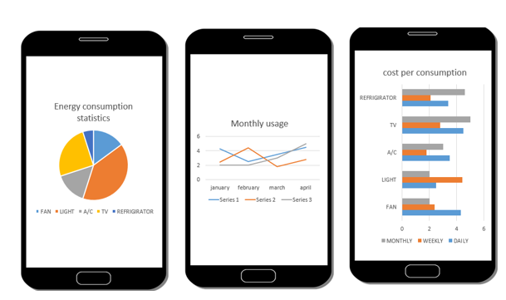

For second problem the, that is for optimization, we are setting a virtual bill (as of consumers wish) and we continuously monitor their usage and notify them about the exhaustion of the limit. The product also provide ‘smart optimize button’, which automatically optimize the gadgets to efficiency.

For the next problem, that is “priority back up”, the user has the freedom to set which of his appliance should be given with topmost priority. By default Light and fan (HVAC) will be give the topmost priority. This come in to action when the Battery life is reducing, as the backup power goes down the priority list will be enabled. The solution for the final problem is that this product also give controls and notifications to the “Grid connected solar PV” so that the solar energy is used efficiently utilized during peak and non-peak hours. The extra energy produced is sold to the electricity board, which earns the consumer some extra amount.

So using this product any “Home can be an energy efficient Home”