Climate and plant distribution

Patricia LaPorte

# Climate and Plant Distribution

As the strongest of the five state factors that control ecosystems processes and structure, climate influences plant distribution across the globe through two features: temperature and precipitation. Annual minimum temperature limits the expansion of vegetation when it exceeds a species lethal threshold for survival. For example, at temperatures below -15oC, the probability of intracellular ice formation increases for the majority of broad-leaved, evergreen trees, while conifers from the boreal regions survive at temperatures below -40oC. Although grassland is spread out in a wide range of latitude and altitudes, C3 and C4 grasses respond differently to temperature and moisture, with C4 grasses predominant in tropical and Southern hemisphere latitudes, while C3 grasses prevail in areas with minimum temperatures below 15oC.

List of important publications:

Sollins et al. (1996) DOI: [10.1016/S0016-7061(96)00036-5](https://doi.org/10.1016/S0016-7061(96)00036-5)

# Humification as a theory is unsupported

Explain how humication theory is unsupported.

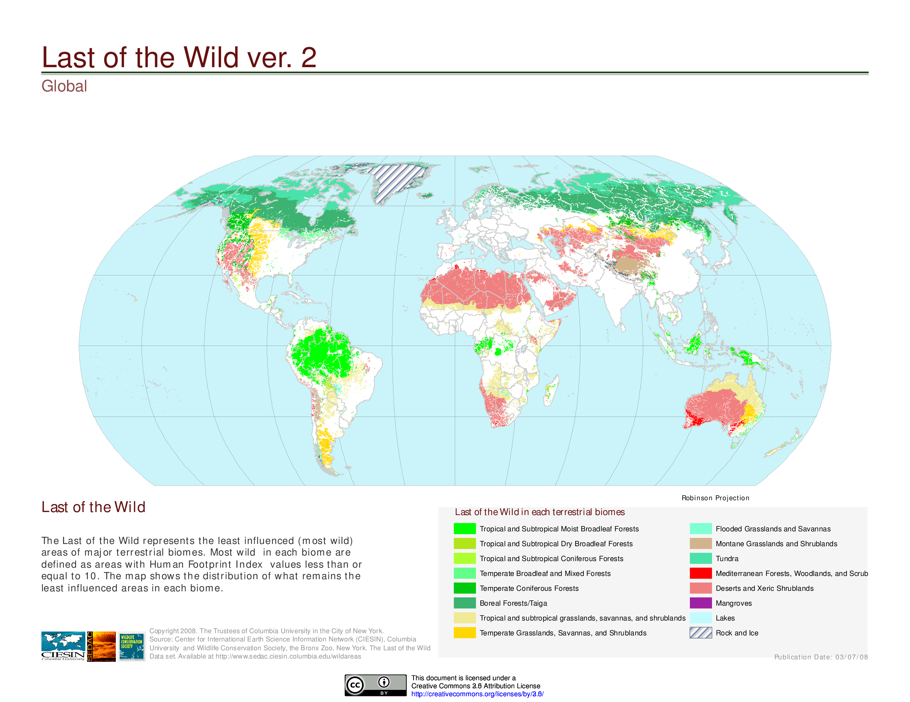

Figure 1. The distribution of the least influenced terrestrial biomes illustrates the influence of climate on plant distribution. For example, Boreal forests For full figure text see

Discuss the emerging understandings in stabilization mechanisms.

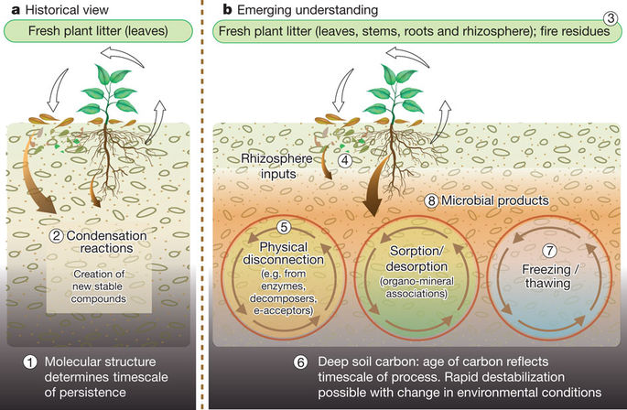

Figure 2. An emerging understanding of stabilization/destabilization processes has replaced humification theory. For full figure text see Schmidt et al. (2011) DOI: [10.1038/nature10386](https://www.nature.com/articles/nature10386)

List of important publications:

Schmidt et al. (2011) DOI: [10.1038/nature10386](https://www.nature.com/articles/nature10386)

# Rethinking the Conceptual Theory of SOM Sequestration

As paradigms have shifted, its important to get away from humification terminology and embrace mechanistic theories and conceptualizations of soil carbon stabilization.

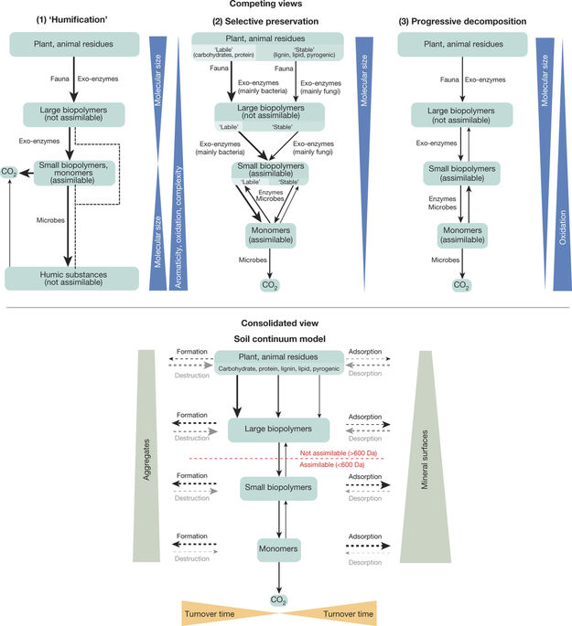

Figure 3. The soil continum model (SCM) is an attempt to bring together disparate conceptualizations of soil carbon storage, which is an important step forward in soil science as we try to determine the best measurement and modeling techniques to predict SOC changes. For full figure text see Lehmann & Kleber (2015) DOI: [10.1038/nature16069](https://www.nature.com/articles/nature16069)

List of important publications:

Lehmann & Kleber (2015) DOI: [10.1038/nature16069](https://www.nature.com/articles/nature16069)

# Moving forward: bringing together theory, measurement, and modeling

Theory, measurement, and modeling need to be thought of as a single process to close the loop of the scientific method and create usable products to not just inform further science, but also provide farmers, land managers, policy makers, and the general public a tool to understand soil carbon.

List of important publications:

Triangle paper