**Name: Prashant Singhai**

**Registration No: 15BCE0531**

**EXPERIMENT 10**

***(Design of Experiments –CRD, RBD and LSD)***

Problem: Suppose the following table represents the sales figures of the 3 new menu items in the 18 restaurants after a week of test marketing. At .05 level of significance, test whether the average sales volume for the 3 new menu items are all equal.

|  |  |  |
| --- | --- | --- |
| Item 1 | Item2 | Item3 |
| 22 | 52 | 16 |
|  |  |  |
| 42 | 33 | 24 |
| 44 | 8 | 19 |
| 52 | 47 | 18 |
|  |  |  |
| 45 | 43 | 34 |
| 37 | 32 | 39 |
|  |  |  |

***(Enter the Above data in Excel Sheet)***

***R code:-***

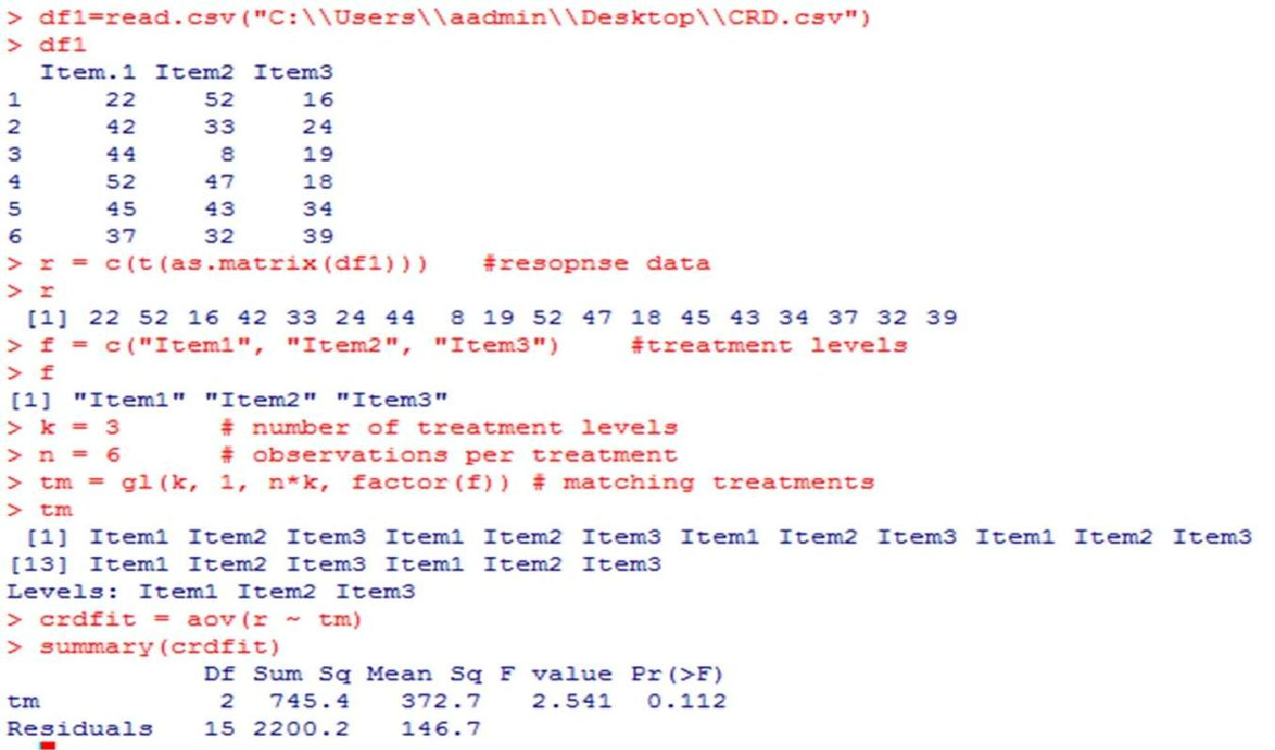

**Completle Randomised design ( Method of ANOVA for one wayclassificantion with un equal number of Observations)**

Problem 1:

The following Table shows the lives (in hours) of four batches of electric lamps

|  |  |  |  |  |  |  |  |  |
| --- | --- | --- | --- | --- | --- | --- | --- | --- |
| Batches |  |  | Life of Bulbs in Hrs | | | |  |  |
| 1 | 1600 | 1610 | 1650 | 1680 | 1700 | 1720 | 1800 |  |
|  |  |  |  |  |  |  |  |  |
| 2 | 1580 | 1640 | 1640 | 1700 | 1750 |  |  |  |
| 3 | 1460 | 1550 | 1600 | 1620 | 1640 | 1660 | 1740 | 1820 |
|  |  |  |  |  |  |  |  |  |
| 4 | 1510 | 1520 | 1530 | 1570 | 1600 | 1680 |  |  |
|  |  |  |  |  |  |  |  |  |

**(Enter the Above data in Excel Sheet)**

R code:->data=c(1600,1610,1650,1680,1700,1720,1800,1580,1640,1640,1700,1750,1460,15 5 0,1600,1620,1640,1660,1740,1820,1510,1520,1530,1570,1600,1680)

>batchs=c("batch1","batch1","batch1","batch1","batch1","batch1","batch1","batch2

",

"batch2","batch2","batch2","batch2","batch3","batch3","batch3","batch3","batch3"," b atch3","batch3","batch3","batch4","batch4","batch4","batch4","batch4","batch4")

* Anova1=aov(data~batchs)
* summary(Anova1)

Df Sum Sq Mean Sq F value

|  |  |
| --- | --- |
| Pr(>F) batchs | 3 44361 14787 |

2.149 0.123

Residuals 22 151351 6880

Problem 2 : The data recorded for yield in a randomized block design experiment involving six treatments in four randomized blocks are given below. Analyse and interpret the data.

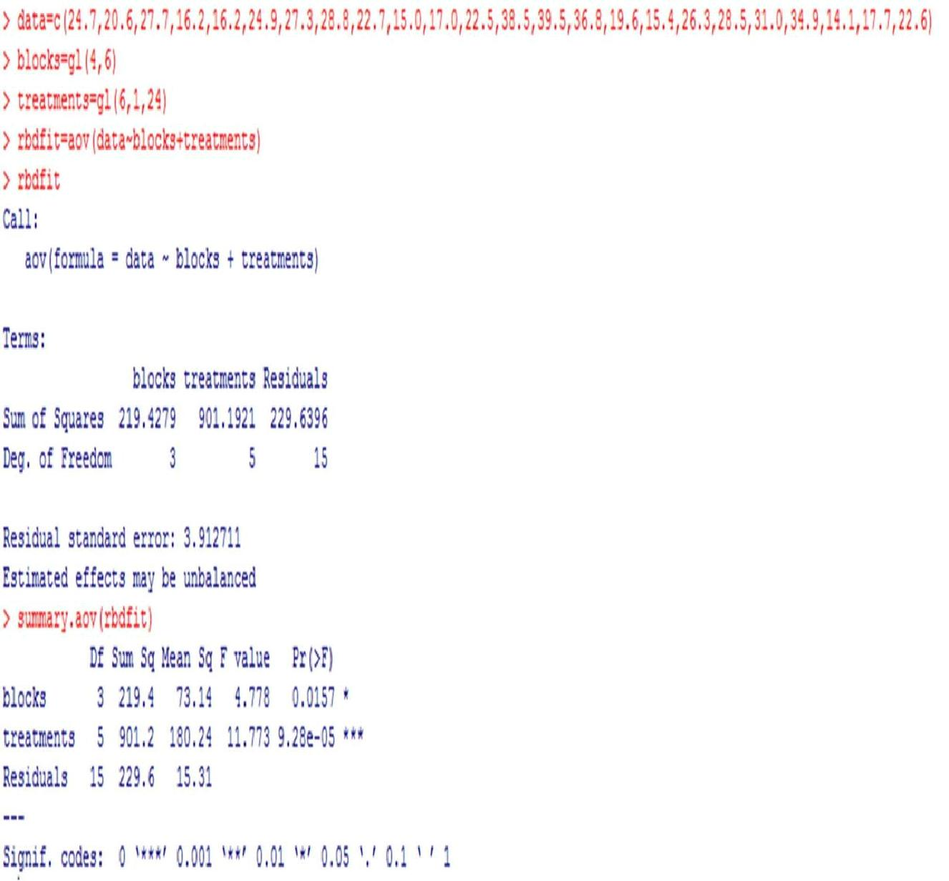

**Challenging Task**

1. A firm wishes to compare four programs for training workers to perform a certain manual task. Twenty new employees are randomly assigned to the training programs, with 5 in each program. At the end of the training period, a test is conducted to see how quickly trainees can perform the task. The number of times the task is performed per minute is recorded for each trainee

Program 1 Program 2 Program 3 Program 4 9 10 12 9 12 6 14 8 14 9 11 11 11 9 13 7 13 10 11 8 Calculate and interpret the above one way ANOVA table.

* p1=c(9,12,14,11,13)
* p2=c(10,6,9,9,10)
* p3=c(12,14,11,13,11)
* p4=c(9,8,11,7,8)

>data=data.frame(p1,p2,p3,p4)

* r=c(t(as.matrix(data)))

>r

[1] 9 10 12 9 12 6 14 8 14 9 11 11 11 9 13 7 13 10 11 8 >factor=c("PA","PB","PC","PD")

* k=4
* n=5

>tm=gl(k,1,n*k,factor(factor))

>crdfit=aov(r~tm)

>summary(crdfit)

Df Sum Sq Mean Sq F value Pr(>F)

|  |  |  |
| --- | --- | --- |
| tm | 3 54.95 | 18.32 7.045 0.00311 ** |

Residuals 16 41.60 2.60

---

Signif. codes:‘**’ 00 .‘***’01‘*’0 .**0**01.05 ‘.’ 0.1 ‘ ’ 1

>pvalueis lower than 0.05 so reject null hypothesis that there is not a significance difference in the program

2. In a factory producing edible oil and marketing its product in 15 kg tins, uses five filling machines. Random samples of the packed tins were taken for each machine A,B,C,D and E were presented below

A B C D E 14.85 14.28 14.16 15.25 14.60 15.00 14.42 14.15 15.30 14.84 15.25 14.19 15.10 14.82 15.10 14.50 15.35 14.74 14.80 15.00

Analysis of data to test the Equality of efficiency of machines .

* A=c(14.85,15.00,15.25,15.10,14.80)
* B=c(14.28,14.42)
* C=c(14.16,14.15,14.19,14.50)
* D=c(15.25,15.30,15.10,15.35,15.00)
* E=c(14.60,14.84,14.82,14.74)

>levels=c('A1','A1','A1','A1','A1','B1','B1','C1','C1','C1','C1','D1','D1','D1','D1','D1','E1','E1','E1','E1')

>data=c(A,B,C,D,E)

>anoval=aov(data~levels)

>summary(anoval)

Df Sum Sq Mean Sq F value Pr(>F)

|  |  |  |
| --- | --- | --- |
| levels | 4 2.6205 0.6551 28.11 8.18e-07 *** | |
| Residuals | 15 0.3496 | 0.0233 |
| --- |  |  |
| Signif. c | | 0.001 ‘**’ 0. |

>p value is lower than 0.05 so reject null hypothesis that the data is significanly same.