Statistics for Engineers (LAB) L13+L14  
Probability Distribution

Prashant Singhai

15BCE0531

Problem 1

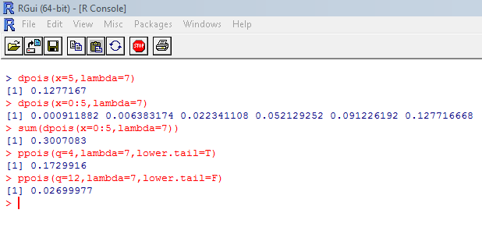

Problem 2

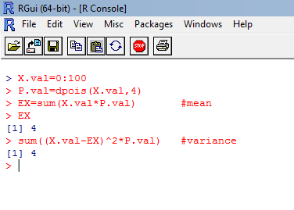

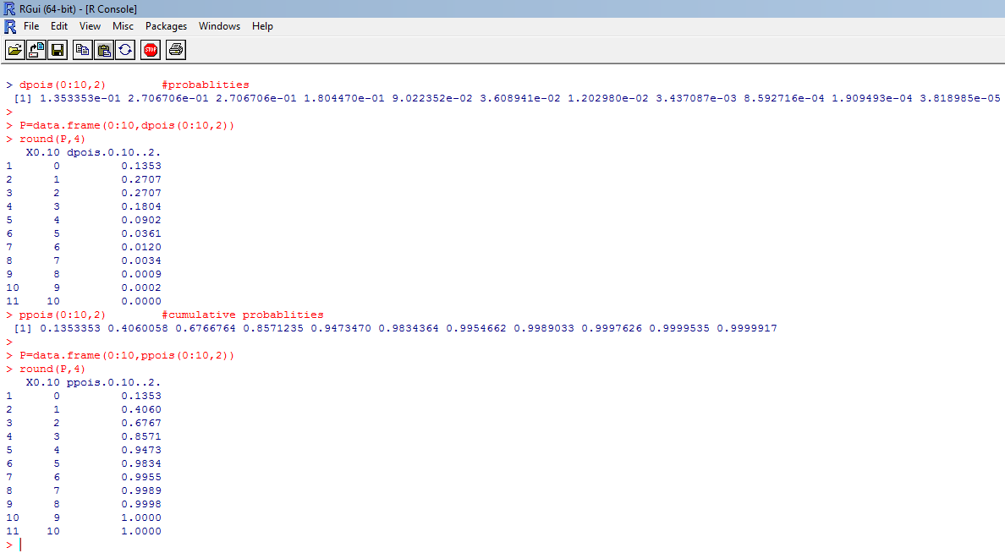

Problem 3

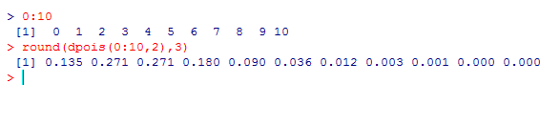

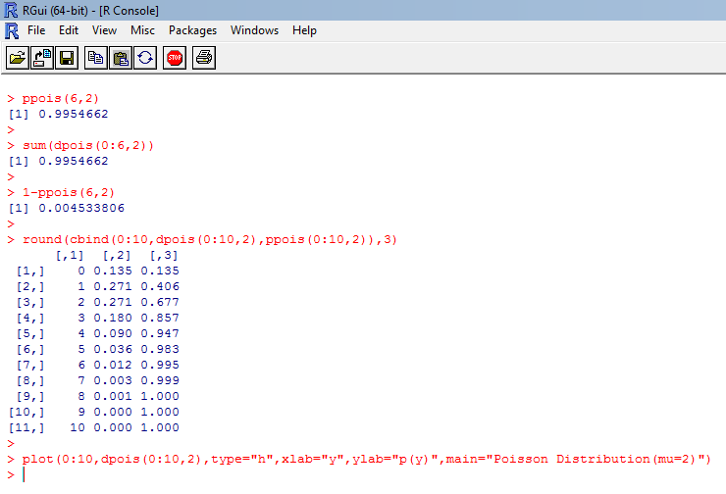

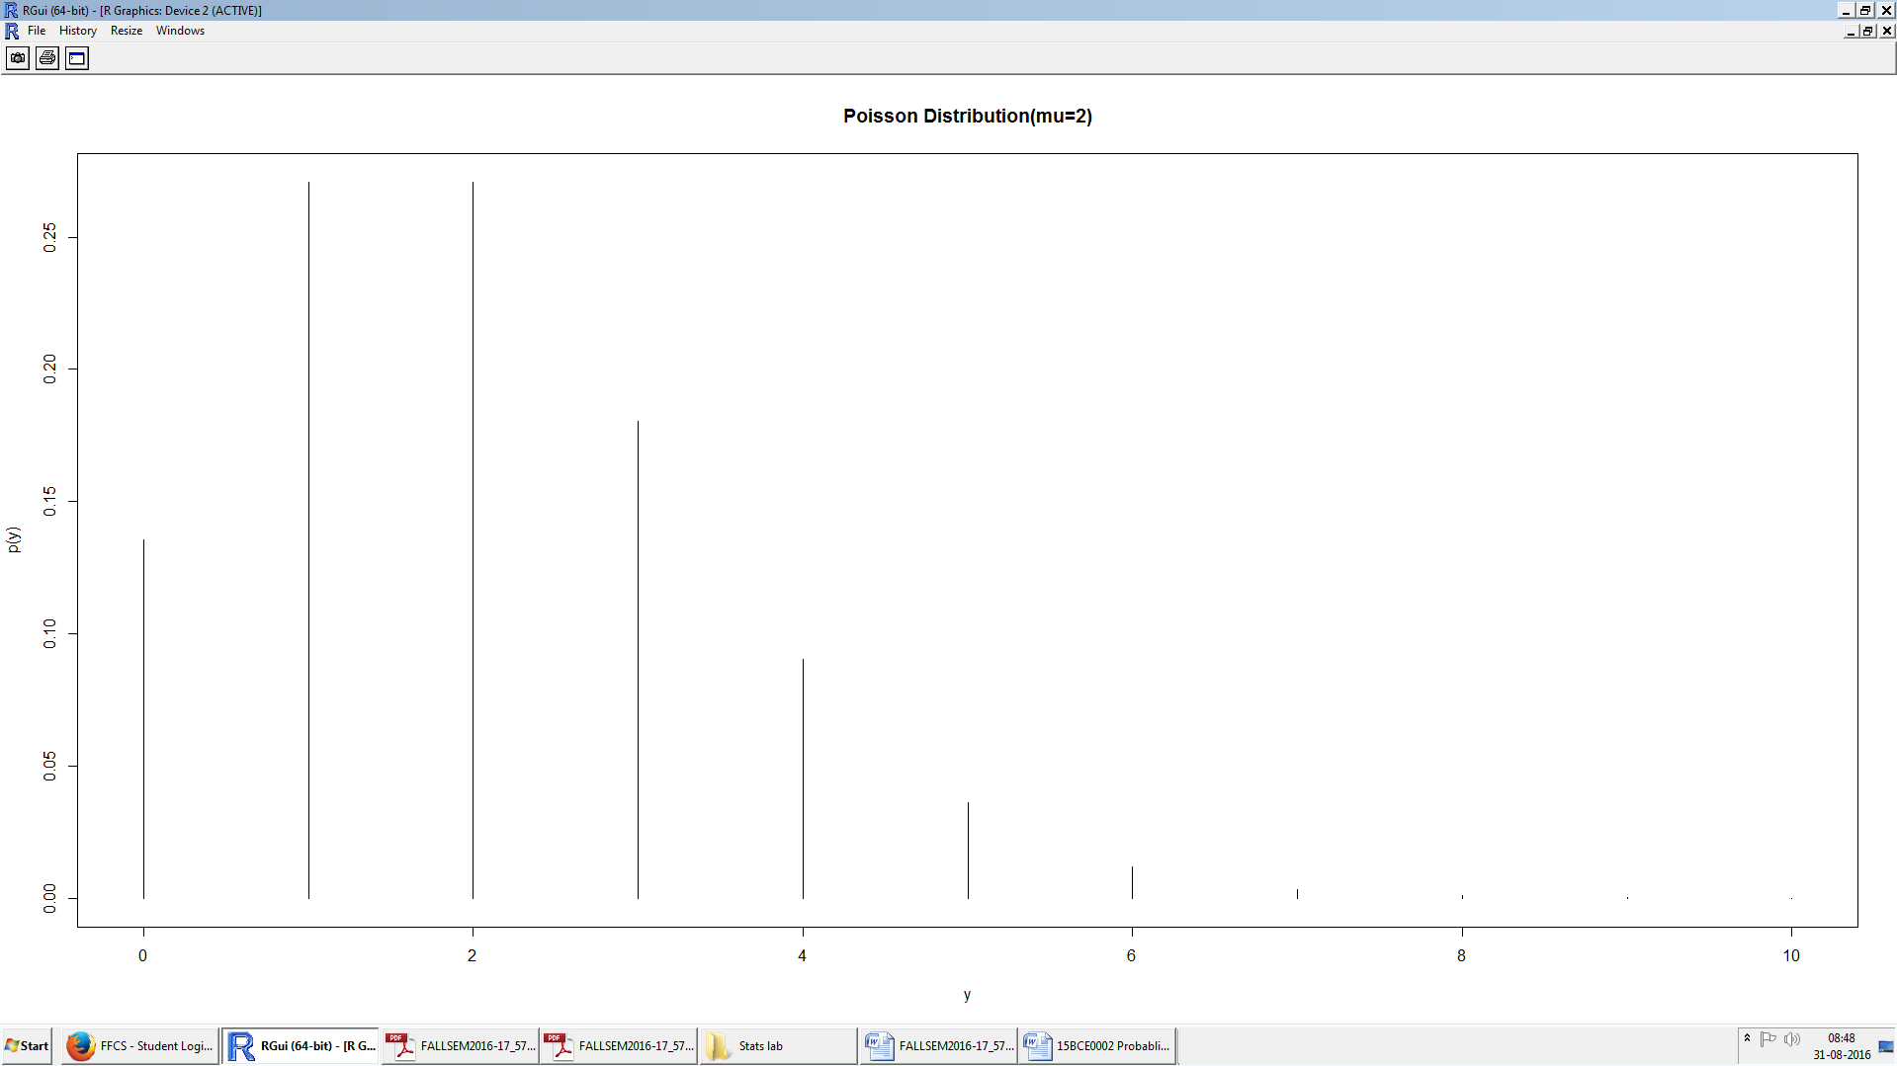  
  
  
  
  
**Challenging Task:**

**Problem 1:**A recent national study showed that approximately 55.8% of collegestudents have

used Google as a source in at least one of their term papers. Let X equal the number

of students in a random sample of size n = 42 who have used Google as a source:

1. How is X distributed?
2. Sketch the probability mass function (roughly).

**Ans:**

1.



2.



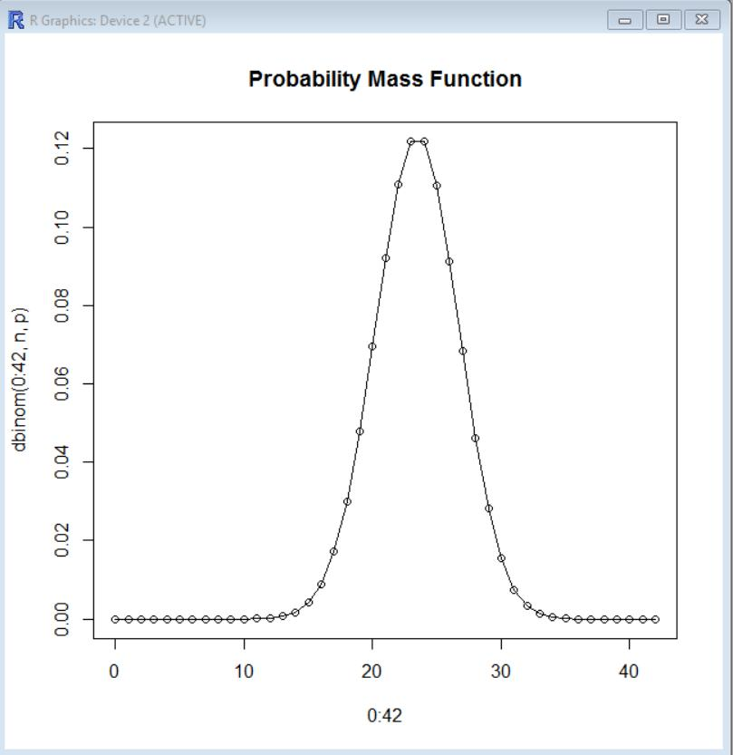

**Problem 2:**The number of traffic accidents that occur on a particular stretch of roadduring a month follows aPoisson distribution with a mean of 7.6.

1. Find the probability that less than three accidents will occur next month on this stretch of road.
2. Find the probability of observing exactly three accidents on this stretch of road next month.
3. Find the probability that the next two months will both result in four accidents each occurring on this stretch of road.
4. Check the mean and variance of the Poisson distribution
5. Plot the Poisson distribution and compare with binomial distribution.

**Ans:**

1.

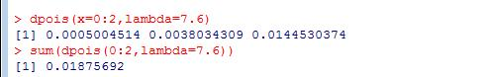

2.



3.

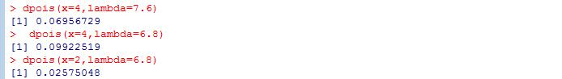

4.

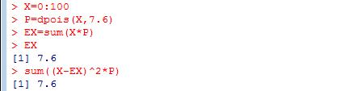

5.



