Name: Prashant Singhai

Registration No: 15BCE0531

EXPERIMENT 5

Problem-1

* a= c(175,168,168,190,156,181,175,174,179)
* b= c(120,180,125,188,130,190,110,185,112,188)
* a= c(175,168,168,190,156,181,175,174,179,182)
* z.test(a,b,var.equal=FALSE,paired =FALSE)

Two Sample z-test

data: a and b

t = 1.8827, df = 10.224, p-value = 0.08848

alternative hypothesis: true difference in means is not equal to 0 95 percent confidence interval:

-3.95955 47.95955 sample estimates: mean of x mean of y

* 1. 152.8
* x= c(15,10,13,7,9,8,21,14,8)
* y=c(15,14,12,8,14,7,16,10,15,12)
* z.test(x,y,alt="less",var.equal= TRUE)

Two Sample z-test

data: x and y

t = -0.3594, df = 17, p-value = 0.3619

alternative hypothesis: true difference in means is less than 0 95 percent confidence interval:

-Inf 2.432433 sample estimates: mean of x mean of y 11.66667 12.30000

Problem-2

* before=c(12.9,13.5,12.8,15.6,17.2,19.2,12.6,15.3,14.4,11.3)
* after=c(12.7,13.6,12.0,15.2,16.8,20.0,15.9,16.0,11.1)
* z.test(before,after,paired=TRUE)

Error in complete.cases(x, y) : not all arguments have the same length

* after=c(12.7,13.6,12.0,15.2,16.8,20.0,12.0,15.9,16.0,11.1)
* z.test(before,after,paired=TRUE)

z-test

data: before and after

t = -0.2133, df = 9, p-value = 0.8358

alternative hypothesis: true difference in means is not equal to 0

95 percent confidence interval: -0.5802549 0.4802549 sample estimates:

mean of the differences -0.05

PROBLEM-3

* before=c(12.9,13.5,12.8,15.6,17.2,19.2,12.6,15.3,14.4,11.3)
* after=c(12.7,13.6,12.0,15.2,16.8,20.0,12.0,15.9,16.0,11.1)
* z.test(before,after,paired=TRUE,alt="less")

z-test

data: before and after

t = -0.2133, df = 9, p-value = 0.4179

alternative hypothesis: true difference in means is less than 0 95 percent confidence interval:

-Inf 0.3796859 sample estimates: mean of the differences

-0.05

* unit_A= c(14.1, 10.1 ,14.7,13.7,14.0)
* unit_B=c(14.0,14.5,13.7,12.7,14.1)
* var.test(unit_A,unit_B)

z test to compare two variances

data: unit_A and unit_B

F = 7.3304, num df = 4, denom df = 4, p-value = 0.07954 alternative hypothesis: true ratio of variances is not equal to 1 95 percent confidence interval:

0.7632268 70.4053799 sample estimates:

ratio of variances 7.330435

**Challenging Task**

To Test the Hypothesis for Large Samples By Using Two Sample Z-Test.

1.In thelargecityA,20per centof Randomsample of 900Schoolchildren had defective eye– sight.In the large cityB,15percentof randomsample of1600schoolchildrenhad the same defective.IsthisDifference between the twoProportionsSignificant?Obtain

95%confidence limitsof the differencein thepopulation proportions. >x<-c(180,240)

>n<-c(900,1600)

>prop.test (x,n,correct=FALSE)

2-sampletest forequalityof proportionswithoutcontinuity correction

data:xout ofn

X-squared=10.302,df=1, p-value=0.001329 alternativehypothesis:two.sided 95percentconfidenceinterval:

0.01855096 0.08144904

sampleestimates:

prop1prop2

0.20 0.15

Here there issignificanceas“P”value islessthan

The confidence limitsare 1.855%to 8.14%.

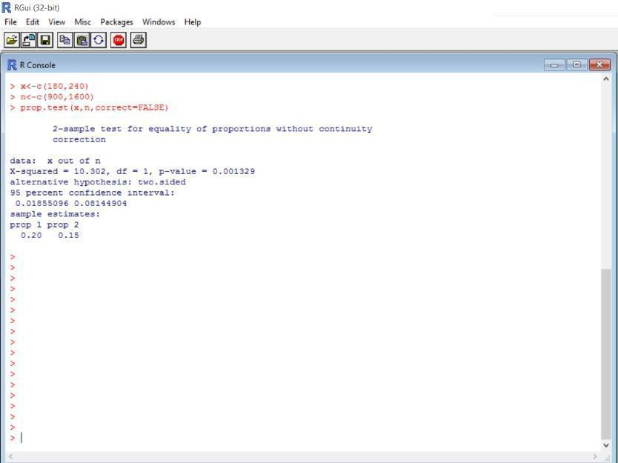

2.Acigarette manufacturingfirmclaimsitsbrand Aof the cigarettes outsellsitsbrand Bby8%. ifit’sfound that 42out sample of200 smoker pre randomsample of100smokers prefersbrand B,testwhether the8%differenceisavalid claim.

>x<-c(42,18)

> n<-c(200,100)

>prop.test(x,n,alternative="greater",correct=FALSE)

2-sampletest forequalityof proportionswithoutcontinuity correction

data:xout ofn X-squared=0.375,df=1,p-value=0.2701 alternativehypothesis:greater 95percentconfidenceinterval: - 0.04897867 1.00000000 sampleestimates:

prop1prop2 0.21 0.18

Here the P value isgreater than alphaL.O.Svalue. Hence accept

the nullhypothesis.

