**EXPERIMENT 9**

Registration No.: 15BCE0531

Name: Prashant Singhai

**CHI-SQUARE TEST**

**(INDEPENDENCE OF ATTRIBUTES AND GOODNESS OF FIT)**

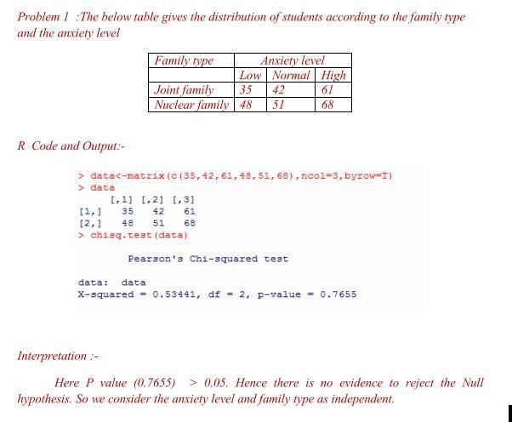

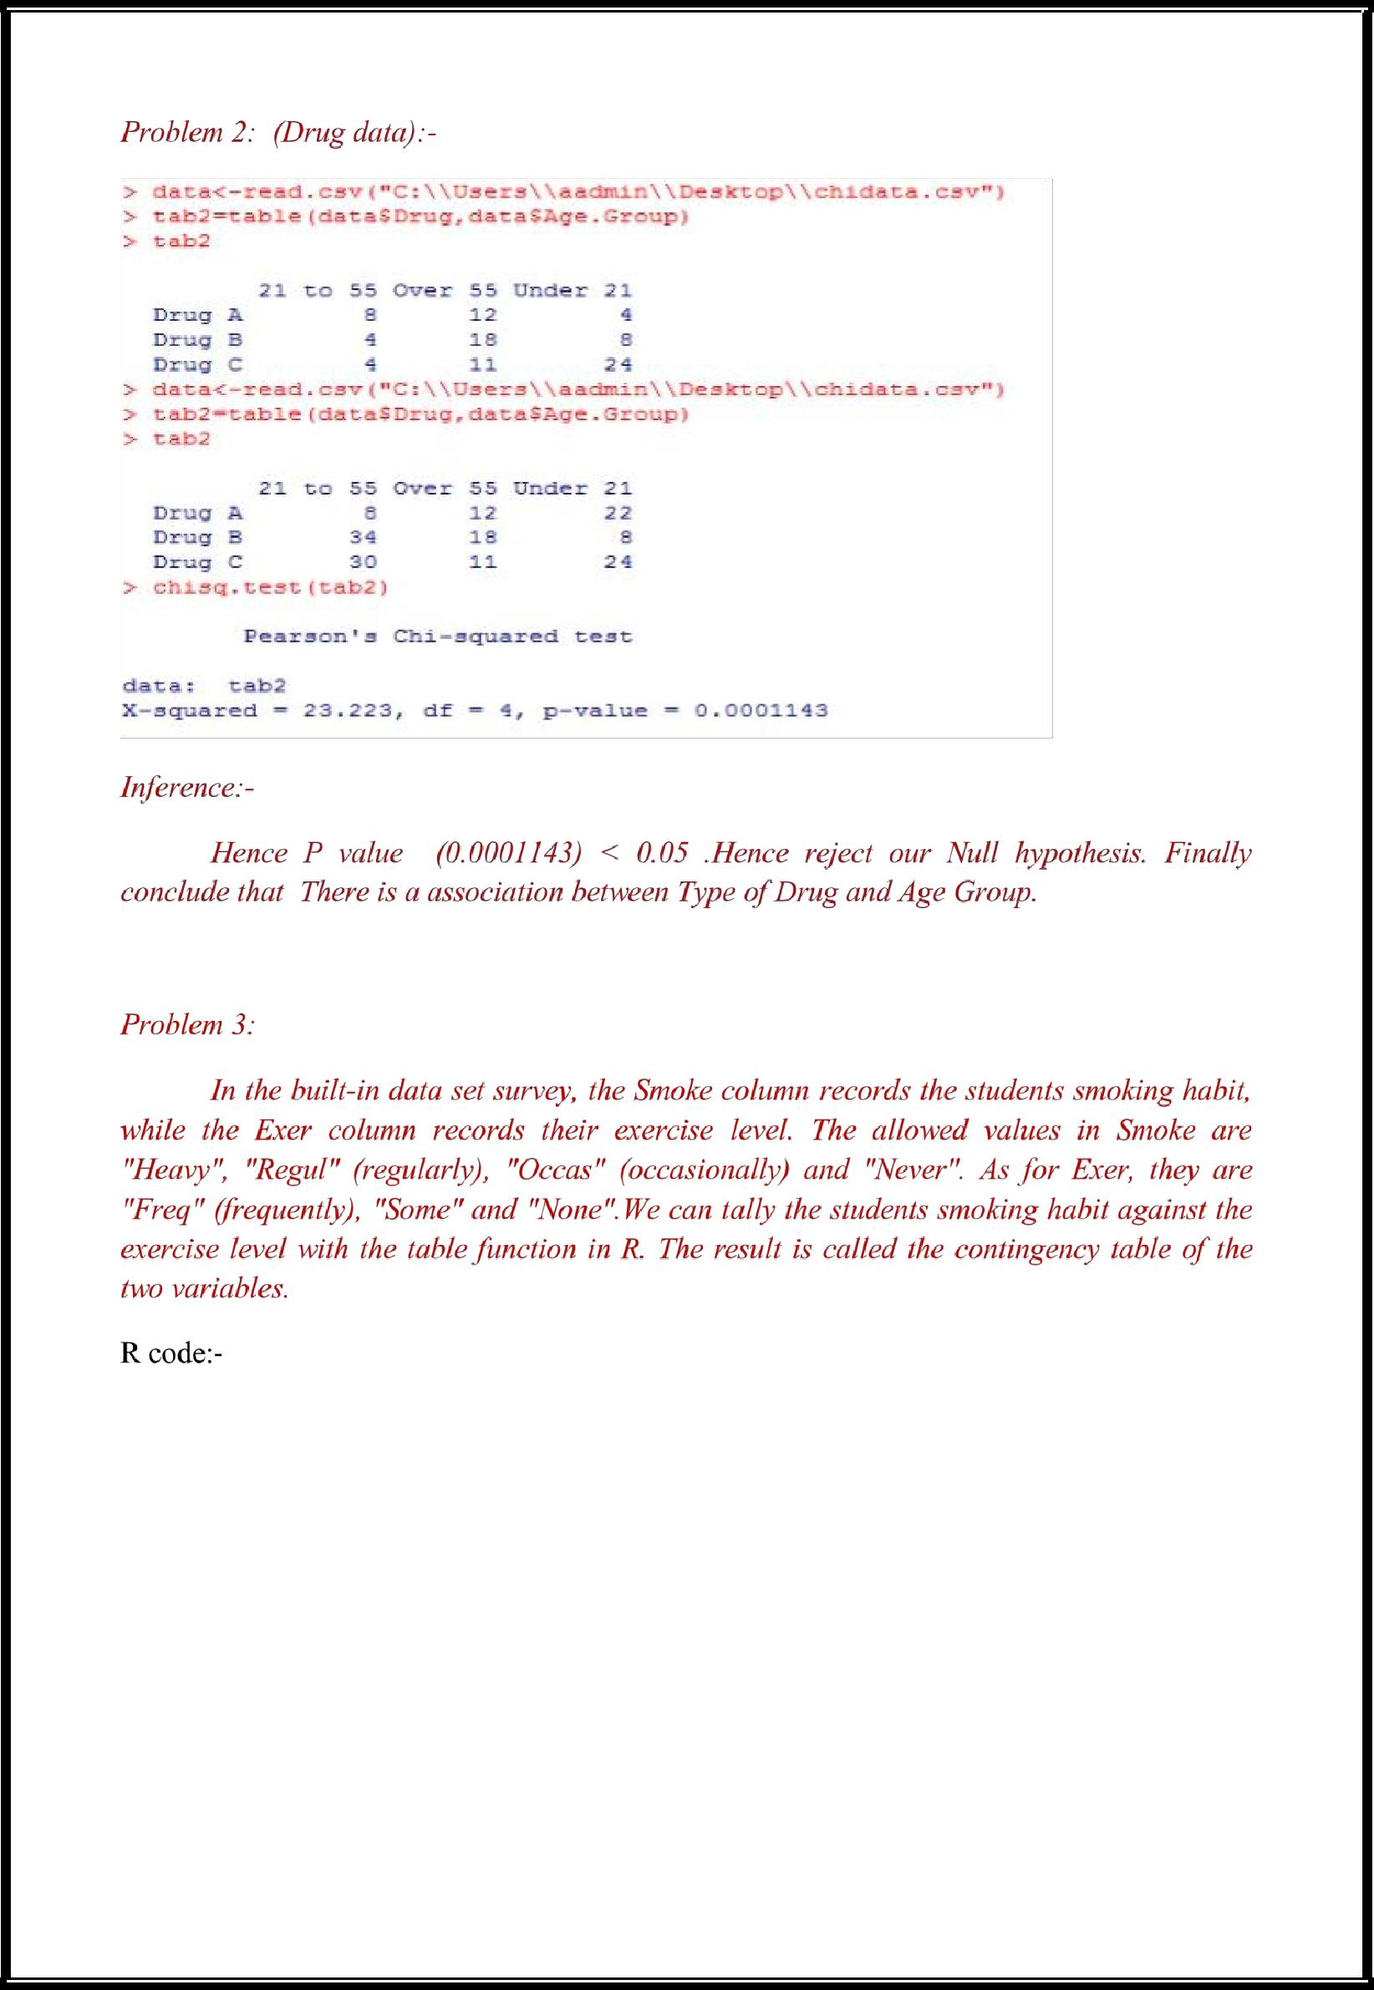

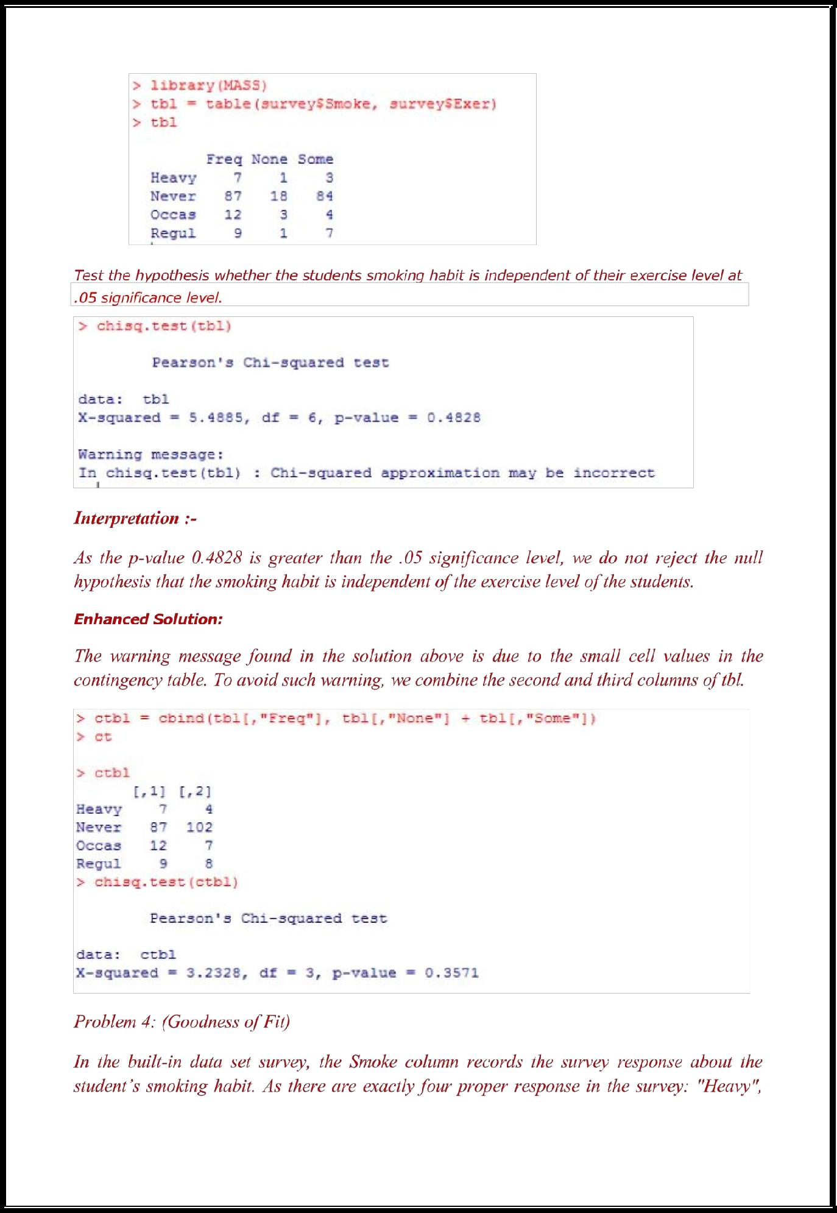

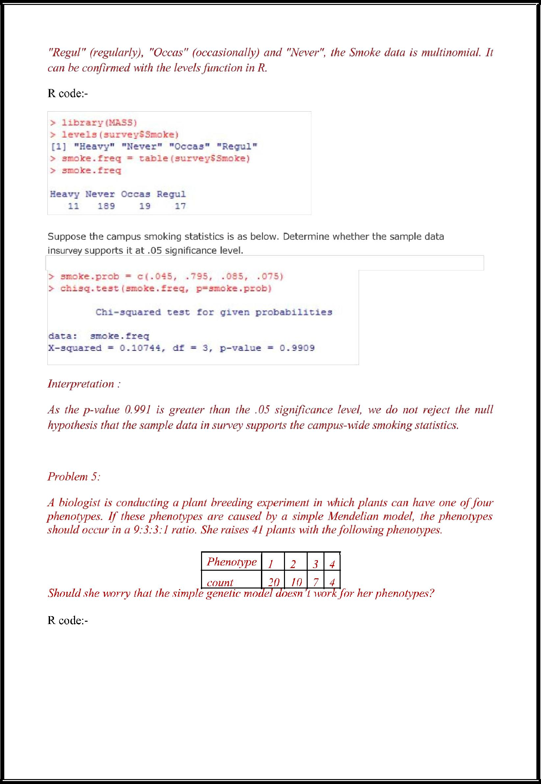

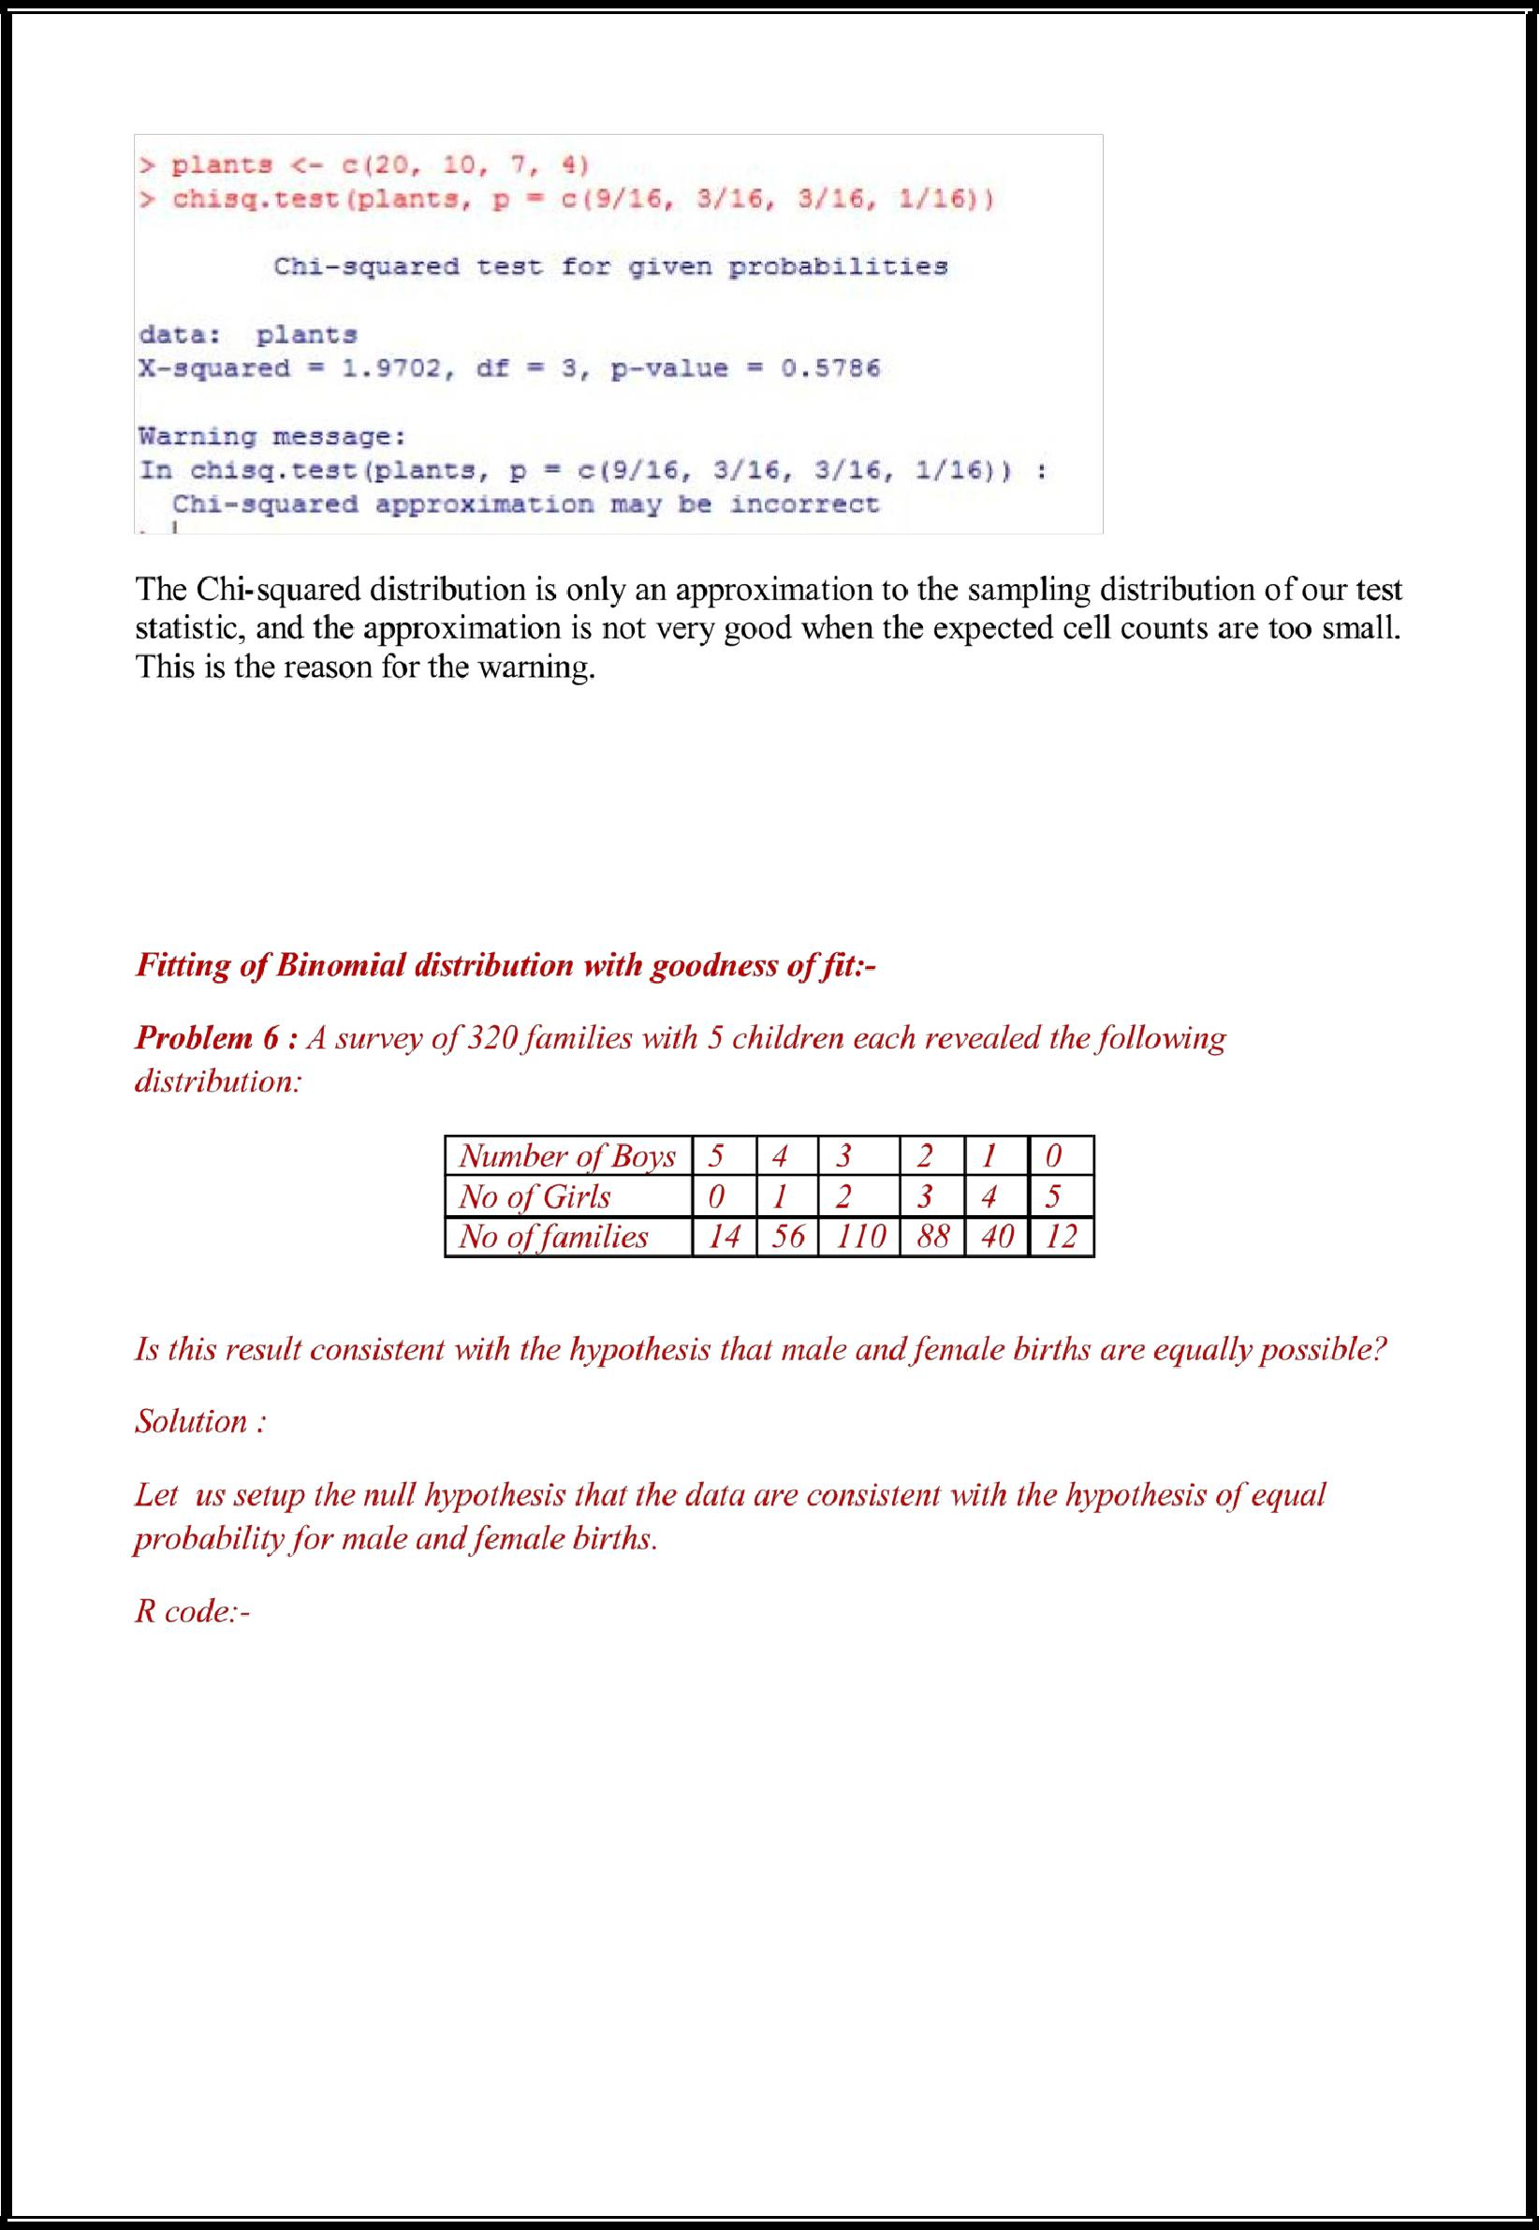

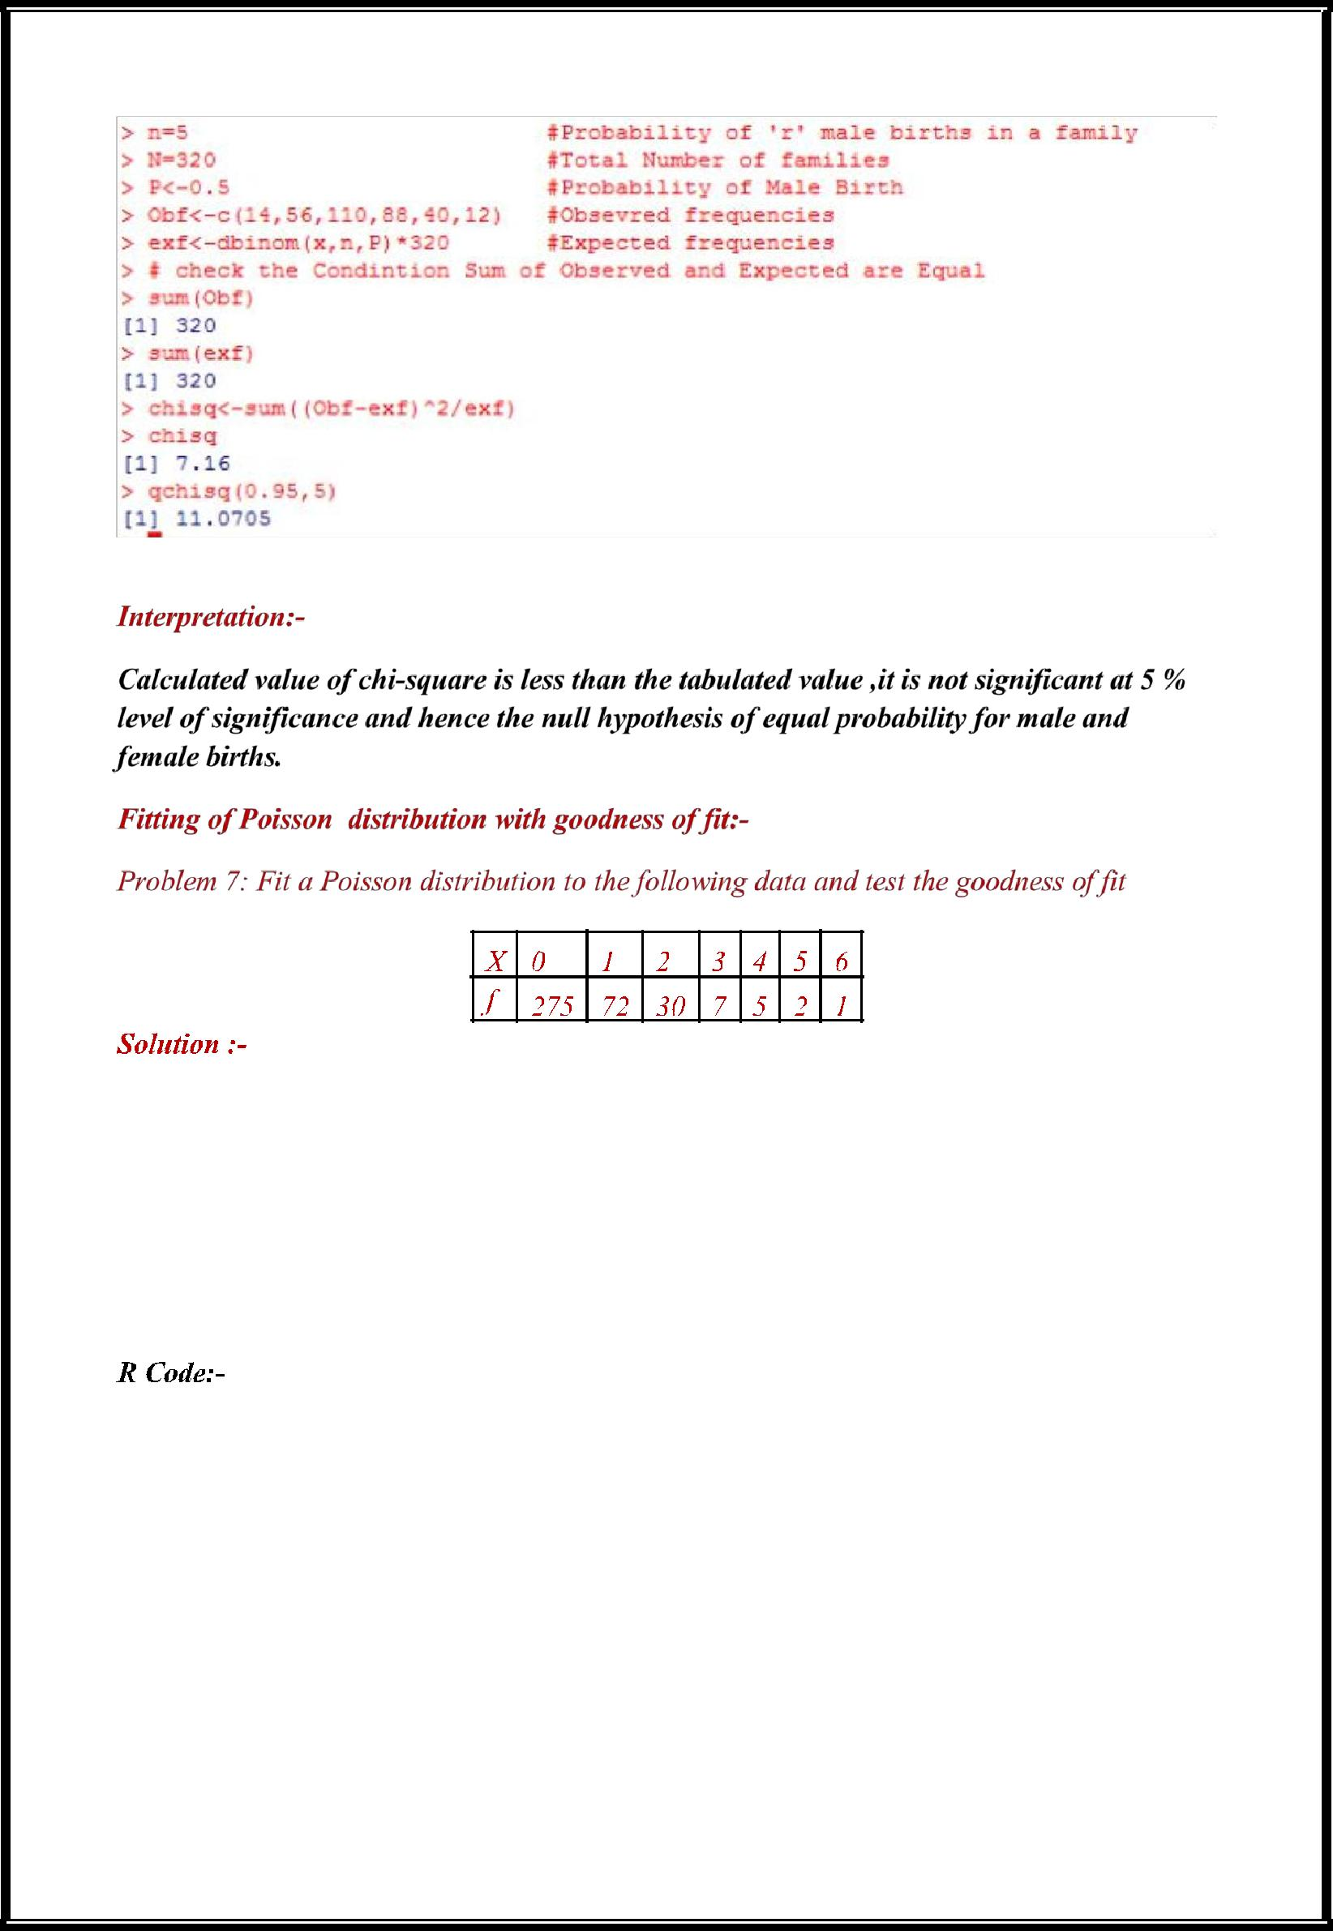

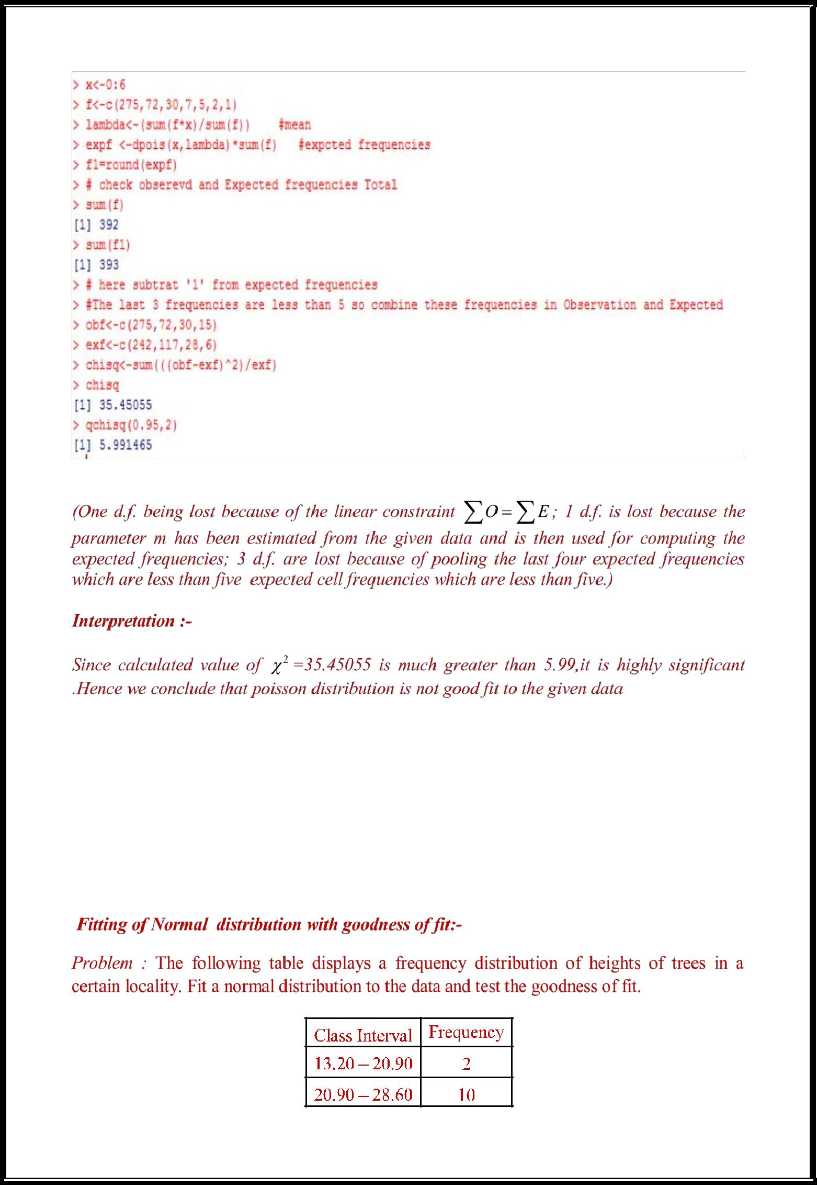

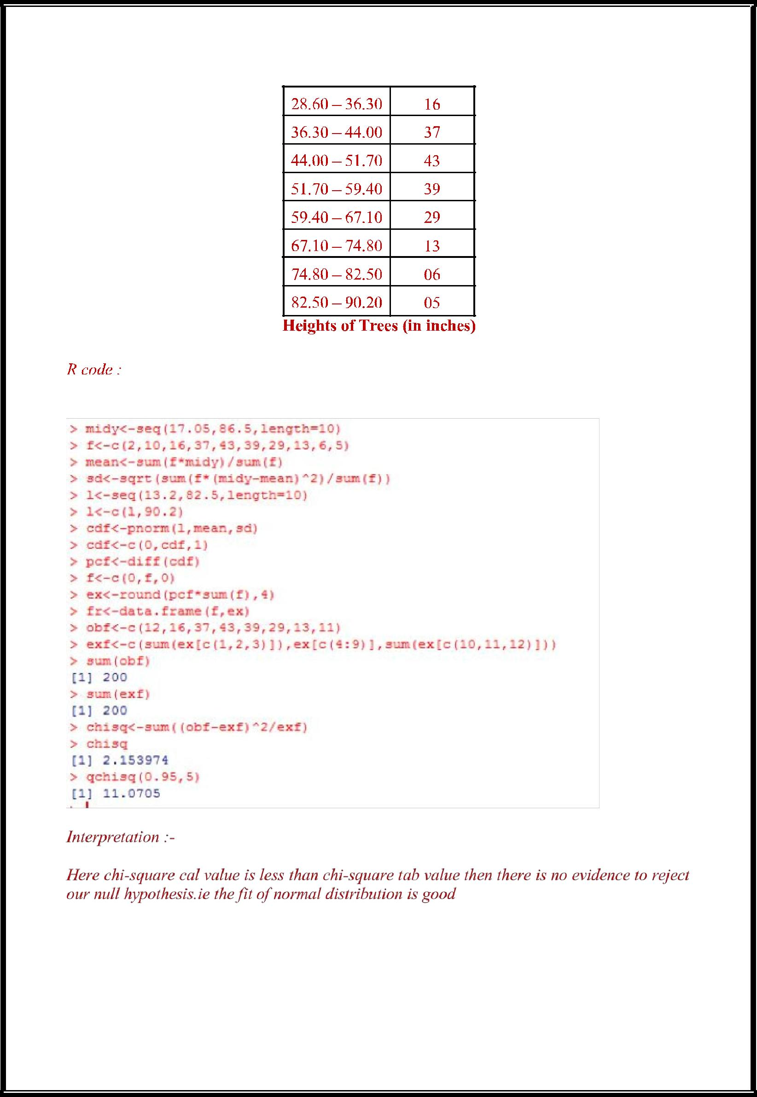

**Challenging Task**

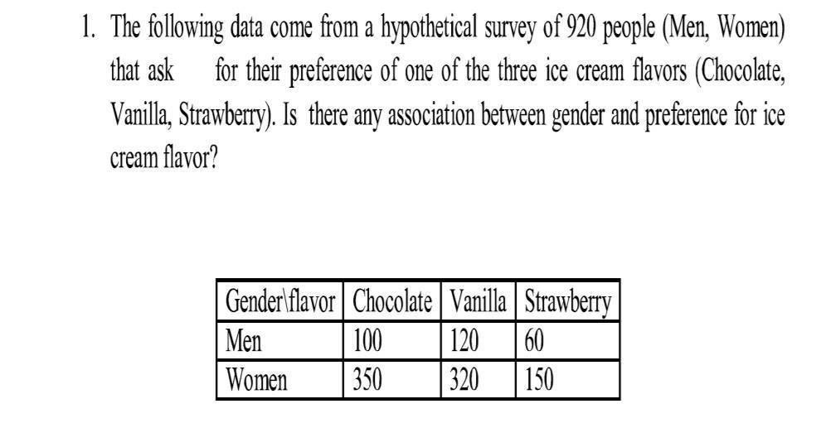

R-CODE:

> data<-

matrix(c(100,120,60,350,320,150),ncol=3,byrow=T) >

data

[,1] [,2] [,3]

[1,] 100 120 60

[2,] 350 320 150

> chisq.test(data)

Pearson's Chi-squared test

data: data

X-squared = 4.3195, df = 2, p-value = 0.1154



Inference:

Here p-value (0.1154) > 0.05 . Hence there is nno evidence to reject the null hypothesis.

So the gender and preference for ice-cream flavor are independent.

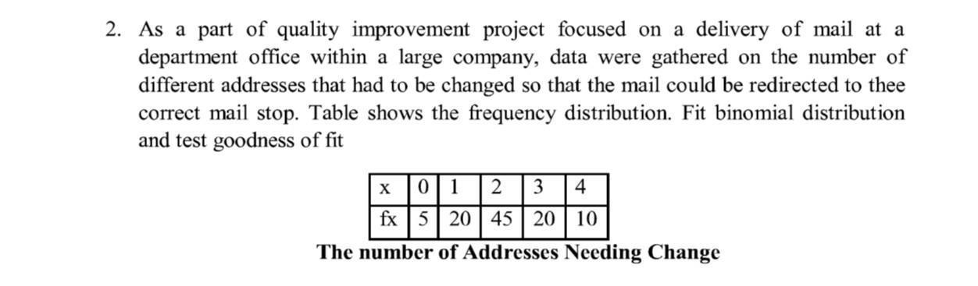

R-CODE:

* n=4
* N=100
* P<-0.5
* Obf<-c(5,20,45,20,10)
* x<-0:4
* exf<-dbinom(x,n,P)*100
* sum(Obf)

[1] 100

* sum(exf) [1] 100
* chisq<-sum((Obf-exf)^2/exf)
* chisq

[1] 6

> qchisq(0.95,4) [1] 9.487729

>

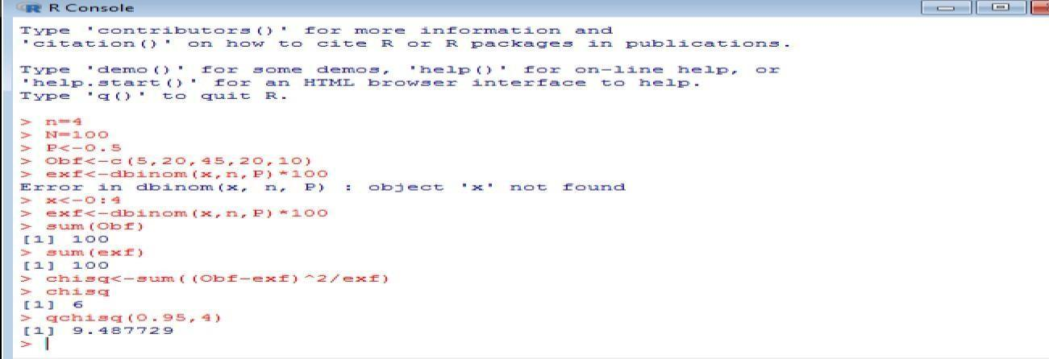

**Interpretation:**

**Calculated value of chi-square is less than the tabulated value ,it is not significant at 5% level of significance and hence null hypothesis is valid.**

