Statistics for Engineers (LAB) L13+L14  
Measures of Central Tendency

Prashant Singhai

15BCE0531

Problem 1

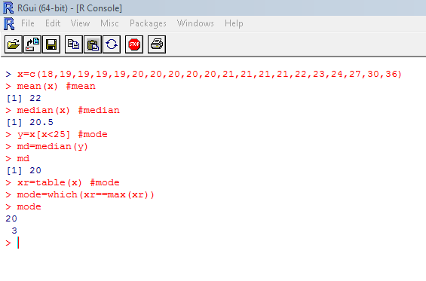

Problem 2

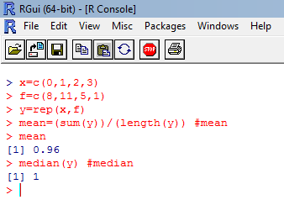

Problem 2

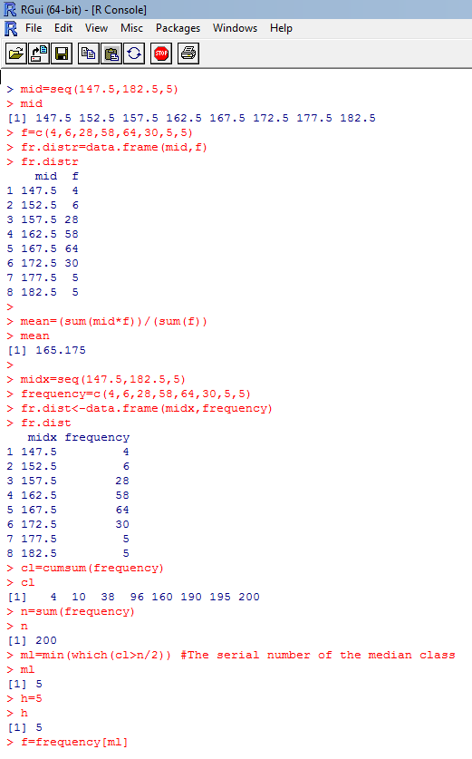

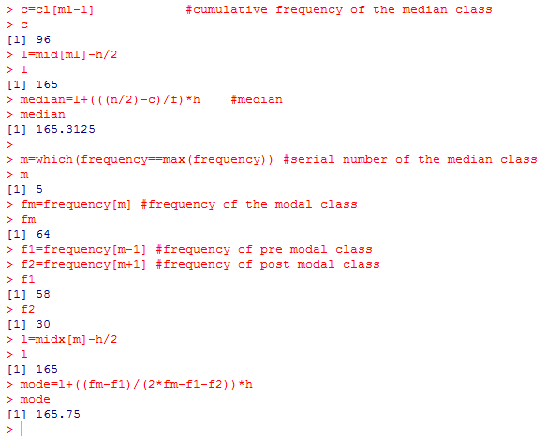

Problem 3

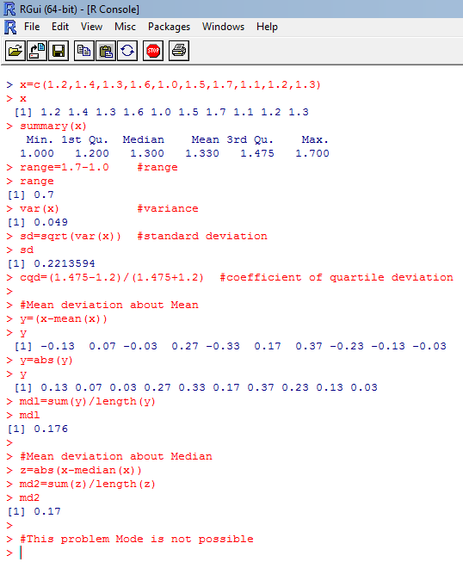

Problem 4

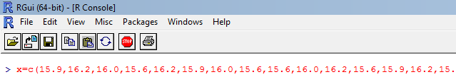



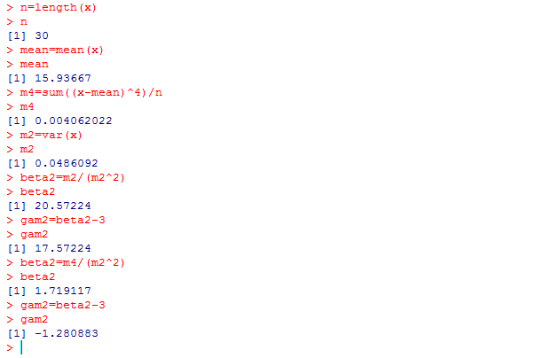

**Challenging Task:**

Q-Create your own (Student Record) dataset and do the summary statistics and graphs with interpretation. Use at least 60 observations with five variables

Challenging Task Solutions:

> data=read.csv("C:/Users/user pc/Desktop/StudentData.csv")

> data

Name Marks_Maths Marks_Science Marks_Computer Gender

|  |  |  |  |  |  |  |
| --- | --- | --- | --- | --- | --- | --- |
| 1 | Keith Kennedy | 59 | 78 | 39 |  | M |
| 2 | Laura Stevens | 97 | 62 | 97 |  | F |
| 3 | Lori Ruiz | 61 | 55 | 86 F |  |  |
| 4 | Joyce Mitchell | 51 | 100 | 66 |  | F |
| 5 | Sarah Hanson | 68 | 88 | 80 |  | F |
| 6 | Phyllis Collins | 63 | 48 | 73 | F |  |
| 7 | Lisa Shaw | 59 | 37 | 36 | F |  |
| 8 | Diane Wright | 74 | 32 | 71 |  | F |

1. Brenda Coleman 86 97 75 F
2. Linda James 54 96 50 F
3. Robin Weaver 40 78 65 F
4. Harold Foster 66 57 30 M
5. Johnny Gonzalez 70 50 80 M
6. Marilyn Flores 54 72 83 F
7. Carl Bailey 35 63 75 M
8. Janet Henderson 55 93 38 F
9. Johnny Mills 59 54 56 M
10. Mary Robertson 96 72 59 F

|  |  |  |  |  |  |  |  |
| --- | --- | --- | --- | --- | --- | --- | --- |
| 19 | Helen Harris 34 |  | 52 |  | 83 | F |  |
| 20 | Jeremy Boyd 49 |  | 75 |  | 76 | M |
| 21 | Janice Lopez 44 |  | 87 |  | 72 | F |
| 22 | Jerry Peters 93 |  | 66 |  | 65 | M |
| 23 | Larry Burns 39 |  | 54 |  | 78 | M |
| 24 | Evelyn Cruz 92 |  | 41 |  | 44 | F |
| 25 | Ruby Austin 49 |  | 48 |  | 55 | F |
| 26 | Earl Howard 45 |  | 33 |  | 84 | M |
| 27 | James Oliver 65 |  | 74 |  | 80 | M |
| 28 | Earl Knight 55 |  | 64 |  | 54 | M |
| 29 | Christopher Murphy | 48 |  | 95 |  | 33 | M |
| 30 | Louise Lee 100 |  | 64 |  | 65 | F |  |
| 31 | Juan Willis 92 |  | 91 |  | 74 | M |  |
| 32 | Karen Fields 98 |  | 91 |  | 50 | F |  |
| 33 | Susan Ray 66 |  | 74 |  | 85 | F |  |
| 34 | Theresa Ruiz 49 |  | 96 |  | 62 | F |  |
| 35 | Kevin Larson 92 |  | 60 |  | 56 | M |  |
| 36 | Steven Smith 96 |  | 41 |  | 88 | M |  |
| 37 | Russell Owens 55 |  | 45 |  | 93 | M |  |
| 38 | Todd Ferguson 69 |  | 68 |  | 48 | M |  |
| 39 | Ruth Reed 45 |  | 70 |  | 94 | F |  |

|  |  |  |  |  |
| --- | --- | --- | --- | --- |
| 40 | Sean Frazier | 48 | 60 | 72 M |
| 41 | Scott Cunningham | 35 | 85 | 100 M |
| 42 | Sarah Warren | 38 | 63 | 69 F |
| 43 | Sean Brooks | 50 | 38 | 37 M |
| 44 | Steven Reyes | 82 | 82 | 72 M |
| 45 | Paul Wagner | 80 | 69 | 56 M |
| 46 | Cheryl Murray | 58 | 44 | 56 F |
| 47 | Paula Torres | 34 | 94 | 46 F |
| 48 | Louis Marshall | 57 | 83 | 81 M |
| 49 | Anna Brown | 32 | 82 | 52 F |
| 50 | Roy Stephens | 50 | 95 | 34 M |
| 51 | Marilyn Collins | 34 | 69 | 57 F |
| 52 | Tammy Gardner | 88 | 50 | 100 F |
| 53 | Ryan Phillips | 86 | 80 | 50 M |
| 54 | Michelle Baker | 99 | 39 | 31 F |
| 55 | Maria Patterson | 50 | 41 | 63 F |
| 56 | Tammy Bryant | 78 | 88 | 56 F |
| 57 | Stephanie Russell | 87 | 72 | 73 F |
| 58 | Brandon Burton | 54 | 98 | 72 M |
| 59 | Matthew Peterson | 46 | 92 | 97 M |
| 60 | Anthony Kelley | 48 | 70 | 68 M |

> Maths=data$Marks_Maths

> median(Maths) [1] 57.5

> mean(Maths) [1] 62.6

> Sci=data$Marks_Science

> median(Sci) [1] 69.5

> mean(Sci) [1] 68.58333

> Comp=data$Marks_Computer

> median(Comp) [1] 67

> mean(Comp) [1] 65.66667

> var(Maths) [1] 416.3797

> SD=sqrt(var(Maths))

> SD

[1] 20.40538

> var(Sci)

[1] 380.4506

> sqrt(var(Sci))

[1] 19.50514

> var(Comp) [1] 346.3277

> sqrt(var(Comp)) [1] 18.60988

> summary(data)

Name Marks_Maths Marks_Science Marks_Computer Gender Anna Brown : 1 Min. : 32.0 Min. : 32.00 Min. : 30.00 F:32

Anthony Kelley: 1 1st Qu.: 48.0 1st Qu.: 53.50 1st Qu.: 53.50 M:28

Brandon Burton: 1 Median : 57.5 Median : 69.50 Median : 67.00

Brenda Coleman: 1 Mean : 62.6 Mean : 68.58 Mean : 65.67

Carl Bailey : 1 3rd Qu.: 80.5 3rd Qu.: 85.50 3rd Qu.: 80.00

Cheryl Murray : 1 Max. :100.0 Max. :100.00 Max. :100.00

(Other) :54