Statistics for Engineers (LAB) L13+L14  
CORELATION

Prashant Singhai

15BCE0531

Problem



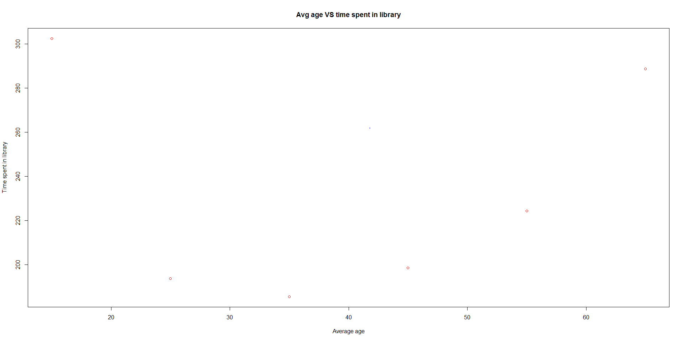

Problem

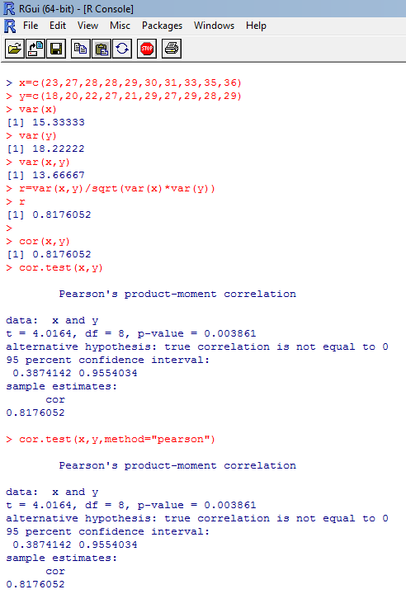

Problem

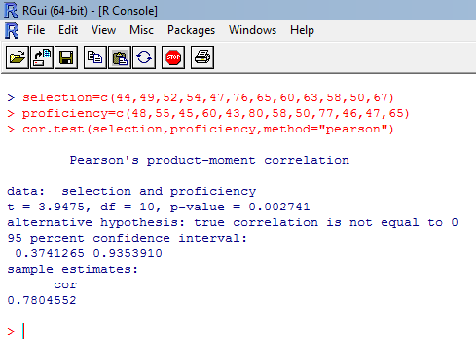

Problem

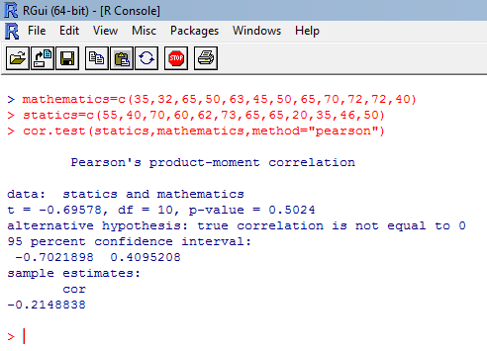

Problem

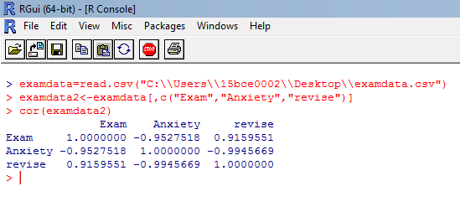

**Challenging Task :**  
 **Q1.**

> X=c(3.545,2.6,3.245,3.93,3.995,3.115,3.235,3.225,2.44,3.24,2.29,2.5,4.02)

> Y=c(30,32,30,24,26,30,33,27,27,32,37,34,26)

> cor(X,Y)

[1] -0.7086541

**Q2**

>p=c(4,15,1,11,13,19,6,10,15,3,11,20,7,11,10,6,7,18,8,2,7,12,13,15,4,3,9,7,10,2,15,1,3,6,13,15,16,1 4,1,8)

>q=c(16,19,0,19,25,24,22,21,13,7,28,31,4,26,11,12,14,16,20,13,12,23,22,19,12,10,7,22,7,0,16,17,11,5,29,29,20,16,3,8)

> r=c(6,13,1,13,12,11,7,8,12,4,15,14,7,14,9,5,7,12,10,6,9,13,9,13,9,5,7,8,8,2,7,6,9,9,15,11,9,7,2,10)

> cor(p,q)

[1] 0.6440382

> cor(p,r)

[1] 0.732074

> cor(q,r)

[1] 0.7468472