**Registration No.: 15BCE0531**

**Name: Prashant Singhai**

EXPERIMENT 7

1. **test Single mean and t-test for difference of means**

Problem 1

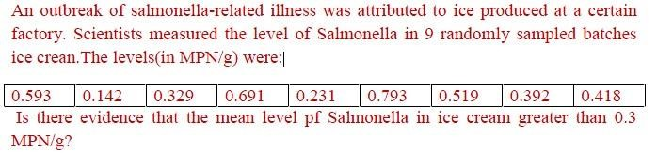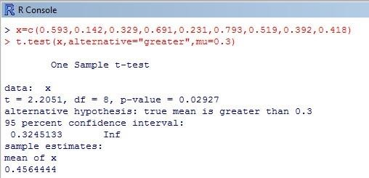

Problem 2

# Suppose that 10 volunteers have taken an intelligence test; here are the results obtained. The average score of the entire population is 75 in the same test. Is there any significant difference (with a significance level of 95%) between the sample and population means, assuming that the variance of the population is not known.

**Scores: 65, 78, 88, 55, 48, 95, 66, 57, 79, 81**

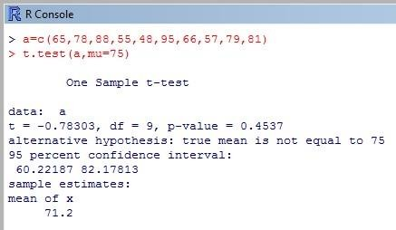

Problem 3

# Comparing two independent sample means, taken from two populations with unknown variance.The following data shows the heights of individuals of two different countries with unknown population variances. Is there any significant difference b/n the average heights of two groups.

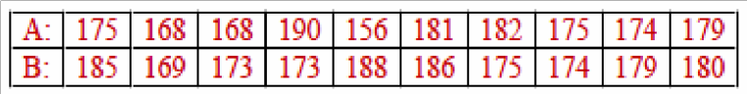

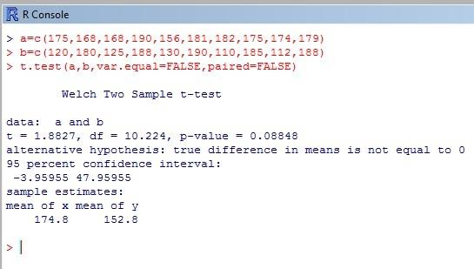

Problem 4

# Suppose the recovery time for patients taking a new drug is measured (in days). A placebo group is also used to avoid the placebo effect. The data are as follows

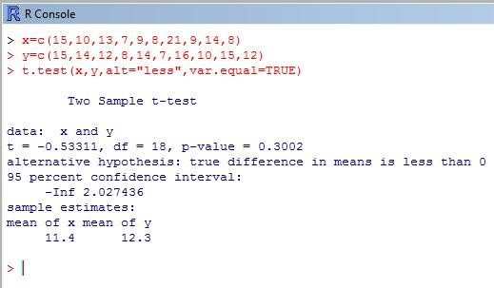

**Challenging task**

Problem 5

# Six subjects were given a drug (trearment group) and an additional 6 subjects a placebo(control group).Their reaction time to stimulus was measured(in ms).We want to perform a two sample t-test for comparing the means of the treatment and control groups.

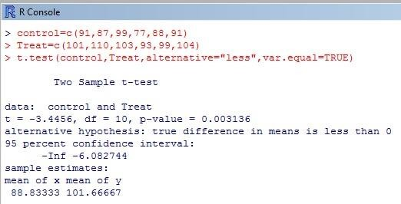

Problem 1: A recent national study showed that approximately 55.8% of college students have used

Google as a source in at least one of their term papers. Let X equal the number of students in a random sample of size n = 42 who have used Google as a source:

How is X distributed?

Ans-Random Variable X yields a binomial distribution.

Sketch the probability mass function (roughly).

> probs=dbinom(0:42,42,0.558)

> plot(0:42,probs,type='h')

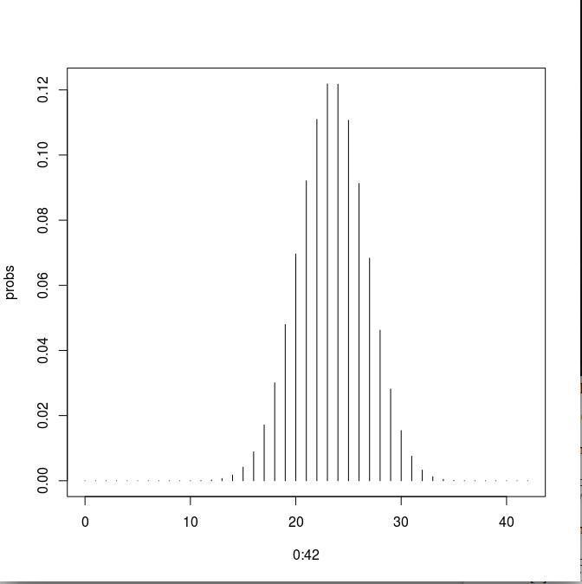Sketch the

cumulativ e distributio n function (roughly).

> probs=pbi nom(0:42, 42,0.558)

> plot(0:42,probs,type='h')

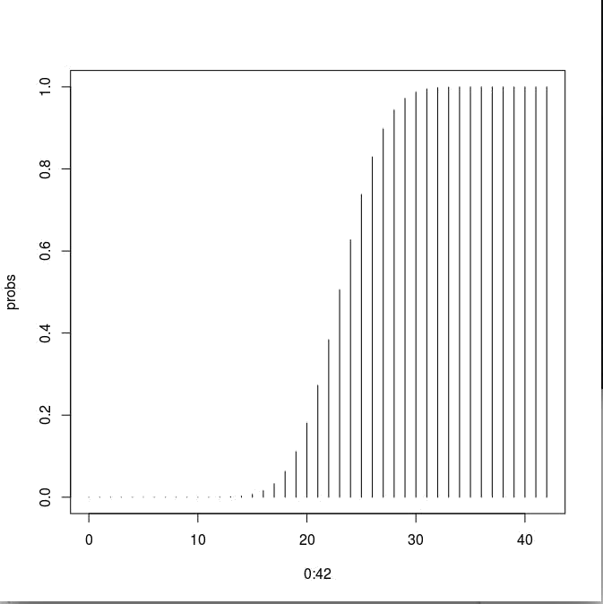

Find the probability that X is equal to 17.

> probs=dbinom(17,42,0.558)

> probs [1] 0.0171515

* 1. **Find the probability that X is at most 13.**

> probs=pbinom(13,42,0.558)

> probs

[1] 0.001005323

* 1. **Find the probability that X is bigger than 11. > 1-pbinom(11,42,0.558) [1] 0.9999036**
  2. **Find the probability that X is at least 15.**

**> 1-pbinom(14,42,0.558) [1] 0.9972253**

* 1. **Find the probability that X is between 16 and 19, inclusive**

**> sum(dbinom(16:19,42,0.558)) [1] 0.1040649**

* 1. **Give the mean of X, denoted E(X).**

> n=42

> p=0.558

> q=1-p

> Mean=n*p

> Mean [1] 23.436

* 1. **Give the variance of X.**

> Variance=n*p*q

> Variance [1] 10.35871

* 1. **Give the standard deviation of X.**

> SD=sqrt(Variance)

> SD

[1] 3.218495

Find E(4X + 51:324)

Compare mean and variance

**> all(Mean==Variance) [1] FALSE**

**> all(Mean>Variance) [1] TRUE**

Problem 2: (Traffic accident problem) The number of traffic accidents that occur on a particular stretch of road during a month follows a Poisson distribution with a mean of 7.6.

1. **Find the probability that less than three accidents will occur next month on this stretch**

of road.

We know that for a poisson distribution mean=variance=λ=7.6 Hence,the code:

**> ppois(2,7.6) [1] 0.01875692**

1. **Find the probability of observing exactly three accidents on this stretch of road next month.**

**> dpois(3,7.6) [1] 0.03661436**

Find the probability that the next two months will both result in four accidents each occurring on this stretch of road.

Check the mean and variance of the poisson distribution.

> X.val=0:100

> P.val=dpois(X.val,7.6)

**> EX=sum(X.val*P.val)**

**> EX**

[1] 7.6

> VarX=sum(((X.valEX)^2)*P.val) > VarX

[1] 7.6

* 1. **Plot the Poisson distribution and compare with binomial distribution > plot(X.val,P.val,type='h')**

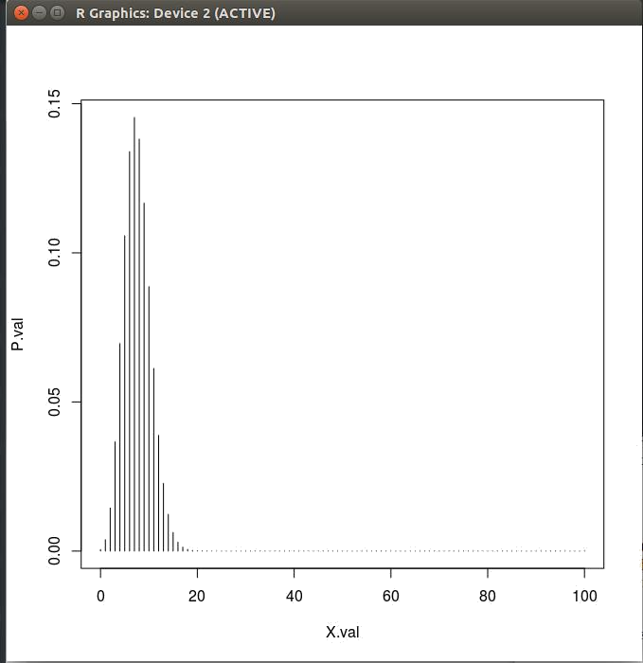



Plot the graph

. Sol.:)

> pnorm(1.5)pnorm(0.8) [1] 0.1450482 >plot.new()

> curve(dnorm,xlim=c(-2,2),ylim=c(0,0.5),xlab="z",ylab="f(z)")

> zleft=0.8

> zright=1.5

> x1=seq(zleft,zright,0.02)

> x=c(zleft,x1,zright)

> y1=dnorm(x1,0,1)

> y=c(0,y1,0)

> polygon(x,y,col='purple')

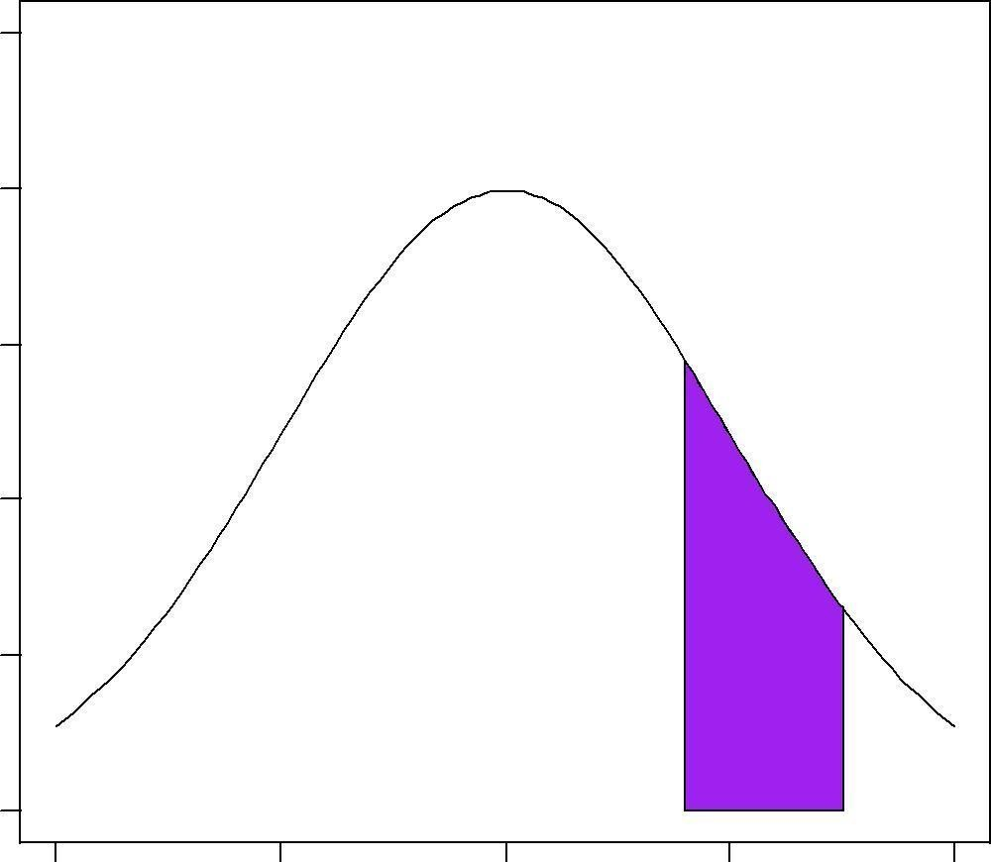

-2 -1 0 1 2

z

> pnorm(zright)-pnorm(zleft) [1] 0.1450482

* + 1. **P (Z ≤**

2) sol.:)

**>pnorm(2) - pnorm(0) [1] 0.4772499**

**>plot.new()**

>curve(dnorm, xlim = c(-4,4), ylim = c(0, 0.5), xlab = "z", ylab="f(z)")

> zleft = 0

> zright = 2

> x = c(zleft, seq(zleft, zright, by=.001), zright)

> y = c(0, dnorm(seq(zleft, zright, by=.001)),

0) >polygon(x, y, col="pink")

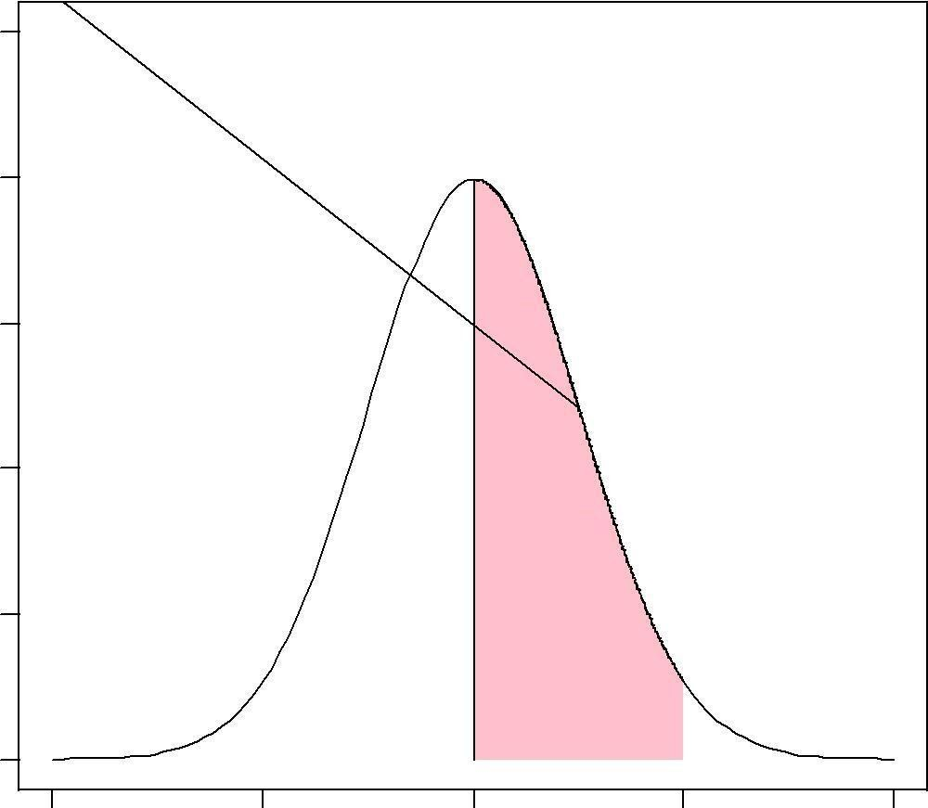

-4 -2 0 2 4

z

* + 1. **P (Z ≥ 1). sol.:) > 1 - pnorm(1)**

[1] 0.1586553

>plot.new()

>curve(dnorm, xlim = c(-3, 3), ylim = c(0, 0.5), xlab = "z", ylab="f(z)")

> z = 1

> x = c(z, seq(z, 3, by=.001), 3)

> y = c(0, dnorm(seq(z, 3, by=.001)), 0) >polygon(x, y, col="orange")

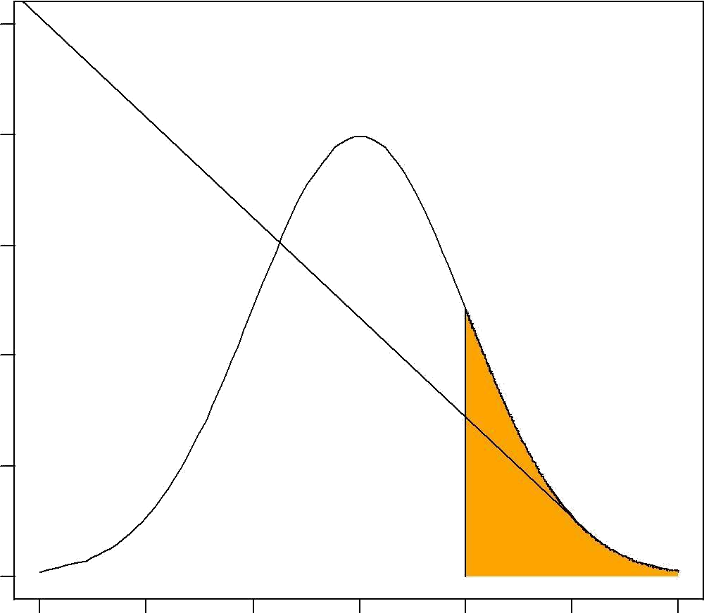

-3 -2 -1 0 1 2 3

z

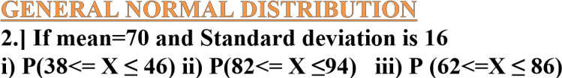

Find the Probability values and Plot the graph with text. Sol.:)

**(i) P(38<= X ≤ 46)**

**> x=seq(0,150)**

**> y=dnorm(x,70,16) > plot(x,y,type="l") > x=seq(38,46)**

**> y=dnorm(x,70,16)**

> pnorm(46,70,16)-pnorm(38,70,16) [1] 0.04405707

**> polygon(c(38,x,46),c(0,y,0),col="pink")**

**>text(40,0.0025,"0.044")**

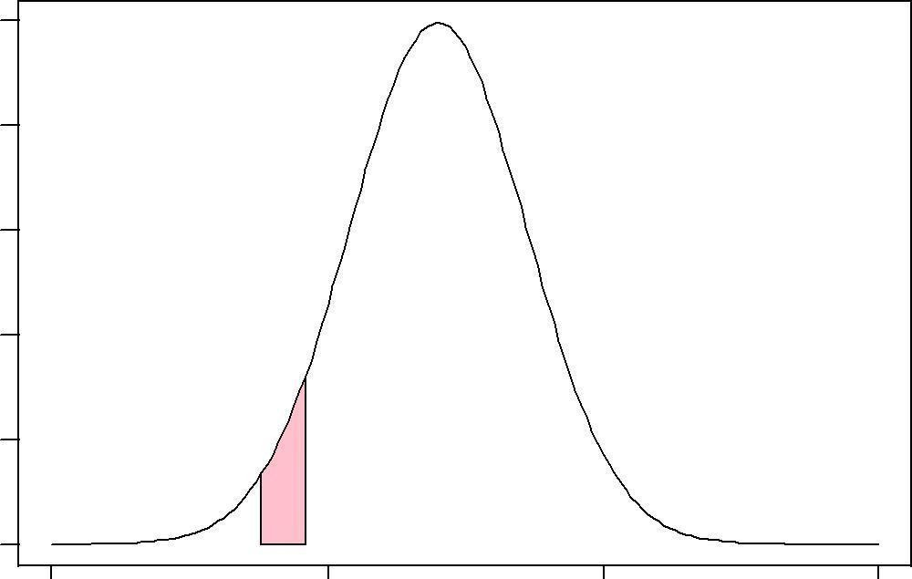

0.044

**0 50 100 150**

**x**

ii) P(82<= X ≤94) > x=seq(0,150)

> y=dnorm(x,70,16)

> plot(x,y,type="l")

> x=seq(82,94)

> y=dnorm(x,70,16)

> polygon(c(82,x,94),c(0,y,0),col="blue")

> pnorm(94,70,16)-pnorm(82,70,16) [1] 0.1598202

> text(89,0.005,"0.159",col="pink")

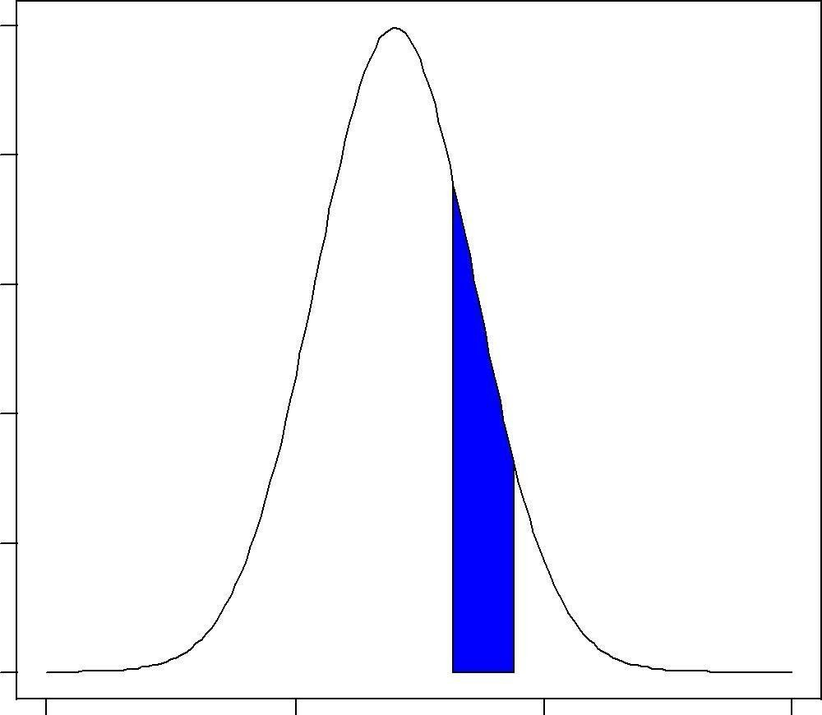

0.159

0 50 100 150

x

iii) P (62<=X ≤ 86) > x=seq(0,150)

> y=dnorm(x,70,16)

> plot(x,y,type="l")

> x=seq(62,86)

> y=dnorm(x,70,16)

> polygon(c(62,x,86),c(0,y,0),col="orange")

> pnorm(86,70,16)-pnorm(62,70,16)

**[1] 0.5328072**

**>text(70,0.01,"0.53")**

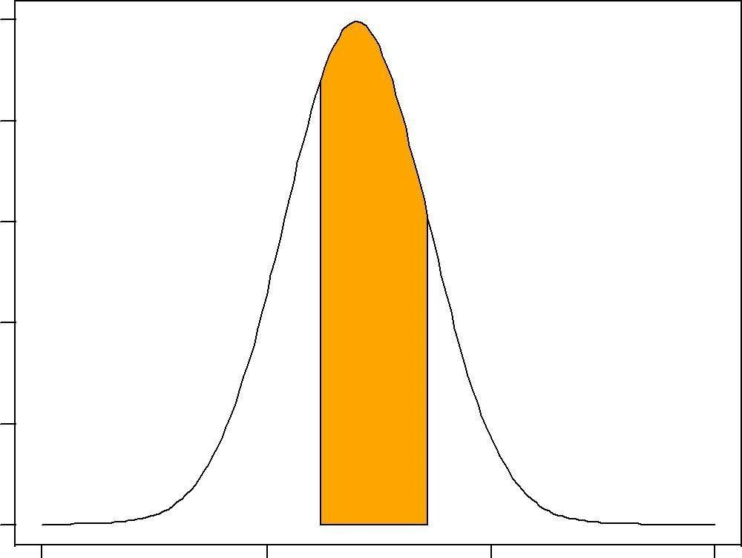

0.53

**0 50 100 150 x**

3.] 1000 students had Written an examination the mean of test is 35 and standard deviation is 5.Assumning the to be normal find

How many students Marks Lie between 25 and 40 How many students get more than 40

How many students get below 20 iv) How many students get 50

sol.:) (i) ( pnorm(40, mean=35, sd=5) - pnorm(25, mean=35, sd=5))*1000 [1] 818.5946

(ii)

(1 - pnorm(40, mean=35, sd=5))*1000 [1] 158.6553

(iii) (pnorm(20, mean=35, sd=5))*1000 [1] 1.34989

* + 1. **dnorm(50,mean=35,sd= 5) [1] 0.000886369**