Name: Prashant Singhai

**Registration No.:15BCE0531**

**EXPERIMENT 8**

**STANDARD NORMAL DISTRIBUTION**

Problem 1

*A school athletics has taken a new instructor, and want to test the effectiveness of the*

*new type of training proposed by the new instructor comparing the average times of 10 runners in the 100 meters. The results are given below(time in seconds)*

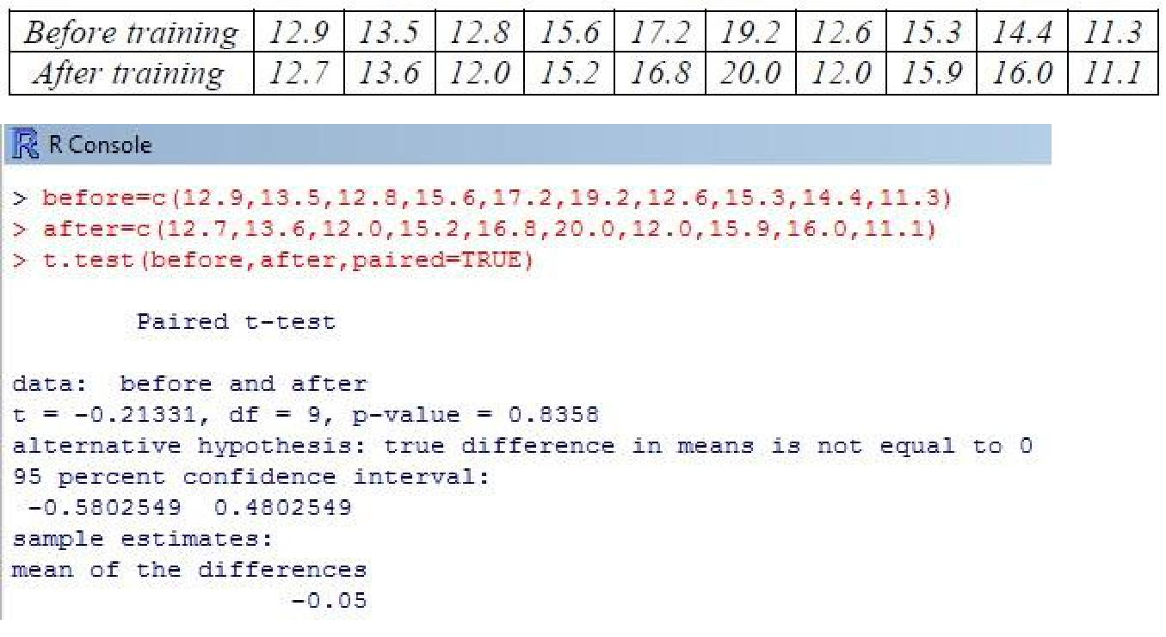

Problem 2

*Suppose now that the manager of the team (given the results obtained) fired the coach*

*who has not made any improvement, and take another, more promising. We report the times of athletes after the second training:*

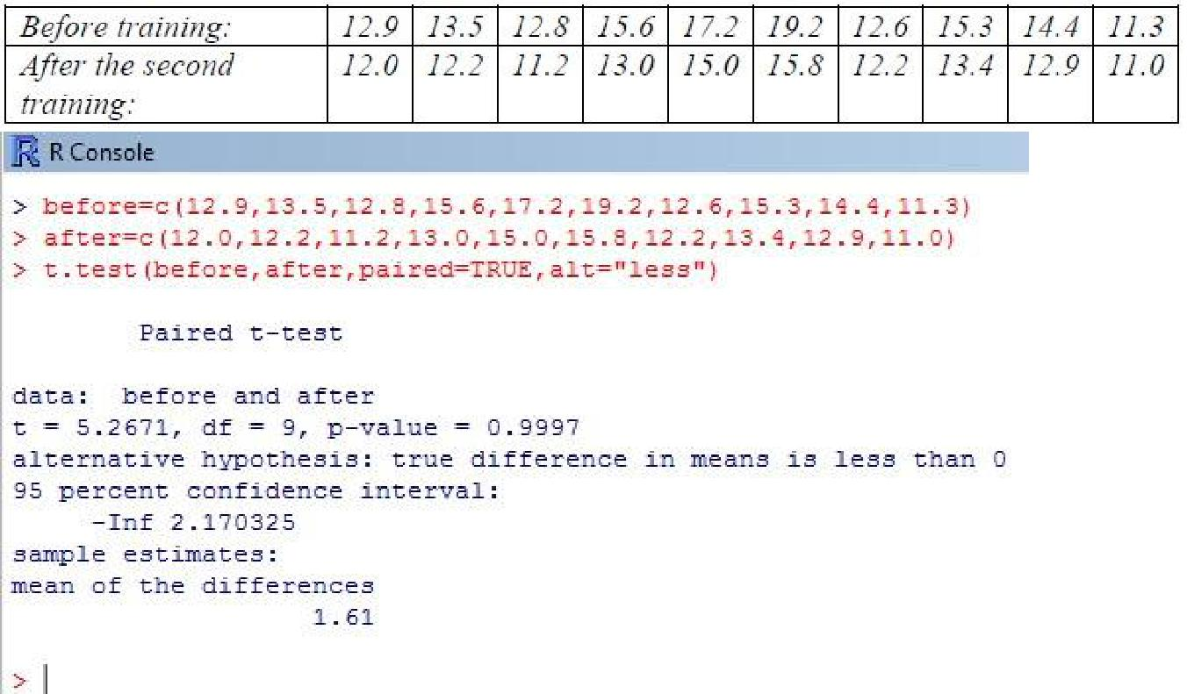

Problem 3

*Consider the paired data below that represents cholesterol levels on 10 men before and after a certain medication*



*Test the claim that, on average, the drug lowers cholesterol in all men. I.e., test the claim that ud > 0. Test this at the 0.05 significance level.*

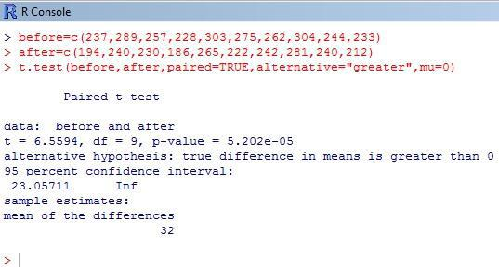

Problem 4

***F Test to Compare Two Variances***

*Problem 1 :-*

*Five Measurements of the output of two units have given the following results (in kilograms of material per one hour of operation) .Assume that both samples have been obtained from normal populations, test at 10% significance level if two populations have the same variance.*

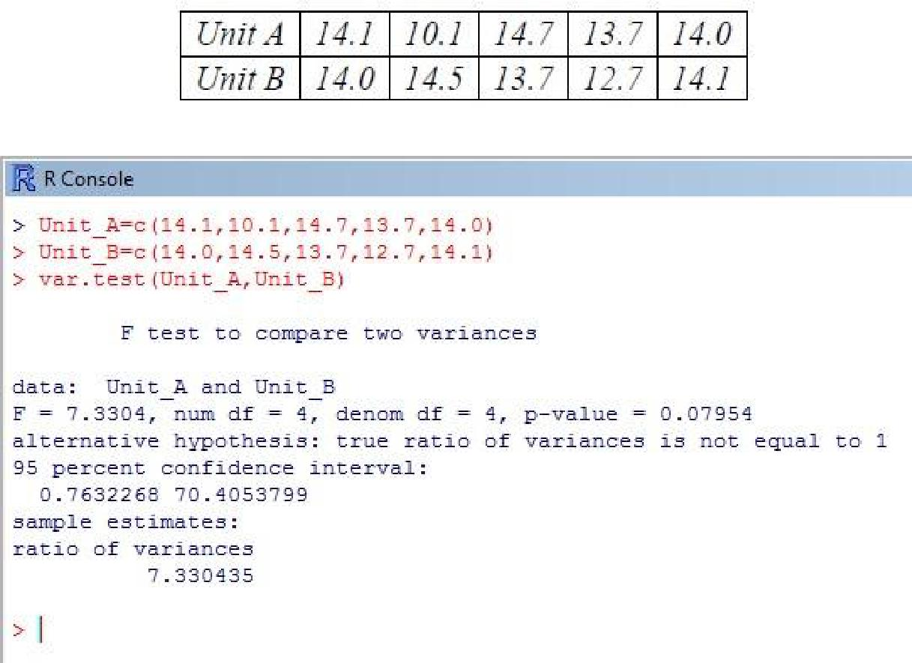

***Problem 2: Energy Data :- (Variance Ratio-test)***

Six subjects were given a drug (trearment group) and an additional 6 subjects a placebo(control group).Their reaction time to stimulus was measured(in ms).We want to perform a two sample t-test for comparing the means of the treatment and control groups.

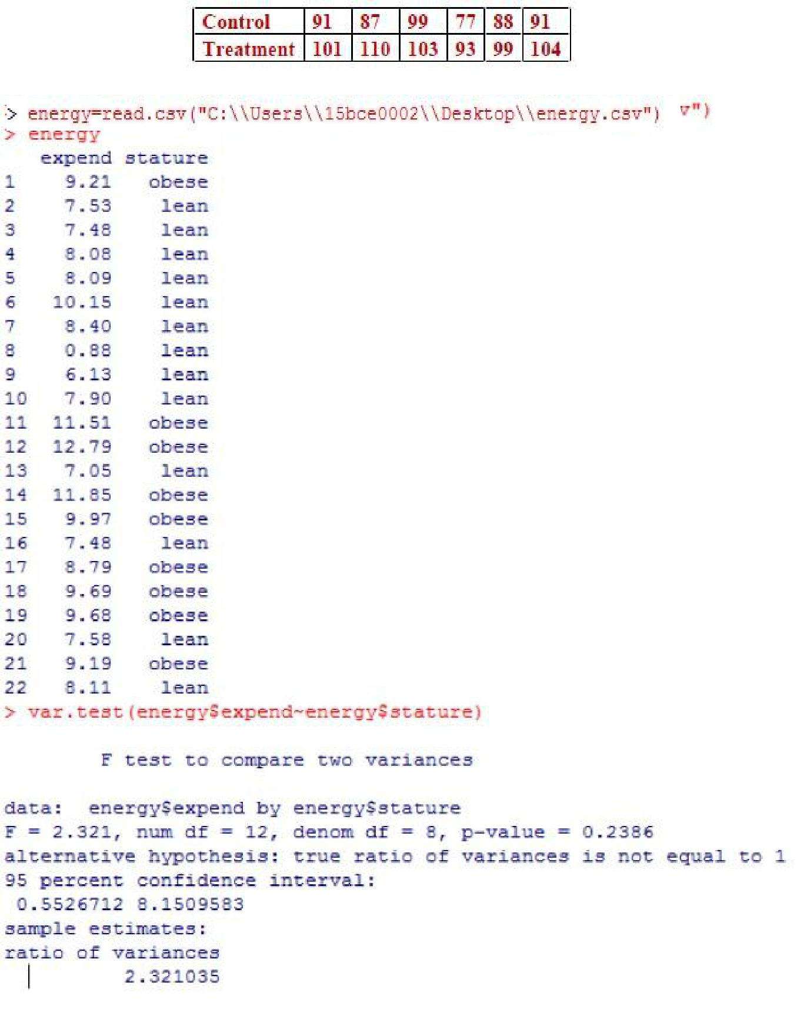

**Challenging Task**

**1.] Find (i) P (0.8<=Z<= 1.5) (ii) P (Z ≤ 2) (iii) P (Z ≥ 1). Find These probability values and Plot the graph .**

**Sol.:)**

>

pnorm(1.5)pnorm(0.8) [1] 0.1450482 >plot.new()

* curve(dnorm,xlim=c(-2,2),ylim=c(0,0.5),xlab="z",ylab="f(z)")
* zleft=0.8
* zright=1.5
* x1=seq(zleft,zright,0.02)
* x=c(zleft,x1,zright)
* y1=dnorm(x1,0,1)
* y=c(0,y1,0)
* polygon(x,y,col='purple')

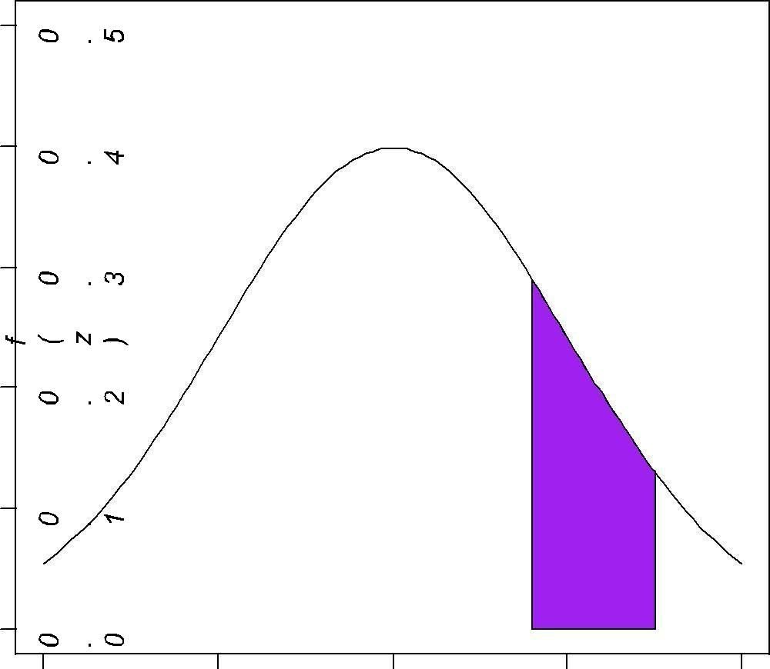

-2 -1 0 1 2

z

> pnorm(zright)-pnorm(zleft) [1] 0.1450482

**(ii) P (Z ≤**

**2) sol.:)**

>pnorm(2) - pnorm(0) [1] 0.4772499

> plot.new()

>curve(dnorm, xlim = c(-4,4), ylim = c(0, 0.5), xlab = "z", ylab="f(z)")

* zleft = 0
* zright = 2
* x = c(zleft, seq(zleft, zright, by=.001), zright)
* y = c(0, dnorm(seq(zleft, zright, by=.001)), 0) >polygon(x, y, col="pink")

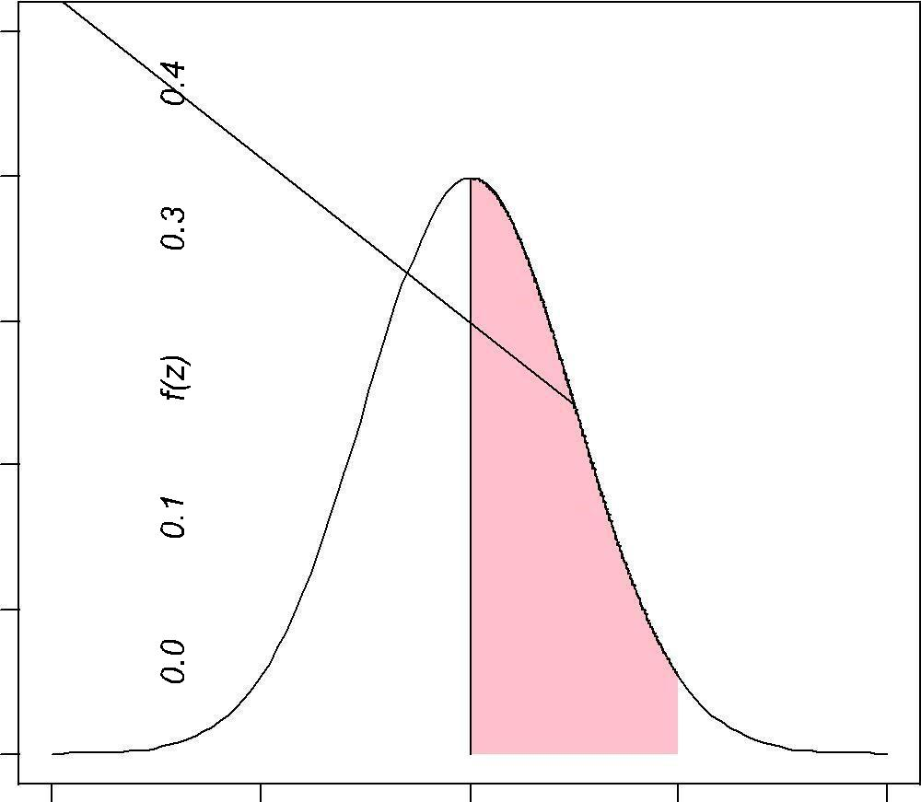

-4 -2 0 2 4

z

**(iii) P (Z ≥ 1).** **sol**.:) > 1 - pnorm(1)

[1] 0.1586553 >plot.new()

>curve(dnorm, xlim = c(-3, 3), ylim = c(0, 0.5), xlab = "z", ylab="f(z)") > z = 1 > x = c(z, seq(z, 3, by=.001), 3)

> y = c(0, dnorm(seq(z, 3, by=.001)), 0)

>polygon(x, y, col="orange")

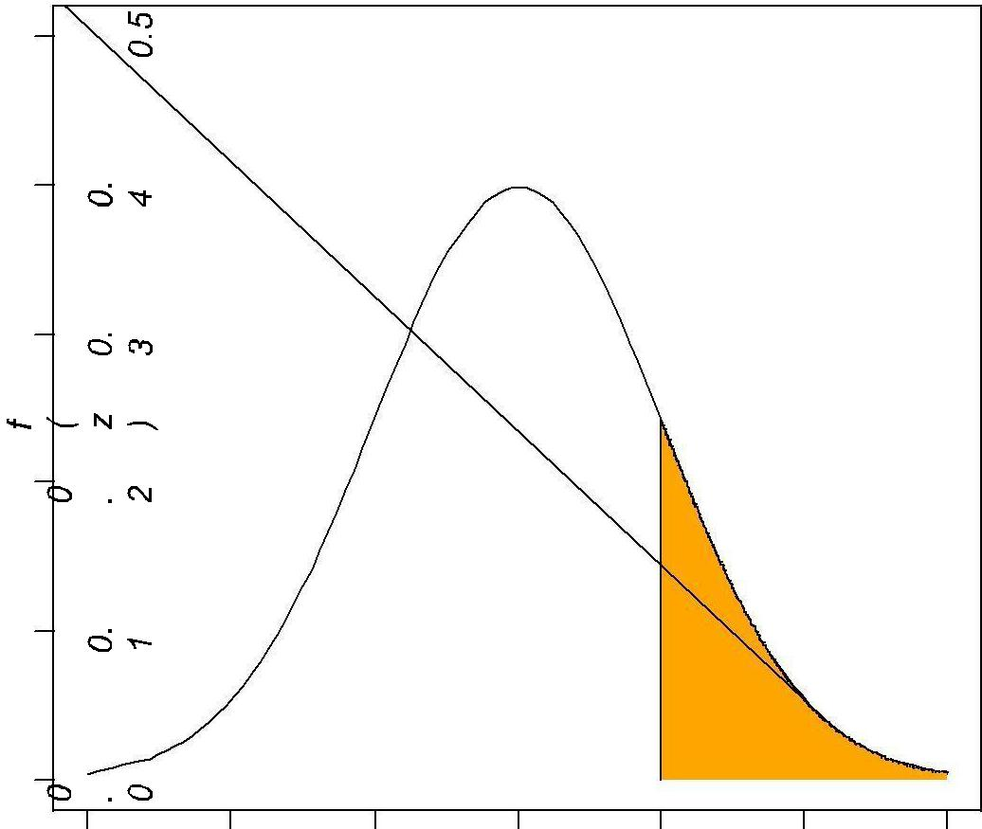

-3 -2 -1 0 1 2 3

z

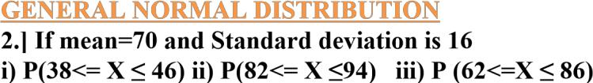

**Find the Probability values and Plot the graph with text. Sol.:)**

1. **P(38<= X ≤ 46)**

> x=seq(0,150) >

y=dnorm(x,70,16)

* plot(x,y,type="l") > x=seq(38,46)
* y=dnorm(x,70,16)
* pnorm(46,70,16)-pnorm(38,70,16) [1] 0.04405707
* polygon(c(38,x,46),c(0,y,0),col="pink")

>text(40,0.0025,"0.044")

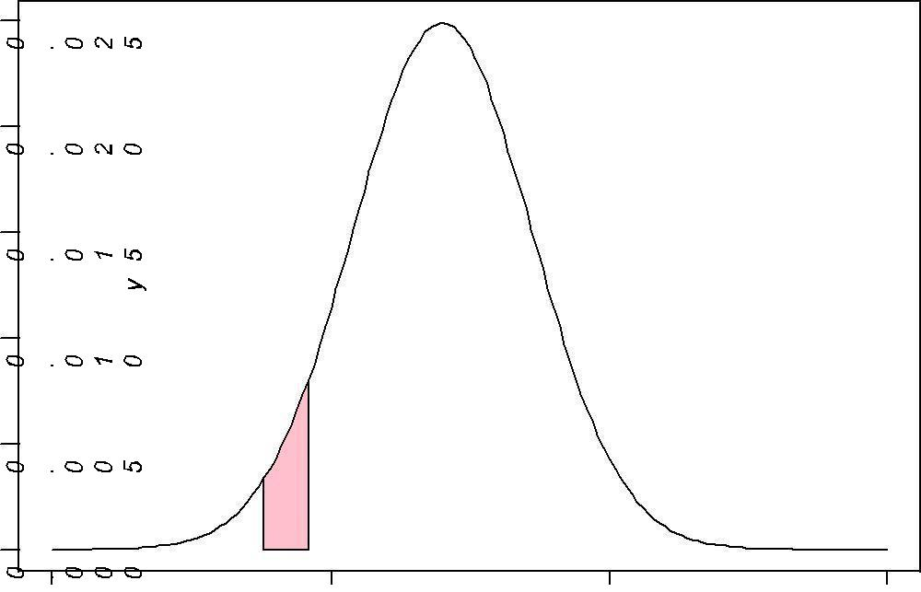

0.044

0 50 100 150

x

**ii) P(82<= X ≤94)** >x=seq(0,150)

* + y=dnorm(x,70,16)
  + plot(x,y,type="l")
  + x=seq(82,94)
  + y=dnorm(x,70,16)
  + polygon(c(82,x,94),c(0,y,0),col="blue")
* pnorm(94,70,16)-pnorm(82,70,16) [1]

0.1598202

> text(89,0.005,"0.159",col="pink")

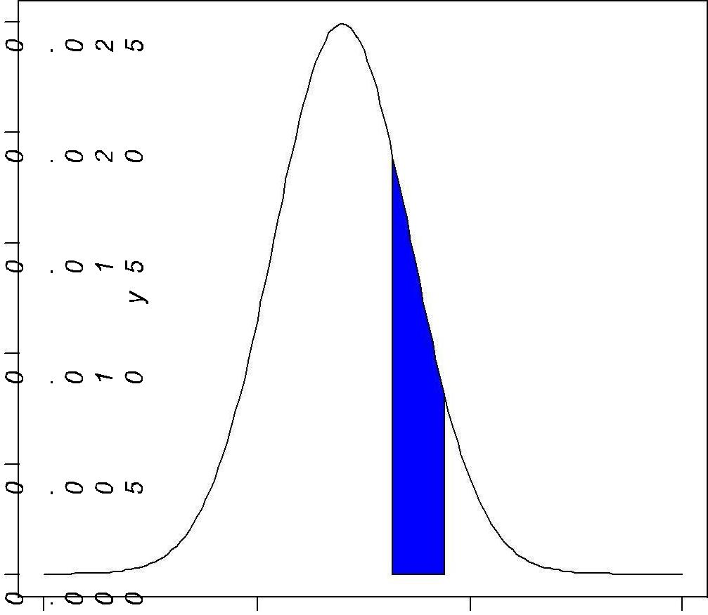

0.159

0 50 100 150

x

1. **P (62<=X ≤ 86)** 
   * x=seq(0,150)

* y=dnorm(x,70,16)
* plot(x,y,type="l")
* x=seq(62,86)
* y=dnorm(x,70,16)
* polygon(c(62,x,86),c(0,y,0),col="orange")
* pnorm(86,70,16)-pnorm(62,70,16)

[1] 0.5328072 >text(70,0.01,"0.53")

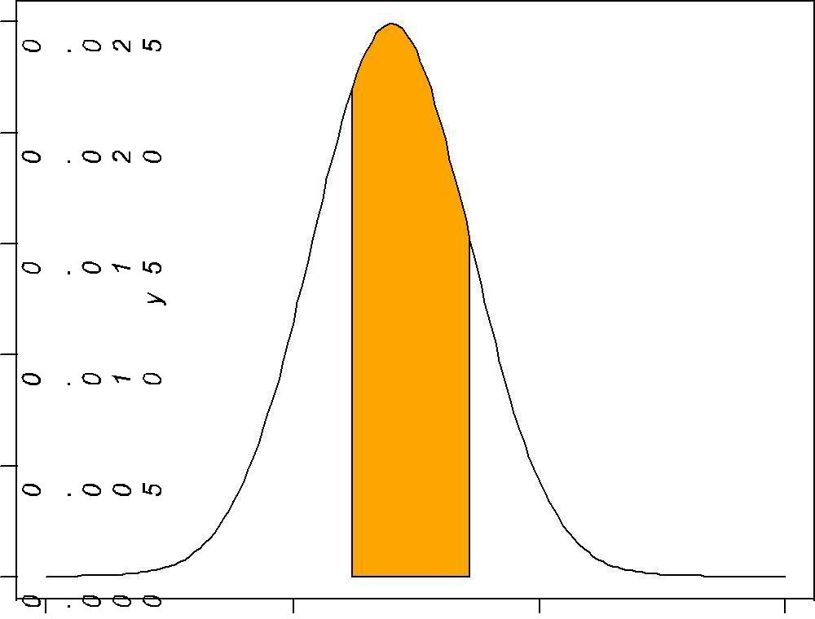

0.53

0 50 100 150 x

**3.] 1000 students had Written an examination the mean of test is 35 and standard deviation is 5.Assumning the to be normal find**

1. **How many students Marks Lie between 25 and 40**
2. **How many students get more than 40**

**iii)How many students get below 20 iv) How many students get 50**

**sol.:)** (i) ( pnorm(40, mean=35, sd=5) - pnorm(25, mean=35,sd=5))*1000 [1] 818.5946

( ii)

(1 - pnorm(40, mean=35, sd=5))*1000 [1] 158.6553

(iii) (pnorm(20, mean=35, sd=5))*1000 [1] 1.34989

(iv)dnorm(50,mean=35,sd=5) [1] 0.000886369