
Department of Computer Science [AI & CCCS]
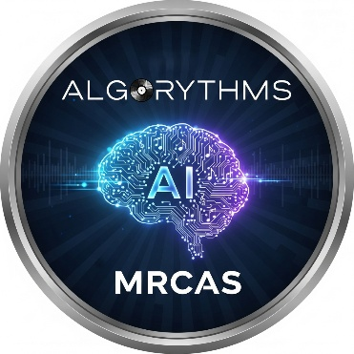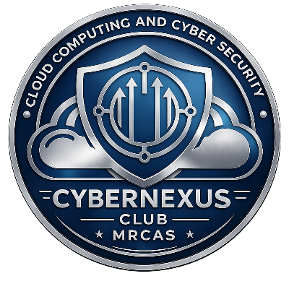
Organizes

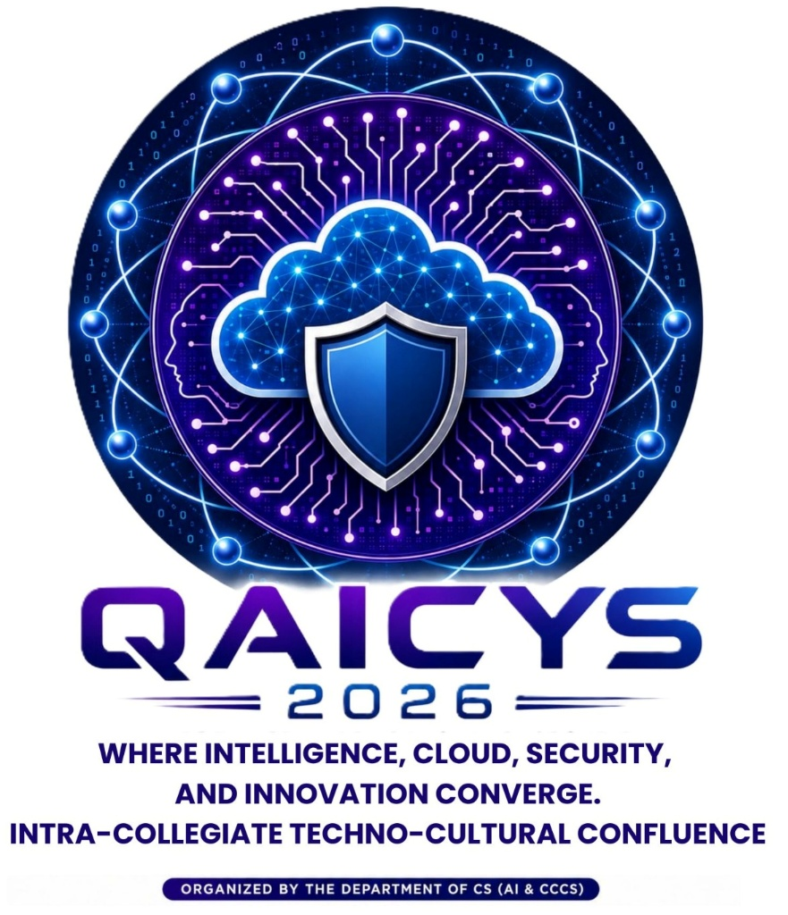

QAICYS 2026
Intra - Collegiate Techno-Cultural Symposium
RULE BOOK

GENERAL INSTRUCTIONS
- All participants must carry their College ID Card.
- Participants must carry the event token issued to them for verification and entry.
- Participants are required to report to their respective event venue at least 15 minutes before the scheduled start time.
- Registration will close immediately after the commencement of the event.
- Participants must strictly adhere to the event schedule and timings.
- The decision of the judges and the organizing committee shall be final and binding.
- Any form of malpractice, plagiarism, impersonation, or misconduct will result in immediate disqualification.
- Mobile phones and other electronic devices are prohibited unless explicitly permitted for the respective event.
- Participants are responsible for bringing all materials required for their respective events.
- Participants are expected to maintain discipline, professionalism, and proper decorum throughout the symposium.
- Any damage caused to college property or event materials will invite appropriate disciplinary action.
- The organizing committee reserves the right to modify the event schedule, venue, or rules if deemed necessary.
- Participation certificates will be issued only to eligible participants in accordance with the event guidelines.
- Participants are requested to cooperate with the event coordinators and volunteers to ensure the smooth conduct of the symposium.

EVENT SCHEDULE

Date | Event | Timing | Venue
13 August 2026 (Thursday) | Pitch Perfect (Paper Presentation) | 10:15 AM – 12:00 PM | L-Shape Hall
13 August 2026 (Thursday) | Bid Byte (Tech Auction) | 10:15 AM – 11:45 AM | LH 10
13 August 2026 (Thursday) | Pixel Cipher (Logo Creation) | 10:15 AM – 11:15 AM | Lab 02
13 August 2026 (Thursday) | Promtopia (Prompt Writing) | 1:40 PM – 2:40 PM | Lab 02
13 August 2026 (Thursday) | Synapse (Connection) | 1:40 PM – 3:10 PM | L-Shape Hall
13 August 2026 (Thursday) | Henna Hues (Mehendi) | 1:40 PM – 2:40 PM | LH 12
13 August 2026 (Thursday) | Palette Pop (Nail Art) | 1:40 PM – 2:40 PM | LH 13
14 August 2026 (Friday) | The Verdict (For & Against) | 9:30 AM – 11:00 AM | LH 10
14 August 2026 (Friday) | Click Craft (Mobile Photography) | 9:30 AM – 10:45 AM | LH 11
14 August 2026 (Friday) | Unscripted (Dance / Mime / Theatre) | 9:30 AM – 12:40 PM | Canteen
14 August 2026 (Friday) | Battle Zone (E-Sports) | 10:30 AM – 12:30 PM | L-Shape Hall
14 August 2026 (Friday) | Estrella – Star of the Event | Round 1: 9:30 AM – 10:00 AM  Round 2: 11:30 AM – 12:30 PM  Round 3: 1:30 PM – 2:00 PM | LH 09  &  Canteen
TECHNICAL EVENTS

Pitch Perfect (Paper Presentation)
Faculty Coordinator: Mrs. J. Anitha Gracy
Team Size: Maximum 2 Participants
Rules & Regulations
- Each team can have a maximum of two participants.
- The paper may be based on any domain, provided it demonstrates how Artificial Intelligence supports, enhances, or improves the efficiency, effectiveness, or innovation within that domain.
- The presentation must be original, and plagiarism is strictly prohibited.
- Presentation time is 7 minutes.
- Question and Answer session is 2 minutes.
- The presentation should be relevant to the topic.
- Participants must submit their presentation in the prescribed format before the specified deadline
- Participants must maintain professional presentation etiquette.
- The decision of the judges shall be final.

Bid Byte (Tech Auction)
Faculty Coordinator: Ms. J. Anitha Gracy
Team Size: 3 Participants
- 1 Team Lead
- 2 Team Members
Rules & Regulations
Team Formation
- Each team must consist of three members.
- Every team must have a team name.
Participation
- During both the auction and answering phases, only one member from each team may participate.
- The participant may be either the Team Lead or any one Team Member.
Event Structure
Round 1 – Logo Identification
- Total Time: 1 Minute 30 Seconds.
- First 30 seconds for direct answering.
- If unanswered, a 30-second auction will be conducted.
- The highest bidder receives a clue.
- The winning team gets the remaining 30 seconds to answer.
Round 2 – Tech Detective
- Total Time: 2 Minutes.
- First 1 minute for direct answering.
- If unanswered, a 30-second auction will be conducted.
- Highest bidder receives an additional clue.
- Only the winning team may answer after receiving the clue.
Coin Allocation
- Every team receives 1000 coins for Round 1.
- Every team receives 1000 coins for Round 2.
- Coins cannot be carried over between rounds.
- It is purely a previledge given to the participants and not have any weightage in marking
Penalties
- Rule violations will result in deduction of coins.
Malpractice
- Mobile phones and digital devices are strictly prohibited.
- Any malpractice will lead to immediate disqualification.

Promtopia (Prompt Writing)
Faculty Coordinator: Ms. S. V. Abinaya Shree
Team Size: Individual
Rules & Regulations
- The entire prompt must be written by the participant.
- Only one prompt is allowed.
- Multi-turn conversations and follow-up prompts are prohibited.
- Only text prompts are permitted.
- Images, audio, and files are not allowed.
- The prompt must not contain the final answer.
- Editing after submission is not permitted.
- The judges' decision shall be final.

Pixel Cipher (Logo Creation)
Faculty Coordinator: Dr. A. Dhava Pandiammal
Team Size: Individual
Venue: Lab 02
Timing: 10:15 AM – 11:15 AM
Rules & Regulations
- Theme will be announced on the spot.
- Total duration is 60 minutes.
- 5 minutes for understanding the theme.
- 40 minutes for logo creation.
- Participants must explain their logo after designing.
- Only Canva is permitted.
- The judges' decision shall be final.

Synapse (Connection)
Faculty Coordinator: Ms. V. Nandhini
Team Size: 2 Participants
Venue: L-Shape Hall
Timing: 1:40 PM – 3:10 PM
Rules & Regulations
Round 1 – Quiz
- 50 questions.
- 20 seconds per question.
- Answers must be written on the provided A4 sheet.
- Top 10 teams qualify.
Round 2 – Guess the Clue
- 30 questions.
- AI Tool Identification.
- First clue – 20 seconds.
- Second clue – 10 seconds.
- Third clue – 10 seconds.
- Top 5 teams qualify.
Round 3 – Connect
- 40 questions.
- Two images will be displayed.
- Teams must identify the connection.
- 30 seconds per question.
- Team with the highest score wins.

NON-TECHNICAL EVENTS

Henna Hues (Mehendi)
Faculty Coordinator: Dr. A. Dhava Pandiammal
Team Size: 2 Partcipants (Artist & Model)
Rules & Regulations
- Mehendi should be of bangle length.
- Participants must bring their own Mehendi cones.
- Designs must be created during the competition.
- Pre-drawn designs are not allowed.
- Mobile phones and printed references are prohibited.
- Copying or receiving assistance will result in disqualification.
- The judges' decision shall be final.

Palette Pop (Nail Art)
Faculty Coordinator: Ms. S. V. Abinaya Shree
Team Size: 2 Participants (Artist & Model)
Rules & Regulations
- Participants must bring their own nail art materials.
- Nail art must be created during the competition.
- Pre-painted nails are not allowed.
- Participants must keep their workspace clean.
- The judges' decision shall be final.

The Verdict (For & Against)
Faculty Coordinator: Ms. S. V. Abinaya Shree
Team Size: Individual
Rules & Regulations
- Topics will be announced on the spot.
- Participants must speak both For and Against the given topic.
- Participants must switch sides immediately upon the judges' signal.
- Evaluation is based on presentation, confidence, content, and communication skills.
- The judges' decision shall be final.

ClickCraft (Mobile Photography)
Faculty Coordinator: Ms. J. Anitha Gracy
Team Size: Individual
Rules & Regulations
- This is an individual event.
- The photograph must be captured using a mobile phone only. DSLR, mirrorless, and other professional cameras are not permitted.
- Participants may capture their photograph any time from the date of the theme announcement until the event date.
- Each participant may submit only one photograph.
- The photograph must be based on the theme "Life at MRCAS."
- Editing, filters, AI-generated or AI-enhanced images, and heavy photo manipulation are strictly prohibited.
- The photograph must not contain any watermark, logo, participant's name, or identifying text.
- Participants must preserve the original image on their mobile device for verification.
- Participants should obtain permission before capturing close-up photographs of individuals and must not disturb college activities or invade anyone's privacy.
- Each participant must present their photograph and briefly explain its title, concept, relevance to the theme, and the story behind it.
- Any form of plagiarism, downloaded images, AI-generated content, or violation of the rules will result in immediate disqualification.
- The decision of the judges shall be final and binding.

Unscripted (As You Like It)
Faculty Coordinator: Dr. A. Dhava Pandiammal
Team Size: Maximum 5 Participants
Events:
- Dance
- Mime
- Theatre
Venue: Canteen
Timing: 9:30 AM – 12:40 PM
Rules & Regulations
- Maximum of five participants per team.
- Teams may perform Dance, Mime, or Theatre.
- Performance duration must not exceed 5 minutes.
- Dance performances must use decent and appropriate songs.
- Vulgar, offensive, or inappropriate content is strictly prohibited.
- Participants must report to the venue 15 minutes before the event.
- The judges' decision shall be final.

Estrella – Star of the Event
Faculty Coordinator: Ms. S. V. Abinaya Shree
Team Size: Individual
Maximum Participants: 20
Rules & Regulations
Eligibility
- Participants must have participated in at least one Technical Event or Non-Technical Event.
Round 1
- Aptitude Test.
- Top 5 participants qualify.
Round 2
- Ad Zap.
- Top 3 participants qualify.
Round 3
- Stress Interview conducted by the judges.
- Overall performance determines the winner.
- The judges' decision shall be final.

Battle Zone (E-Sports)
Faculty Coordinator: Dr. A. Dhava Pandiammal
Team Size: 4 Participants
Rules & Regulations
Tournament Format
- Battle Royale Match 1
- Battle Royale Match 2
- Clash Squad Final
Battle Royale Rules
- Bermuda Map only.
- No Revival.
- No Weapon Attributes.
- No Character Skills.
- No Event Updates.
- No Hacks or Panel.
- PC Players are not allowed.
- Quick-out penalty applies.
Clash Squad Rules
- Bermuda Map only.
- No Roof Play.
- No Gloo Wall Climbing or Breaking.
- No Character Skills.
- No Gun Skins.
- No Grenades.
- No Airdrops.
- No Emotes.
- Only One-Tap.
- No Hacks or Panel.
- Quick-out penalty applies.

