|  |
| --- |
| CURRICULUM  CBME |
|  |
| 2021  COMMUNITY MEDICINE  GOVT MEDICAL COLLEGE SURAT |

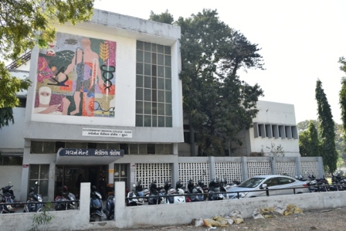

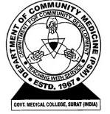

Competency Based Revised Curriculum

|  |
| --- |
| Community Medicine  Curriculum committee |
|  |
|  |

INTRODUCTION

In spite of being number one in respect to the quantity of medical colleges, India is facing enormous challenges in health sector. An effort to achieve a desired impact and for filing a huge gap between quantitative growth and quality medical education following points have been identified(1):

* Unequal resources distribution
* Aged curriculum system and so as assessment methods
* Neglected research united with untrained faculties

Not only there is an urgent need to put revised curriculum and assessment in action but also inspiring and motivating all stakeholders to bring desired changes in the medical education at all level is the need of the hour.(2)

To overcome above challenges and giving a vision and direction to the medical education in India medical Council of India (MCI) came out with the competency based education plan. Two most important areas of this regulation are(3):

* The thrust in the new regulations is continuation and evolution of thought in medical education making it more learner-centric, patient-centric, gender sensitive, outcome -oriented and environment appropriate.
* In particular, the curriculum provides for early clinical exposure, electives and longitudinal care. Skill acquisition is an indispensable component of the learning process in medicine.

This guideline coupled with the Graduate Medical Education Regulations, 2018 to facilitate the further teaching process from 2019, known as the roll out plan by MCI.

This document highlights our sincere effort to adopt this revised curriculum and regulation by MCI and should be seen as alive document needed time to time update as there is always scope of improvement.

INDEX

Contents

Understanding the competencies table 1

Deriving learning objectives from competencies 2

Deriving learning methods from competencies 3

Deriving assessment methods from competencies 4

Explanation of terms used in this manual 6

Competency identified for Community Medicine 7

Phase wise distribution of competency 23

Phase I: 1st M.B.B.S 24

Phase II: 2nd M.B.B.S 26

Phase III: 3rd M.B.B.S 28

Specific Learning Objectives (SLO) 31

Concept of health and disease 31

Hospital waste management 32

Disaster management 33

Biostatistics and its application 34

Nutrition 34

Sociology 35

Environment and health 35

Epidemiology 35

Demography – status of health indicators in India 36

Acts – MTP, PNDT and Human organ transplantation act 36

Concept of health and Disease 36

Relationship of social and behavioral to health and disease 37

Environment and health 37

Nutrition 39

Biostatistics and its application 41

Epidemiology 42

Concept of health and Disease 42

Lesson Plans 43

Concept of Health and Disease 43

Relationship of social and behavioral to health and disease 45

Environment and health 47

Nutrition 48

Assessment Methods 50

Viva 50

Short question 51

Short notes 90

Full question 91

MCQs 92

Topics distribution for university exam paper wise 93

# Understanding the competencies table

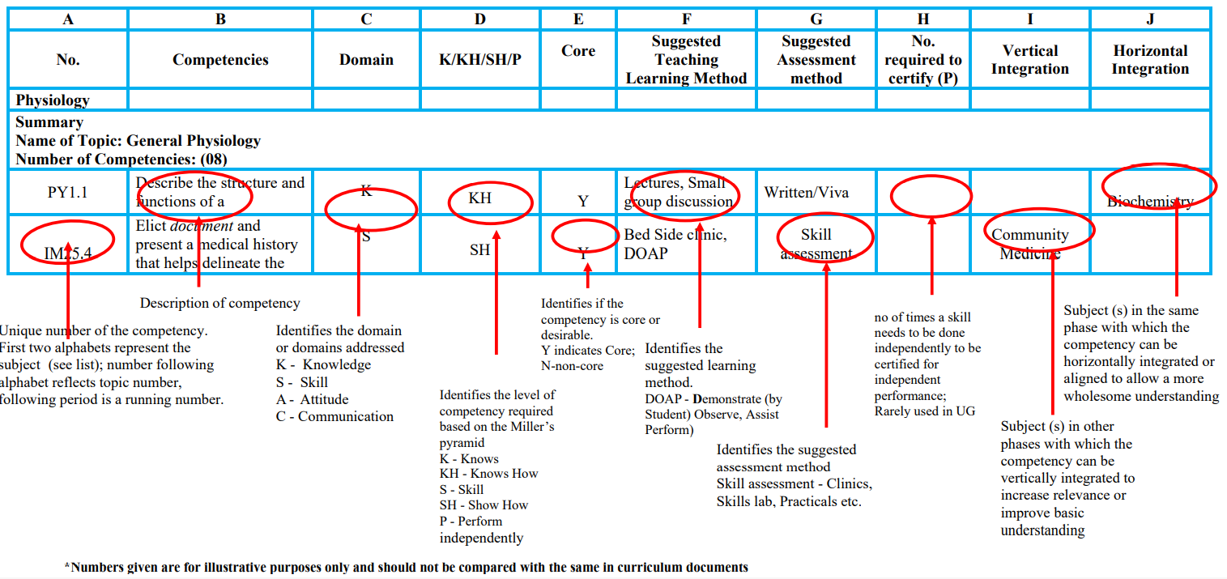

### Deriving learning objectives from competencies

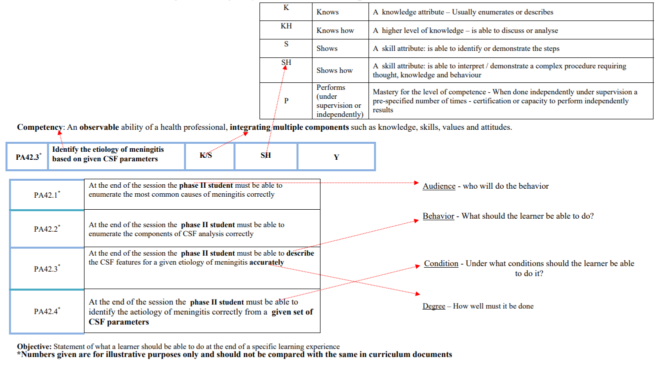

### Deriving learning methods from competencies

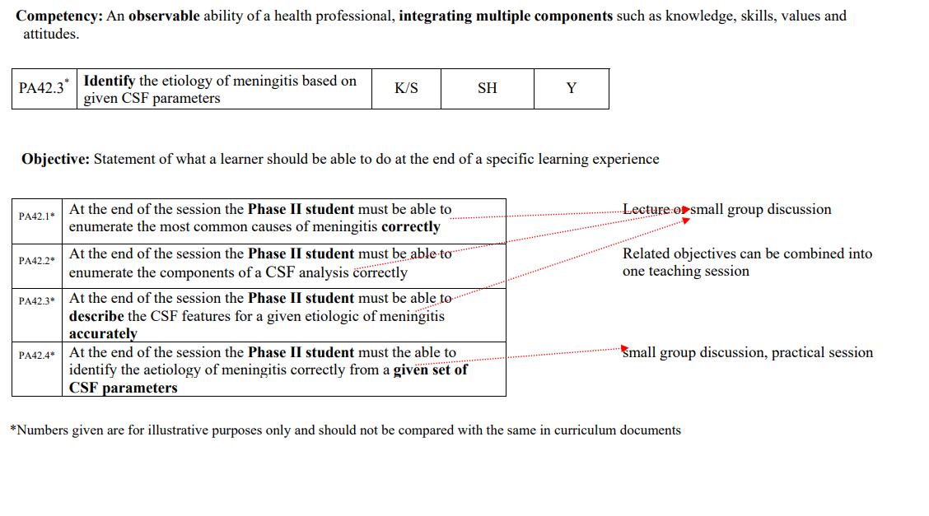

### Deriving assessment methods from competencies

EXAMPLE 1

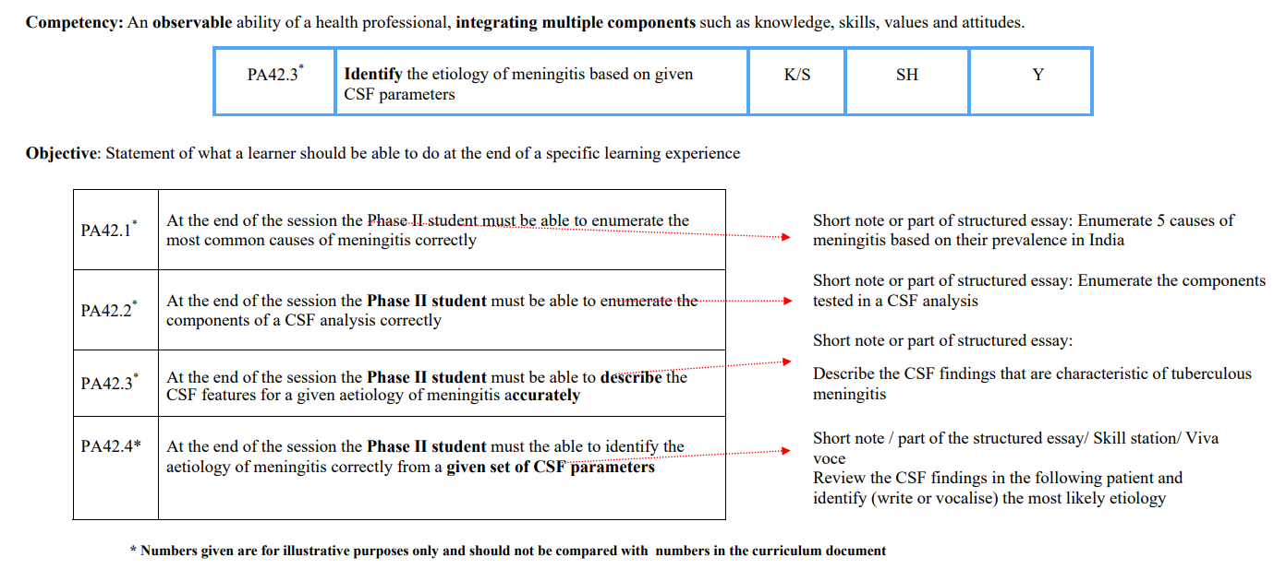

EXAMPLE 2

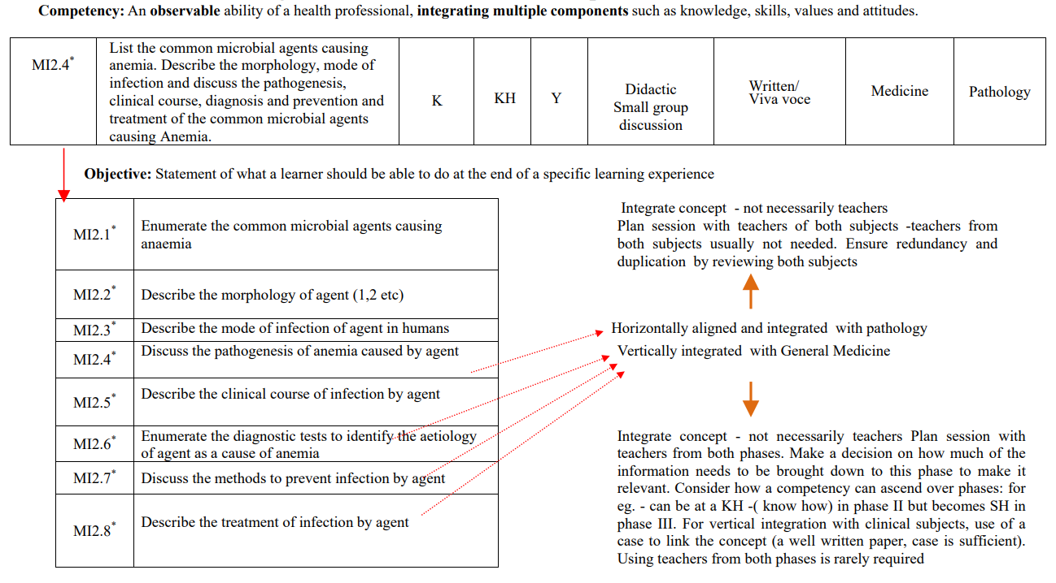

Note:

1. Specified essential competencies only will be required to be performed independently at the end of the final year MBBS.

2. The word ‘perform’ or ‘do’ is used ONLY if the task has to be done on patients or in laboratory practical in the pre/para- clinical phases.

3. Most tasks that require performance during undergraduate years will be performed under supervision.

4. If a certification to perform independently has been done, then the number of times the task has to be performed under supervision will be indicated in the last column.

# Explanation of terms used in this manual

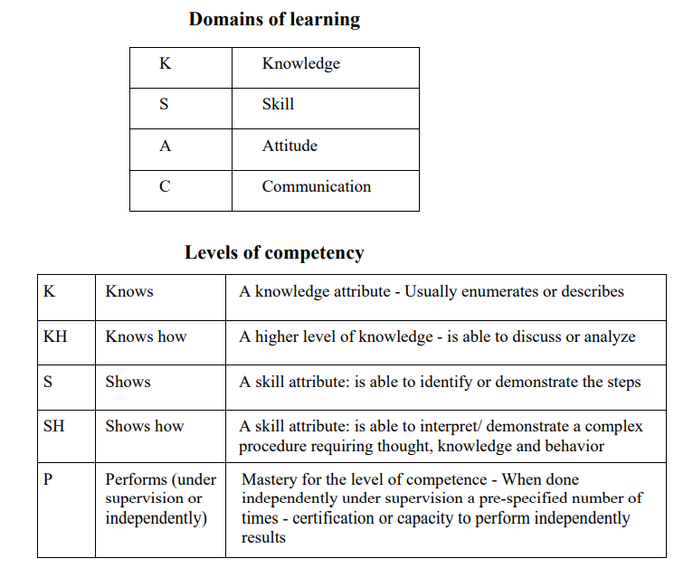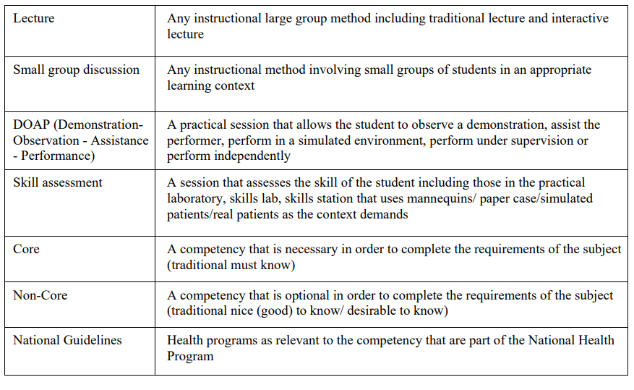

# Competency identified for Community Medicine

PHASE-I, PHASE-II, PHASE-III

|  |  |  |  |  |  |  |  |  |  |  |  |  |
| --- | --- | --- | --- | --- | --- | --- | --- | --- | --- | --- | --- | --- |
| **Number** | **COMPETENCY**  **The student should be able to** | | **Domain**  **K/S/A/C** | **Level**  **K/KH/ SH/P** | **Core Y/N** | **Suggested Teaching learning method** | **Suggested Assessment method** | | **Number required to certify P** | Vertical Integration | **Horizontal Integration** | |
| COMMUNITY MEDICINE (Topic 20 outcome 107) | | | | | | | | | | | | |
| Topic: Concept of Health and Disease Number of competencies: (10) Number of procedures that require certification:(NIL) | | | | | | | | | | | | |
| CM1.1 | Define and describe the concept of Public Health | | K | KH | Y | Lecture, Small group-discussion | Written / Viva voce | |  |  |  | |
| CM1.2 | Define health; describe the concept of holistic health including concept of spiritual health and the relativeness & determinants of health | | K | KH | Y | Lecture, Small group discussion | Written / Viva voce | |  |  |  | |
| CM1.3 | Describe the characteristics of agent, host and environmental factors in health and disease and the multi factorial etiology of disease | | K | KH | Y | Lecture, Small group discussion | Written / Viva voce | |  |  |  | |
| CM1.4 | Describe and discuss the natural history of disease | | K | KH | Y | Lecture, Small group discussion | Written / Viva voce | |  |  |  | |
| CM1.5 | Describe the application of interventions at various levels of prevention | | K | KH | Y | Lecture, Small group discussion | Written / Viva voce | |  |  |  | |
| CM1.6 | Describe and discuss the concepts, the principles of Health promotion and Education, IEC and Behavioral change communication (BCC) | | K | KH | Y | Lecture, Small group discussion | Written / Viva voce | |  |  |  | |
| CM1.7 | Enumerate and describe health indicators | | K | KH | Y | Lecture, Small group discussion | Written / Viva voce | |  |  |  | |
| CM1.8 | Describe the Demographic profile of India and discuss its impact on health | | K | KH | Y | Lecture, Small group discussion | Written / Viva voce | |  |  |  | |
| CM1.9 | Demonstrate the role of effective Communication skills in health in a simulated environment | | S | SH | Y | DOAP sessions | Skill Assessment | |  | AETCOM |  | |
| CM1.10 | Demonstrate the important aspects of the doctor patient relationship in a simulated environment | | S | SH | Y | DOAP sessions | Skill Assessment | |  | AETCOM |  | |
| **Number** | | **COMPETENCY**  **The student should be able to** | **Domain K/S/A/C** | **Level K/KH/ SH/P** | **Core Y/N** | **Suggested Teaching learning method** | | **Suggested Assessment method** | **Number required to certify P** | Vertical Integration | | **Horizontal Integration** |
| Topic: Relationship of social and behavioural to health and disease Number of competencies: (5) Number of procedures that require certification: (NIL) | | | | | | | | | | | | |
| CM2.1 | | Describe the steps and perform clinico socio-cultural and demographic assessment of the individual, family and community | S | SH | Y | Lecture, Small group discussion,  DOAP session | | Written / Viva voce/ Skill assessment |  |  | |  |
| CM2.2 | | Describe the socio-cultural factors, family (types), its role in health and disease & demonstrate in a simulated environment the correct assessment of socio-economic status | S | SH | Y | Lecture, Small group discussion, DOAP session | | Written / Viva voce/ Skill assessment |  |  | |  |
| CM2.3 | | Describe and demonstrate in a simulated environment the assessment of barriers to good health and health seeking behaviour | S | SH | Y | Lecture, Small group discussion, DOAP session | | Written / Viva voce/ Skill assessment |  |  | |  |
| CM2.4 | | Describe social psychology, community behaviour and community relationship and their impact on health and disease | K | KH | Y | Lecture, Small group discussion | | Written / Viva voce |  |  | |  |
| CM2.5 | | Describe poverty and social security measures and its relationship to health and disease | K | KH | Y | Lecture, Small group discussion | | Written / Viva voce |  |  | |  |
| Topic: Environmental Health Problems Number of competencies: (8) Number of procedures that require certification: (NIL) | | | | | | | | | | | | |
| CM3.1 | | Describe the health hazards of air, water, noise, radiation and pollution | K | KH | Y | Lecture, Small group discussion | | Written / Viva voce |  | General Medicine, ENT | |  |
| CM3.2 | | Describe concepts of safe and wholesome water, sanitary sources of water, water purification processes, water quality standards, concepts of water conservation and rainwater harvesting | K | KH | Y | Lecture, Small group discussion, DOAP session | | Written / Viva voce |  |  | |  |
| CM3.3 | | Describe the aetiology and basis of water borne diseases  /jaundice/hepatitis/ diarrheal diseases | K | KH | Y | Lecture, Small group discussion, DOAP session | | Written / Viva voce |  | Microbiology, General Medicine, Pediatrics | |  |
| CM3.4 | | Describe the concept of solid waste, human excreta and sewage disposal | K | KH | Y | Lecture, Small group discussion | | Written / Viva voce |  |  | |  |
| CM3.5 | | Describe the standards of housing and the effect of housing on health | K | KH | Y | Lecture, Small group discussion | | Written / Viva voce |  |  | |  |
| CM3.6 | | Describe the role of vectors in the causation of diseases. Also discuss National Vector Borne disease Control Program | K | KH | Y | Lecture, Small group discussion | | Written / Viva voce |  | Microbiology | |  |
| CM3.7 | | Identify and describe the identifying features and life cycles of vectors of Public Health importance and their control measures | S | SH | Y | Lecture, Small group discussion, DOAP session | | Written / Viva voce/ Skill assessment |  | Microbiology | |  |
| CM3.8 | | Describe the mode of action, application cycle of commonly used insecticides and rodenticides | K | KH | Y | Lecture, Small group discussion | | Written / Viva voce |  | Pharmacology | |  |
| Topic: Principles of health promotion and education Number of competencies: (3) Number of procedures that require certification: (NIL) | | | | | | | | | | | | |
| CM4.1 | | Describe various methods of health education with their advantages and limitations | K | KH | Y | Lecture, Small group discussion | | Written / Viva voce |  |  | |  |
| CM4.2 | | Describe the methods of organizing health promotion and education and counselling activities at individual family and community settings | K | KH | Y | Lecture, Small group discussion | | Written / Viva voce |  |  | |  |
| CM4.3 | | Demonstrate and describe the steps in evaluation of health promotion and education program | S | SH | Y | Small group session, DOAP session | | Written / Viva voce/ Skill assessment |  |  | |  |
| Topic: Nutrition Number of competencies: (08) Number of procedures that require certification: (NIL) | | | | | | | | | | | | |
| CM5.1 | | Describe the common sources of various nutrients and special nutritional requirements according to age, sex, activity, physiological conditions | K | KH | Y | Lecture, Small group discussion | | Written / Viva voce |  | General Medicine, Pediatrics | |  |
| CM5.2 | | Describe and demonstrate the correct method of performing a nutritional assessment of individuals, families and the community by using the appropriate method | S | SH | Y | DOAP sessions | | Skill Assessment |  | General Medicine, Pediatrics | |  |
| CM5.3 | | Define and describe common nutrition related health disorders (including macro-PEM, Micro-iron, Zn, iodine, Vit. A), their control and management | K | KH | Y | Lecture, Small group discussion | | Written / Viva voce |  | General Medicine, Pediatrics | |  |
| CM5.4 | | Plan and recommend a suitable diet for the individuals and families based on local availability of foods and economic status, etc in a simulated environment | S | SH | Y | DOAP sessions | | Skill Assessment |  | General Medicine, Pediatrics | |  |
| CM5.5 | | Describe the methods of nutritional surveillance, principles of nutritional education and rehabilitation in the context of socio- cultural factors. | K | KH | Y | Lecture, Small group discussion | | Written / Viva voce |  | General Medicine, Pediatrics | |  |
| CM5.6 | | Enumerate and discuss the National Nutrition Policy, important national nutritional Programs including the Integrated Child Development Services Scheme (ICDS) etc | K | KH | Y | Lecture, Small group discussion | | Written / Viva voce |  | Pediatrics | |  |
| CM5.7 | | Describe food hygiene | K | KH | Y | Lecture, Small group discussion | | Written / Viva voce |  |  | | Microbiology |
| CM5.8 | | Describe and discuss the importance and methods of food fortification and effects of additives and adulteration | K | KH | Y | Lecture, Small group discussion | | Written / Viva voce |  | Pediatrics | |  |
| Topic: Basic statistics and its applications Number of competencies: (04) Number of procedures that require certification: (NIL) | | | | | | | | | | | | |
| CM6.1 | | Formulate a research question for a study | K | KH | Y | Small group discussion, Lecture, DOAP sessions | | Written / Viva voce/ Skill assessment |  | General Medicine, Pediatrics | |  |
| CM6.2 | | Describe and discuss the principles and demonstrate the methods of collection, classification, analysis, interpretation and presentation of statistical data | S | SH | Y | Small group, Lecture, DOAP sessions | | Written / Viva voce/ Skill assessment |  | General Medicine, Pediatrics | |  |
| CM6.3 | | Describe, discuss and demonstrate the application of elementary statistical methods including test of significance in various study designs | S | SH | Y | Small group discussion, Lecture, DOAP sessions | | Written / Viva voce/ Skill assessment |  | General Medicine, Pediatrics | |  |
| CM6.4 | | Enumerate, discuss and demonstrate Common sampling techniques, simple statistical methods, frequency distribution, measures of central tendency and dispersion | S | SH | Y | Small group discussion, Lecture, DOAP sessions | | Written / Viva voce/ Skill assessment |  | General Medicine, Pediatrics | |  |
| Topic: Epidemiology Number of competencies: (09) Number of procedures that require certification: (NIL) | | | | | | | | | | | | |
| CM7.1 | | Define Epidemiology and describe and enumerate the principles, concepts and uses | K | KH | Y | Small group discussion, Lecture | | Written / Viva voce |  | General Medicine | |  |
| CM7.2 | | Enumerate, describe and discuss the modes of transmission and measures for prevention and control of communicable and non- communicable diseases | K | KH | Y | Small group discussion, Lecture | | Written / Viva voce |  | General Medicine | |  |
| CM7.3 | | Enumerate, describe and discuss the sources of epidemiological data | K | KH | Y | Small group discussion, Lecture | | Written / Viva voce |  | General Medicine | |  |
| CM7.4 | | Define, calculate and interpret morbidity and mortality indicators based on given set of data | S | SH | Y | Small group, DOAP sessions | | Written/ Skill assessment |  | General Medicine | |  |
| CM7.5 | | Enumerate, define, describe and discuss epidemiological study designs | K | KH | Y | Small group discussion, Lecture | | Written / Viva voce |  | General Medicine | |  |
| CM7.6 | | Enumerate and evaluate the need of screening tests | S | SH | Y | Small group discussion, DOAP sessions | | Written/ Skill assessment |  | General Medicine | |  |
| CM7.7 | | Describe and demonstrate the steps in the Investigation of an epidemic of communicable disease and describe the principles of control measures | S | SH | Y | Small group discussion, DOAP sessions | | Written/ Skill assessment |  | General Medicine | | Microbiology |
| CM7.8 | | Describe the principles of association, causation and biases in epidemiological studies | K | KH | Y | Small group discussion, Lecture | | Written / Viva voce |  | General Medicine | |  |
| CM7.9 | | Describe and demonstrate the application of computers in epidemiology | S | KH | Y | Small group discussion, DOAP sessions | | Written |  |  | |  |
| Topic: Epidemiology of communicable and non- communicable diseases N umber of competencies:(7) Number of procedures that require certification:(NIL) | | | | | | | | | | | | |
| CM8.1 | | Describe and discuss the epidemiological and control measures including the use of essential laboratory tests at the primary care level for communicable diseases | K | KH | Y | Small group discussion, Lecture | | Written / Viva voce |  | General Medicine, Pediatrics | | Microbiology, Pathology |
| CM8.2 | | Describe and discuss the epidemiological and control measures including the use of essential laboratory tests at the primary care level for Non Communicable diseases (diabetes, Hypertension, Stroke, obesity and cancer etc.) | K | KH | Y | Small group discussion, Lecture | | Written / Viva voce |  | General Medicine | |  |
| CM8.3 | | Enumerate and describe disease specific National Health Programs including their prevention and treatment of a case | K | KH | Y | Small group discussion, Lecture | | Written / Viva voce |  | General Medicine, Pediatrics | |  |
| CM8.4 | | Describe the principles and enumerate the measures to control a disease epidemic | K | KH | Y | Small group discussion, Lecture | | Written / Viva voce |  | General Medicine, Pediatrics | |  |
| CM8.5 | | Describe and discuss the principles of planning, implementing and evaluating control measures for disease at community level bearing in mind the public health importance of the disease | K | KH | Y | Small group discussion, Lecture | | Written / Viva voce |  | General Medicine, Pediatrics | |  |
| CM8.6 | | Educate and train health workers in disease surveillance, control & treatment and health education | S | SH | Y | DOAP sessions | | Skill assessment |  |  | |  |
| CM8.7 | | Describe the principles of management of information systems | K | KH | Y | Small group discussion, Lecture | | Written / Viva voce |  |  | |  |
| Topic: Demography and vital statistics Number of competencies: (07) Number of procedures that require certification: (NIL) | | | | | | | | | | | | |
| CM9.1 | | Define and describe the principles of Demography, Demographic cycle, Vital statistics | K | KH | Y | Small group discussion, Lecture | | Written / Viva voce |  |  | |  |
| CM9.2 | | Define, calculate and interpret demographic indices including birth rate, death rate, fertility rates | S | SH | Y | Lecture, Small group discussion, DOAP sessions | | Skill assessment |  | OBGY, Pediatrics | |  |
| CM9.3 | | Enumerate and describe the causes of declining sex ratio and its social and health implications | K | KH | Y | Small group discussion, Lecture | | Written / Viva voce |  |  | |  |
| CM9.4 | | Enumerate and describe the causes and consequences of population explosion and population dynamics of India. | K | KH | Y | Small group discussion, Lecture | | Written / Viva voce |  |  | |  |
| CM9.5 | | Describe the methods of population control | K | KH | Y | Small group discussion, Lecture | | Written / Viva voce |  | obgy | |  |
| CM9.6 | | Describe the National Population Policy | K | KH | Y | Small group discussion, Lecture | | Written / Viva voce |  |  | |  |
| CM9.7 | | Enumerate the sources of vital statistics including census, SRS, NFHS, NSSO etc | K | KH | Y | Small group discussion, Lecture | | Written / Viva voce |  |  | |  |
| Topic: Reproductive maternal and child health Number of competensies:(09) Number of procedures that require certification: (NIL) | | | | | | | | | | | | |
| CM10.1 | | Describe the current status of Reproductive, maternal, newborn and Child Health | K | KH | Y | Small group discussion, Lecture | | Written / Viva voce |  | Obstetrics & Gynaecology, Pediatrics | |  |
| CM10.2 | | Enumerate and describe the methods of screening high risk groups and common health problems | K | KH | Y | Small group discussion, Lecture | | Written / Viva voce |  | Pediatrics, OBGY | |  |
| CM10.3 | | Describe local customs and practices during pregnancy, childbirth, lactation and child feeding practices | K | KH | Y | Small group discussion, Lecture | | Written / Viva voce |  | Pediatrics, OBGY | |  |
| CM10.4 | | Describe the reproductive, maternal, newborn & child health (RMCH); child survival and safe motherhood interventions | K | KH | Y | Small group discussion, Lecture | | Written / Viva voce |  | Pediatrics, OBGY | |  |
| CM10.5 | | Describe Universal Immunization Program; Integrated Management of Neonatal and Childhood Illness (IMNCI) and other existing Programs. | K | KH | Y | Small group discussion, Lecture | | Written / Viva voce |  | Pediatrics | |  |
| CM10.6 | | Enumerate and describe various family planning methods, their advantages and shortcomings | K | KH | Y | Small group discussion, Lecture | | Written / Viva voce |  |  | |  |
| CM10.7 | | Enumerate and describe the basis and principles of the Family Welfare Program including the organization, technical and operational aspects | K | KH | Y | Small group discussion, Lecture | | Written / Viva voce |  |  | |  |
| CM10.8 | | Describe the physiology, clinical management and principles of adolescent health including ARSH | K | KH | Y | Small group discussion, Lecture | | Written / Viva voce |  |  | |  |
| CM10.9 | | Describe and discuss gender issues and women empowerment | K | KH | Y | Small group discussion, Lecture | | Written / Viva voce |  |  | |  |
| Topic: Occupational Health Number of competencies: (05) Number of procedures that require certification: (NIL) | | | | | | | | | | | | |
| CM11.1 | | Enumerate and describe the presenting features of patients with occupational illness including agriculture | K | KH | Y | Small group discussion, Lecture | | Written / Viva voce |  |  | |  |
| CM11.2 | | Describe the role, benefits and functioning of the employees state insurance scheme | K | KH | Y | Small group discussion, Lecture | | Written / Viva voce |  |  | |  |
| CM11.3 | | Enumerate and describe specific occupational health hazards, their risk factors and preventive measures | K | KH | Y | Small group discussion, Lecture | | Written / Viva voce |  |  | |  |
| CM11.4 | | Describe the principles of ergonomics in health preservation | K | KH | Y | Small group discussion, Lecture | | Written / Viva voce |  |  | |  |
| CM11.5 | | Describe occupational disorders of health professionals and their prevention & management | K | KH | Y | Small group discussion, Lecture | | Written / Viva voce |  |  | |  |
| Topic: Geriatric services Number of competencies: (04) Number of procedures that require certification: (NIL) | | | | | | | | | | | | |
| CM12.1 | | Define and describe the concept of Geriatric services | K | KH | Y | Lecture, Small group discussion | | Written / Viva voce |  | General Medicine | |  |
| CM12.2 | | Describe health problems of aged population | K | KH | Y | Lecture, Small group discussion | | Written / Viva voce |  | General Medicine | |  |
| CM12.3 | | Describe the prevention of health problems of aged population | K | KH | Y | Lecture, Small group discussion | | Written / Viva voce |  | General Medicine | |  |
| CM12.4 | | Describe National program for elderly | K | KH | Y | Lecture, Small group discussion | | Written / Viva voce |  | General Medicine | |  |
| Topic: Disaster Management Number of competencies: (04) Number of procedures that require certification: (NIL) | | | | | | | | | | | | |
| CM13.1 | | Define and describe the concept of Disaster management | K | KH | Y | Lecture, Small group discussion | | Written / Viva voce |  | General Surgery, General Medicine | |  |
| CM13.2 | | Describe disaster management cycle | K | KH | Y | Lecture, Small group discussion | | Written / Viva voce |  | General Surgery, General Medicine | |  |
| CM13.3 | | Describe man made disasters in the world and in India | K | KH | Y | Lecture, Small group discussion | | Written / Viva voce |  | General Surgery, General Medicine | |  |
| CM13.4 | | Describe the details of the National Disaster management Authority | K | KH | Y | Lecture, Small group discussion | | Written / Viva voce |  | General Surgery, General Medicine | |  |
| Topic: Hospital waste management Number of competencies: (03) Number of procedures that require certification: (NIL) | | | | | | | | | | | | |
| CM14.1 | | Define and classify hospital waste | K | KH | Y | Lecture, Small group discussion, visit to hospital | | Written / Viva voce |  |  | | Microbiology |
| CM14.2 | | Describe various methods of treatment of hospital waste | K | KH | Y | Lecture, Small group discussion, visit to hospital | | Written / Viva voce |  |  | | Microbiology |
| CM14.3 | | Describe laws related to hospital waste management | K | KH | Y | Lecture, Small group discussion | | Written / Viva voce |  |  | | Microbiology |
| Topic: Mental Health Number of competencies: (03) Number of procedures that require certification: (NIL) | | | | | | | | | | | | |
| CM15.1 | | Define and describe the concept of mental Health | K | KH | Y | Lecture, Small group discussion | | Written / Viva voce |  | Psychiatry | |  |
| CM15.2 | | Describe warning signals of mental health disorder | K | KH | Y | Lecture, Small group discussion | | Written / Viva voce |  | Psychiatry | |  |
| CM15.3 | | Describe National Mental Health program | K | KH | Y | Lecture, Small group discussion | | Written / Viva voce |  | Psychiatry | |  |
| Topic: Health planning and management Number of competencies: (04) Number of procedures that require certification: (NIL) | | | | | | | | | | | | |
| CM16.1 | | Define and describe the concept of Health planning | K | KH | Y | Lecture, Small group discussion | | Written / Viva voce |  |  | |  |
| CM16.2 | | Describe planning cycle | K | KH | Y | Lecture, Small group discussion | | Written / Viva voce |  |  | |  |
| CM16.3 | | Describe Health management techniques | K | KH | Y | Lecture, Small group discussion | | Written / Viva voce |  |  | |  |
| CM16.4 | | Describe health planning in India and National policies related to health and health planning | K | KH | Y | Lecture, Small group discussion | | Written / Viva voce |  |  | |  |
| Topic: Health care of the communtiy Number of competencies:(05) Number of procedures that require certification: (NIL) | | | | | | | | | | | | |
| CM17.1 | | Define and describe the concept of health care to community | K | KH | Y | Lecture, Small group discussion | | Written / Viva voce |  |  | |  |
| CM17.2 | | Describe community diagnosis | K | KH | Y | Lecture, Small group discussion | | Written / Viva voce |  |  | |  |
| CM17.3 | | Describe primary health care, its components and principles | K | KH | Y | Lecture, Small group discussion | | Written / Viva voce |  |  | |  |
| CM17.4 | | Describe National policies related to health and health planning and millennium development goals | K | KH | Y | Lecture, Small group discussion | | Written / Viva voce |  |  | |  |
| CM17.5 | | Describe health care delivery in India | K | KH | Y | Lecture, Small group discussion | | Written / Viva voce |  |  | |  |
| Topic: International Health Number of competencies: (2) Number of procedures that require certionat(NIL) | | | | | | | | | | | | |
| CM18.1 | | Define and describe the concept of International health | K | KH | Y | Lecture, Small group discussion | | Written / Viva voce |  |  | |  |
| CM18.2 | | Describe roles of various international health agencies | K | KH | Y | Lecture, Small group discussion | | Written / Viva voce |  |  | |  |
| Topic: Essential Medicine Number of competencies: (3) Number of procedures that require certification: (NIL) | | | | | | | | | | | | |
| CM19.1 | | Define and describe the concept of Essential Medicine List (EML) | K | KH | Y | Lecture, Small group discussion | | Written / Viva voce |  |  | | Pharmacology |
| CM19.2 | | Describe roles of essential medicine in primary health care | K | KH | Y | Lecture, Small group discussion | | Written / Viva voce |  |  | | Pharmacology |
| CM19.3 | | Describe counterfeit medicine and its prevention | K | KH | Y | Lecture, Small group discussion | | Written / Viva voce |  |  | | Pharmacology |
| Topic: Recent advances in Community Medicine Number of competencies: (04) Number of procedures that require certification: (NIL) | | | | | | | | | | | | |
| CM20.1 | | List important public health events of last five years | K | KH | Y | Lecture, Small group discussion | | Written / Viva voce |  |  | |  |
| CM20.2 | | Describe various issues during outbreaks and their prevention | K | KH | Y | Lecture, Small group discussion | | Written / Viva voce |  |  | |  |
| CM 20.3 | | Describe any event important to Health of the Community | K | KH | Y | Lecture, Small group discussion | | Written / Viva voce |  |  | |  |
| CM 20.4 | | Demonstrate awareness about laws pertaining to practice of medicine such as Clinical establishment Act and Human Organ Transplantation Act and its implications | K | KH | Y | Lecture, Small group discussion | | Written / Viva voce |  |  | |  |
| Column C: K- Knowledge, S – Skill, A - Attitude / professionalism, C- Communication. Column D: K – Knows, KH - Knows How, SH - Shows how, P- performs independently, Column F: DOAP session – Demonstrate, Observe, Assess, Perform. Column H: If entry is P: indicate how many procedures must be done independently for certification/ graduation | | | | | | | | | | | | |
|  | |  |  |  |  |  | |  |  |  | |  |
|  | |  |  |  |  |  | |  |  |  | |  |

# Phase wise distribution of competency

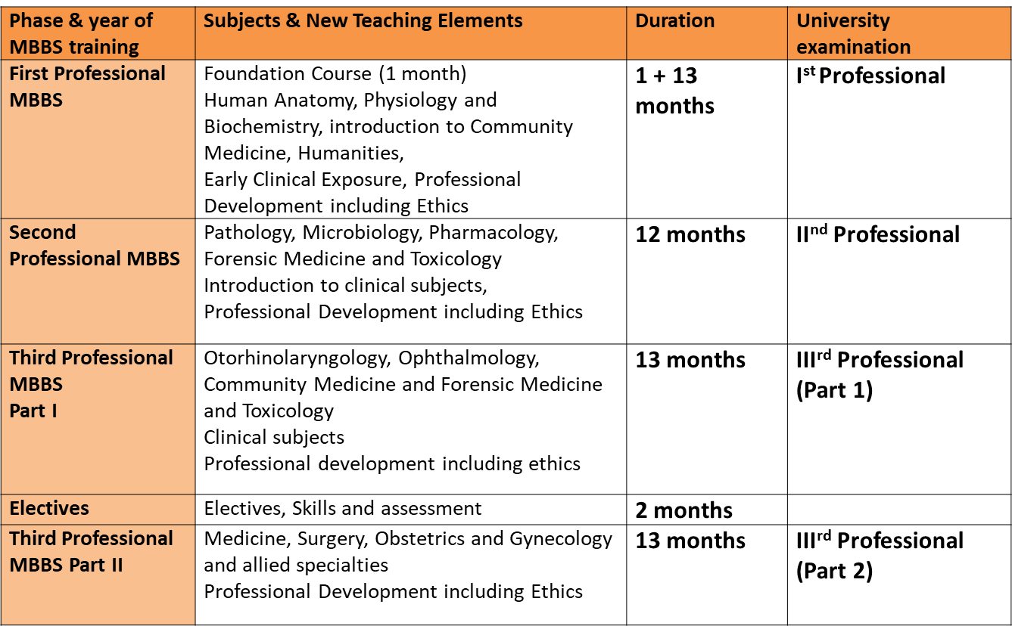

## Phase I: 1st M.B.B.S

|  |  |  |  |  |  |
| --- | --- | --- | --- | --- | --- |
| **Phase** | **Lectures (hours)** | **Small Group Teaching/ Tutorials/ Integrated learning/ Practical (hours)** | **Self-directed learning (hours)** | **Total**  **(hours)** | **Clinical Posting** |
| I | 20 | 27 | 5 | 52 | - |
| II | 20 | 30 | 10 | 60 | 4 weeks |
| III | 40 | 60 | 5 | 105 | 6 weeks |

|  |  |  |  |  |  |  |  |  |
| --- | --- | --- | --- | --- | --- | --- | --- | --- |
| Sr No | Topic | Competency | SLO | TL methods | | Integration | |  |
|  | Concept of health and disease | CM 1.1 | SLO |  |  |  |  |  |
|  | Concept of health and disease | CM 1.2 | SLO |  |  |  |  |  |
|  | Concept of health and disease | CM 1.3 |  |  |  |  |  |  |
|  | Concept of health and disease | CM 1.4 | SLO |  |  |  |  |  |
|  | Concept of health and disease | CM 1.6 |  |  |  |  |  |  |
|  | Concept of health and disease | CM 1.9 | SLO |  |  |  |  |  |
|  | Concept of health and disease | CM 1.10 | SLO |  |  |  |  |  |
|  | Hospital waste management | CM 14.1 | SLO |  |  |  |  |  |
|  | Hospital waste management | CM 14.2 | SLO |  |  |  |  |  |
|  | Hospital waste management | CM 14.3 | SLO |  |  |  |  |  |
|  | Disaster management | CM 13.1,13.2 | SLO |  |  |  |  |  |
|  | Disaster management | CM 13.3 | SLO |  |  |  |  |  |
|  | Disaster management | CM 13.4 | SLO |  |  |  |  |  |
|  | Biostatistics and its application | CM 6.1 | SLO |  |  |  |  |  |
|  | Biostatistics and its application | CM 6.4 | SLO |  |  |  |  |  |
|  | Biostatistics and its application (ICMR-STS) | CM 6.4 | SLO |  |  |  |  |  |
|  | Nutrition – Macro and Micronutrients | CM5.1 | SLO |  |  |  |  |  |
|  | Sociology – basic terms | CM2.2 | SLO |  |  |  |  |  |
|  | Environment and health | CM3.1 | SLO | Short film |  |  |  |  |
|  | Epidemiology –basic term | CM7.1 | SLO |  |  |  |  |  |
|  | Demography – status of health  indicators in India | CM9.1 | SLO |  |  |  |  |  |
|  | Acts – MTP, PNDT and Human  organ transplantation act | CM20.4 | SLO |  |  |  |  |  |

## **Phase II: 2nd M.B.B.S**

|  |  |  |  |  |  |
| --- | --- | --- | --- | --- | --- |
| **Phase** | **Lectures (hours)** | **Small Group Teaching/ Tutorials/ Integrated learning/ Practical (hours)** | **Self-directed learning (hours)** | **Total**  **(hours)** | **Clinical Posting** |
| I | 20 | 27 | 5 | 52 | - |
| II | 20 | 30 | 10 | 60 | 4 weeks |
| III | 40 | 60 | 5 | 105 | 6 weeks |

|  |  |  |  |  |  |  |  |  |
| --- | --- | --- | --- | --- | --- | --- | --- | --- |
| Sr No | Topic | Competency | SLO | TL methods | | Integration | |  |
|  | Concept of health and Disease | CM 1.8 | SLO |  |  |  |  |  |
|  | Relationship of social and behavioral to health and disease | CM 2.1 | SLO |  |  |  |  |  |
|  | CM 2.3 | SLO |  |  |  |  |  |
|  | CM 2.5 | SLO |  |  |  |  |  |
|  | Environment and health | CM 3.1 | SLO |  |  |  |  |  |
|  | Environment and health | CM 3.2 | SLO |  |  |  |  |  |
|  | Environment and health | CM 3.3 | SLO |  |  |  |  |  |
|  | Environment and health | CM 3.4 | SLO |  |  |  |  |  |
|  | Environment and health | CM 3.5 | SLO |  |  |  |  |  |
|  | Nutrition | CM 5.2 | SLO |  |  |  |  |  |
|  | Nutrition | CM 5.3 | SLO |  |  |  |  |  |
|  | Nutrition | CM 5.4 | SLO |  |  |  |  |  |
|  | Nutrition | CM 5.5 | SLO |  |  |  |  |  |
|  | Nutrition | CM 5.6 | SLO |  |  |  |  |  |
|  | Nutrition | CM 5.7 | SLO |  |  |  |  |  |
|  | Nutrition | CM 5.8 | SLO |  |  |  |  |  |
|  | Biostatistics and its application | CM 6.2 | SLO |  |  |  |  |  |
|  | Biostatistics and its application | CM 6.3 | SLO |  |  |  |  |  |
|  | Epidemiology | CM 7.1 | SLO |  |  |  |  |  |
|  | CM 7.2 | SLO |  |  |  |  |  |
|  | CM 7.3 | SLO |  |  |  |  |  |
|  | CM 7.4 | SLO |  |  |  |  |  |
|  | CM 7.5 | SLO |  |  |  |  |  |
|  | CM 7.6 | SLO |  |  |  |  |  |
|  | CM 7.7 | SLO |  |  |  |  |  |
|  | CM 7.8 | SLO |  |  |  |  |  |
|  | CM 7.9 | SLO |  |  |  |  |  |
|  | Demography and Vital statistics | CM 9.2 | SLO |  |  |  |  |  |
|  | CM 9.3 | SLO |  |  |  |  |  |
|  | CM 9.4 | SLO |  |  |  |  |  |
|  | CM 9.5 | SLO |  |  |  |  |  |
|  | CM 9.6 | SLO |  |  |  |  |  |
|  | CM 9.7 | SLO |  |  |  |  |  |
|  | Geriatrics Services | CM 12.1 | SLO |  |  |  |  |  |
|  | CM 12.2 | SLO |  |  |  |  |  |
|  | CM 12.3 | SLO |  |  |  |  |  |
|  | CM 12.4 | SLO |  |  |  |  |  |
|  | Essential Medicine | CM 19.1 | SLO |  |  |  |  |  |
|  | CM19.2 | SLO |  |  |  |  |  |
|  | CM 19.3 | SLO |  |  |  |  |  |

## **Phase III: 3rd M.B.B.S**

|  |  |  |  |  |  |
| --- | --- | --- | --- | --- | --- |
| **Phase** | **Lectures (hours)** | **Small Group Teaching/ Tutorials/ Integrated learning/ Practical (hours)** | **Self-directed learning (hours)** | **Total**  **(hours)** | **Clinical Posting** |
| I | 20 | 27 | 5 | 52 | - |
| II | 20 | 30 | 10 | 60 | 4 weeks |
| III | 40 | 60 | 5 | 105 | 6 weeks |

|  |  |  |  |  |  |  |  |  |
| --- | --- | --- | --- | --- | --- | --- | --- | --- |
| Sr No | Topic | Competency | SLO | TL methods | | Integration | |  |
|  | Concept of Health and Disease | CM 1.7 |  |  |  |  |  |  |
|  | Relationship of social and behavioral to health and disease | CM 2.4 |  |  |  |  |  |  |
|  | Environmental Health Problems | CM 3.6 |  |  |  |  |  |  |
|  | Environmental Health Problems | CM 3.7 |  |  |  |  |  |  |
|  | Environmental Health Problems | CM 3.8 |  |  |  |  |  |  |
|  | Principles of health promotion and education | CM 4.1 |  |  |  |  |  |  |
|  | CM 4.2 |  |  |  |  |  |  |
|  | CM 4.3 |  |  |  |  |  |  |
|  | Epidemiology of communicable and non- communicable diseases | CM 8.1 |  |  |  |  |  |  |
|  | CM 8.2 |  |  |  |  |  |  |
|  | CM 8.3 |  |  |  |  |  |  |
|  | CM 8.4 |  |  |  |  |  |  |
|  | CM 8.5 |  |  |  |  |  |  |
|  | CM 8.6 |  |  |  |  |  |  |
|  | CM 8.7 |  |  |  |  |  |  |
|  | Reproductive maternal and child health | CM 10.1 |  |  |  |  |  |  |
|  | CM 10.2 |  |  |  |  |  |  |
|  | CM 10.3 |  |  |  |  |  |  |
|  | CM 10.4 |  |  |  |  |  |  |
|  | CM 10.5 |  |  |  |  |  |  |
|  | CM 10.6 |  |  |  |  |  |  |
|  | CM 10.7 |  |  |  |  |  |  |
|  | CM 10.8 |  |  |  |  |  |  |
|  | CM 10.9 |  |  |  |  |  |  |
|  | Occupational Health | CM 11.1 |  |  |  |  |  |  |
|  | CM 11.2 |  |  |  |  |  |  |
|  | CM 11.3 |  |  |  |  |  |  |
|  | CM 11.4 |  |  |  |  |  |  |
|  | CM 11.5 |  |  |  |  |  |  |
|  | Mental Health | CM 15.1 |  |  |  |  |  |  |
|  | CM 15.1 |  |  |  |  |  |  |
|  | CM 15.1 |  |  |  |  |  |  |
|  | Health planning and management | CM 16.1 |  |  |  |  |  |  |
|  | CM 16.2 |  |  |  |  |  |  |
|  | CM 16.3 |  |  |  |  |  |  |
|  | CM 16.4 |  |  |  |  |  |  |
|  | Health care of the community | CM 17.1 |  |  |  |  |  |  |
|  | CM 17.2 |  |  |  |  |  |  |
|  | CM 17.3 |  |  |  |  |  |  |
|  | CM 17.4 |  |  |  |  |  |  |
|  | CM 17.5 |  |  |  |  |  |  |
|  | International Health | CM 18.1 |  |  |  |  |  |  |
|  | CM 18.2 |  |  |  |  |  |  |
|  | Recent advances in Community Medicine | CM 20.1 |  |  |  |  |  |  |
|  | CM 20.2 |  |  |  |  |  |  |
|  | Recent advances in Community Medicine | CM 20.3 |  |  |  |  |  |  |

# Specific Learning Objectives (SLO)

Phase I: 1st M.B.B.S

## Concept of health and disease

|  |  |  |  |  |  |
| --- | --- | --- | --- | --- | --- |
| CM NO | Competency | SLO | TLM | Lesson plan | Assessment |
| 1.1 | Define and describe the concept of Public Health | 1. Differentiate using at least 3 features- the clinical medicine and the public health  2. describe the special need of public health in India and other countries  3 Discuss the changing concepts of Public Health |  | LP | AP |
| 1.2 | Define health; describe the concept of holistic health including concept of spiritual health and the relativeness & determinants of health | 1. Define health  2. Describe the dimensions of health  3. Define standard of living, level of living and quality of life  4. Explain physical quality of life index and human development index  5. Explain the determinants of health |  | LP |  |
| 1.3 | Describe the characteristics of agent, host and  environmental factors in health and disease and  the multi factorial etiology of disease | 1. Draw and explain an epidemiological triad with an example  2. Describe the characteristics of agent, host and environmental factors in health and disease |  | LP |  |
| 1.4 | Describe and discuss the natural history of  disease | Discuss the natural history of disease with an illustration |  | LP |  |
| 1.5 | Describe the application of interventions at  various levels of prevention | 1. Discuss the various levels of prevention with an example for each  2. Define an intervention  3. Enlist the modes of intervention  4. Explain the modes of intervention with an example |  | LP |  |
| 1.6 | Describe and discuss the concepts, the principles  of Health promotion and Education, IEC and  Behavioral change communication (BCC) | 1. Define health education, IEC, BCC  2. Discuss the principles of health education  3. Describe the models of health education with examples  4. Explain the approaches of health education  5. List the barriers of health education |  | LP |  |
| 1.7 | Enumerate and describe health indicators | 1.Mention the uses of health indicators  2. List the characteristics of a an indicator  3. Enumerate the health indicators  4. Describe the health indicators |  | LP |  |
| 1.9 | Demonstrate the role of effective Communication  skills in health in a simulated environment | 1. Explain the levels of communication in a doctor-patient relationship  2. Demonstrate effective communication skills in health in a simulated  environment |  | LP |  |
| 1.10 | Demonstrate the important aspects of the doctor patient relationship in a simulated environment | Demonstrate good doctor patient relationship in a simulated  environment |  | LP |  |

## Hospital waste management

|  |  |  |  |  |  |
| --- | --- | --- | --- | --- | --- |
| CM No | Competency | SLO | TLM | Lesson plan | Assessment |
| 14.1 | Define and Classify hospital waste | 1. Definition of Bio Medical Waste  2. Sources of Bio Medical Waste  3. Different types of Bio Medical Waste generated from hospital  4. Different categories of Bio Medical Waste  5. Health hazards of Bio Medical Waste | SGD  HOSPITAL VISIT |  |  |
| 14.2 | Describe various method of treatment of Hospital Waste | 1. Explain different waste treatment method  2. Disposal method as per their color coding bag/container | SGD  HOSPITAL VISIT |  |  |
| 14.3 | Describe laws related to hospital waste | 1. Laws related to Bio Medical Waste  2. Importance of Cytotoxic and Bio hazard symbol | lecture |  |  |

## Disaster management

|  |  |  |  |  |  |
| --- | --- | --- | --- | --- | --- |
| 13.1 | Define and describe the concept of Disaster  management | 1. Define the term ‘Disaster’ and ‘hazards’.  2. Enlist natural disasters worldwide and in India  3. Describe the concept of Disaster management |  |  |  |
| 13.2 | Describe disaster management cycle | 1. Name the fundamental aspects of disaster management  2. Describe disaster management cycle  3. Understand disaster management cycle |  |  |  |
| 13.3 | Describe man-made disasters in the world and in  India | 1 Enlist the man-made disasters  2. Describe man-made disasters in the world  3. Describe man-made disasters in India |  |  |  |
| 13.4 | Describe the details of the National Disaster  management Authority | 1. Describe the details of the National Disaster management Authority  2. Enlist the International agencies providing health humanitarian assistance during disaster |  |  |  |

## Biostatistics and its application

|  |  |  |  |  |  |
| --- | --- | --- | --- | --- | --- |
| 6.1 | Formulate a research question for a study | 1. Define health research  2. Explain health research  3. List the purpose of doing research  4. Differentiate the meaning of research question, objectives and hypothesis  5. Formulate a research question for a given study |  |  |  |
| 6.4 | Enumerate, discuss and demonstrate Common  sampling techniques, simple statistical methods, frequency distribution, measures of central tendency and dispersion | 1. Define the terms – sample size, sampling  2. Describe the importance of sampling  3. Calculate sample size  4. List various sampling techniques  5. Explain various sampling techniques  6. Demonstrate common sampling techniques  7. Enumerate and describe the measures of central tendency, uses and limitations  8. Calculate and interpret various measures of central tendency  9. Enumerate and describe the measures of dispersion, uses and limitations  10. Calculate and interpret various measures of dispersion |  |  |  |
| 6.4 | Biostatistics and its application (ICMR-STS) | As above |  |  |  |

## Nutrition

|  |  |  |  |  |  |
| --- | --- | --- | --- | --- | --- |
| 5.1 | Describe the common sources of various  nutrients and special nutritional requirements  according to age, sex, activity and physiological  conditions | 1. Define nutrition  2. Describe the common sources of various nutrients (Macro and Micronutrients )  3. Describe the special nutritional requirements according to age, sex, activity and physiological conditions  4. Calculate the calorie requirement of an individual based on age, gender and occupation |  | LP |  |

## Sociology

|  |  |  |  |  |  |
| --- | --- | --- | --- | --- | --- |
| 2.2 | Describe the socio cultural factors, family (types), its role in health and disease & demonstrate in a simulated environment the correct assessment of socio-economic status | 1. Describe the socio cultural factors  2. Describe the types of family  3. Describe the role socio cultural factors in health and disease.  4. Demonstrate the role socio cultural factors in a simulated environment.  5. Assess the socio-economic status of the family. | small group discussion/ didactic |  |  |

## Environment and health

|  |  |  |  |  |  |
| --- | --- | --- | --- | --- | --- |
| 3.1 | Describe the health hazards of air, water, noise, radiation and pollution | 1. Describe the various health hazards caused by pollution of air, water and soil as wells as those due to noise and radiation  2. Discuss the ways to prevent various environmental pollution  3. Interpret the various pollution related indices and their importance to  Public health | Short video |  |  |

## Epidemiology

|  |  |  |  |  |  |
| --- | --- | --- | --- | --- | --- |
| 7.1 | Define Epidemiology and describe and  enumerate the principles, concepts and uses | 1. Define the term epidemiology  2. List various components and approaches of epidemiology  3. Describe the aims of epidemiology  4. Enumerate various uses of epidemiology | Didactic lecture on basic terms |  |  |

## Demography – status of health indicators in India

|  |  |  |  |  |  |  |
| --- | --- | --- | --- | --- | --- | --- |
| 9.1 | Define and describe the principles of Demography, Demographic cycle, Vital statistics | 1. Define demography  2. Explain the principles of demography  3. Discuss the demographic cycle  4. Enumerate and describe vital statistics | Didactic lecture on basic terms |  |  |  |

## Acts – MTP, PNDT and Human organ transplantation act

|  |  |  |  |  |  |
| --- | --- | --- | --- | --- | --- |
| 20.4 | Demonstrate awareness about laws pertaining to  practice of medicine such as Clinical  establishment Act and Human Organ  Transplantation Act and its implications | 1. Mention the laws related to health  2. Describe various acts pertaining to practice of medicine  3. Explain the Clinical establishment Act  4. Enumerate the implications of Clinical establishment Act  5. Explain the Human Organ Transplantation Act  6. Discuss the implications of Organ Transplantation Act | Poster competition or quiz |  |  |

Phase II: 2nd M.B.B.S

## Concept of health and Disease

|  |  |  |  |  |  |
| --- | --- | --- | --- | --- | --- |
| CM NO | Competency | SLO | TLM | Lesson plan | Assessment |
| 1.8 | Describe the Demographic profile of India and  discuss its impact on health | 1. Describe the Demographic profile of India  2. Discuss the impact of Demographic profile on health | Didactic lecture on basic terms |  |  |

## Relationship of social and behavioral to health and disease

|  |  |  |  |  |  |
| --- | --- | --- | --- | --- | --- |
| 2.1 | Describe the steps and perform Clinico socio-cultural and demographic assessment of the individual, family and community | 1. Describe the steps of clinico socio-cultural and demographic assessment of the individual, family and community  2. Perform the clinico socio-cultural and demographic assessment of the individual, family and community. | SGD |  |  |
| 2.3 | Describe and demonstrate in a simulated environment the assessment of barriers to good health and health seeking behavior. | 1 At end of the session students should able to describe various barriers and facilitators of HSB  2. Able to list actions by individual and health system to facilitate HSB | SGD | LP |  |
| 2.5 | Describe poverty and social security measures and its relationship to health and disease | 1. Define the poverty and enlist the ranking of various countries as per their poverty index  2. Describe social security measures for health and disease.  3. Describe poverty and social security measures and its relationship to health and disease. | SGD | LP |  |

## Environment and health

|  |  |  |  |  |  |
| --- | --- | --- | --- | --- | --- |
| 3.1 | Describe the health hazards of air, water, noise, radiation and pollution | 1. Describe the various health hazards caused by pollution of air, water and soil as wells as those due to noise and radiation  2. Discuss the ways to prevent various environmental pollution  3. Interpret the various pollution related indices and their importance to  Public health |  |  | AP |
| 3.2 | Describe concepts of safe and wholesome water, Sanitary sources of water, water purification processes, water quality standards, concepts of water conservation and rainwater harvesting | 1. Describe the concepts of safe and wholesome water  2. Discuss various sanitary sources of water and water purification processes  3. Illustrate the various methods of water conservation and rainwater harvesting |  | LP | AP |
| 3.3 | Describe the etiology and basis of water borne diseases /jaundice/hepatitis/ diarrheal diseases | 1. list at least 5 different water borne diseases conditions related to physical chemical and microbiological quality of water  2. Discuss the epidemiology and preventive measures of water borne  Diseases / jaundice /hepatitis/diarrheal diseases  3. Explain various treatment and preventive measures to combat these  Diseases  I. Student should be able to describe correctly content of ORS  II. Demonstration of ORS preparation with correct steps to mother |  |  |  |
| 3.4 | Describe the concept of solid waste, human excreta and sewage disposal | 1. List the types of solid waste and the hazards due to each type.  2.Describe various scientific methods of sewage/liquid waste and solid Waste disposal  3. Discuss hazards due to human excreta and open defecation/ student should able to draw with understanding sanitary barrier Illustration  4. Explain the principles behind functioning of sanitary latrines and other methods of human excreta disposal/ student should able to draw with understanding sanitary barrier Illustration |  |  |  |
| 3.5 | Describe the standards of housing and the effect of housing on health | 1. Describe the factors determining environmental health related to housing  2. Discuss housing standards (should be able to list criteria)  3. Interpret the effects of abnormalities in housing on health |  |  |  |

## Nutrition

|  |  |  |  |  |  |
| --- | --- | --- | --- | --- | --- |
| 5.2 | Describe and demonstrate the correct method of  performing a nutritional assessment of individuals, families and communities by using appropriate methods | 1. List the methods used for nutritional assessment of individuals, families and communities  2. Describe different method of performing nutritional assessment of individuals, families and communities  3. Demonstrate the correct method of performing a nutritional assessment  of individuals, families and communities by using appropriate methods | DOAP  video |  |  |
| 5.3 | Define and describe common nutrition related health disorders (including macro – PEM, Micro – iron, Zn, Iodine, Vit.A), their control and management | 1. Know and understand the common nutritional deficiency disorders prevalent in India (including macro – PEM, Micro – iron, Zn, Iodine, Vit.A).  2. Identify these disorders correctly.  3. Describe the appropriate management for such disorders, considering all the aspects of the patient and community.  4. Lay out prevention and control plan for a particular disorder in a given community. | Case or problem based discussion/ interactive lecture/ video/ role-play / small group activity/demonstration etc. | LP |  |
| 5.4 | Plan and recommend suitable diet for individuals  and families based on local availability of foods  and economic status, etc in a simulated environment | 1. List the factors affecting nutritional status of an individual or families  2. Describe the factors affecting the nutritional status of an individual or families  3. Plan a suitable diet for individuals based on local availability of foods and economic status, etc in a simulated environment  4. Recommend a suitable diet for families based on local availability of foods and economic status, etc in a simulated environment |  |  |  |
| 5.5 | Describe the methods of nutritional surveillance,  principles of nutritional education and rehabilitation in the context of sociocultural factors | 1. Define nutritional surveillance  2. List the indicators used in nutritional surveillance  3. Describe the methods of nutritional surveillance  4. Describe the principles of nutritional education  5. Describe nutritional rehabilitation in the context of sociocultural factors |  |  |  |
| 5.6 | Enumerate and discuss the national nutritional  policy, important nutritional programs including  the Integrated Child Development Service  Scheme (ICDS) etc | 1. Enumerate the important nutritional programs in India  2. Summarize the key features of important nutritional programs  3. Discuss about Integrated Child Development Service Scheme (ICDS),  Vit A prophylaxis programme, control of iodine deficiency disorders,  mid-day meal program  4. Discuss national nutritional policy |  |  |  |
| 5.7 | Describe food hygiene | 1 Understand concept of food hygiene  2 Methods of food hygiene(milk,meat,fish,egg,fruits and vegetables)  3 Different laws for food hygiene in India | Small group activity like discussion later presentation |  |  |
| 5.8 | Describe and discuss the importance and methods of food fortification and effects of additives and adulteration | 1. Define food fortification, food additives and adulteration of food  2. List some common adulterants  3. Describe the methods of food fortification  4. Discuss the importance of food fortification  5. Discuss the effects of additives and adulteration |  |  |  |

## Biostatistics and its application

|  |  |  |  |  |  |
| --- | --- | --- | --- | --- | --- |
| 6.2 | Describe and discuss the principles and demonstrate the methods of collection, classification, analysis, interpretation and presentation of statistical data | 1. Explain about different methods of data collection and classification (Qualitative or Quantitative)  2. Tell about data entry, data cleaning and analysis in M.S Excel (Should know some software commonly used for analysis)  3. Describe common statistical test used for Qualitative and Quantitative data and their interpretation  4. Describe various methods of presentation of Qualitative and Quantitative data | Small group discussion, Lecture, DOAP sessions / LCD |  |  |
| 6.3 | Describe, discuss and demonstrate the application of elementary statistical methods including test of significance in various study designs | 1. Enlist different statistical tests for Qualitative and Quantitative data (chi-square test, t-test & z-test)  2. Calculate different statistical tests for Qualitative and Quantitative data (chi-square test, t-test & z-test) and their significance |  |  |  |

## Epidemiology

|  |  |  |  |  |  |
| --- | --- | --- | --- | --- | --- |
| 7.1 |  |  |  |  |  |
| 7.2 |  |  |  |  |  |
| 7.3 |  |  |  |  |  |
| 7.4 |  |  |  |  |  |
| 7.5 |  |  |  |  |  |
| 7.6 |  |  |  |  |  |
| 7.7 |  |  |  |  |  |
| 7.8 |  |  |  |  |  |
| 7.9 |  |  |  |  |  |

Phase III: 3rd M.B.B.S

## Concept of health and Disease

|  |  |  |  |  |  |
| --- | --- | --- | --- | --- | --- |
| CM NO | Competency | SLO | TLM | Lesson plan | Assessment |
| 1.8 | Describe the Demographic profile of India and  discuss its impact on health | 1. Describe the Demographic profile of India  2. Discuss the impact of Demographic profile on health | Didactic lecture on basic terms |  |  |
|  |  |  |  |  |  |
|  |  |  |  |  |  |
|  |  |  |  |  |  |

# Lesson Plans

Lesson Plans

## Concept of Health and Disease

CM 1.1

Define and Describe the Concept of public health

SLO:

At the end of the session students shall be able to

1. Differentiate using at least 3 features- the clinical medicine and the public health

2. describe the special need of public health in India and other countries

Domain: Knowledge(K)

Level: Knows How (KH)

Method of teaching: small group discussion/ didactic

In a lecture hall having around 250 students, initial 20 minutes would be utilized to introduce the concepts related to public health.

The whole class would be divided in to two groups: Right side and left side. Right side will speak on clinical medicine and left on public health for 4-8 minutes.

Similarly right side will talk on secondary care and tertiary care and left on primary health care in context of public health services in India for 12-20 minutes

Total 10 minutes shall be spared for all Stuents to ask questions related to the term public health to the teacher.

Assessment method : Group Viva

**CM 1.2**

Define health; describe the concept of holistic health including concept of spiritual health and the relativeness & determinants of health

**Domain: Knowledge(K)**

**Level: Knows How (KH)**

**Method of teaching: small group discussion/ didactic**

**In a lecture hall having  around 250  students, initial 20 minutes would be utilized to introduce the terms health and holistic health as well as determinants of health**

**Next 15 minutes students would be asked to meditate for 10 minutes while sitting on their seats. Last 10-15 minutes would be used to elicit their perception regarding the determinants of health( and the diseases)**

**Assessment method : Viva**

**CM 1.3**

***Describe the characteristics of agent, host and environmental*** ***factors in health and disease and the multi factorial aetiology of*** ***disease***

**SLO:**

**At the end of the session students shall be able to**

**1. list  at least  two different characteristics of agent, host and environmental factors in health and disease**

**2. describe the   multi factorial aetiology of disease**

**Domain: Knowledge(K)**

**Level: Knows How (KH)**

**Method of teaching: small group discussion/ didactic**

**In a lecture hall having  around 250  students, initial 20 minutes would be utilized to introduce the terms agent, host and environment terms in context of their role in health and disease causation verbally. Three different examples  of Malaria, Diabetes and maternal health would be used to explain the role  of the agent, host and environmental factors**

**Next 10 minutes students would be divided in to 8 groups having around 35 students in each groups and eight different situations would be given  separately to each group as follows.**

**They shall talk to each other in a group on topic allotted to them as given below.**

**1. Environmental factors in road traffic accidents**

**2.  Host factors in  SAM/Protein Energy Malnutrition**

**3. Agent factors in Pulmonary Tuberculosis**

**4. Dog bite in  urban slum**

**5. Measles in unimmunized young  children**

**6. Silicosis in  akik stone industry in Khambhat, Gujarat**

**7.  Dental Flurosis in lathi village of Amareli district of Saurastra, Gujarat**

**8. Cirrhosis of liver( Alcohol induced ) in posh localities of Ahmadabad**

**Total 16-24  minutes  shall be spared for all 8 groups  interacting them one by one  for their topic.  Assessment method : Viva**

## Relationship of social and behavioral to health and disease

CM 2.3

|  |  |  |
| --- | --- | --- |
| SLO | * At end of the session students should able to describe various barriers and facilitators of HSB * Able to list actions by individual and health system to facilitate HSB | In batch of 4 groups  1st Group in Basement 1 to 60 , Dr Abhay  2nd group in Lecture Hall 61 to 120 ,Dr Vipul  3rd in Museum 121 to 180, Dr Naresh  4th in Seminar room 181 onwards Dr Mamata |
| This groups will be sub divided again in the 4 subgroups to discuss the barrier and facilitators of health seeking behaviors. Each group can discuss 4 aspect of health seeking behaviors given below. Facilitator moderate the groups and generate discussion by giving interesting example case studies etc.#  https://lh4.googleusercontent.com/3gsCr3fzkdL9MKQ2UWlFYhfbDs6Yl7lrlVnqb2qpcmVRFrOlZ6KMuotu5y4xYOCHgrP6SGfohFR5yjQJlwKUxFqCiIvl_BT6CFvbIPG1Xop8oBo7WjiHwubIO5-p77gZ8l-wavo  #Facilitators and Barriers to Health-SeekingBehaviours among Filipino Migrants: InductiveAnalysis to Inform Health PromotionD. Maneze,1,2 M. DiGiacomo,2 Y. Salamonson,3,4 J. Descallar,4 and P.M. Davidson2,5 | | |

CM 2.5 Describe poverty and social security measures and its relationship to health and disease

Venue : New seminar room

SLO:

At the end of the session students shall be able to

1. List at least 5 different diseases conditions related to economic poverty

2. Describe the multi factorial aetiology of poverty in India

Domain: Knowledge (K)

Level: Knows How (KH)

Method of teaching: small group discussion/ didactic using ppt

In a seminar room, students would be sensitized to different aspects of poverty using ppt.

Next 10 minutes students would be encouraged to give their opinion on poverty and health

1. Environmental factors responsible for poverty in India

2. Host factors in economic poverty and diseases

3. Agent factors for poverty

Total 30 minutes shall be spared for all 8 groups interacting them one by one for their topic. Assessment method: Viva

All postgraduate students are requested to attend the session starting at 10 am. Session would be extended for postgraduates

## Environment and health

CM 3.2  Physical, chemical and microbiological quality of water and standards of drinking water

Venue : Laboratory

SLO:

At the end of the session students shall be able to

1. list at least 5 different water borne diseases conditions related to physical chemical and microbiological quality of water

2. describe the standards of water quality in India

Domain: Knowledge(K)

Level: Knows How (KH)

Method of teaching: small group discussion/ didactic in laboratory with some demonstration

In a seminar room, students would be sensitized to different aspects of poverty using ppt.

Next 10 minutes students would be encouraged to give their opinion on poverty and health

Total 90 minutes shall be spared for interaction for their topic.

Assessment method : Viva

CM Revision on environment health- practical session

Venue : Garden and other premises of department

SLO:

At the end of the session students shall be able to

1. understand and locate breeding places and potential breeding places for mosquito and housefly

2. Public health engineering aspects of sanitary well, sanitary latrin, solid aste disposal, piped drinking water supply, compost and kitchen garden and soil , water and air pollution

Domain: Knowledge(K)

Level: Knows How (KH)

Method of teaching: Demonstration

All students would be moving outdoor in search of understanding the above concepts and will hae interctive demonstration using crude and primitive models

Total 90 minutes shall be spared for various objectives

Assessment method : Viva

Faculties and postgraduate students are invited to join the session at their convenience and comfort startung at 9 am.

## Nutrition

5.1 Describe the common sources of various nutrients and special nutritional requirements according to age, sex, activity, physiological conditions

CONTENTS:

1. Concept of Macro and micro nutrients with their sources
2. Concept of Consumption unit, Recommended Dietary Allowances of various nutrients
3. Reason for special nutritional requirements according to age, sex, activity, physiological conditions and their actuals.

TL METHOD: Case or problem based discussion/ interactive lecture/ video/ role-play / small group activity/demonstration

LOGISTICS NEEDED: AV aids/ppt/charts or models/ case report.

ASSESSMENT TOOL: To assess outcome matching with objectives. Oral question answer.

FOLLOW UP ACTIVITY:

5.3 Define and describe common nutrition related health disorders (including macro – PEM, Micro – iron, Zn, Iodine, Vit.A), their control and management.

SPECIFIC LEARNING OBJECTIVES:

At the end of the session student must be able to:

1. Know and understand the common nutritional deficiency disorders prevalent in India (including macro – PEM, Micro – iron, Zn, Iodine, Vit.A).

2. Identify these disorders correctly.

3. Describe the appropriate management for such disorders, considering all the aspects of the patient and community.

4. Lay out prevention and control plan for a particular disorder in a given community.

SET INDUCTION/MOTIVATION: Previous knowledge will be assessed and generate interest in the topic among students.

CONTENTS:

1. Commonly encountered nutritional disorders – etiopathology, clinical features, socio-demographic distribution in the community.

2. Understanding of nutritional deficiency and availability of nutrition from various food items.

3. Clinical features to identify and diagnose these disorders in a community.

4. Understanding of prevention and control of these disorders, from public health point of view.

TL METHOD: Case or problem based discussion/ interactive lecture/ video/ role-play / small group activity/demonstration etc.

LOGISTICS NEEDED: AV aids/ppt/charts or models/ case report/Black board/ specimen/ photographs etc.

# Assessment Methods

## Viva

1. Concept of Health and Disease

2. Relationship of social and behavioral to health and disease

3. Environmental Health Problems

4. Principles of health promotion and education

5. Nutrition

6. Basic statistics and its applications

7. Epidemiology

8. Epidemiology of communicable and non- communicable diseases

9. Demography and vital statistics

10. Reproductive maternal and child health

11. Occupational Health

12. Geriatric services

13. Disaster Management

14. Hospital waste management

15. Mental Health

16. Health planning and management

17. Health care of the community

18. International Health

19. Essential Medicine

20. Recent advances in Community Medicine

## Short question

1. Concept of Health and Disease

2. Relationship of social and behavioral to health and disease

3. Environmental Health Problems

CM 3.1

|  |  |  |
| --- | --- | --- |
| 1. | What is the importance of knowing health hazards of air, water, noise | 2 |
| 2. | Mention atleast two health hazards related to air pollution. | 2 |
| 3. | Mention at least two health hazards related to water pollution. | 2 |
| 4. | Mention atleast one health hazard related to noise and radiation pollution. | 2 |
| 5. | Understand the seriousness and prevention of health hazard of any of the risk factor of noise ,water,air,radiation pollution. | 2  T=10 |

CM 3.1

|  |  |  |
| --- | --- | --- |
| 1. | Preventive methods for water /air/noise/soil pollution.(any 2) | 2 |
| 2. | Methods to prevent environmental pollution at household level,rural level, urban level. | 2 |
| 3. | What is sewage treatment plant? | 1 |
| 4. | What would you do as an individual to avoid pollution ? | 1 |
| 5. | What is green house effect? | 1 |
| 6. | What is ecological footprint? | 1 |
| 7 | Measures taken by SMC to prevent environmental pollution. | 2  T=10 |

CM 3.1

|  |  |  |
| --- | --- | --- |
| 1. | Define PSI | 2 |
| 2. | List any pollution related indices correctly | 2 |
| 3. | Mention the importance of indices related to public health | 2 |
| 4. | Describe any three category of air quality standards. | 2 |
| 5. | Analyse and interpret indices correctly. | 2  T=10 |

CM 3.2

|  |  |  |
| --- | --- | --- |
| 1. | What do you mean by safe and wholesome water? | 1 |
| 2. | Name various sanitary sources of water | 1 |
| 3. | Name various water purification process | 1 |
| 4. | Household method to remove impurities of water(any2) | 1 |
| 5. | How to remove turbidity from water? | 1 |
| 6. | How to chlorinate 20 l of water using an appropriate dose of chlorine tablet? | 2 |
| 7. | Methods of water conservation advantage? | 2 |
| 8. | What do you mean by rain water harvesting? | 1  T=10 |

CM 3.3

|  |  |  |
| --- | --- | --- |
| 1. | Describe minimun two etiology of various water borne disease? | 1 |
| 2. | List minimum two etiology of jaundice. | 1 |
| 3. | Identify jaundice patient by physical examination. | 1 |
| 4. | List minimum two type of jaundice | 1 |
| 5. | List all types of hepatitis and transmission | 1 |
| 6. | List minimum 4 etiology factor of hepatitis and diarrhoea | 1 |
| 7. | Explain various treatment and prevention to combat jaundice | 1 |
| 8. | Identify any one disease given in a case | 1 |
| 9. | List various water borne disease | 1 |
| 10. | List minimum two type of dirrhoea | 1 |

CM 3.5

|  |  |  |
| --- | --- | --- |
| 1. | Various housing standards | 3 |
| 2. | Interpret the effect of abnormalities in housing health. | 3 |
| 3. | Importance of ventilation in housing. | 2 |
| 4. | What do you mean by overcrowding. | 2  T=10 |

CM 3.6

|  |  |  |
| --- | --- | --- |
| 1. | Identify the logo of NVBDCP. | 1 |
| 2. | Role of various vectors in causation of disease | 2 |
| 3. | A} Name any three of the vector borne disease under NVBDCP.  B}Mention atleast 2 objectives of the programme. | 2  2 |
| 4. | Mention the formula and calculate any of the mentioned indices  API,ABER,. | 3  T=10 |

CM 3.7

|  |  |  |
| --- | --- | --- |
| 1. | Identify anyone vector in museum /pics. | 2 |
| 2. | A} Briefly explain the identifying features of any 1 vector  B}Briefly explain the salient features of lifecycle of any 1 vector | 2  2 |
| 3. | A}Name any two control measures available for specific vector  B}Briefly describe any one control measure for specific vectors along with mechanism of action. | 2  2  T=10 |

4. Principles of health promotion and education  
CM 4.1

|  |  |  |
| --- | --- | --- |
| 1. | Define health education. | 2 |
| 2. | Various methods of health education with their advantages and limitation. | 3 |
| 3. | Name contents of health education. | 2 |

CM 4.2

|  |  |  |
| --- | --- | --- |
| 1. | Describe the methods of organizing health promotion and education. | 2 |
| 2. | Principles of health education. | 2 |
| 3. | What do you mean by group approach? Describe | 2 |
| 4. | Describe counselling activities of family. | 2 |

CM 4.3

|  |  |  |
| --- | --- | --- |
| 1. | Demonstrate and describe the steps in evaluation of health promotion and education programme. | 3 |

5. Nutrition [(Answer Keys)](https://drive.google.com/file/d/1gbVzASpgxNLb4uy5Fs8Usk_Td7agcfGT/view?usp=sharing)

1. What do you understand by macronutrient?
2. What do you understand by micronutrient?
3. What do you understand by essential, non-essential and conditionally essential amino acids? 1 mark
4. Which are the rich sources of protein for vegetarians?
5. What is daily requirement of protein for a *normal adult male*?
6. Explain supplementary action of protein with example?
7. Examples of PUFA?
8. What do you understand by glycemic index, list two food items each, having high glycemic index and low glycemic index? 2 mark
9. Public health importance of Dietary fiber in five lines (sentences) 5 mark
10. Ocular manifestation of Vita A deficiency is known as ______________, list the manifestation qwqa 5
11. RDA for vita A…….
12. Identification of signs of rickets 2
13. Identification of signs of Vita A 2
14. Identification of signs of Vita B2 2
15. Identification of signs of Vita C 2
16. Iron deficiency anemia cause, prevention and treatment?     5
17. List indicators of IDD 2
18. Most sensitive indicator of environmental Iodine deficiency is __________
19. Explain in 3-4 sentences ‘fluoride is two edge sword’ *in temperate countries 5*
20. Give two common dietary antioxidants?
21. Nutritive value of rice milled, wheat, maize 5
22. Public health importance of ‘parboiling’. 2
23. Nutritive value of Jowar, Bajara, Ragi 5
24. Nutritive value of Soyabean 1
25. What is ‘poor man’s meat’ and in modern times it is debatable 3
26. Write five most important lines on fruits. 5
27. Milk is poor source of __________.
28. Write Nutritive value of one Egg (60 grams) 2
29. Write down energy supplied by protein, Fat, carbohydrate and dietary fiber per gm.
30. What do you mean by “reference protein”, ____________is considered reference protein? 2
31. Define LBW, very low birth weight and extremely low birth weight.
32. Define Underweight, Stunting, Wasting
33. Define SAM.
34. Example of food fortification
35. Technic used for removal of excessive fluoride from water.
36. List the methods of dietary assessment
37. List five common differences between Nutritional surveillance and Growth monitoring. 5
38. What is the full form of HACCP in food surveillance? 2
39. Test for pasteurized milk
40. Write the food items, toxin and its presentation. 5

|  |  |  |  |
| --- | --- | --- | --- |
| Condition | Food | Toxin | Presentation |
| Lathyrism |  |  |  |
| Aflatoxins |  |  |  |
| Ergotism |  |  |  |
| Epidemic Dropsy |  |  |  |
| Endemic Ascites |  |  |  |

1. Criteria for vehicle and nutrient for food fortification 2
2. List community nutrition programme 2
3. Give the nutritive value 6

|  |  |  |  |  |
| --- | --- | --- | --- | --- |
| Preparation | Quantity | Calories |  |  |
| Rice | 1 cup |  |  |  |
| Puri | 1 |  |  |  |
| Khichadi | 1 cup |  |  |  |
| Tea | 1 cup |  |  |  |
| Apple | 1 (medium) |  |  |  |
| Banana | 1 (medium) |  |  |  |

1. Energy expenditure on various physical activities 4marks

|  |  |  |  |  |
| --- | --- | --- | --- | --- |
| Activity | Kcal/hr |  |  |  |
| Gardening |  |  |  |  |
| Watching TV |  |  |  |  |
| Cycling (15km/hr) |  |  |  |  |
| Walking 4 km /hr |  |  |  |  |
|  |  |  |  |  |
|  |  |  |  |  |

1. What is the road to health, explain ,who pioneered it ? 3
2. Name 3 vegetables which can be grown in a small backyard of an urban duplex house as part of kitchen garden 3
3. Name at least 2 reference books for studying nutrition in public health
4. What is the difference between a dietician and a nutritionist?
5. Compare and contrast nutrition monitoring and nutrition surveillance. 5
6. Why there is no national programme for water soluble vitamin supplementation ?2
7. What are the political issues related to universalization of iodized salt in India ? 5
8. Compare and contrast strict vegetarian diet and a mixed veg- non veg diet. ( consider use of Milk is veg diet) 5

6. Basic statistics and its applications

7. Epidemiology

8. Epidemiology of communicable and non- communicable diseases

9. Demography and vital statistics

10. Reproductive maternal and child health

11. Occupational Health

12. Geriatric services

13. Disaster Management

14. Hospital waste management

15. Mental Health

16. Health planning and management

17. Health care of the community

18. International Health

19. Essential Medicine

20. Recent advances in Community Medicine

CM 7.1

|  |  |  |
| --- | --- | --- |
| 1. | Define epidemiology | 2 |
| 2. | Name the father of  epidemiology | 1 |
| 3. | Mention the purpose of study of epidemiology | 2 |
| 4. | Enumerate the principle and concept of epidemiology | 2 |
| 5. | Enumerate 2 types of epidemiological study | 2 |
| 6. | Mention epidemiological triad? | 1  T=10 |

CM 7.2

|  |  |  |
| --- | --- | --- |
| 1. | Enlist various communicable and non communicable diseases. | 2 |
| 2. | Various modes of transmission for communicable disease | 2 |
| 3. | How to prevent communicable disease transmission ? | 2 |
| 4. | How to prevent non communicable disease transmission? | 2 |
| 5. | How to control various epidemic disease? | 2  T=10 |

CM 7.3

|  |  |  |
| --- | --- | --- |
| 1. | Enumerate any two source of epidemiological data. | 2 |
| 2. | Describe any one source of epidemiological data. | 2 |
| 3. | Describe cohort study | 2 |
| 4. | Describe incidence and prevalance | 2 |
| 5. | Mention the formula of incidence and prevalance | 2  T=10 |

CM 7.4

|  |  |  |
| --- | --- | --- |
| 1. | Define morbidity | 2 |
| 2. | Define mortality | 2 |
| 3. | How to calculate morbidity | 2 |
| 4. | How to calculate mortality | 2 |
| 5. | Importance of mortality and morbidity indicators. | 2 |

CM 7.5

|  |  |  |
| --- | --- | --- |
| 1. | Classification of epidemeological  study | 2 |
| 2. | Describe various methods of epidemeological study | 2 |
| 3. | Describe about case control and cohort study | 2 |
| 4. | Mention strength of association of cohort and case control | 2 |
| 5. | Mention formula of risk ratio | 2 |

CM 7.6

|  |  |  |
| --- | --- | --- |
| 1. | What is screening test and mention importance of screening test. | 2 |
| 2. | Describe ice berg phenomenon | 1 |
| 3. | Uses of screening | 2 |
| 4. | Define sensitivity and specificity | 2 |
| 5. | Define false negative and false positive | 2 |

CM 7.7

|  |  |  |
| --- | --- | --- |
| 1. | Objectives of epidemic investigation | 2 |
| 2. | Steps of epidemic investigations | 3 |
| 3. | Define population at risk | 2 |
| 4. | What are classical epidemeological  parameters | 2 |
| 5. | What are ecological factors for investigation of epidemic | 1 |

CM 7.8

|  |  |  |
| --- | --- | --- |
| 1. | Principle of ass. of cohort study. | 2 |
| 2. | Principle of association of case control study | 2 |
| 3. | Define the theory of causation | 1 |
| 4. | Theory of web of causation | 1 |
| 5. | What is bias and type of bias | 2 |
| 6. | How to remove bias by different methods | 1 |
| 7. | Importance of bias detection | 1 |

CM 7.9

|  |  |  |
| --- | --- | --- |
| 1. | What is the benefit of using computers in epidemeology | 2 |
| 2. | What will be the cons of computer use. | 2 |

CM 11.1

|  |  |
| --- | --- |
| (1) The student should be able to name any occupational illness including agriculture | 3 Marks |
| (2) The student should be able to describe any 1 occupational illness including agriculture | 2 Marks |
| (3) The student should be able to enumerate the presenting features of patients with occupational illness including agriculture | 2 Marks |
| (4) The student should be able to describe the presenting features of patients with occupational illness including agriculture | 3 Marks |

CM 11.2

|  |  |
| --- | --- |
| (1) The student should be able to identify the logo of ESIC | 1 Mark |
| (2) The student should know the full form of ESIC | 1 Mark |
| (3) The student should be able to tell that ESIC comes under whom | 1 Mark |
| (4) The student should be able to tell the role of ESIC | 2 Marks |
| (5) The student should be able to describe any 3 benefits of ESIC | 3 Marks |
| (6) The student should be able to describe the functioning of ESIC | 2 Marks |

CM 11.3

|  |  |
| --- | --- |
| (1) The student should be able to name any two occupational health hazard | 2 Marks |
| (2) The student should be able to describe any one occupational health hazard briefly | 2 Marks |
| (3) The student should be able to tell any 3 risk factors of occupational health hazards | 3 Marks |
| (4) The student should be able to tell ways/measures to prevent occupational health hazards | 3 Marks |

CM 11.4

|  |  |
| --- | --- |
| (1) The student should be able to define ergonomics | 2 Marks |
| (2) The student should be able to describe the importance of ergonomics | 2 Marks |
| (3) The student should  tell total number of principles of ergonomics | 1 Mark |
| (4) The student should name any 3 principles of ergonomics | 3 Marks |
| (5) The student should describe any 2 principles of ergonomics | 2 Marks |

CM 11.5

|  |  |
| --- | --- |
| (1) The student should be able to name any 2 occupational disorders of health professionals | 2 Marks |
| (2) The student should be able to describe any 1 of the occupational disorders of health professionals | 2 Marks |
| (3) The student should be able to describe ways to prevent the occupational disorders of health professionals | 3 Marks |
| (4) The student should be able to tell how to manage the occupational disorders of health professionals | 3 Marks |

CM 12.1

|  |  |
| --- | --- |
| (1) The student should be able to define geriatric services | 2  Marks |
| (2) The student should be able to tell the importance of geriatric services | 1 Mark |
| (3) The student should be able to tell the difference between elderly and geriatrics | 2 Marks |
| (4) The student should be able to tell the objectives of geriatric care | 2 Marks |
| (5) The student should be able to tell the factors affecting aging | 1 Mark |
| (6)The student should be able to tell the general principles of geriatric care | 2 Marks |

CM 12.2

|  |  |
| --- | --- |
| (1) The student should be able to tell total number of geriatric giants | 2 Marks |
| (2) The student should be able to name any 3 geriatric giants | 3 Marks |
| (3) The student should be able to name any 3 health problems of aged population | 3 Marks |
| (4) The student should elaborate any 1 health problem of aged population | 2 Mark |

CM 12.3

|  |  |
| --- | --- |
| (1) The student should be able to defines gerontology | 1 Mark |
| (2) The student should be able to tell what does geriatric assessment involve | 2 Marks |
| (3) The student should be able to describe any two points involved in geriatric assessment | 2 Marks |
| (4) The student should be able to tell preventive measures of health problems of aged population | 3 Marks |
| (5) The student should be tell what would he/she add and emphasize on , to prevent health problems of aged population | 2 Marks |

CM

|  |  |  |
| --- | --- | --- |
| 1. | Name disease due physical and chemical agents | 4 |
| 2. | What is byssinosis? prevention ? | 2 |
| 3. | What bagassosis? prevention ? | 2 |
| 4. | What is silicosis ? risk factors ? | 2 |

CM 13.1

|  |  |  |
| --- | --- | --- |
| 1. | Define disaster | 1 |
| 2 | Define hazard | 1 |
| 3 | Describe concept of disaster management | 3 |

CM 13.2

|  |  |  |
| --- | --- | --- |
| 1. | Name three fundamrntal aspects of disaster management | 1 |
| 2 | Describe management cycle | 3 |
| 3 | Define triage and field care | 2 |

CM 13.3

|  |  |  |
| --- | --- | --- |
| 1. | Describe man made disasters in world and in India | 2 |
| 2. | Define relief phase | 2 |

CM 13.4

|  |  |  |
| --- | --- | --- |
| 1. | Describe NDMA | 3 |
| 2. | Decribe rehabilitation of disasater management | 2 |

CM 14.1

|  |  |  |
| --- | --- | --- |
| 1. | Define hospital waste . | 1 |
| 2. | Classify hospital waste | 2 |
| 3 | Importance of waste management | 2 |

CM 14.2

|  |  |  |
| --- | --- | --- |
| 1 | Mention 4 method of hospital waste management. | 2 |
| 2 | Decribe two laws related to hospital waste mangement | 2 |

CM 15.1

|  |  |  |
| --- | --- | --- |
| 1 | Define mental health | 1 |
| 2 | Define IQ and formula | 2 |
| 3 | Classification of mental health assessment | 2 |

CM 15.2

|  |  |  |
| --- | --- | --- |
| 1. | 5 warning signs of mental health disorder | 2 |
| 2. | Identify the logo of mental health program | 2 |
| 3. | Describe objectives of national mental health program | 2 |

CM 16.1

|  |  |  |
| --- | --- | --- |
| 1 | Define health planning and its benefits | 2 |
| 2 | Describe planning cycle . | 2 |
| 3 | Mention methods based on behavioural science and quantitative method | 2 |

CM 16.4

|  |  |  |
| --- | --- | --- |
| 1 | Describe atleast 3 health planning committee of india | 1 |
| 2 | Describe BHORE committee | 1 |
| 3 | Main agenda chhadda | 1 |
| 4 | Main agenda of jungalwala committee | 1 |

CM 17.1

|  |  |  |
| --- | --- | --- |
| 1 | The student should be able to Define the concept  of health care to community | 2 |
| 2 | The student should be able to describe the concept of health care to community | 3 |
| 3 | The student should tell other ways to better explain the concept of health care to community | 3 |

CM 17.2

|  |  |  |
| --- | --- | --- |
| 1 | The student should be able to tell what is community diagnosis | 2 |
| 2 | The student should be able to describe community diagnosis briefly | 3 |
| 3 | The student should tell what does community diagonsis include | 3 |

CM 17.3

|  |  |  |
| --- | --- | --- |
| 1 | What is PHC and describe its principles. | 2 |
| 2 | Describe national policies related health and planning and MDG | 2 |
| 3 | Describe health care in India | 2 |

CM 17.4

|  |  |  |
| --- | --- | --- |
| 1 | Give 4 examples of arthropod borne infection and vectors associated with it. | 2 |
| 2 | What is STD . Give eg. | 1 |
| 3 | Lab test done in case of dengue. What is nervous feeder | 2 |
| 4 | Define zoonotic disease. what is genre of rabies causing virus? | 2 |
| 5 | Most common cause for diarrhoea in children | 1 |
| 6 | World AIDS day is celebrated on ................ | 1 |
| 7 | What is most sensitive test for HIV in infant? | 1 |

CM 17.5

|  |  |  |
| --- | --- | --- |
| 1 | The student should be able to Describe health care delivery in india | 2 |
| 2 | The student should be able to tell what is included in health care delivery | 3 |
| 3 | The student should tell what things to be taken care of for health care delivery | 3 |

CM

|  |  |  |
| --- | --- | --- |
| 1 | Give 4 examples of NCD | 1 |
| 2 | What is primordial prevention , mention its impacts on NCD | 3 |
| 3 | Risk factors for HT | 2 |
| 4 | Most common cancers in males in India/ | 2 |
| 5 | What are screening test done for CA Cx. in low resource setting | 2 |

CM

|  |  |  |
| --- | --- | --- |
| 1 | Fullform of NVBDCP and list diseases under NVBDCP | 2 |
| 2 | What is NLEP . write its targets | 2 |
| 3 | What is SPARSH program | 2 |
| 4 | What is API. describe in brief | 2 |
| 5 | Fullform of NACP | 1 |
| 6 | What is ICIC ? | 1 |

CM

|  |  |  |
| --- | --- | --- |
| 1 | What is epidemic. give 2 examples . | 2 |
| 2 | Difference b/w epidemic ., endemic and pandemic. | 3 |
| 3 | Types of epidemic in detail | 2 |
| 4 | Factors on which speed of epidemic depends | 2 |
| 5 | What are the strategy incase of typhoid epidemic? | 3 |

CM

|  |  |  |
| --- | --- | --- |
| 1 | What are your strategy in disease outbreak case? | 2 |
| 2 | Implementation of planning in disease control | 2 |
| 3 | Steps for evaluating any disease | 2 |
| 4 | Your advices to the community in cholera outbreak. | 2 |
| 5 | Prevention and control in case of dengue | 2 |

## Short notes

1. Concept of Health and Disease

2. Relationship of social and behavioral to health and disease

3. Environmental Health Problems

4. Principles of health promotion and education

5. Nutrition

6. Basic statistics and its applications

7. Epidemiology

8. Epidemiology of communicable and non- communicable diseases

9. Demography and vital statistics

10. Reproductive maternal and child health

11. Occupational Health

12. Geriatric services

13. Disaster Management

14. Hospital waste management

15. Mental Health

16. Health planning and management

17. Health care of the community

18. International Health

19. Essential Medicine

20. Recent advances in Community Medicine

## Full question

1. Concept of Health and Disease

2. Relationship of social and behavioral to health and disease

3. Environmental Health Problems

4. Principles of health promotion and education

5. Nutrition

6. Basic statistics and its applications

7. Epidemiology

8. Epidemiology of communicable and non- communicable diseases

9. Demography and vital statistics

10. Reproductive maternal and child health

11. Occupational Health

12. Geriatric services

13. Disaster Management

14. Hospital waste management

15. Mental Health

16. Health planning and management

17. Health care of the community

18. International Health

19. Essential Medicine

20. Recent advances in Community Medicine

## MCQs

1. Concept of Health and Disease
2. Relationship of social and behavioral to health and disease
3. Environmental Health Problems
4. Principles of health promotion and education
5. Nutrition

[Nutrition Module -1](https://forms.gle/E7nHwzEtSHNTwe7RA)

[Nutrition Module -2](https://forms.gle/ev1j2NSLbAF7Sy8e8)

[Nutrition Module -3](https://forms.gle/VF8PyuBAfLgHjYCC9)

[Nutrition Module -4](https://forms.gle/2fMuCmUEbYPszrQ47)

[Nutrition Module -5](https://forms.gle/5Pujoe2A5bCcoZF39)

1. Basic statistics and its applications
2. Epidemiology

[Basic](https://forms.gle/BSGRzGCSHqepH3tw5)

1. Epidemiology of communicable and non- communicable diseases

[Chickenpox](https://docs.google.com/forms/d/19XBpbCtyOXlET8f6TfAzBiTyFfwGqwGBwjDMAAD3FwM/edit?usp=sharing)

[Rubella](https://docs.google.com/forms/d/1bO0xtF4_LchvI3EdopR_KZ2ZC4aW9gXaDnJxkjczrow/edit?usp=sharing)

[Mumps](https://docs.google.com/forms/d/1J6ZWFofx2aBtPwEkzW2MrLd-J1m11TG_NMEwq16yHwk/edit?usp=sharing)

[Measles](https://docs.google.com/forms/d/1qSC028aceM9LMrtwpFRIhM7IKzjOXwvYuBQPfILArqI/edit?usp=sharing)

[Influenza](https://docs.google.com/forms/d/1lvw7MumMtqc9nsy6858a7N-jcVAeXJf_TMMYY6lialc/edit?usp=sharing)

[Tuberculosis](https://docs.google.com/forms/d/1LnrAfgvN3tRr6BAPBc8wi0jPtbYdXsKoT0HDy4zaK5w/edit?usp=sharing)

1. Demography and vital statistics
2. Reproductive maternal and child health
3. Occupational Health
4. Geriatric services
5. Disaster Management
6. Hospital waste management
7. Mental Health
8. Health planning and management
9. Health care of the community
10. International Health
11. Essential Medicine
12. Recent advances in Community Medicine

# Topics distribution for university exam paper wise

Paper: I-

Gneral Epidemiology & Screening,

Concept of Health,

Environment & Health,

Bio-Statistics,

Public Health Administration,

Demography and family Planning,

National Health Programmes,

Hospital Waste Management,

Disaster Management

Paper: II-

Specific Epidemiology,

Nutrition & Dietetics,

MCH & FP,

Occupational Health,

Genetics,

Sociology & Geriatrics,

Mental Health,

Communication for health Education,

International Health