**1NF – First Normal Form**

Our table design was already in 1NF. Every attribute in our tables do not hold more than one value in it. In other words, every attribute had only atomic values stored in it.

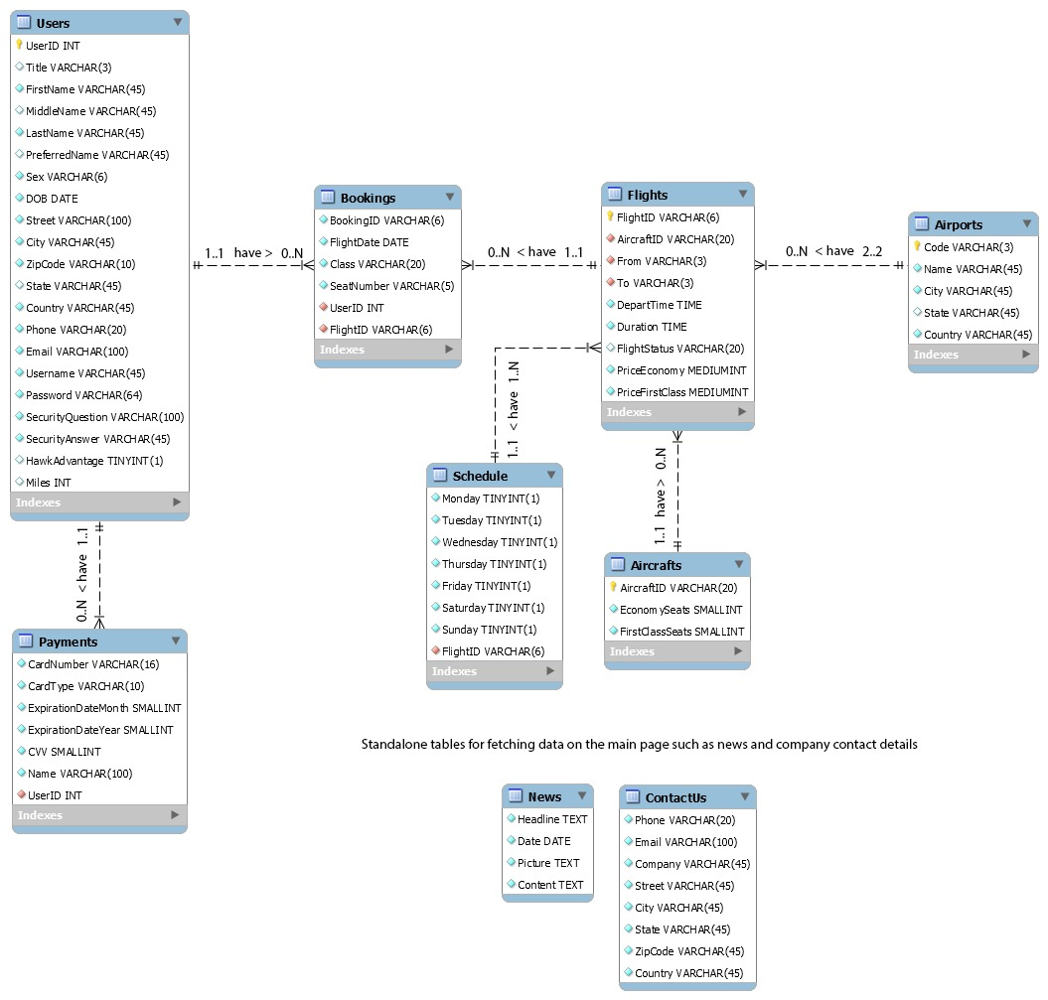

**2NF – Second Normal Form**

For the table to be in second normal form, we had to take care of the following conditions –

* + - Table should be in 1NF.
    - There should be no partial dependency between attributes.

We started off to work on removing partial dependencies from our tables, so that each table could have attributes which are functionally dependent on the primary key thereby avoiding all sorts of partial dependencies in the table.

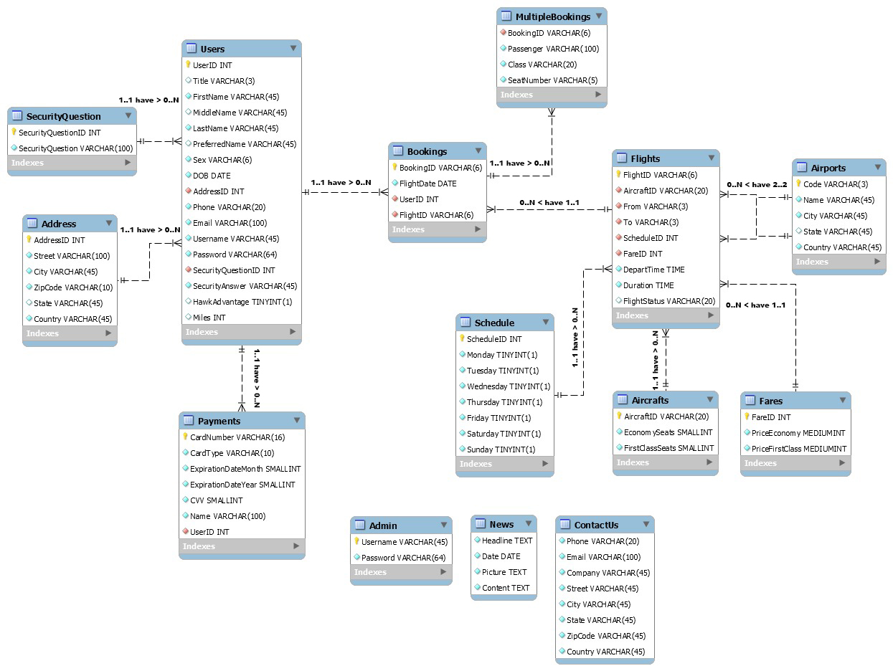

As a part of the normalization we had to split up and create a new table for security questions, user addresses, multiple bookings and flight fares. Thereby we made sure that every attribute in each table was functionally dependent on its own primary key.

**3NF – Third Normal Form**

For the table to be in third normal form, the following conditions had to be satisfied

* The table should be in 2NF.
* The attributes should not have any transitive dependencies.

After finalizing our table to 2NF, we made sure to remove all sorts of transitive dependencies among attributes.

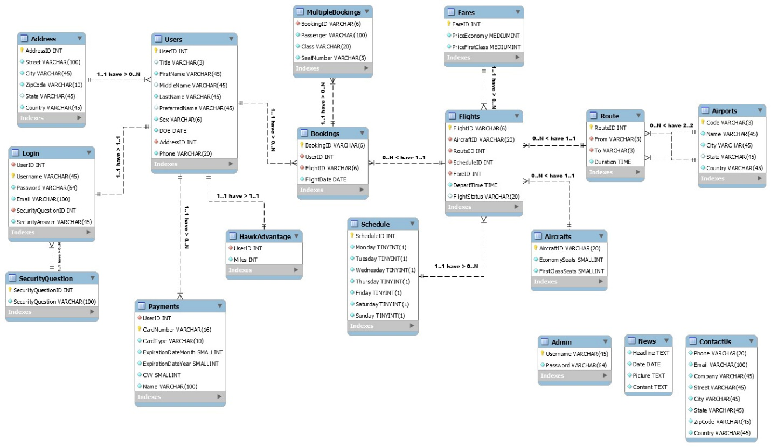

Since, few attributes in the Users table were transitively dependent on the UserId attribute, we separated the attributes associated with UserId and created a new table called Login. Also, Miles were dependent on UserID as well, so for the HawkAdvantage program a new table has been created. This makes our database robust i.e. we tend to find the miles only if the user already has enrolled in HawkAdvantage program.

Similarly, in Flights table the duration was transitively dependent on the From and To information of the flight, so we separated it into a new table named Route which had the details for from to and duration of the flight. This table acts as a liaison between the Flights and Airports table.